Study board conclusions of the semester and teaching evaluation report
Year: | 2024
Campus | Copenhagen
Semester | SMC7
Coordinator: | Cumhur Erkut
Date: | 11.3.25

This document represents the public version of the evaluation of the semester. The document forms together with the semester and teaching evaluation report the basis of any adjustments to the semester’s description, planning, execution and/or evaluation of the next iteration of the semester and are used by the coming semester coordinator and semester planning group.

The document also represents the study board’s response to the students, teachers, coordinators and other interested parties about possible consequences of conditions that the students of the semester have pointed out.

The public conclusions and recommendations of the semester coordinator
The 2024 SMC7 semester was characterized by strong student engagement and enthusiasm, particularly for hands-on courses and projects. However, key challenges emerged in organization, supervision, and communication. Students frequently reported difficulty obtaining clear and timely information, which affected their ability to plan and execute coursework effectively.

Key recommendations for improvement: • Better supervision planning: Ensure that project supervisors introduce their projects timely, distribute their hours more evenly and provide clearer guidance throughout the semester. • More structured online communication: Improve how key dates and changes are communicated, ensuring that all students receive updates in a timely manner. • Improved lecture-lab integration: Especially in NIME and Sound Processing, clearer connections between theoretical content and practical applications should be established. • Stronger foundational teaching in math: Address gaps in fundamental mathematics at the beginning of technical courses to help students build confidence in complex topics.

Overall, the semester was successful, but addressing these organizational challenges will enhance student experience in future integration of the program to Medialog

Conclusion of the study board
The Study Board (MSN) has processed the semester evaluation report and offers the following observations/conclusions:
- Response rate 68%
- Grade distribution fine
- The semester worked well

Samlet status
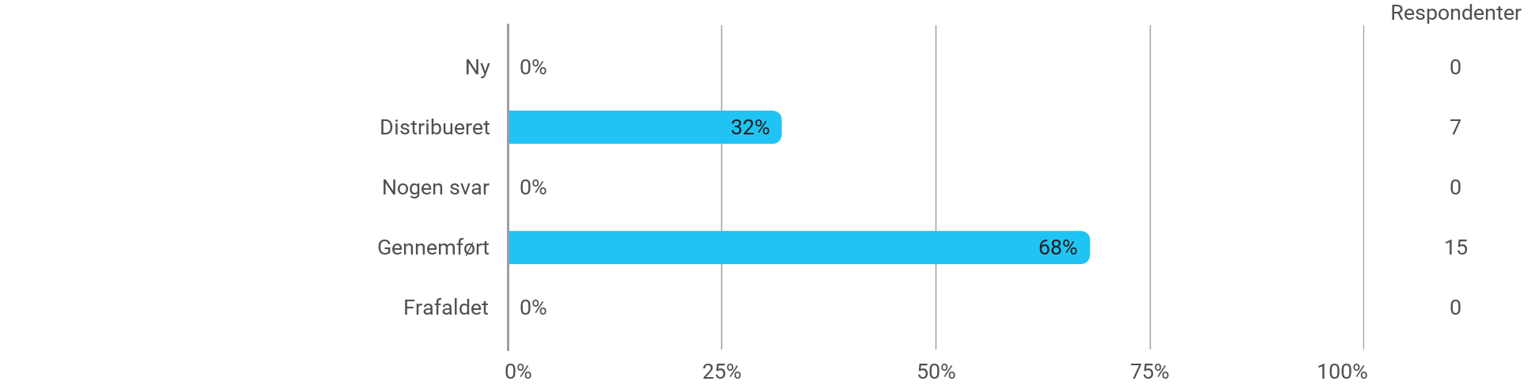

MSc01 SMC - Sound Processing - I have received the expected benefit from the module
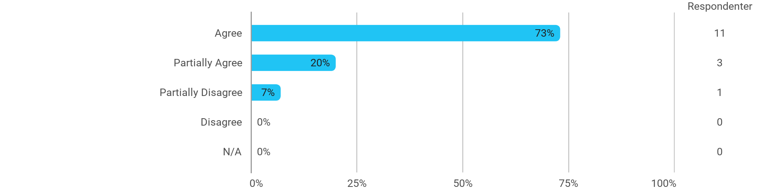

MSc01 SMC - Sound Processing - The literature used has supported my learning
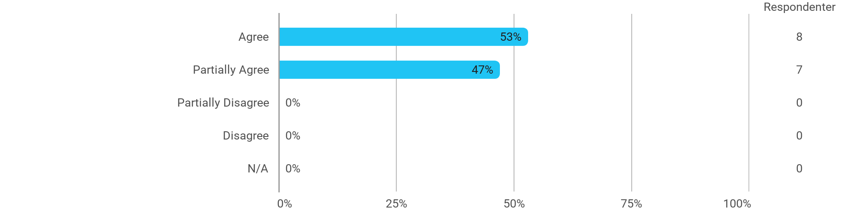

MSc01 SMC - Sound Processing - The form of teaching used has supported my learning
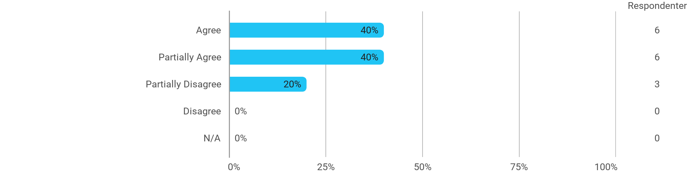

MSc01 SMC - Sound Processing - The exercises/tasks for the course have been relevant
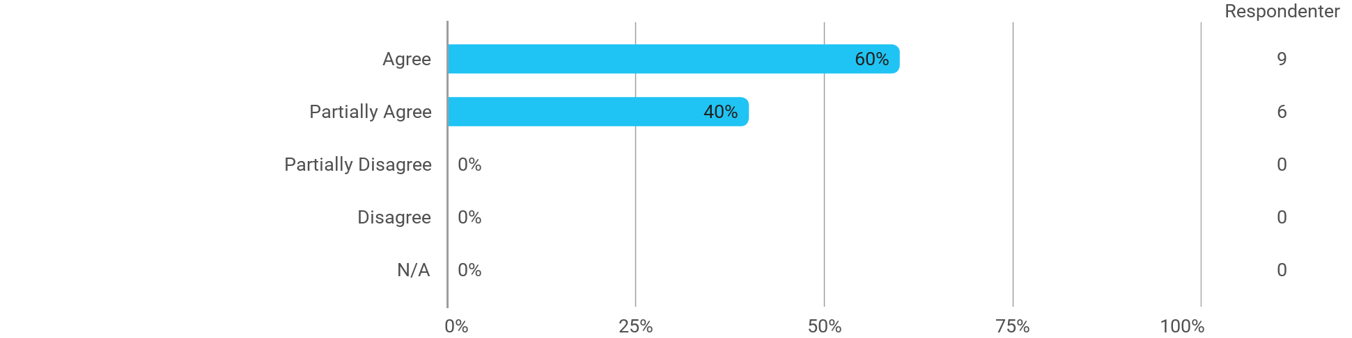

MSc01 SMC - New Interfaces for Musical Expression - I have received the expected benefit from the module
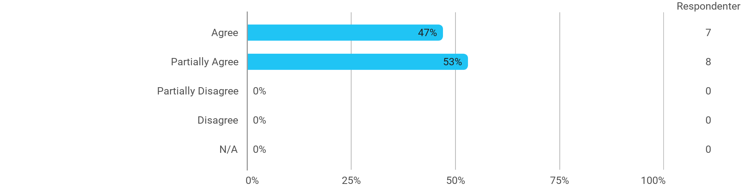

MSc01 SMC - New Interfaces for Musical Expression - The literature used has supported my learning
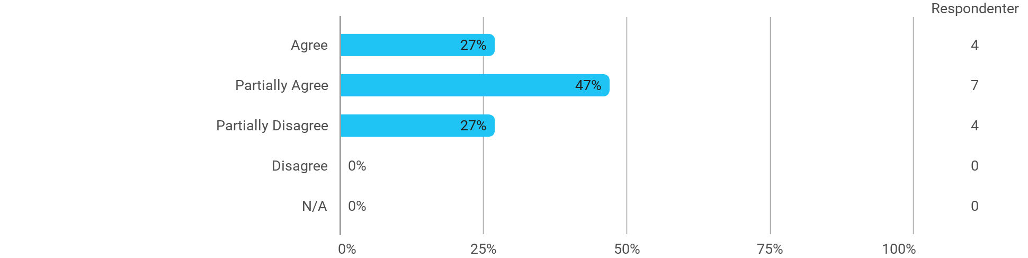

MSc01 SMC - New Interfaces for Musical Expression - The form of teaching used has supported my learning
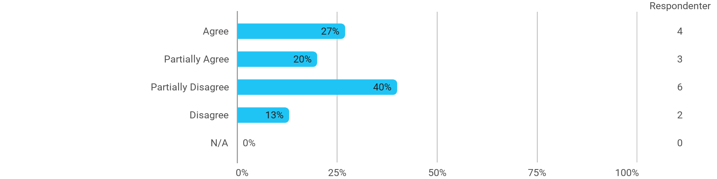

MSc01 SMC - New Interfaces for Musical Expression - The exercises/tasks for the course have been relevant
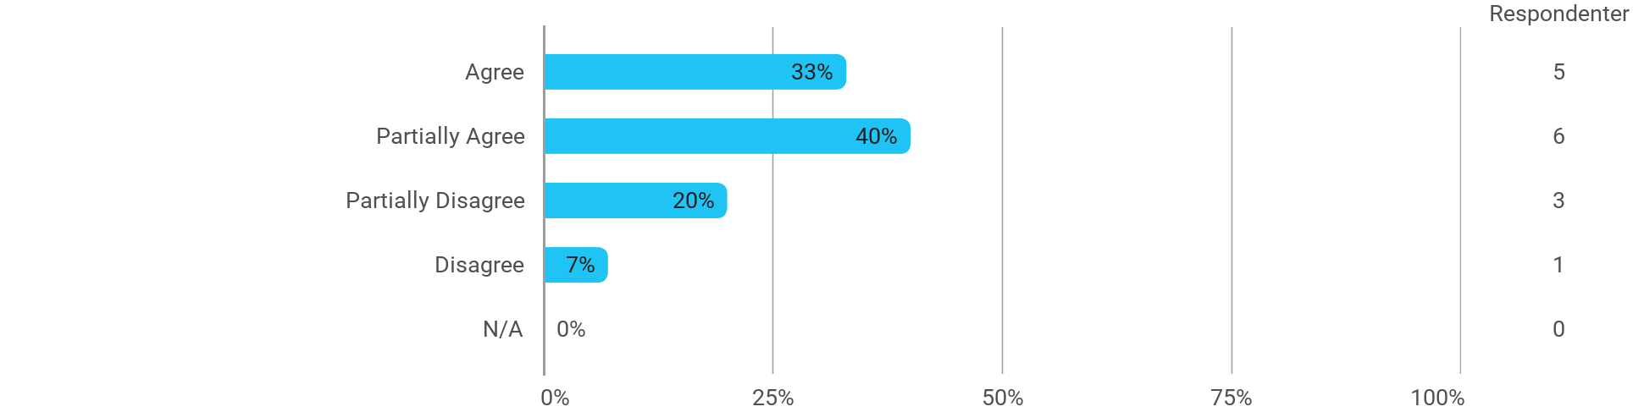

MSc01 SMC - Music Perception and Cognition - I have received the expected benefit from the module

MSc01 SMC - Music Perception and Cognition - The literature used has supported my learning
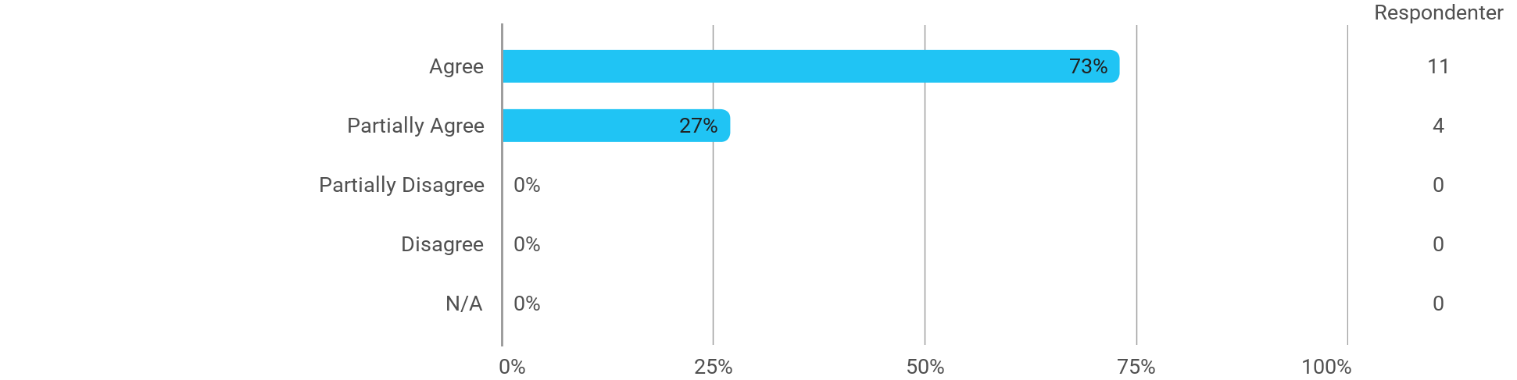

MSc01 SMC - Music Perception and Cognition - The form of teaching used has supported my learning

MSc01 SMC - Music Perception and Cognition - The exercises/tasks for the course have been relevant
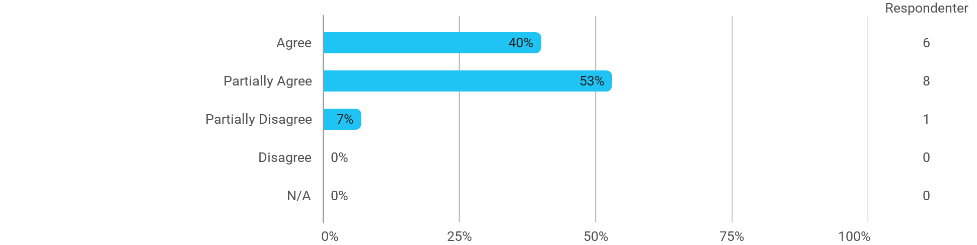

MSc01 SMC (project) - Foundations of SMC - I have received the expected benefit from the module
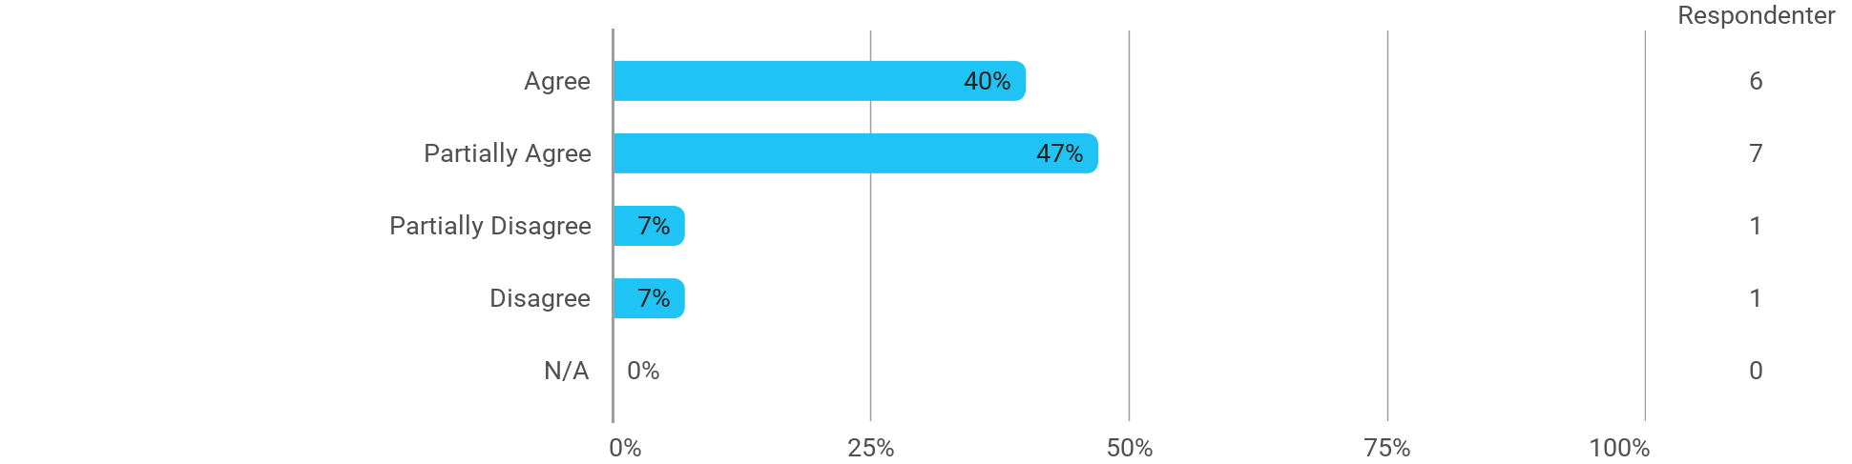

MSc01 SMC (project) - Foundations of SMC - The chosen problem has been a good foundation for unfolding my professional ambitions
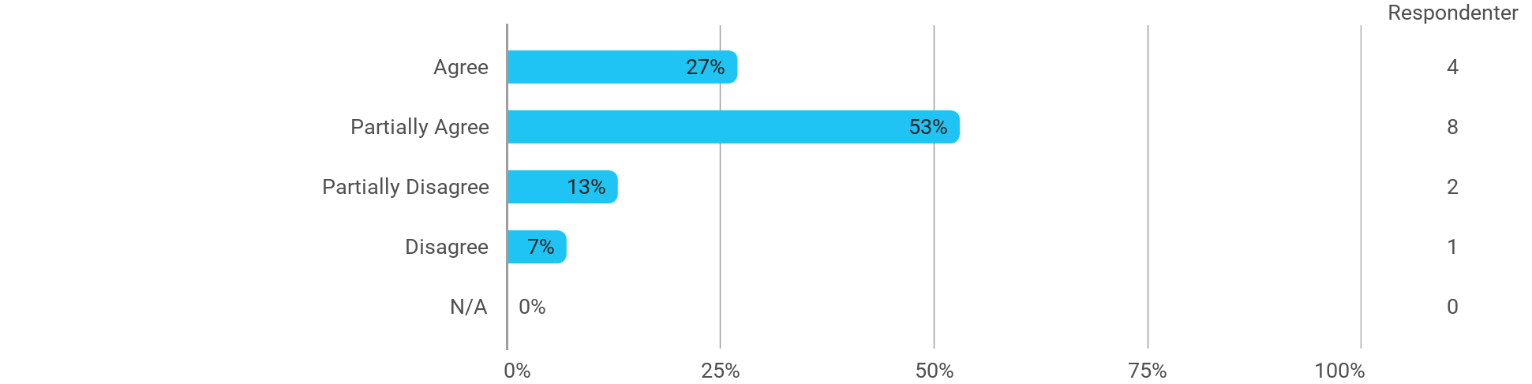

MSc01 SMC (project) - Foundations of SMC - The cooperation in the project group has worked well
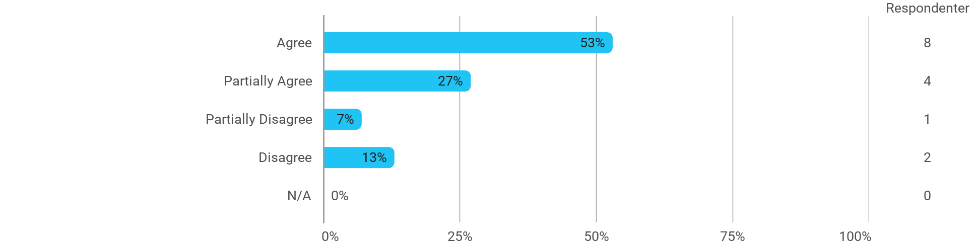

MSc01 SMC (project) - Foundations of SMC - The courses have supported the project work
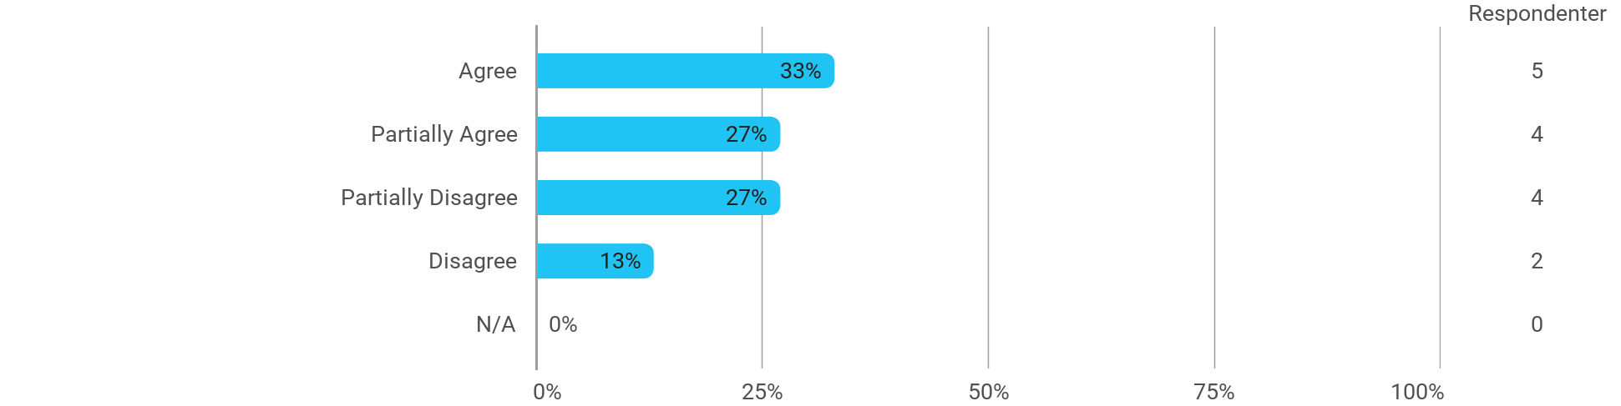

MSc01 SMC (project) - Foundations of SMC - I received the expected supervision
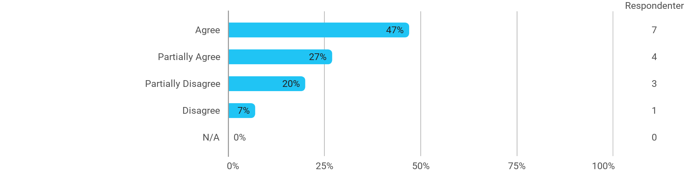

I have developed myself academically during the semester
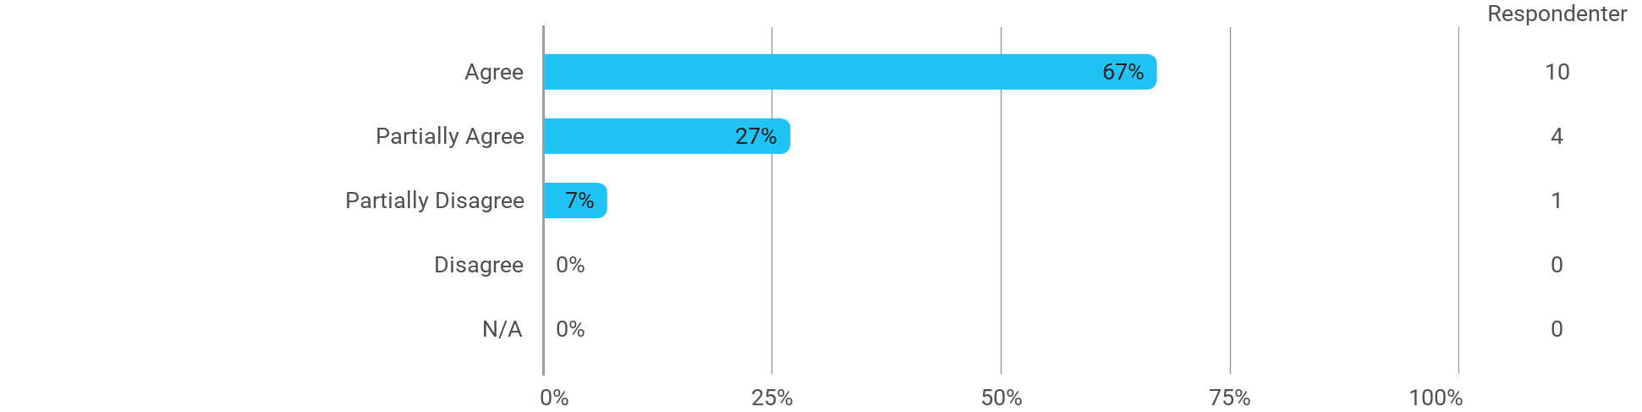

The following activities have developed me academically during the semester: - Project work
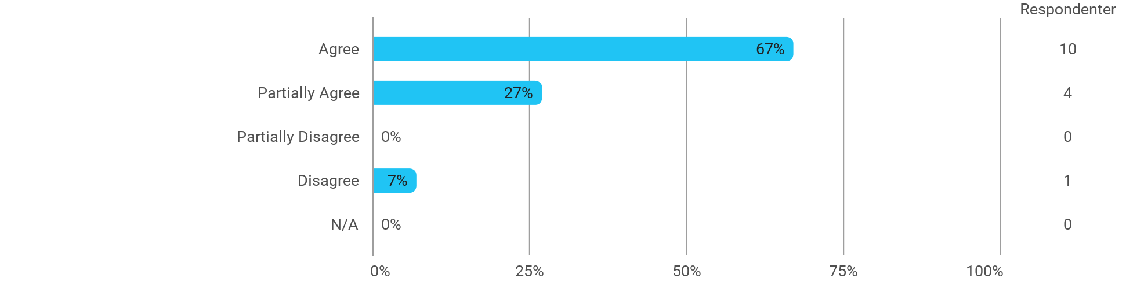

The following activities have developed me academically during the semester: - Academic discussions with fellow students
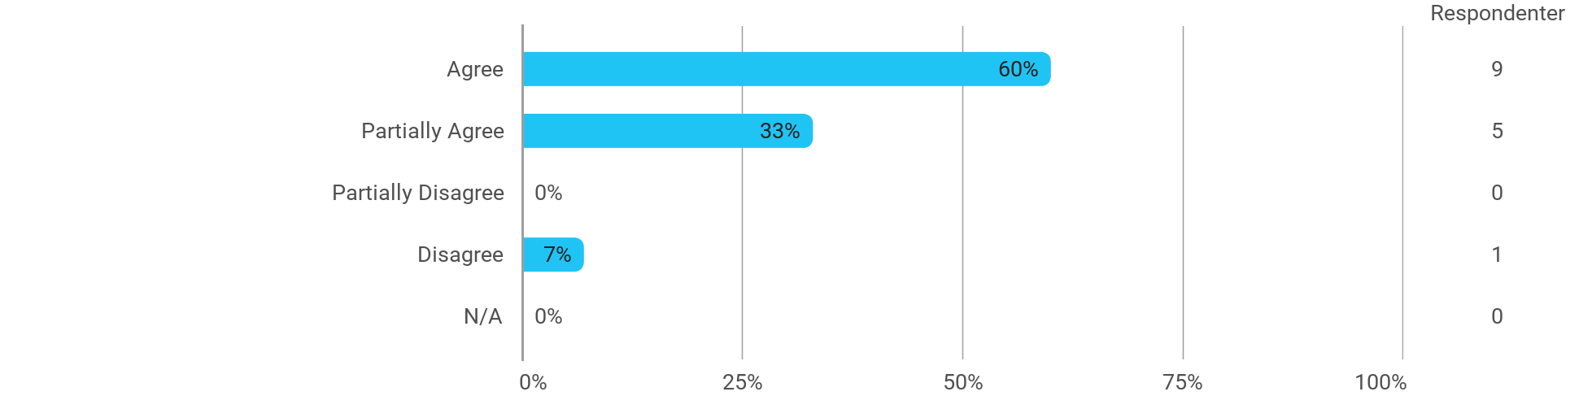

The following activities have developed me academically during the semester: - Academic discussions with teachers

The following activities have developed me academically during the semester: - Practical exercises and experiments

When I reflect on my own efforts, I have: - Been active in lectures
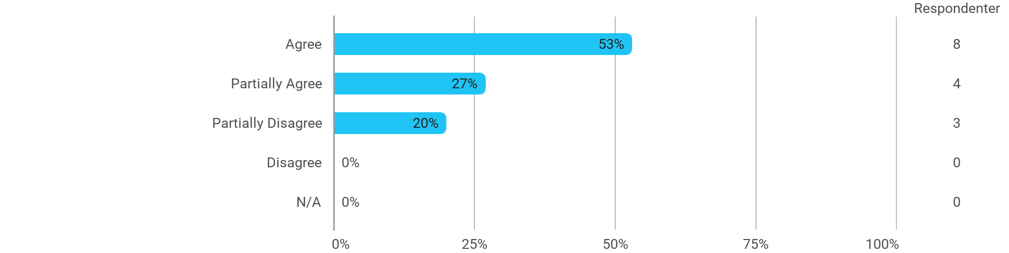

When I reflect on my own efforts, I have: - Participated actively in the project group work
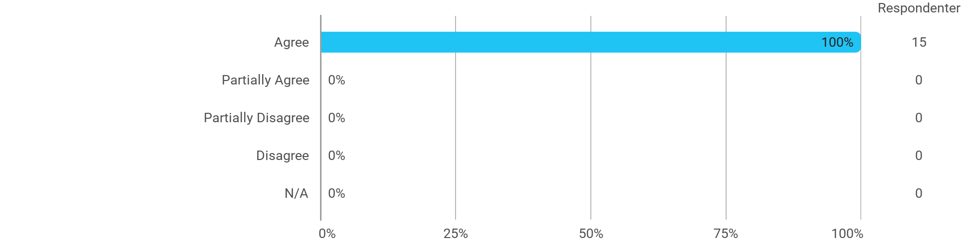

When I reflect on my own efforts, I have: - Prepared myself ahead of class
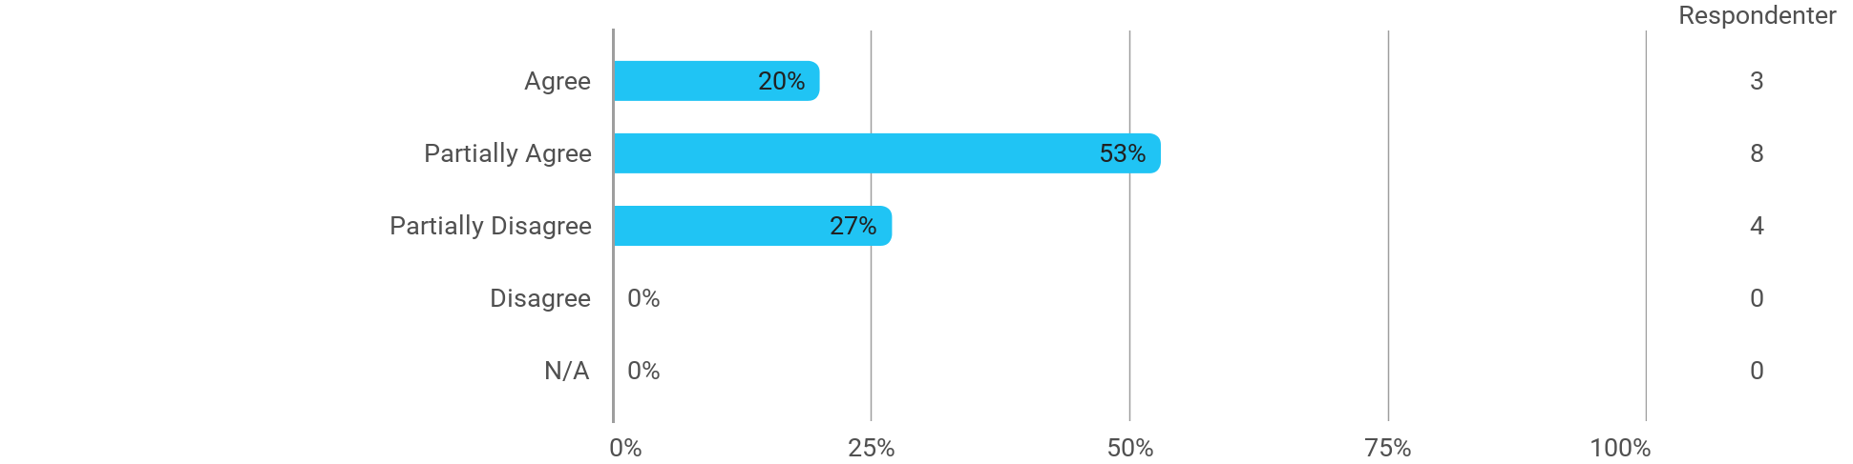

When I reflect on my own efforts, I have: - Prepared myself prior to the project group work

I experience the problem-based and project-oriented form of teaching as conducive to the development of: - My professional skills
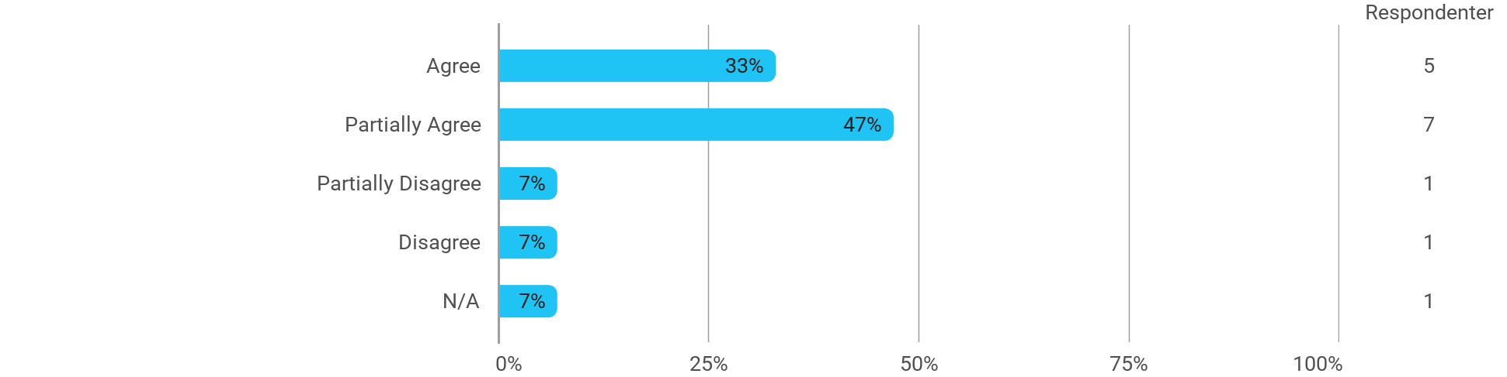

I experience the problem-based and project-oriented form of teaching as conducive to the development of: - My ability to identify and formulate problems
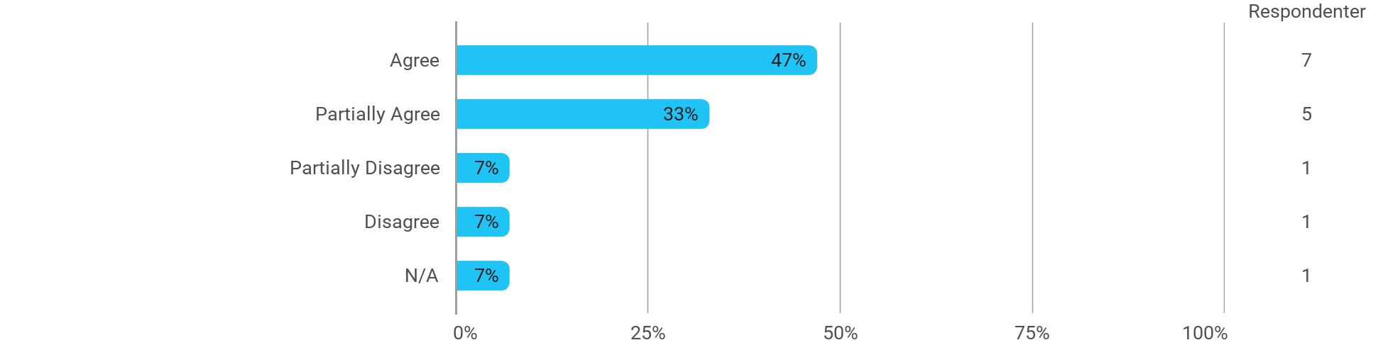

I experience the problem-based and project-oriented form of teaching as conducive to the development of: - My ability to attack and process problems
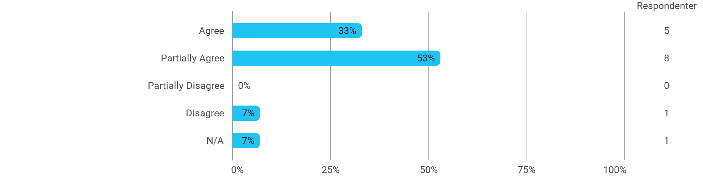

I experience the problem-based and project-oriented form of teaching as conducive to the development of: - My ability to organize a longer work process and "reach the goal" on time
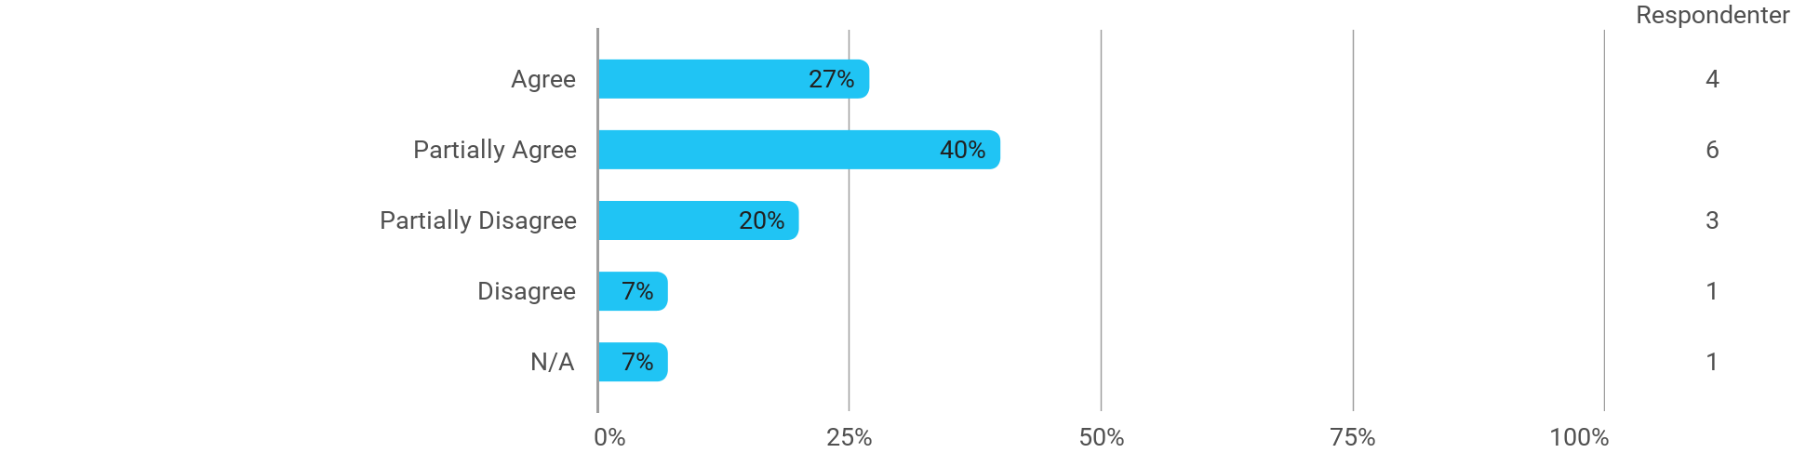

The following questions pertain to the semester as a whole: - I have received sufficient practical information about the semester's activities
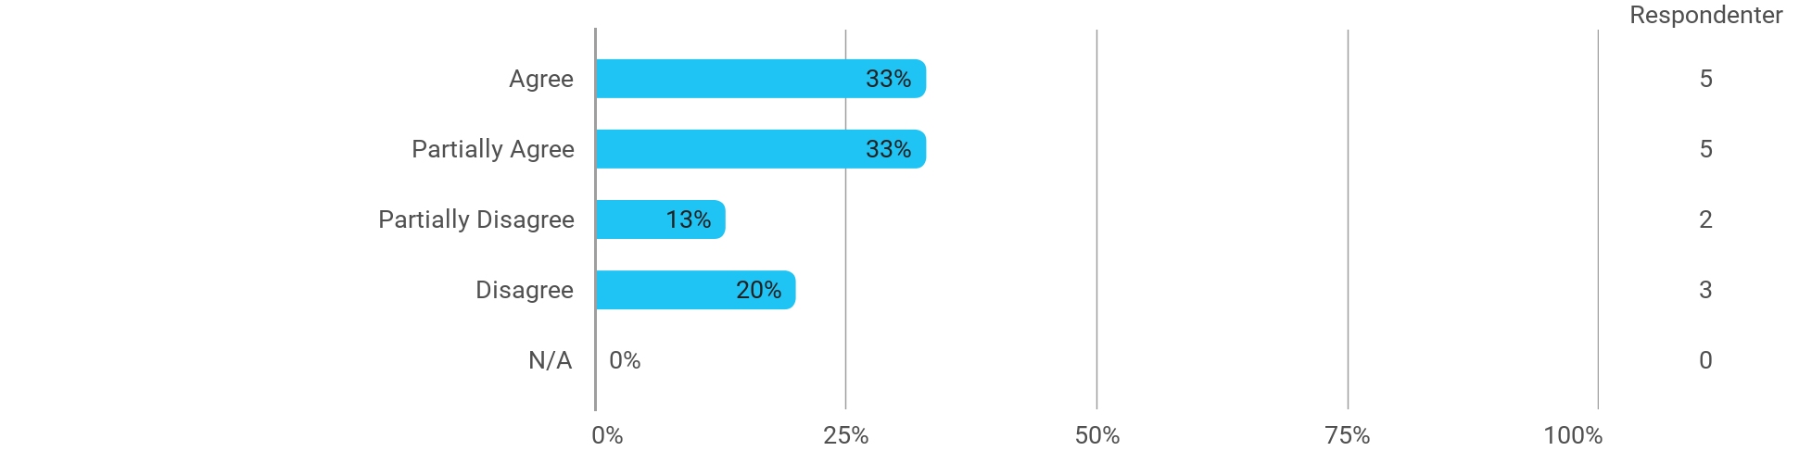

The following questions pertain to the semester as a whole: - I feel that the semester has given me the opportunity to engage in current issues relevant to external partners
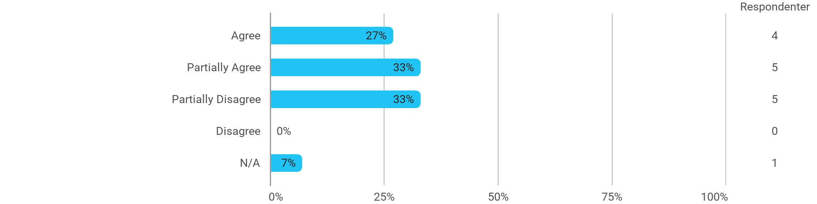

The following questions pertain to the semester as a whole: - I feel that I have addressed issues related to current societal challenges and opportunities
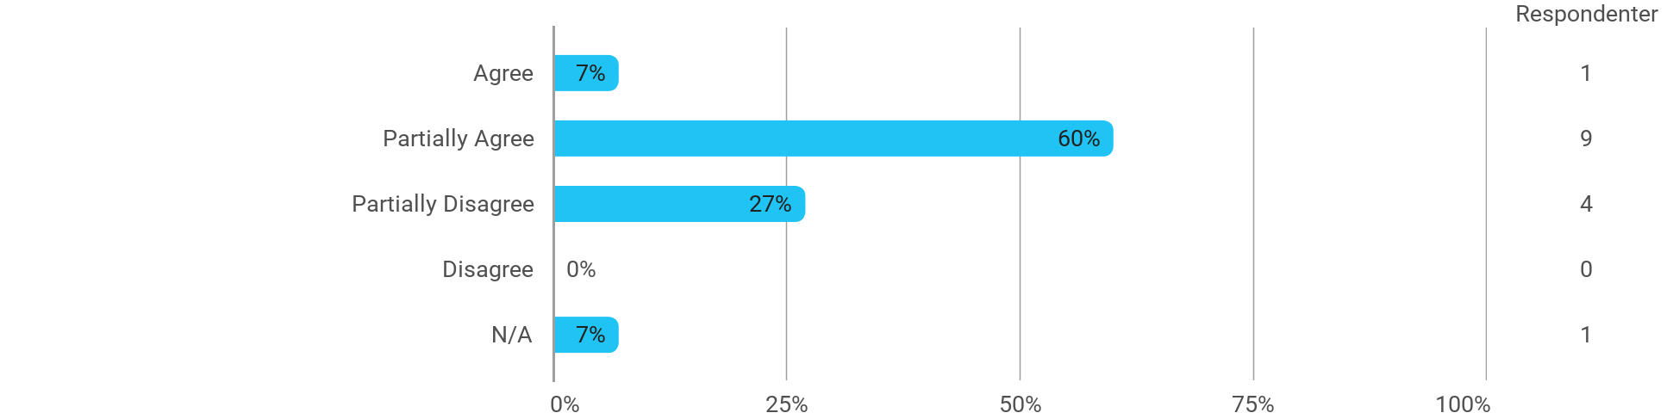

The following questions pertain to the semester as a whole: - I feel that the modules have supported the project work
