|  |  |
| --- | --- |
| **Study board conclusions of the semester and teaching evaluation report** | |
| Year: | 2024 |
| Campus | Copenhagen |
| Semester | SMC9 |
| Coordinator: | Stefania Serafin |
| Date: | 11.3.25 |
|  |  |

This document represents the public version of the evaluation of the semester. The document forms together with the semester and teaching evaluation report the basis of any adjustments to the semester’s description, planning, execution and/or evaluation of the next iteration of the semester and are used by the coming semester coordinator and semester planning group.

The document also represents the study board’s response to the students, teachers, coordinators and other interested parties about possible consequences of conditions that the students of the semester have pointed out.

|  |
| --- |
| **The public conclusions and recommendations of the semester coordinator** |
|  |

|  |
| --- |
| **Conclusion of the study board** |
| The Study Board (MSN) has processed the semester evaluation report and offers the following observations/conclusions:   * The semester coordinator has not filled out the report * Response rate 70% * Grade distribution fine |

## Samlet status

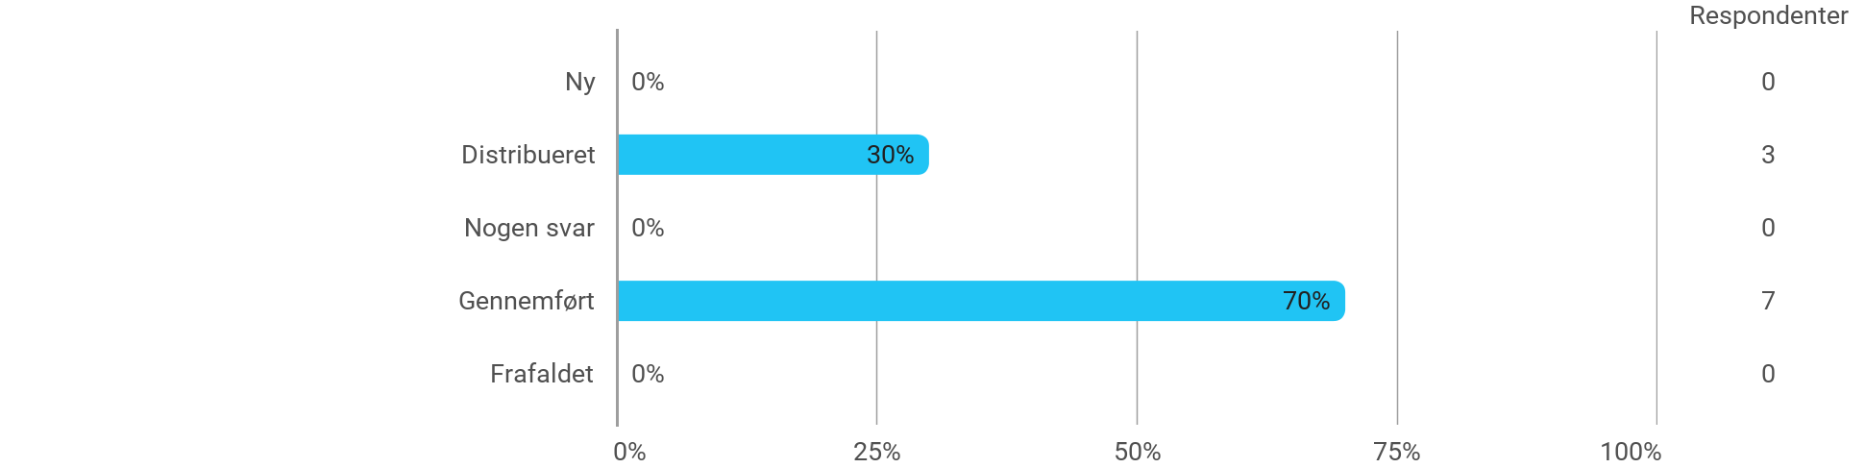

## MSc03 SMC - Research in Sound and Music Computing - I have received the expected benefit from the module

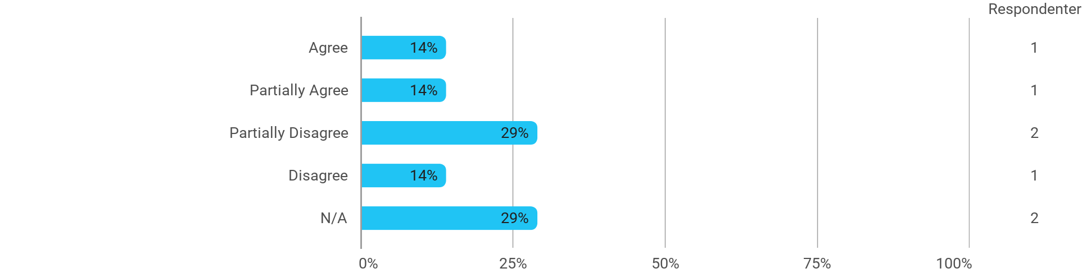

## MSc03 SMC - Research in Sound and Music Computing - The literature used has supported my learning

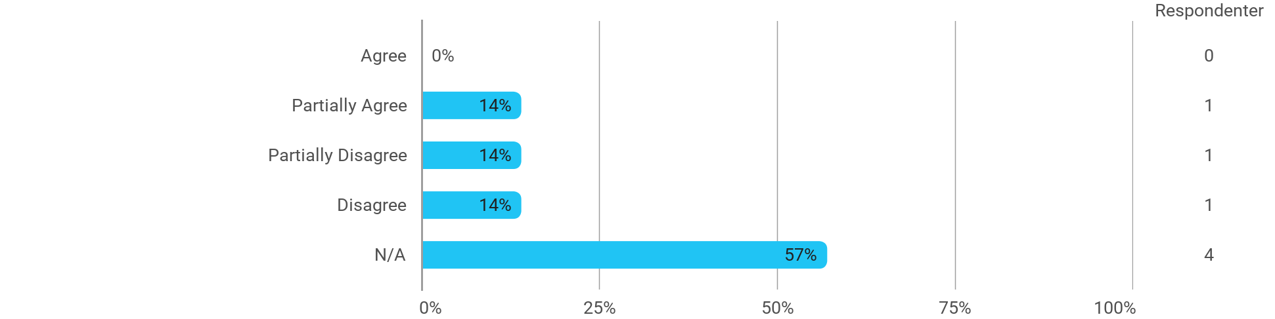

## MSc03 SMC - Research in Sound and Music Computing - The form of teaching used has supported my learning

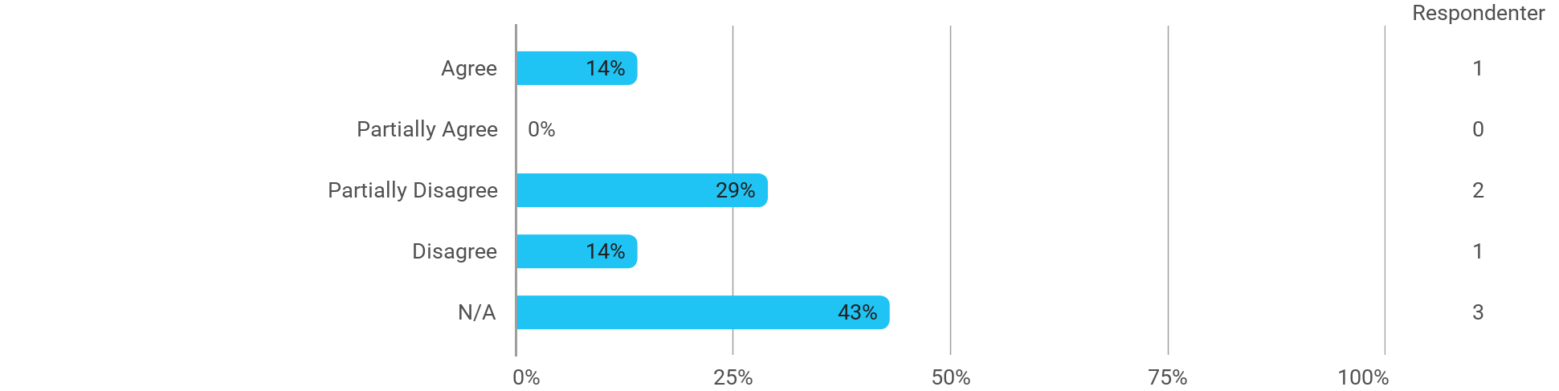

## MSc03 SMC - Research in Sound and Music Computing - The exercises/tasks for the course have been relevant



## MSc03 SMC - Machine Learning for Media Experiences - I have received the expected benefit from the module

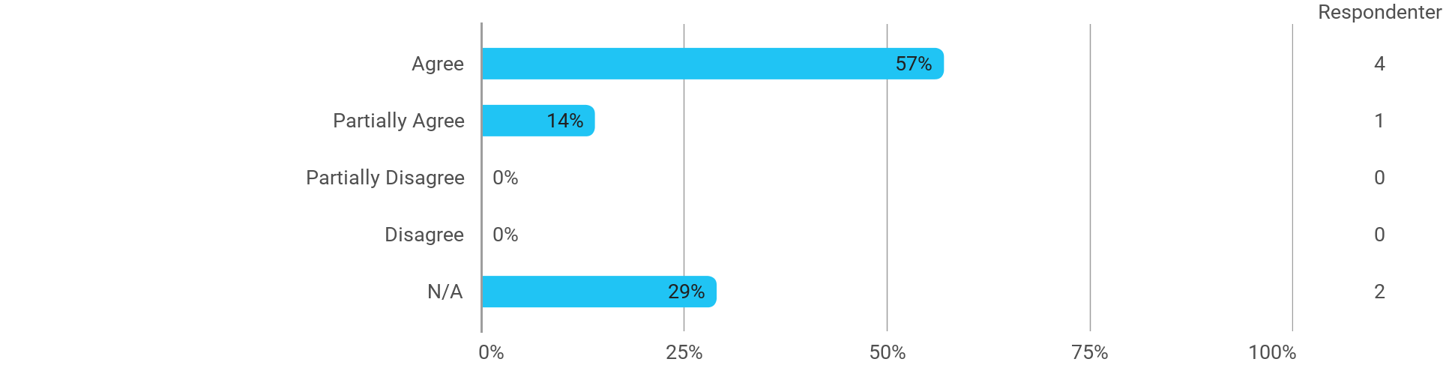

## MSc03 SMC - Machine Learning for Media Experiences - The literature used has supported my learning

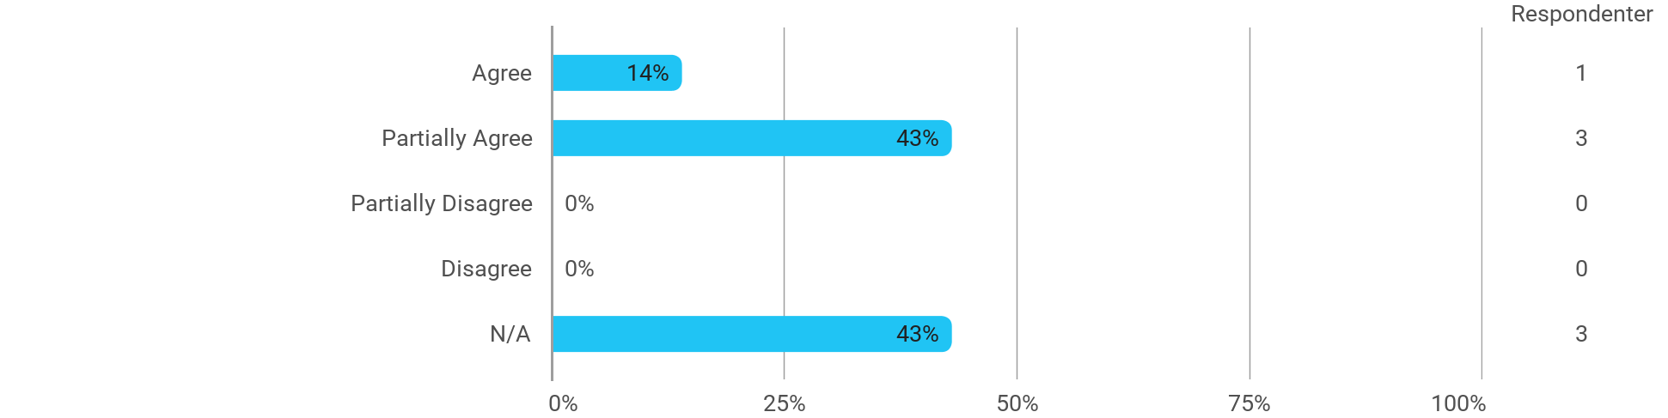

## MSc03 SMC - Machine Learning for Media Experiences - The form of teaching used has supported my learning

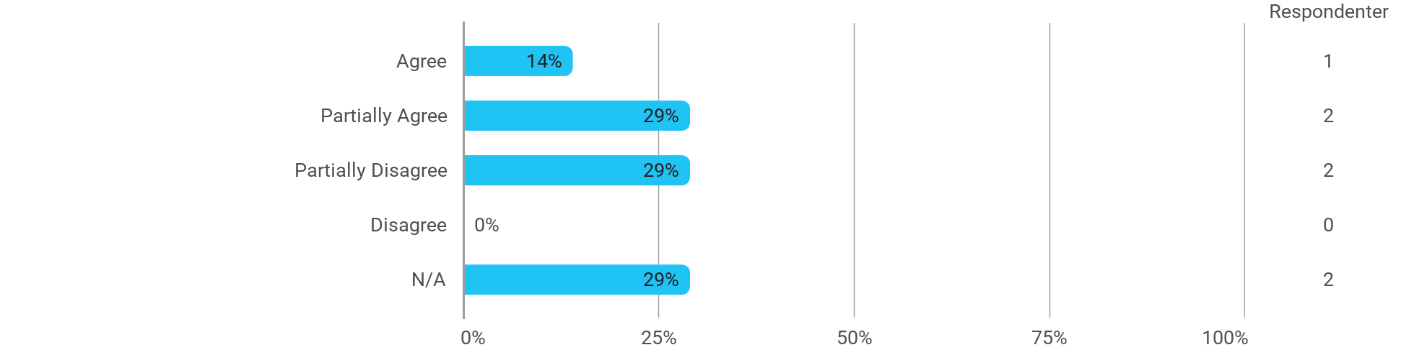

## MSc03 SMC - Machine Learning for Media Experiences - The exercises/tasks for the course have been relevant

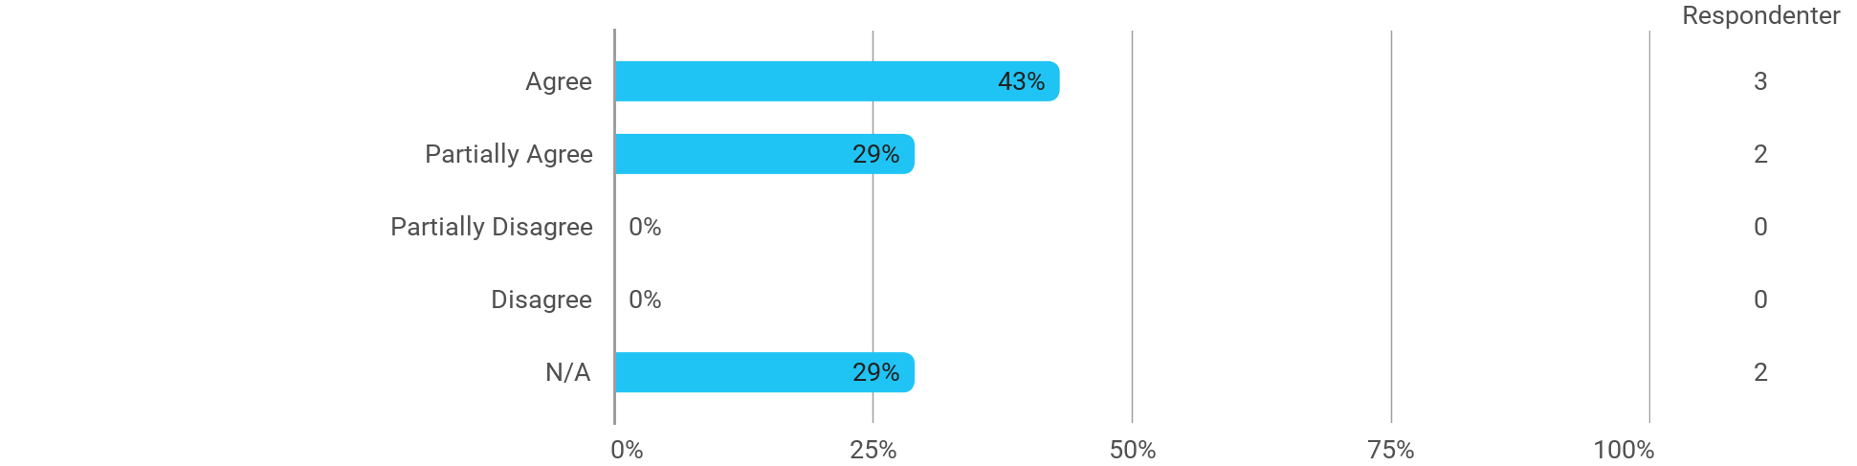

## MSc03 SMC (project) - Sound and Music Innovation - I have received the expected benefit from the module

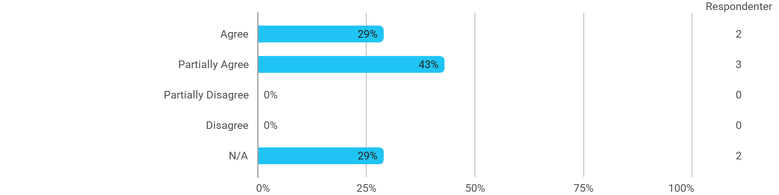

## MSc03 SMC (project) - Sound and Music Innovation - The chosen problem has been a good foundation for unfolding my professional ambitions



## MSc03 SMC (project) - Sound and Music Innovation - The cooperation in the project group has worked well

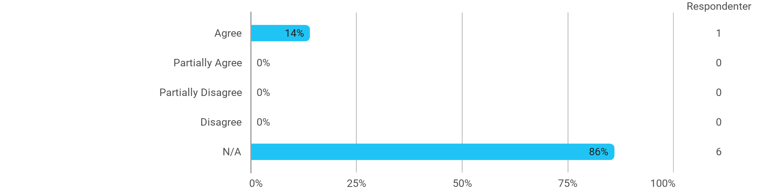

## MSc03 SMC (project) - Sound and Music Innovation - The courses have supported the project work

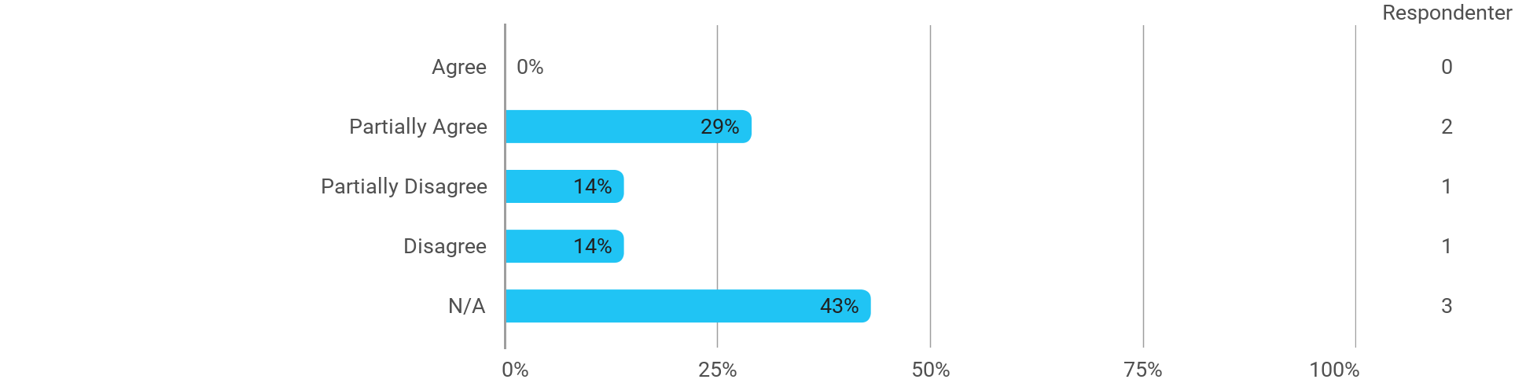

## MSc03 SMC (project) - Sound and Music Innovation - I received the expected supervision



|  |
| --- |

## MSc03 SMC B - Project-Oriented Study in an External Organisation - I have received the expected benefit from the module

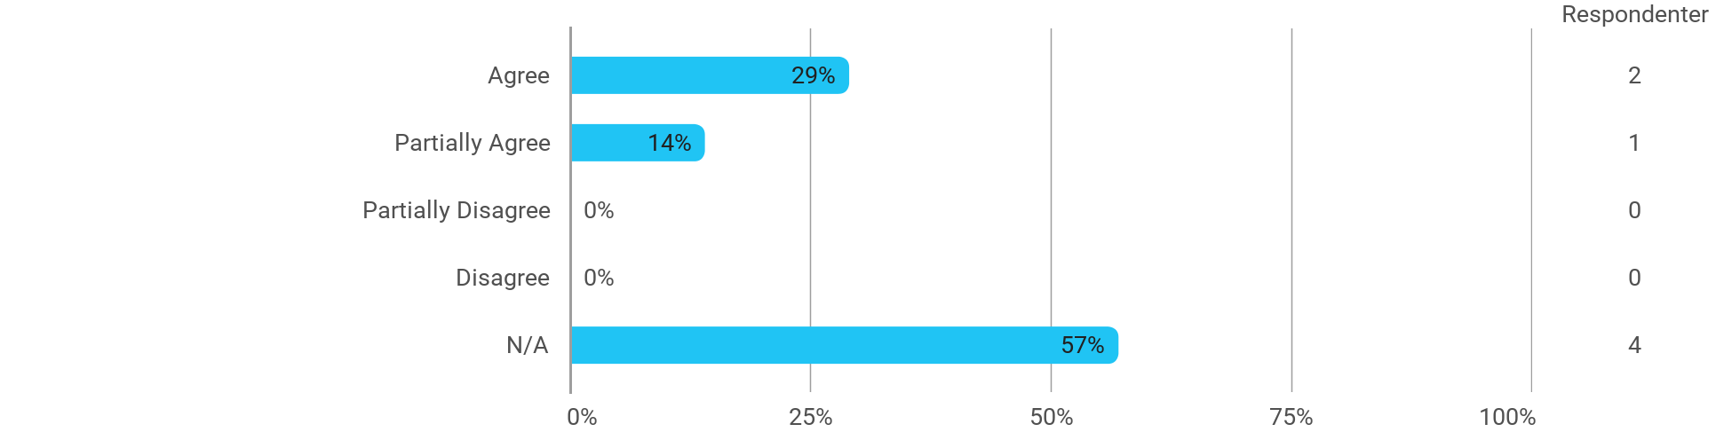

## MSc03 SMC B - Project-Oriented Study in an External Organisation - The chosen problem has been a good foundation for unfolding my professional ambitions

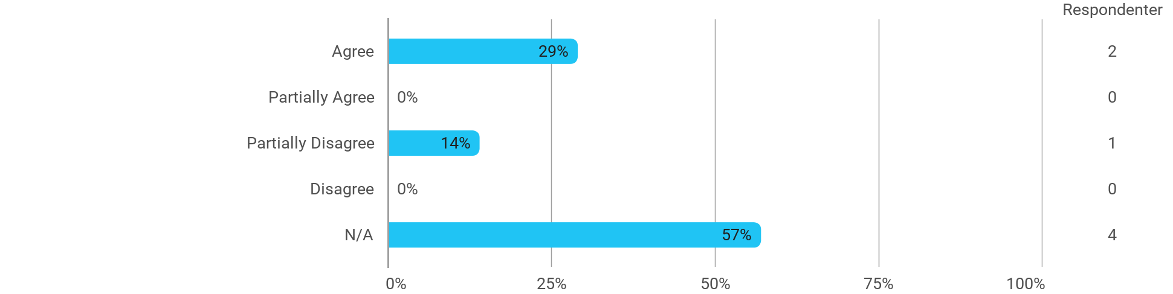

## MSc03 SMC B - Project-Oriented Study in an External Organisation - The cooperation in the project group has worked well

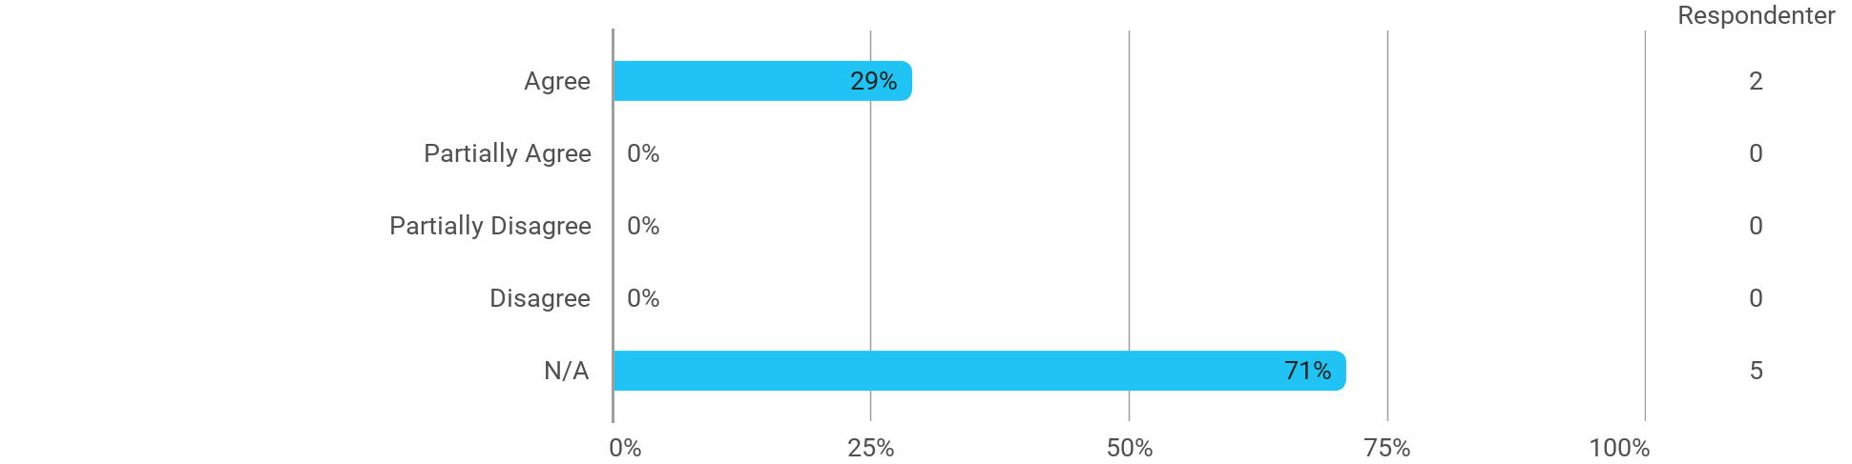

## MSc03 SMC B - Project-Oriented Study in an External Organisation - The courses have supported the project work

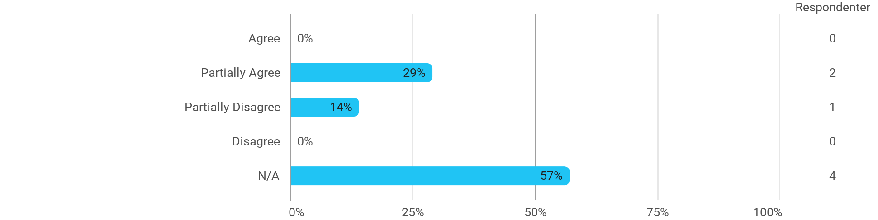

## MSc03 SMC B - Project-Oriented Study in an External Organisation - I received the expected supervision

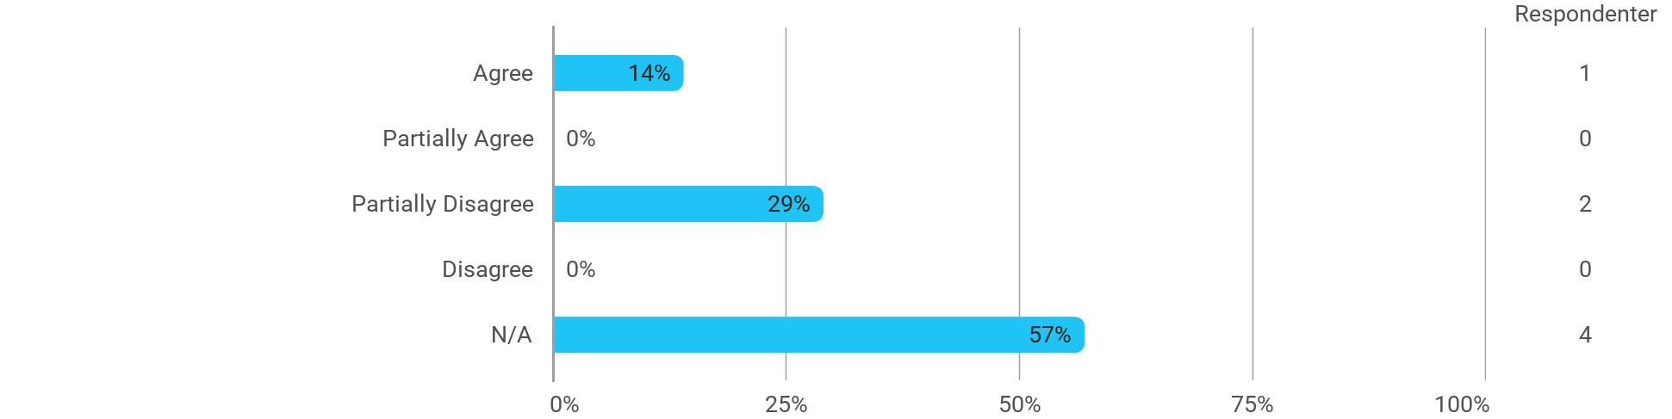

## I have developed myself academically during the semester

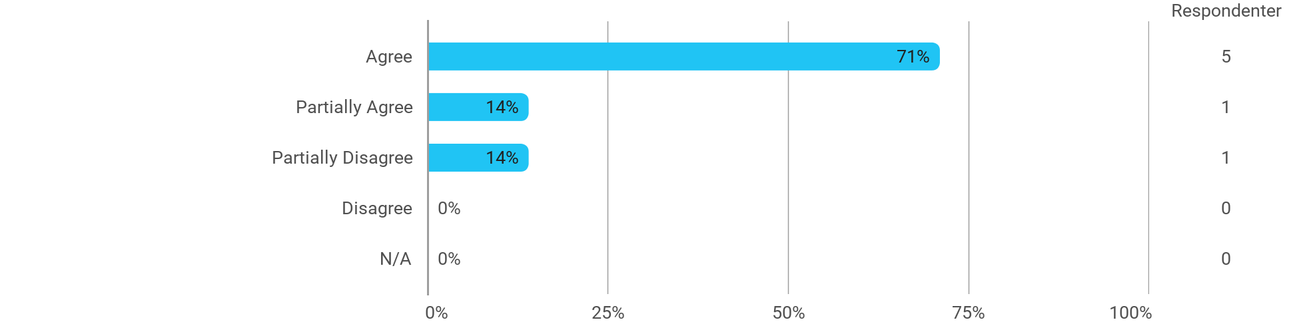

## The following activities have developed me academically during the semester: - Project work

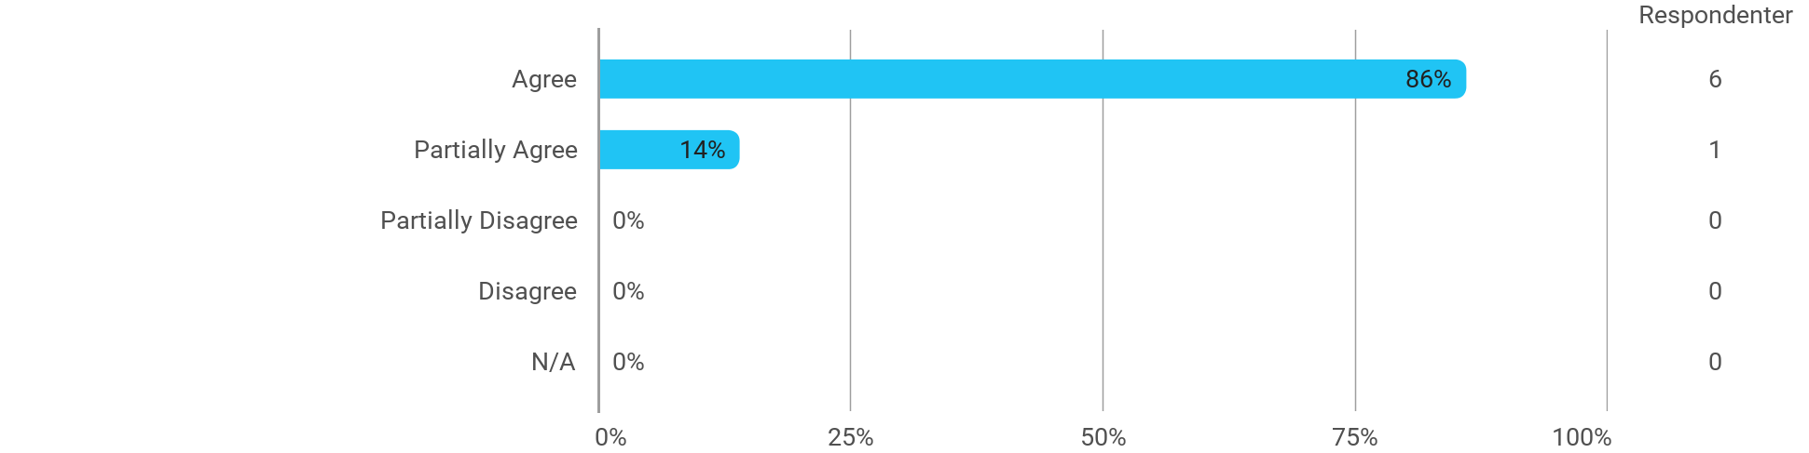

## The following activities have developed me academically during the semester: - Academic discussions with fellow students

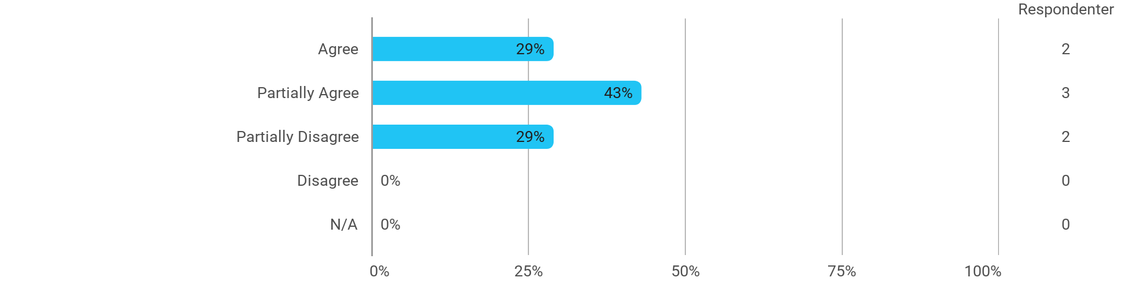

## The following activities have developed me academically during the semester: - Academic discussions with teachers

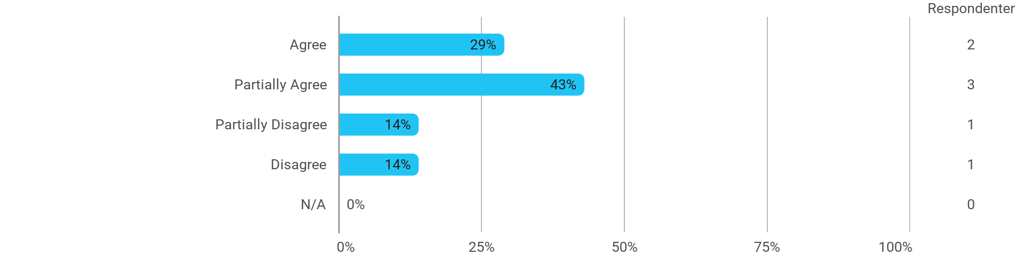

## The following activities have developed me academically during the semester: - Practical exercises and experiments

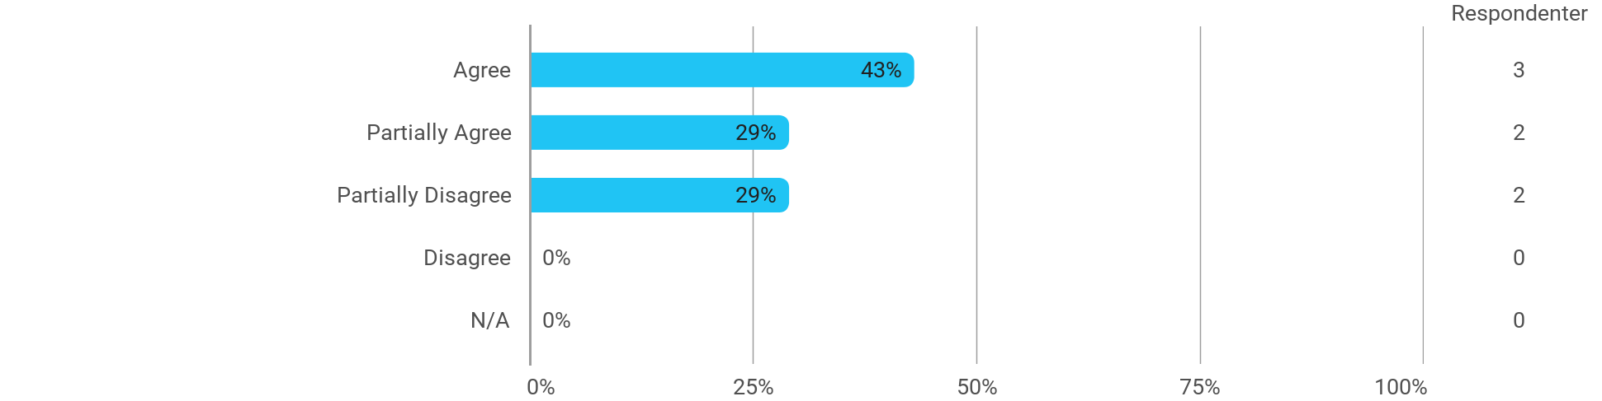

|  |
| --- |

## When I reflect on my own efforts, I have: - Been active in lectures

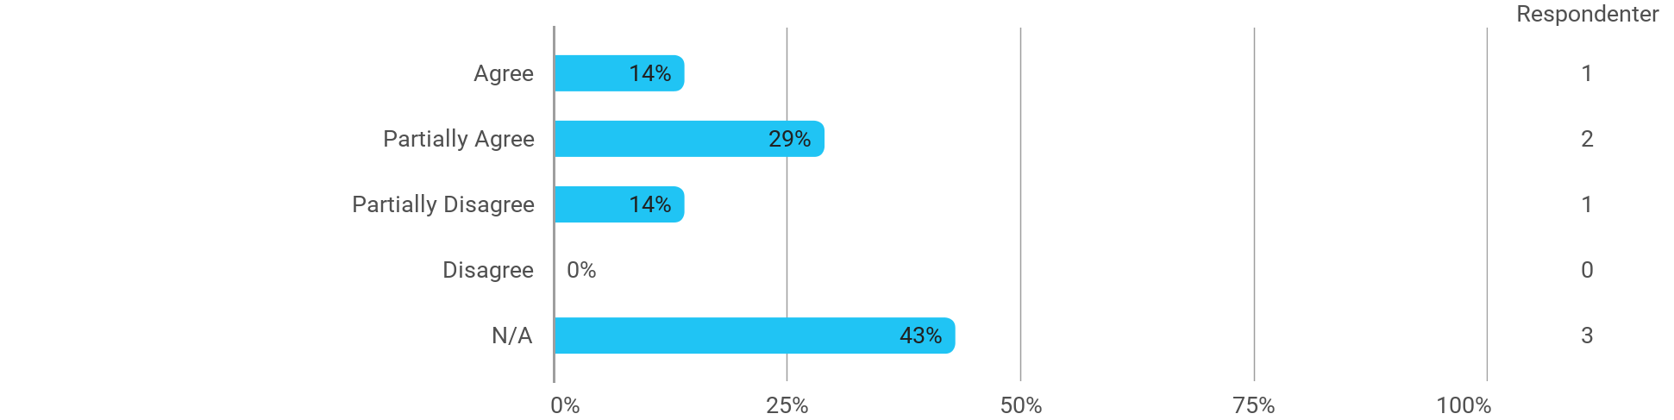

## When I reflect on my own efforts, I have: - Participated actively in the project group work

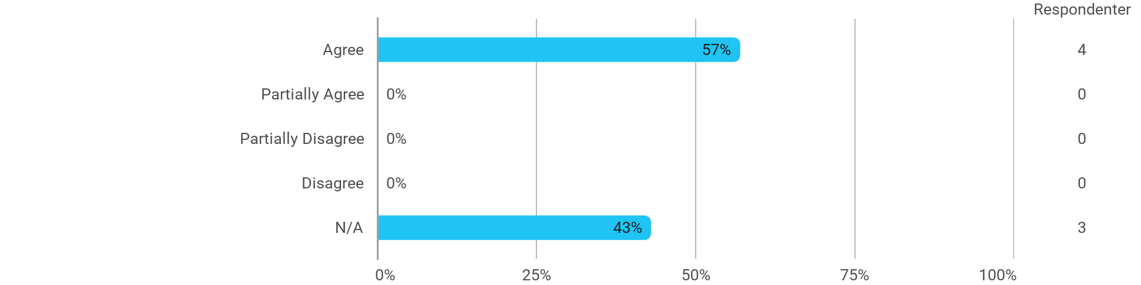

## When I reflect on my own efforts, I have: - Prepared myself ahead of class

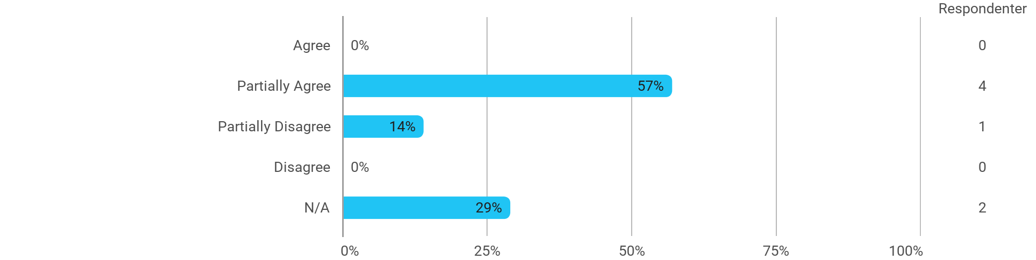

## When I reflect on my own efforts, I have: - Prepared myself prior to the project group work



## I experience the problem-based and project-oriented form of teaching as conducive to the development of: - My professional skills

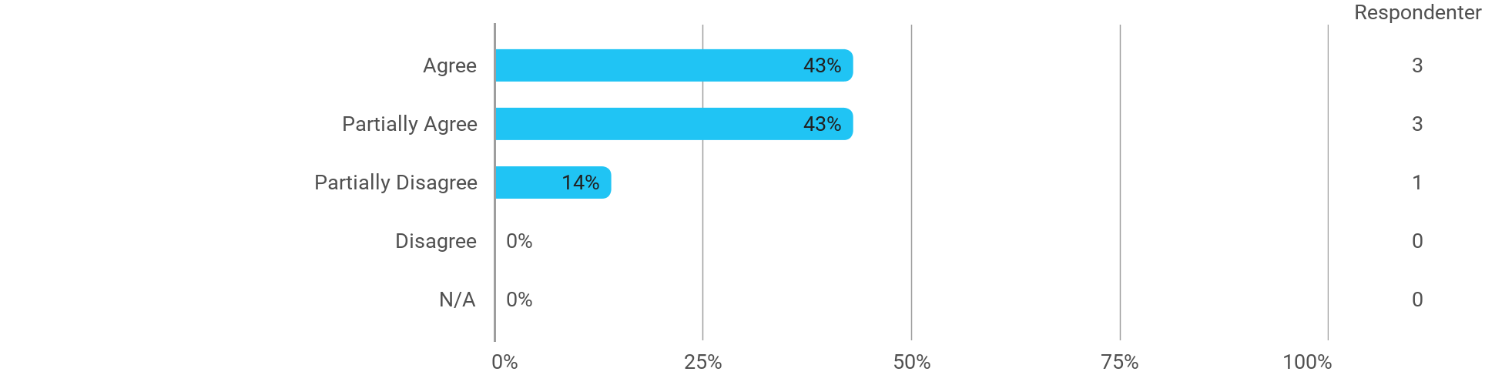

## I experience the problem-based and project-oriented form of teaching as conducive to the development of: - My ability to identify and formulate problems

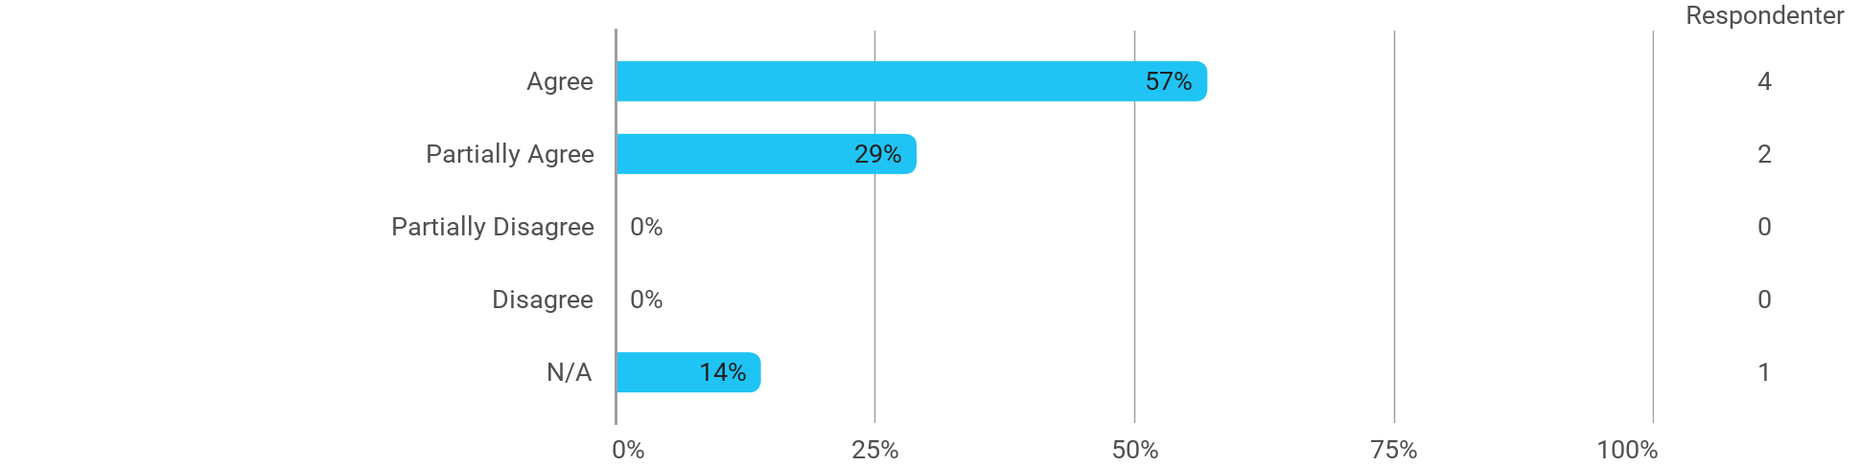

## I experience the problem-based and project-oriented form of teaching as conducive to the development of: - My ability to attack and process problems

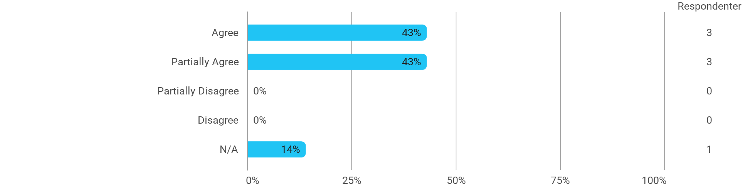

## I experience the problem-based and project-oriented form of teaching as conducive to the development of: - My ability to organize a longer work process and "reach the goal" on time

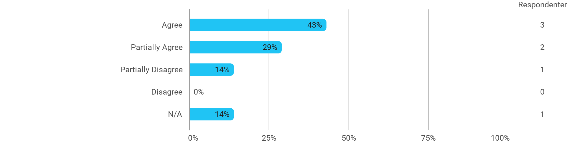

## The following questions pertain to the semester as a whole: - I have received sufficient practical information about the semester's activities

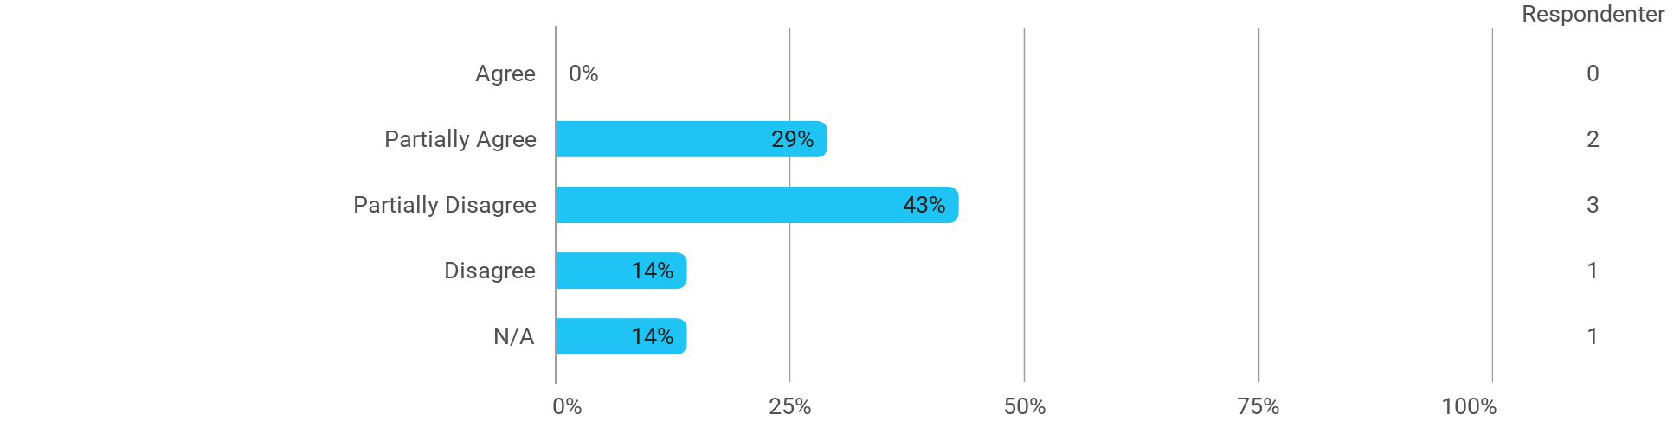

## The following questions pertain to the semester as a whole: - I feel that the semester has given me the opportunity to engage in current issues relevant to external partners

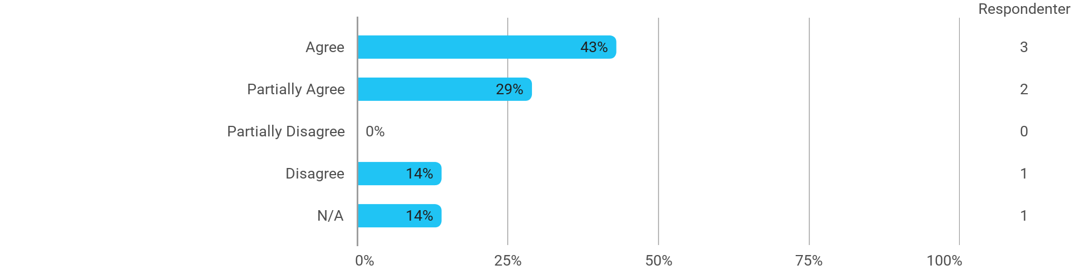

## The following questions pertain to the semester as a whole: - I feel that I have addressed issues related to current societal challenges and opportunities

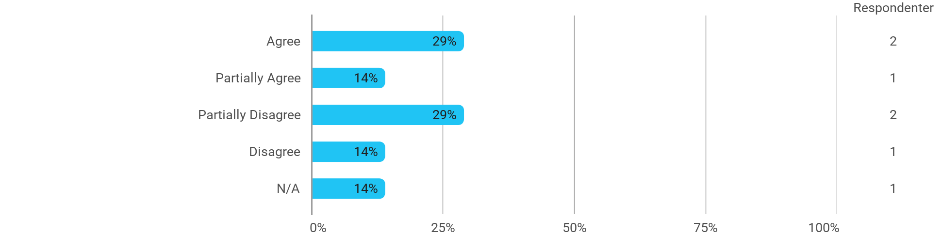

## The following questions pertain to the semester as a whole: - I feel that the modules have supported the project work

