Study board conclusions of the semester and teaching evaluation report
Year: | 2024
Campus | Copenhagen
Semester | LiD7
Coordinator: | Morteza Hosseini
Date: | 030325

This document represents the public version of the evaluation of the semester. The document forms together with the semester and teaching evaluation report the basis of any adjustments to the semester’s description, planning, execution and/or evaluation of the next iteration of the semester and are used by the coming semester coordinator and semester planning group.

The document also represents the study board’s response to the students, teachers, coordinators and other interested parties about possible consequences of conditions that the students of the semester have pointed out.

The public conclusions and recommendations of the semester coordinator
In general, a successful semester
Light & Space The course was conducted successfully. The teaching met expectations and adhered to the plan. It was a well-structured course with clear content, and the assignments were engaging and closely linked to the literature. However, Students asked for more time for preparation and presenting the assignments in class.
Lighting Fundamentals Teaching courses like Lighting Fundamentals, which involve numerous technical terms and physical formulas, presents an exciting challenge for interdisciplinary students. Overall, the course was successful, as it provided a solid foundation in pure science. To enhance understanding and engagement, incorporating more examples and hands-on training would be beneficial. Despite the diverse backgrounds of the students, their enthusiasm and curiosity are commendable, and with continued effort, motivation can be further boosted. The students effectively applied all the knowledge from the Lighting Fundamentals course in their semester projects.
Rendered Light Simulation The course was conducted successfully, with teaching that met expectations and adhered to the plan. Students were pleased with the teacher and teaching materials. Opinions on the course's difficulty varied, reflecting the diverse backgrounds of interdisciplinary students. We need to clearly specify the number of software programs required for the course. Additionally, we should consider how to provide Rhino licenses for the students.

Conclusion of the study board
The Study Board (MSN) has processed the semester evaluation report and offers the following observations/conclusions:
- Response rate 40%
- Grade distribution fine
- Semester worked well
- Some challenges regarding group formation and dynamics are mentioned. The Study Board discussed the group formation processes and challenges related to this. The Study Board recognizes the recurring and general issues with group formation and will encourage coordinators to implement various approaches to address these challenges.

Samlet status

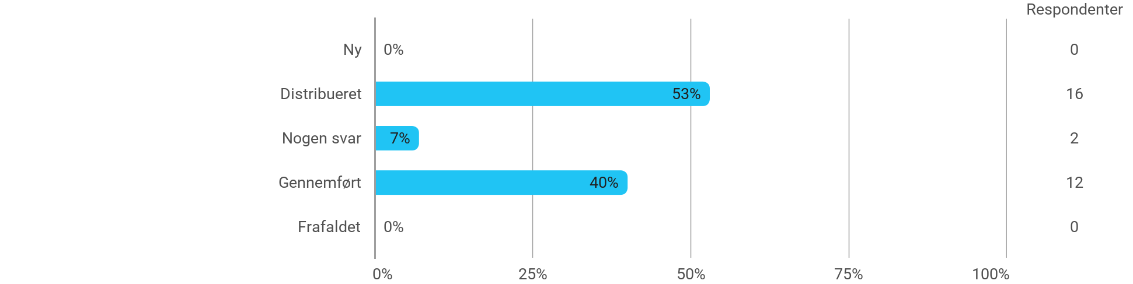

MSc01 LID - Lighting Fundamentals - I have received the expected benefit from the module
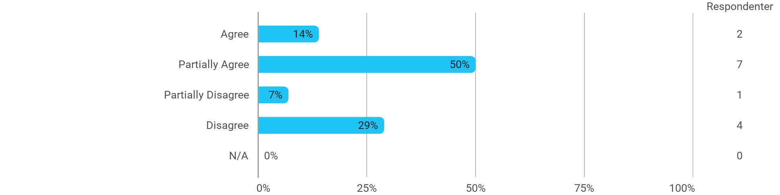

MSc01 LID - Lighting Fundamentals - The literature used has supported my learning
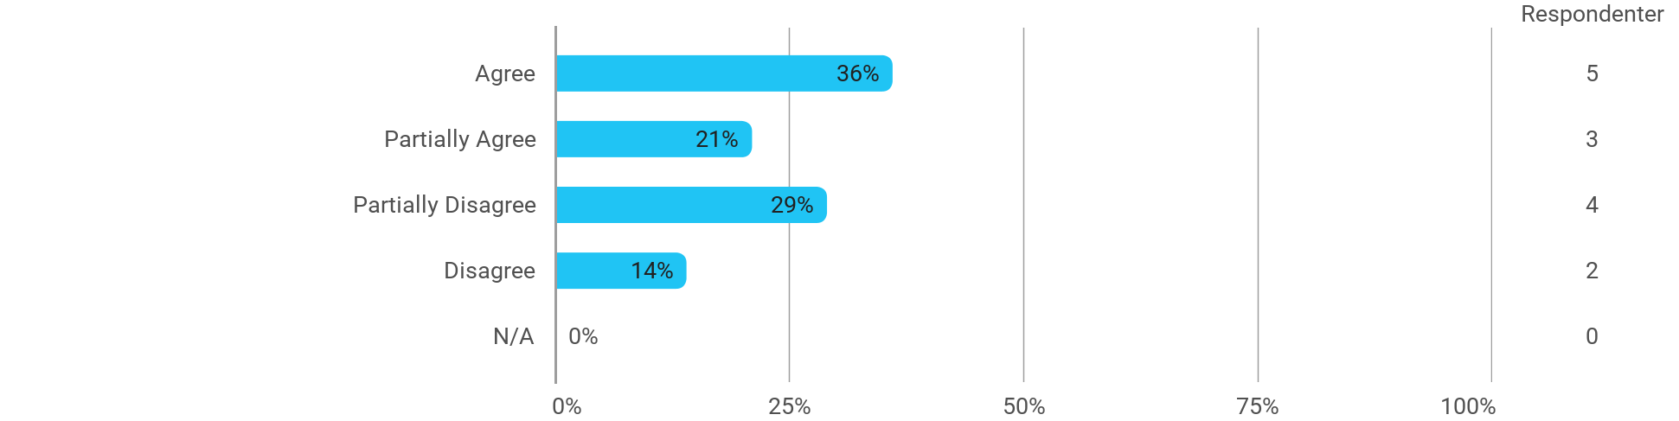

MSc01 LID - Lighting Fundamentals - The form of teaching used has supported my learning
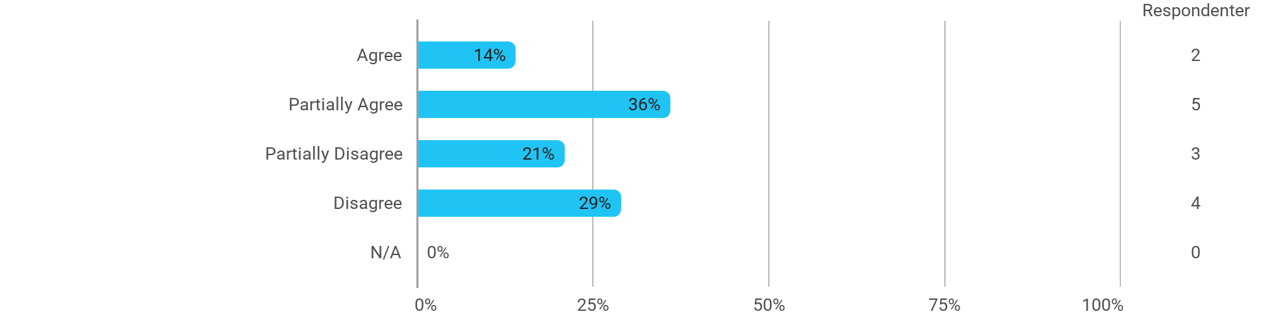

MSc01 LID - Lighting Fundamentals - The exercises/tasks for the course have been relevant
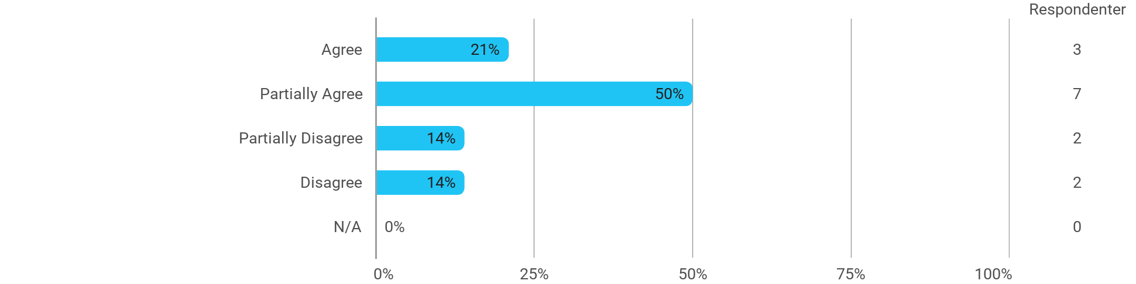

MSc01 LID - Rendered Lighting Simulation/CGI - I have received the expected benefit from the module
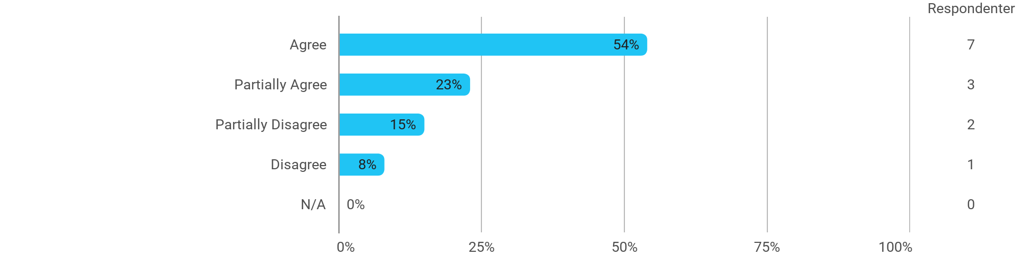

MSc01 LID - Rendered Lighting Simulation/CGI - The literature used has supported my learning
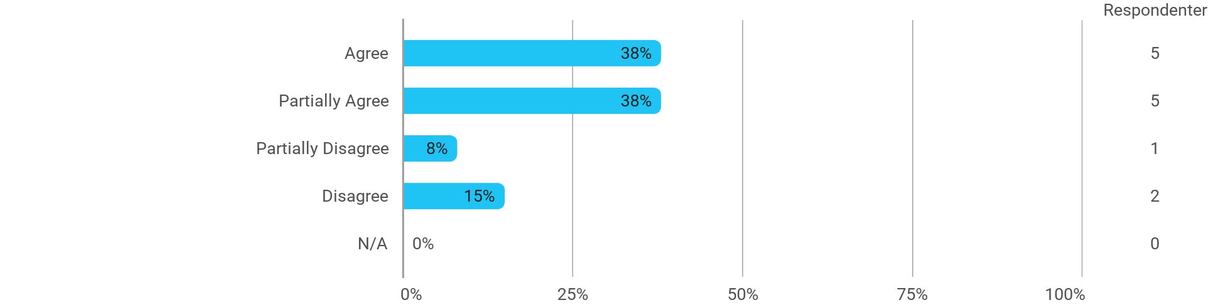

MSc01 LID - Rendered Lighting Simulation/CGI - The form of teaching used has supported my learning
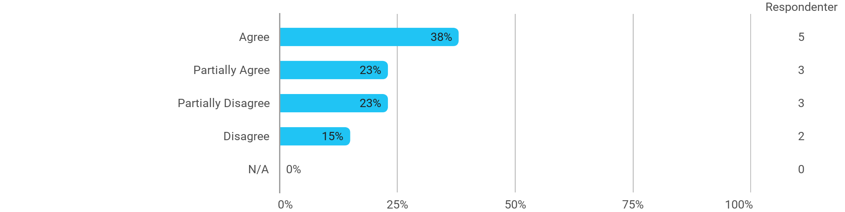

MSc01 LID - Rendered Lighting Simulation/CGI - The exercises/tasks for the course have been relevant
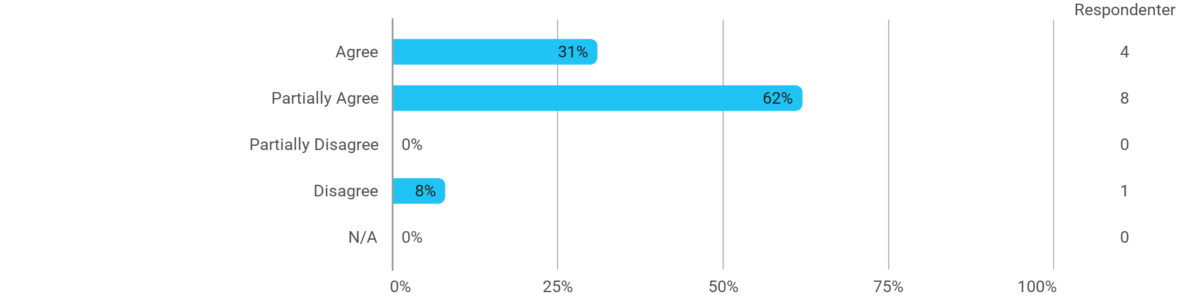

MSc01 LID (project) - Seeing the Light - I have received the expected benefit from the module
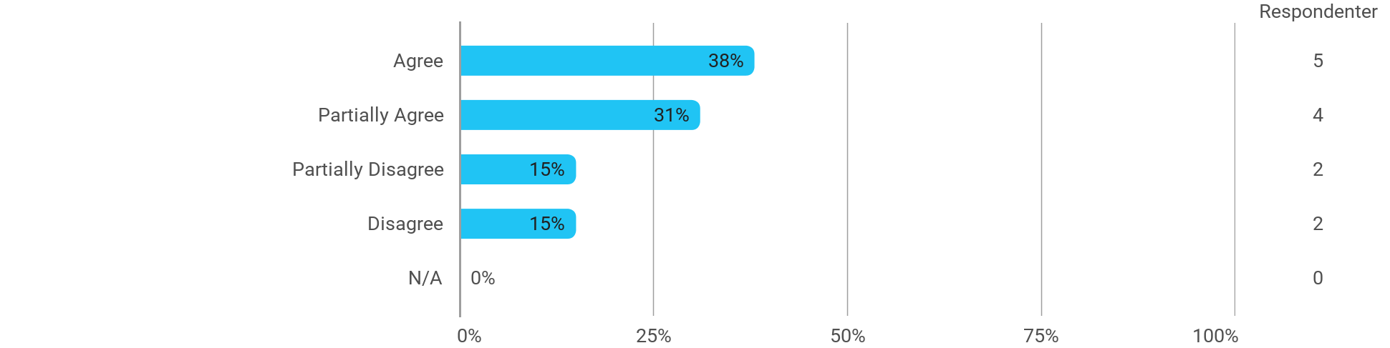

MSc01 LID (project) - Seeing the Light - The chosen problem has been a good foundation for unfolding my professional ambitions
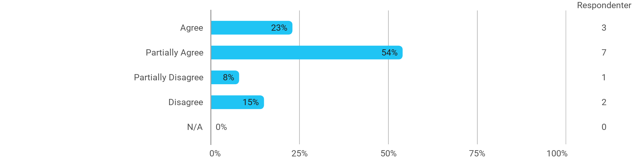

MSc01 LID (project) - Seeing the Light - The cooperation in the project group has worked well
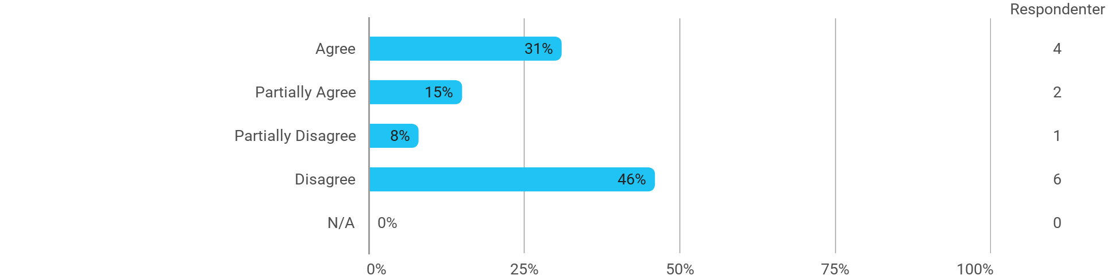

MSc01 LID (project) - Seeing the Light - The courses have supported the project work
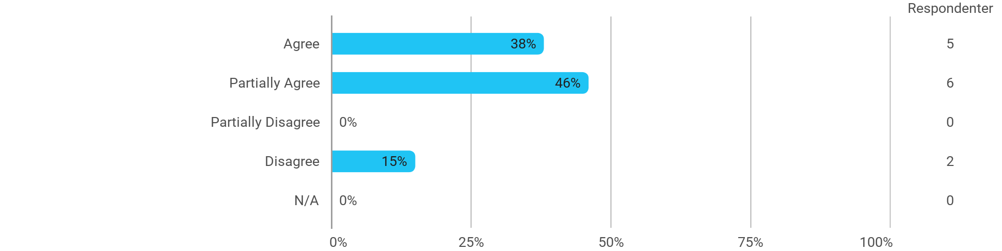

MSc01 LID (project) - Seeing the Light - I received the expected supervision
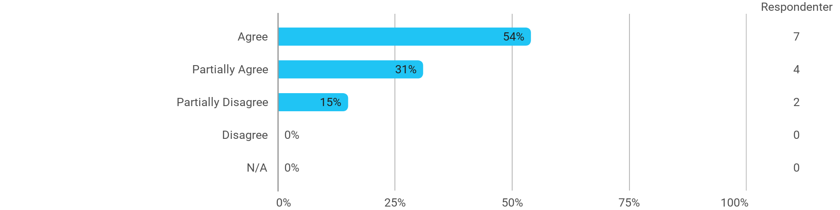

I have developed myself academically during the semester
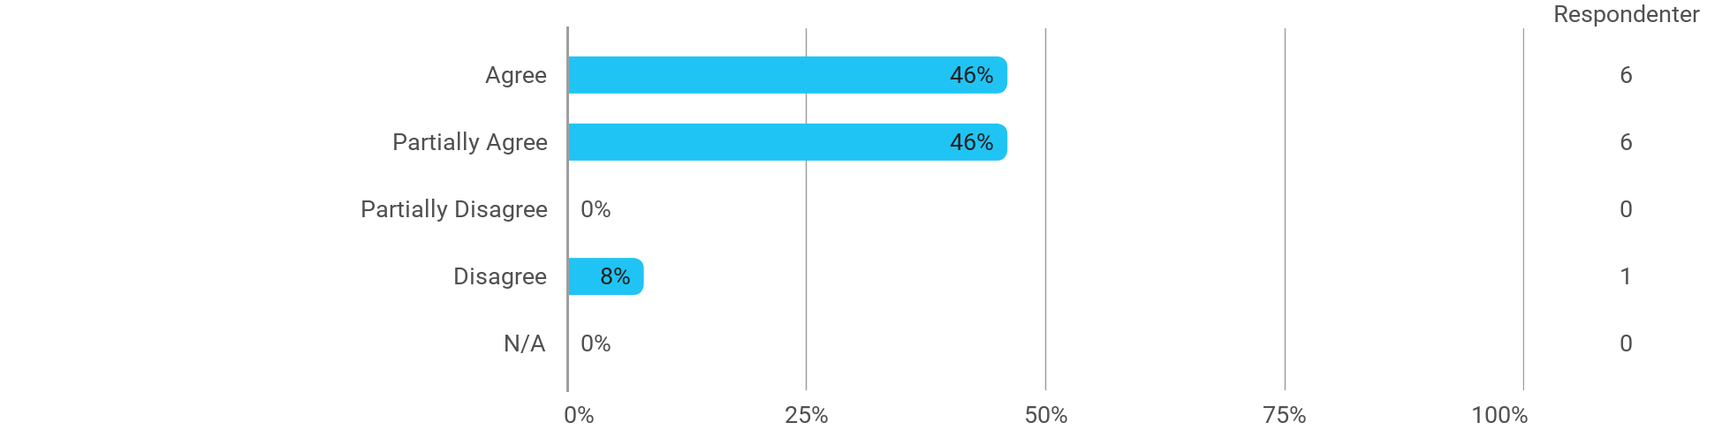

The following activities have developed me academically during the semester: - Project work
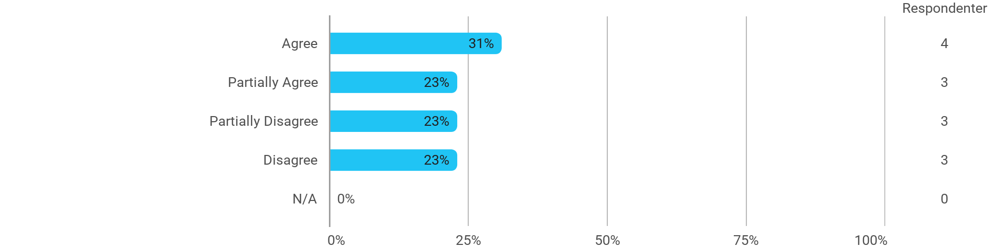

The following activities have developed me academically during the semester: - Academic discussions with fellow students
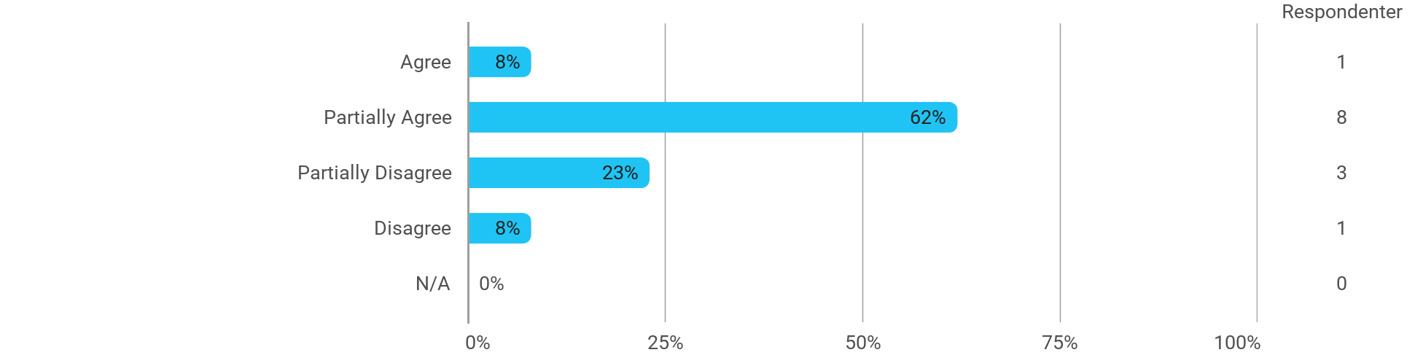

The following activities have developed me academically during the semester: - Academic discussions with teachers
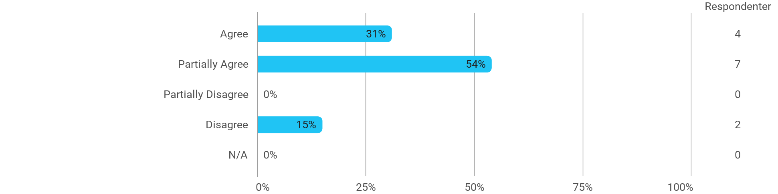

The following activities have developed me academically during the semester: - Practical exercises and experiments
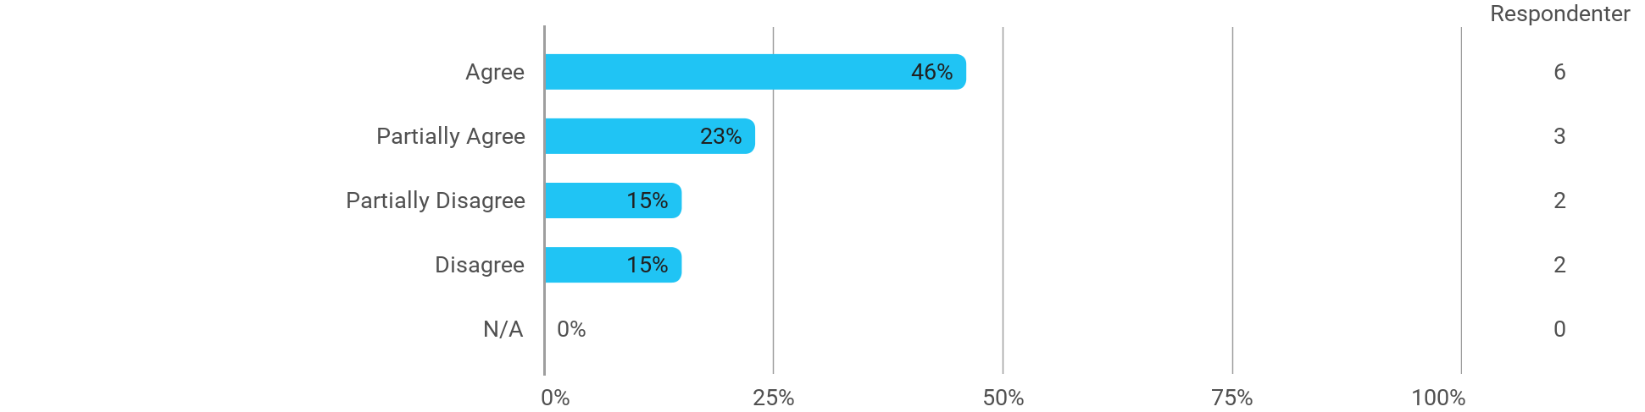

When I reflect on my own efforts, I have: - Been active in lectures
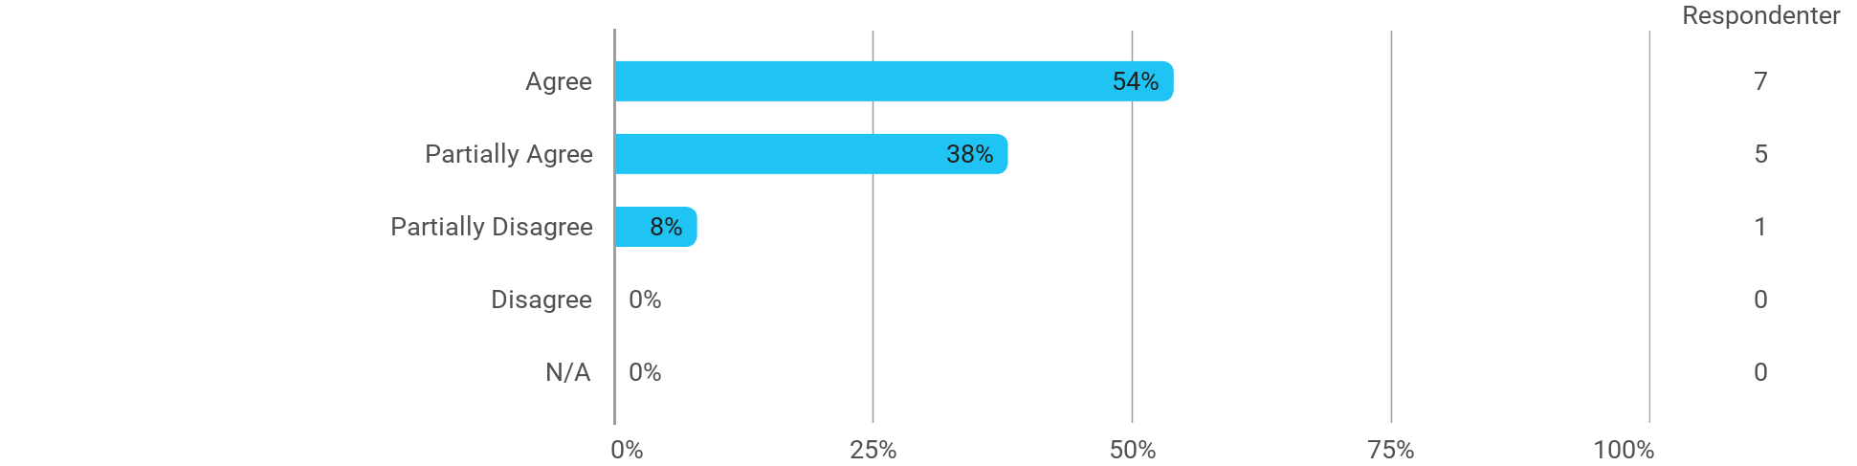

When I reflect on my own efforts, I have: - Participated actively in the project group work
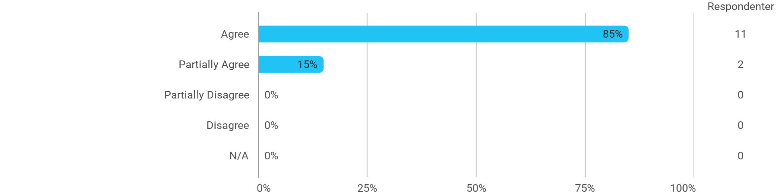

When I reflect on my own efforts, I have: - Prepared myself ahead of class
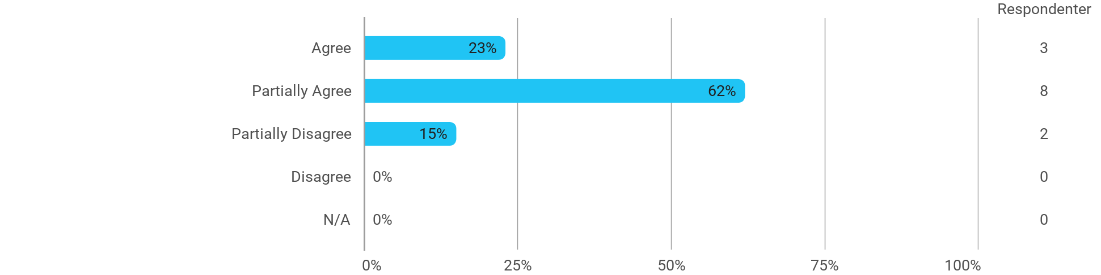

When I reflect on my own efforts, I have: - Prepared myself prior to the project group work
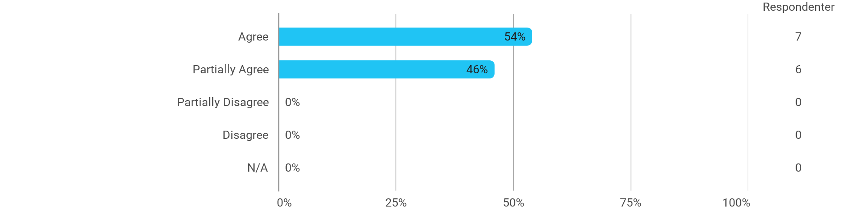

I experience the problem-based and project-oriented form of teaching as conducive to the development of: - My professional skills
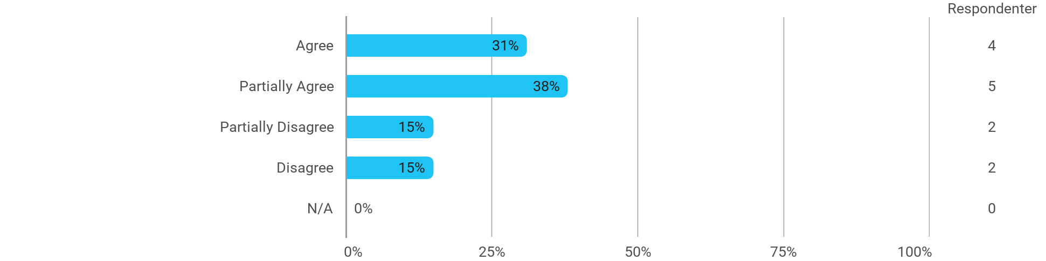

I experience the problem-based and project-oriented form of teaching as conducive to the development of: - My ability to identify and formulate problems

I experience the problem-based and project-oriented form of teaching as conducive to the development of: - My ability to attack and process problems
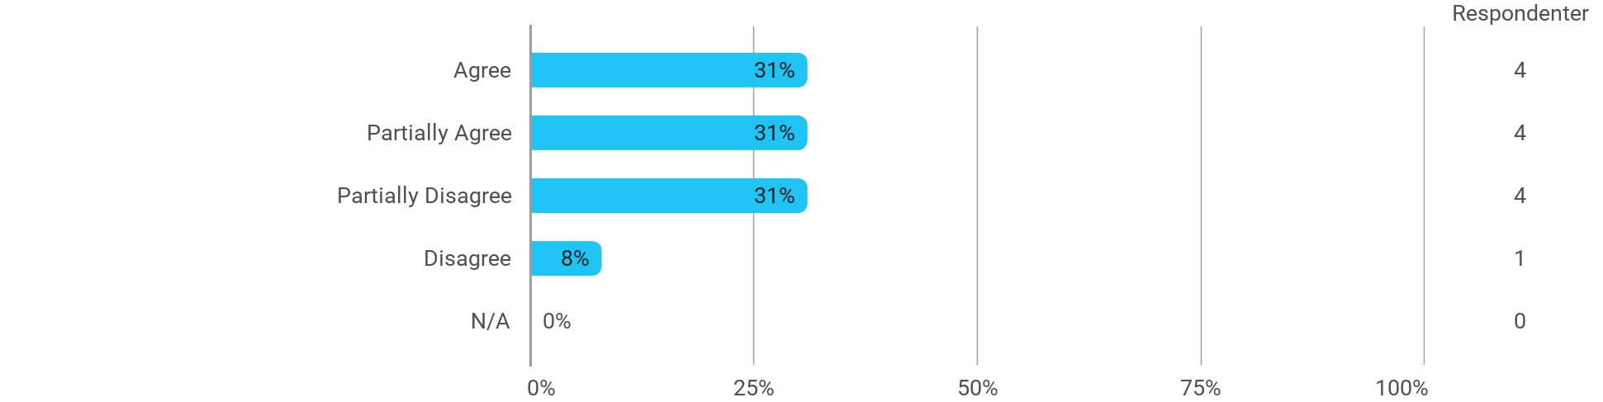

I experience the problem-based and project-oriented form of teaching as conducive to the development of: - My ability to organize a longer work process and "reach the goal" on time
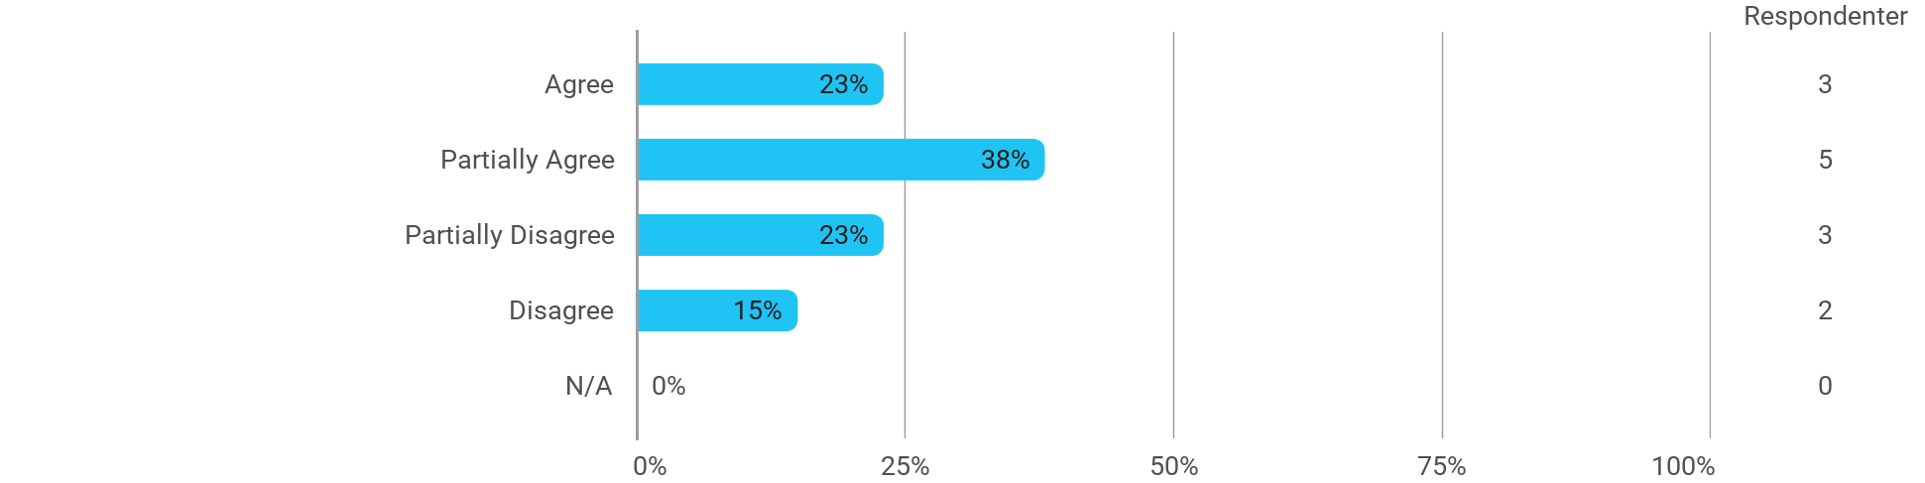

The following questions pertain to the semester as a whole: - I have received sufficient practical information about the semester's activities
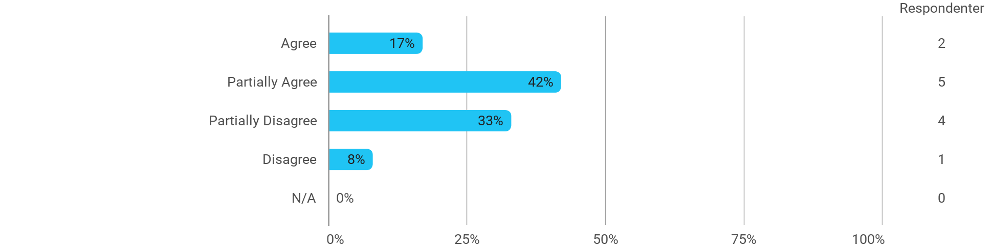

The following questions pertain to the semester as a whole: - I feel that the semester has given me the opportunity to engage in current issues relevant to external partners
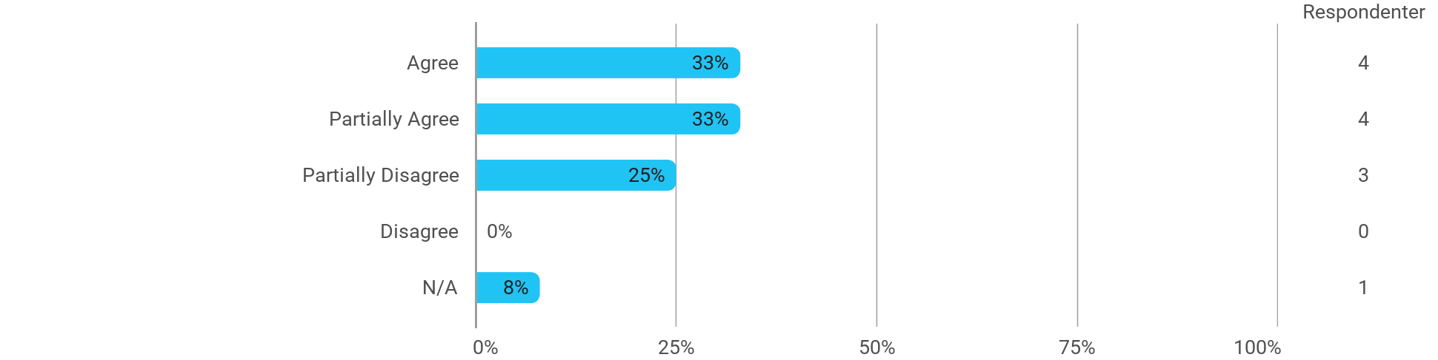

The following questions pertain to the semester as a whole: - I feel that I have addressed issues related to current societal challenges and opportunities
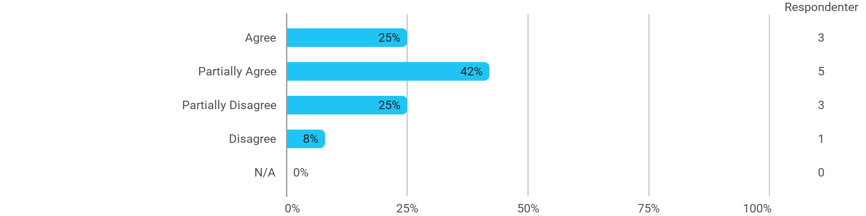

The following questions pertain to the semester as a whole: - I feel that the modules have supported the project work
