Study board conclusions of the semester and teaching evaluation report
Year: | 2024
Campus | Copenhagen
Semester | SSD7
Coordinator: | Amalia de Götzen
Date: | 10.03.25

This document represents the public version of the evaluation of the semester. The document forms together with the semester and teaching evaluation report the basis of any adjustments to the semester’s description, planning, execution and/or evaluation of the next iteration of the semester and are used by the coming semester coordinator and semester planning group.

The document also represents the study board’s response to the students, teachers, coordinators and other interested parties about possible consequences of conditions that the students of the semester have pointed out.

The public conclusions and recommendations of the semester coordinator
The semester evaluation was overall positive: the students appreciated the structure of the semester, the communication and the way in which information was shared. Very positive was also rated the collaboration for the semester project and the engagement through supervision.
Some minor adjustments could be considered in some of the courses: for DPSS considering the overlapping content between videos and class presentation while for UX the density of some of the lectures.
Some other requests from the students are very relevant and will be implemented in the next iteration of the semester: 1) Have a focus on sustainability across courses (Coordinator and Teachers) 2) Deliver a lecture/workshop on design critique (Coordinator and Teachers) 3) Deliver a lecture/workshop on designing within sensitive contexts (Coordinator and UX teacher) 4) Organize oral exam by groups and not alphabetical order to facilitate group work in preparation of the project exam (Coordinator) 5) Organize cross-groups activities in class (Coordinator) 6) Better timing for the final survey: they were asked to fill it in during the last semester group meeting, but at that time they did not get it yet. (Studyboard communicate with the Coordinator about the timing) 7) Official speeches in English and Danish, no AI translation
Conclusion of the study board
The Study Board (MSN) has processed the semester evaluation report and offers the following observations/conclusions:
- Response rate 84%
- Grade dostribution fine
- The semester worked well

Samlet status
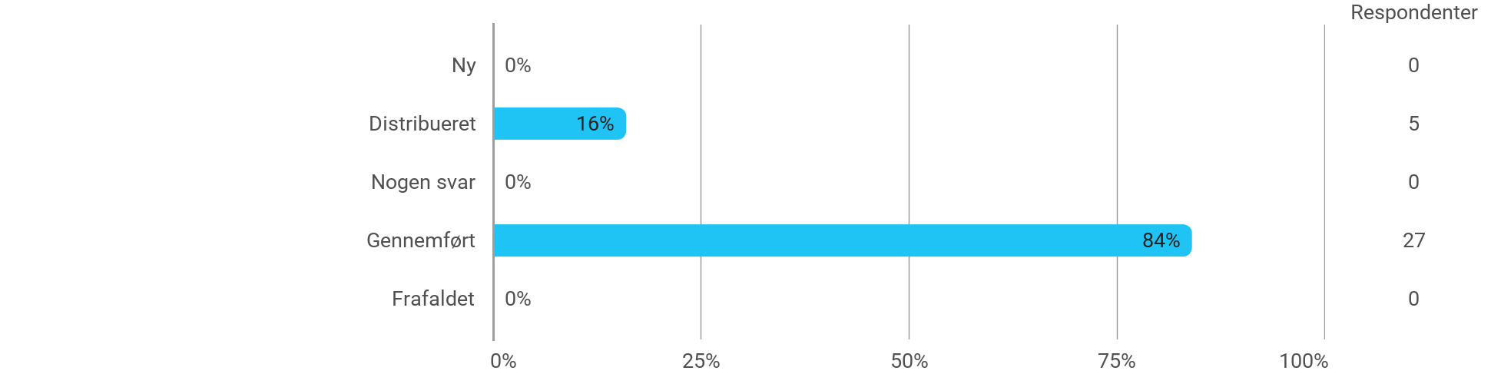

MSc01 SSD - User Experience Design for Service Interaction - I have received the expected benefit from the module
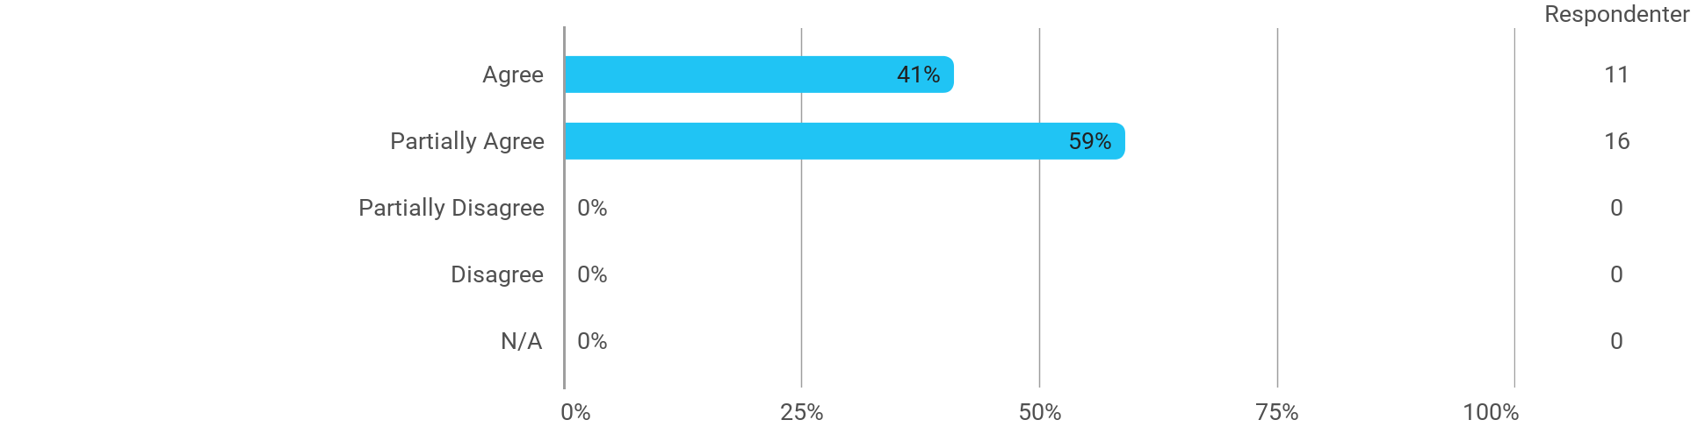

MSc01 SSD - User Experience Design for Service Interaction - The literature used has supported my learning
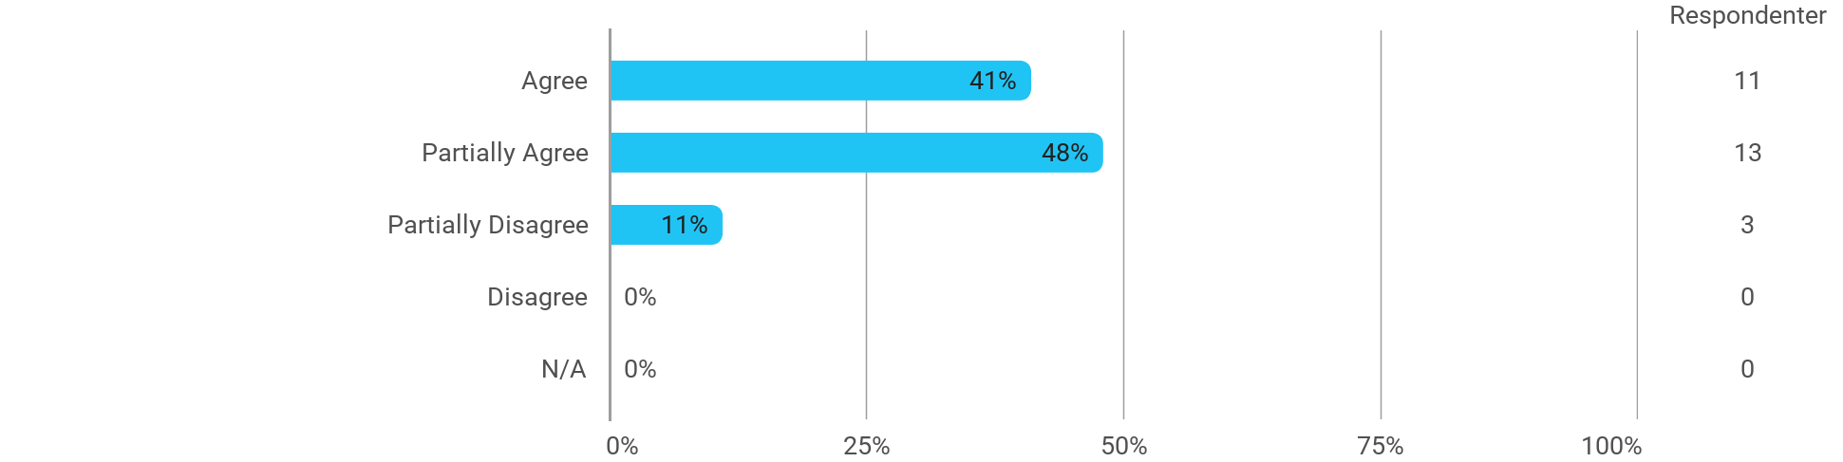

MSc01 SSD - User Experience Design for Service Interaction - The form of teaching used has supported my learning
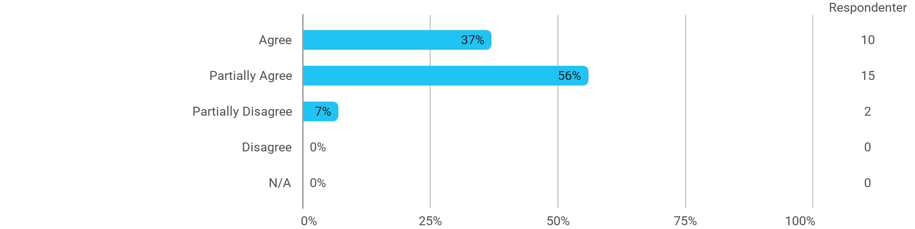

MSc01 SSD - User Experience Design for Service Interaction - The exercises/tasks for the course have been relevant
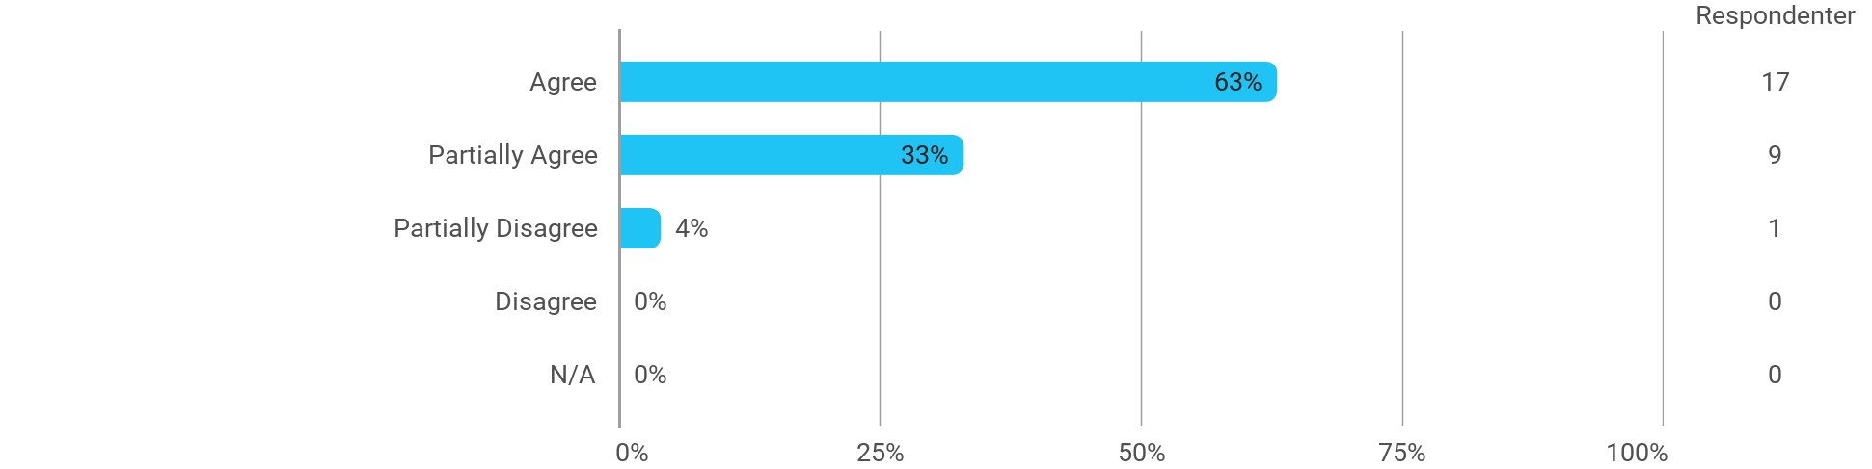

MSc01 SSD - Designing Product Service Systems - I have received the expected benefit from the module
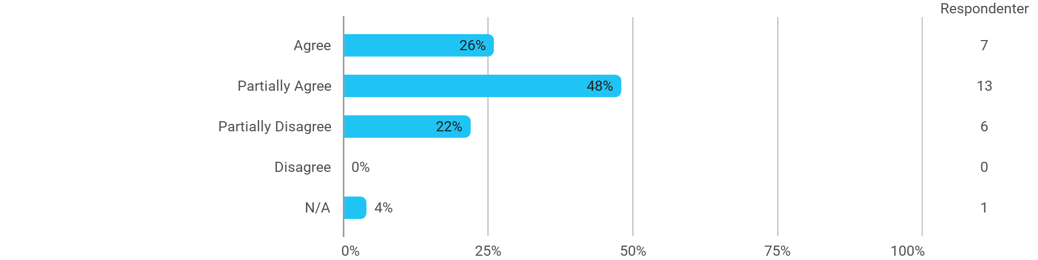

MSc01 SSD - Designing Product Service Systems - The literature used has supported my learning
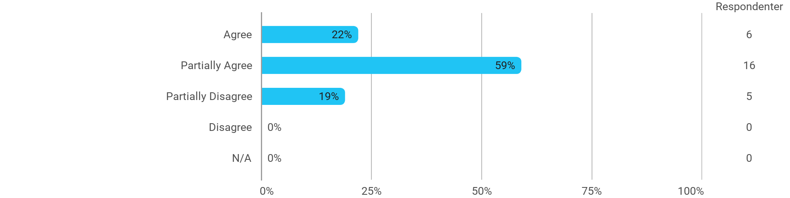

MSc01 SSD - Designing Product Service Systems - The form of teaching used has supported my learning
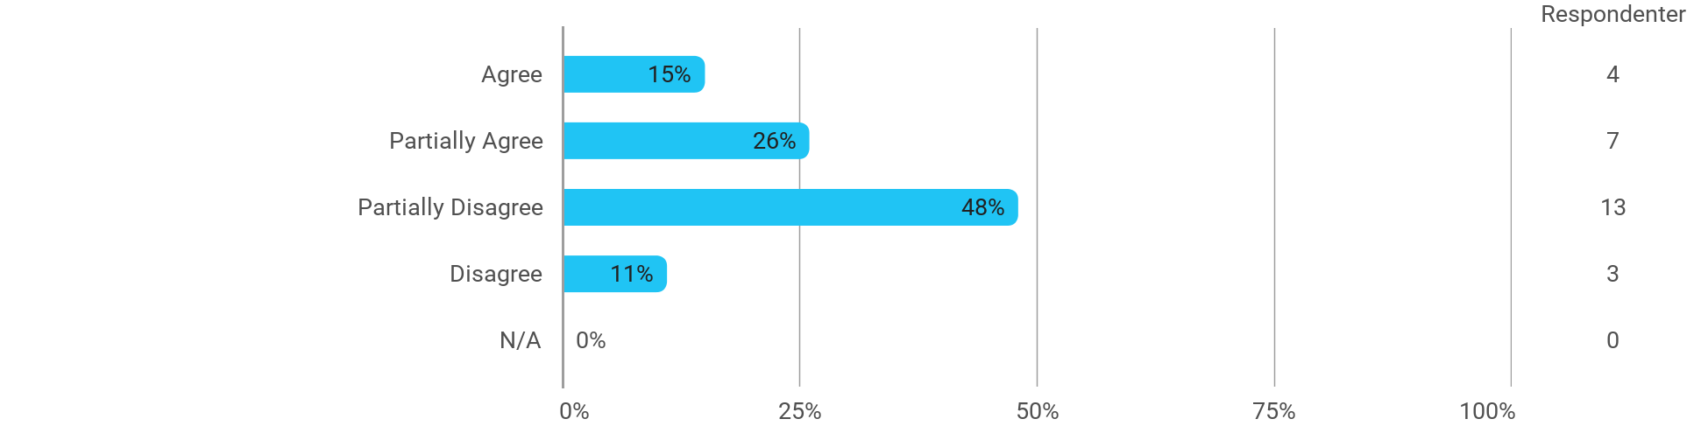

MSc01 SSD - Designing Product Service Systems - The exercises/tasks for the course have been relevant
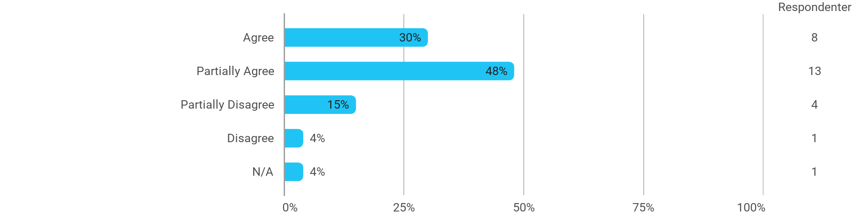

MSc01 SSD - Visualizing and Prototyping for Service Design - I have received the expected benefit from the module
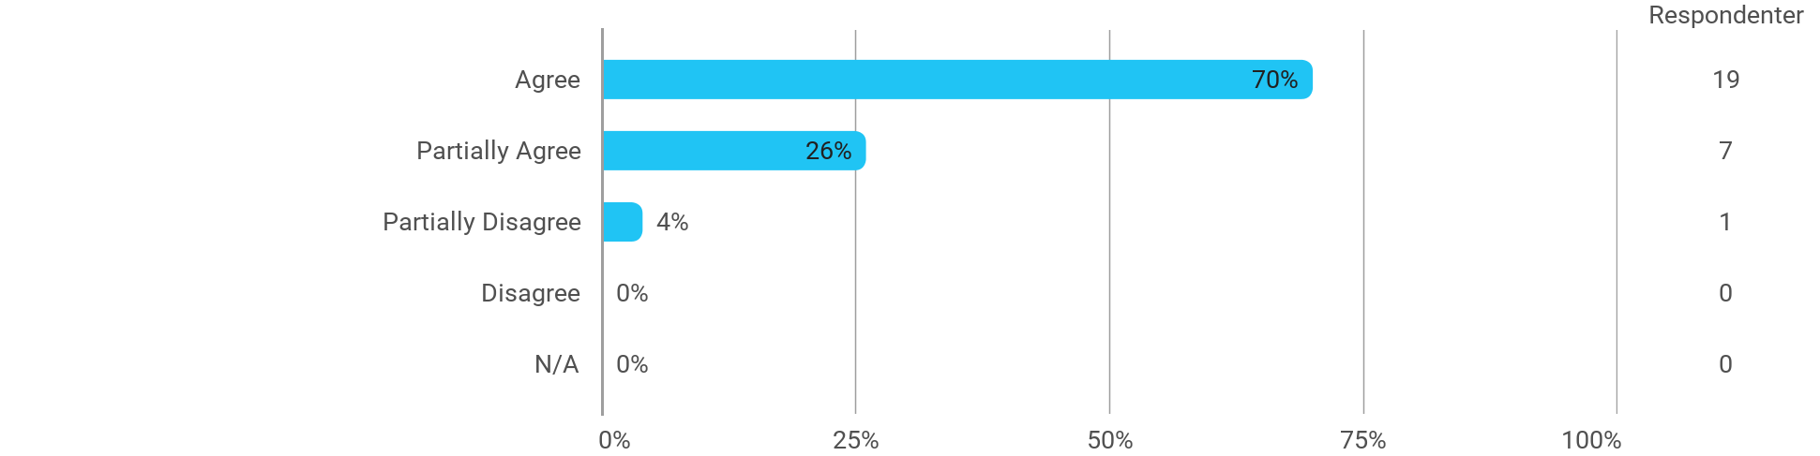

MSc01 SSD - Visualizing and Prototyping for Service Design - The literature used has supported my learning
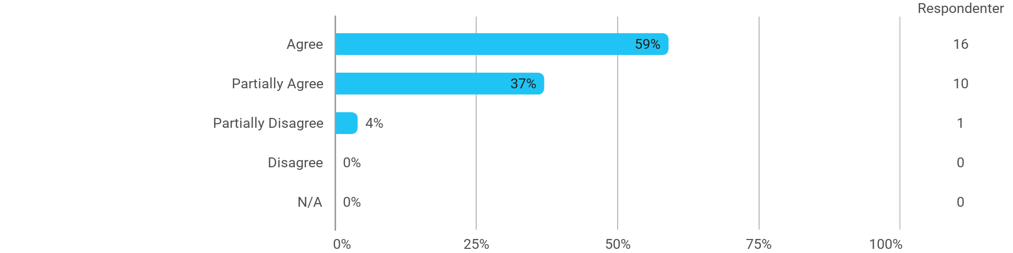

MSc01 SSD - Visualizing and Prototyping for Service Design - The form of teaching used has supported my learning
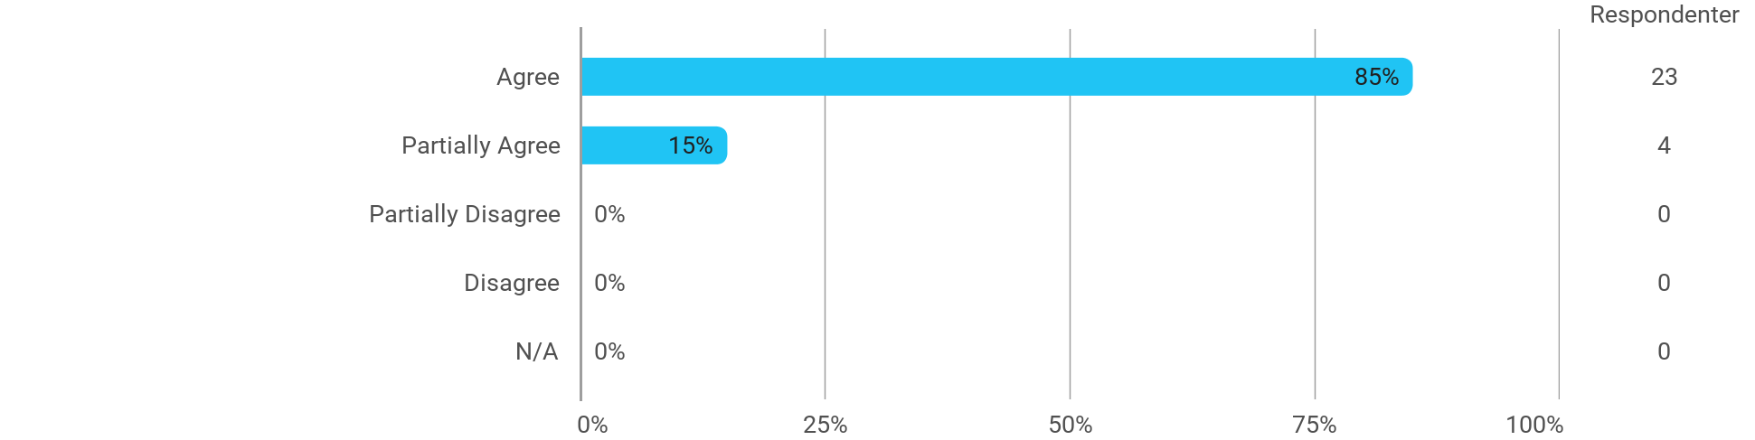

MSc01 SSD - Visualizing and Prototyping for Service Design - The exercises/tasks for the course have been relevant
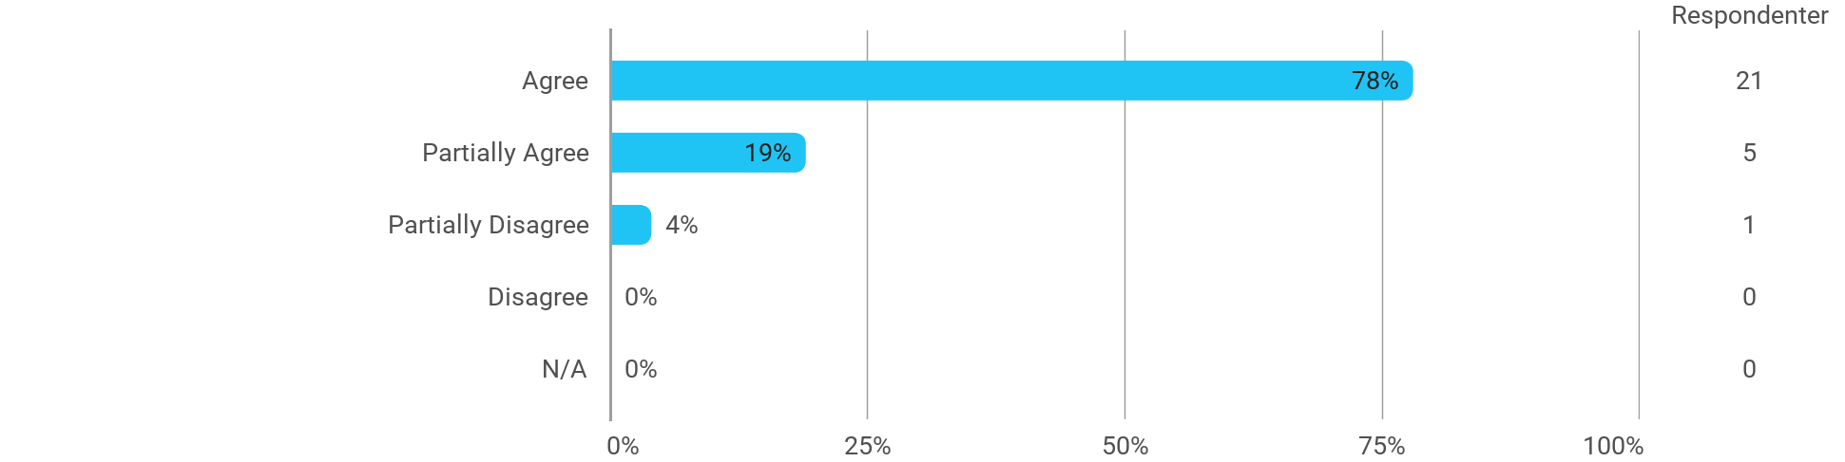

MSc01 SSD (project) - Services as Interaction - I have received the expected benefit from the module

MSc01 SSD (project) - Services as Interaction - The chosen problem has been a good foundation for unfolding my professional ambitions
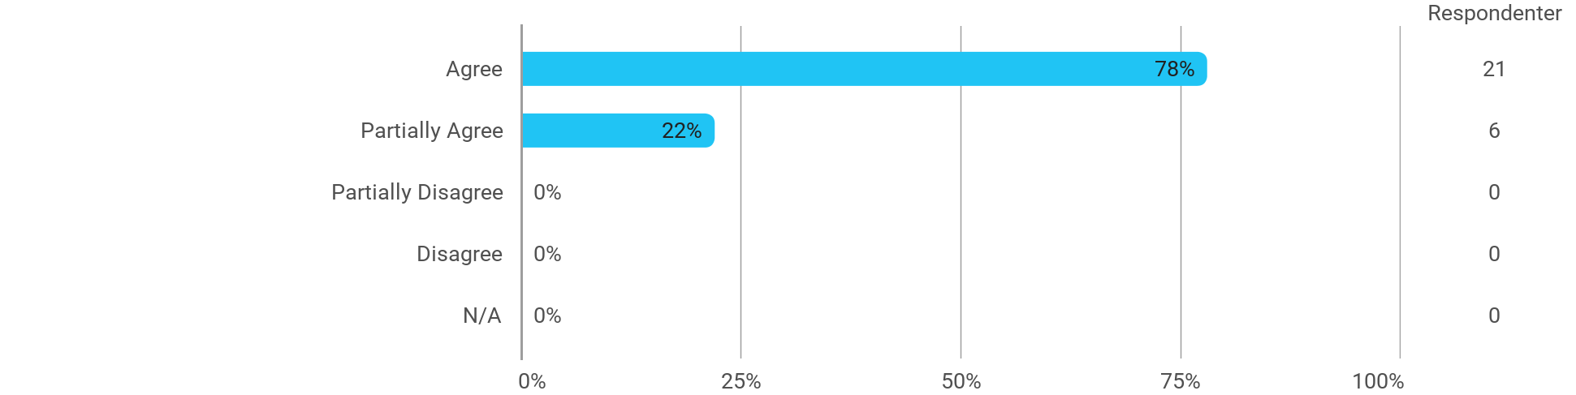

MSc01 SSD (project) - Services as Interaction - The cooperation in the project group has worked well
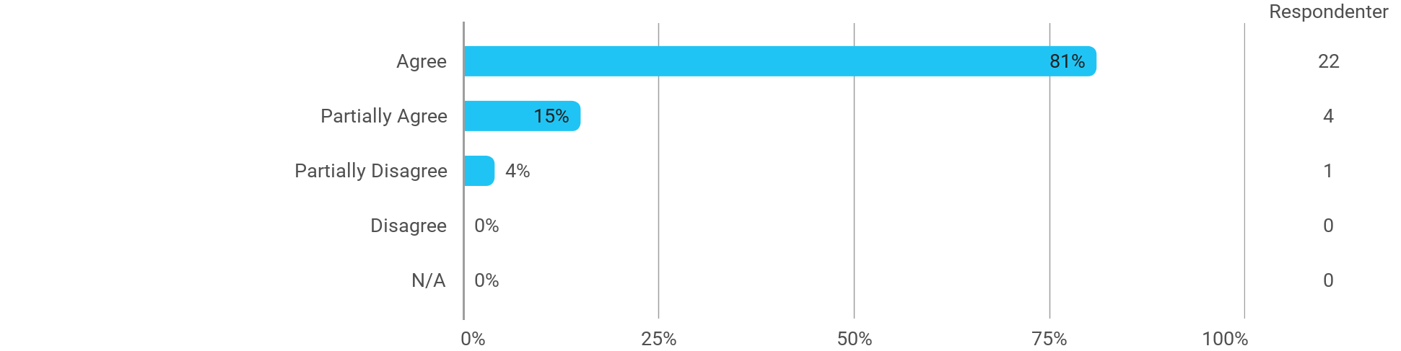

MSc01 SSD (project) - Services as Interaction - The courses have supported the project work
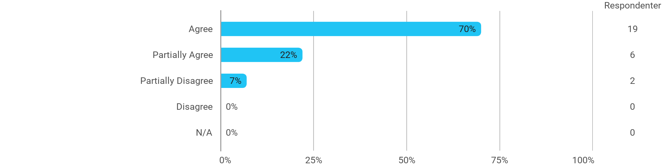

MSc01 SSD (project) - Services as Interaction - I received the expected supervision
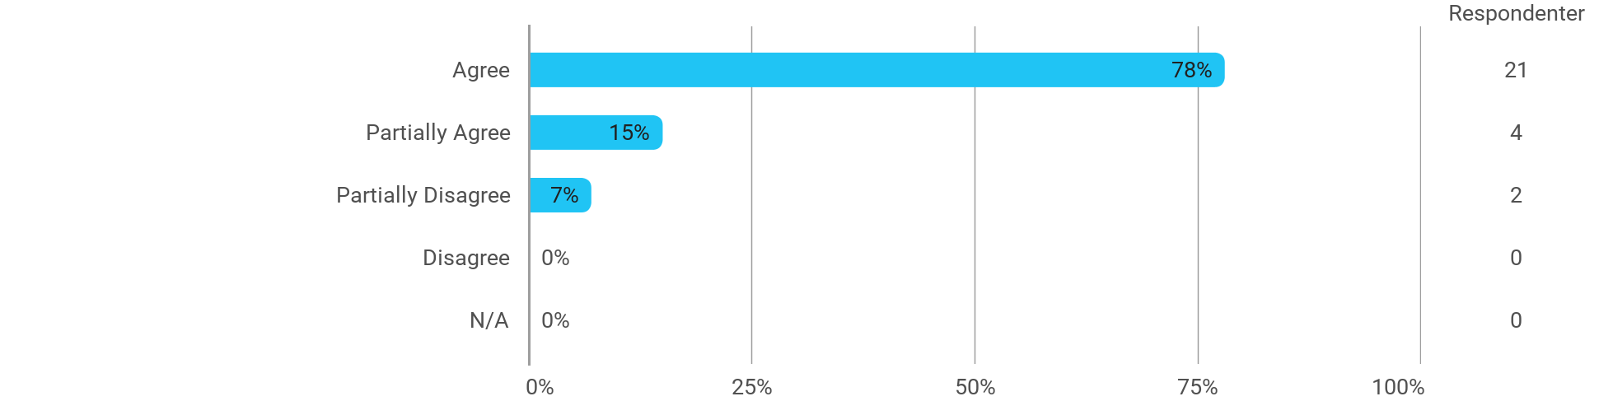

I have developed myself academically during the semester
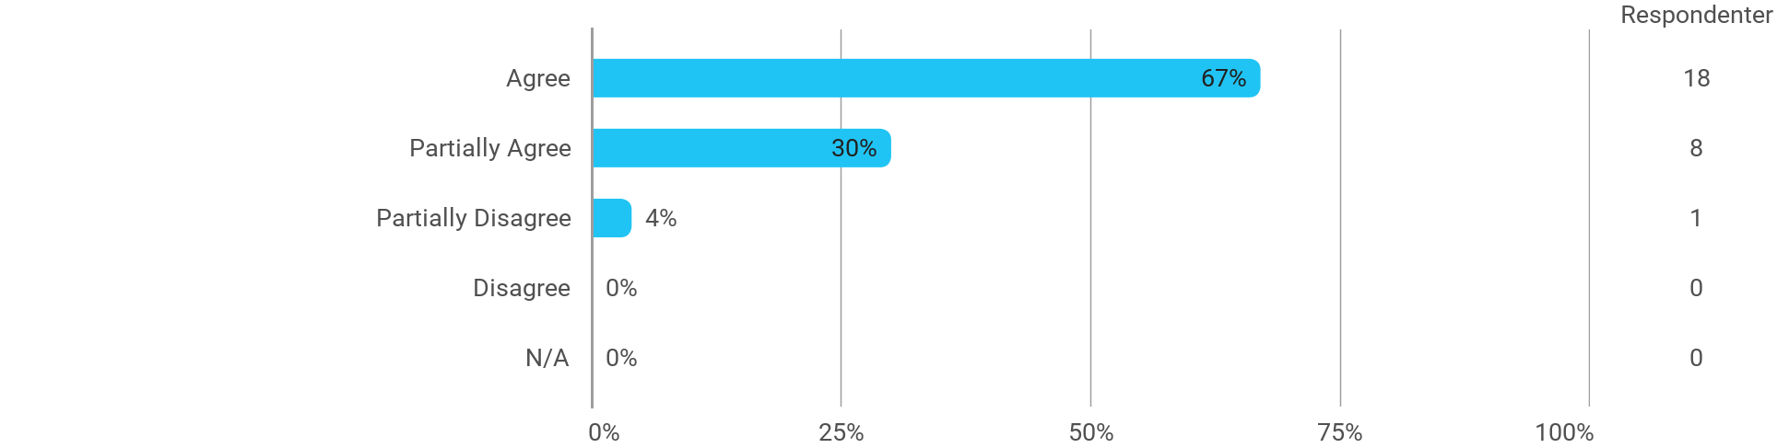

The following activities have developed me academically during the semester: - Project work
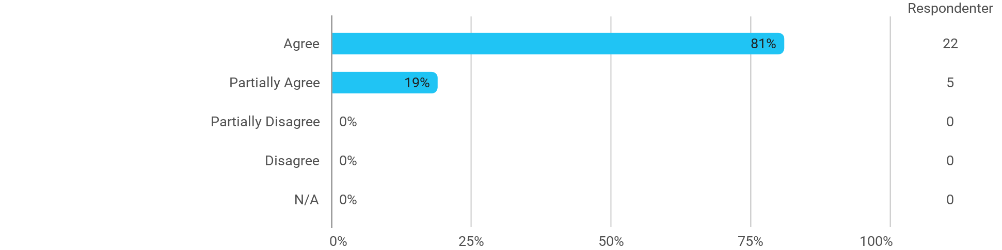

The following activities have developed me academically during the semester: - Academic discussions with fellow students
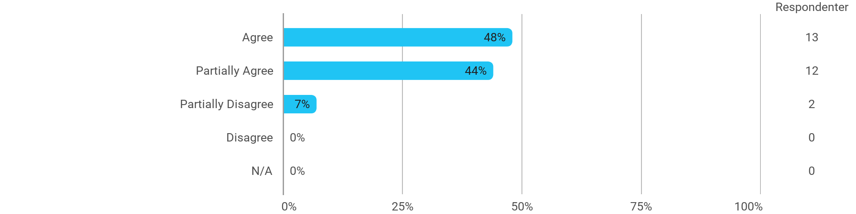

The following activities have developed me academically during the semester: - Academic discussions with teachers
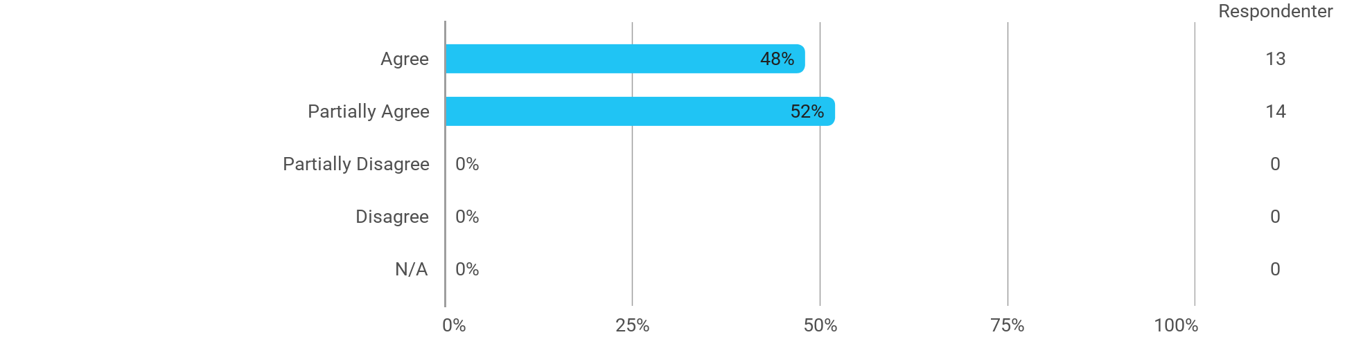

The following activities have developed me academically during the semester: - Practical exercises and experiments

When I reflect on my own efforts, I have: - Been active in lectures
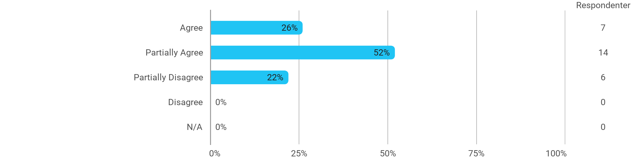

When I reflect on my own efforts, I have: - Participated actively in the project group work

When I reflect on my own efforts, I have: - Prepared myself ahead of class
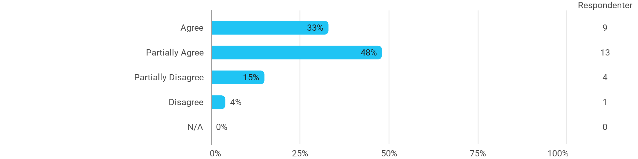

When I reflect on my own efforts, I have: - Prepared myself prior to the project group work

I experience the problem-based and project-oriented form of teaching as conducive to the development of: - My professional skills
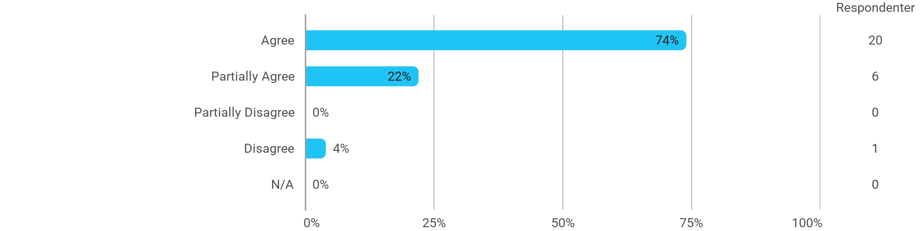

I experience the problem-based and project-oriented form of teaching as conducive to the development of: - My ability to identify and formulate problems
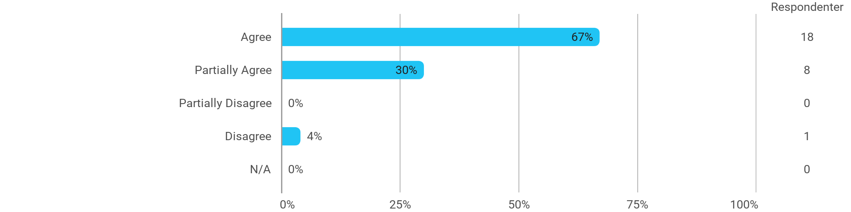

I experience the problem-based and project-oriented form of teaching as conducive to the development of: - My ability to attack and process problems
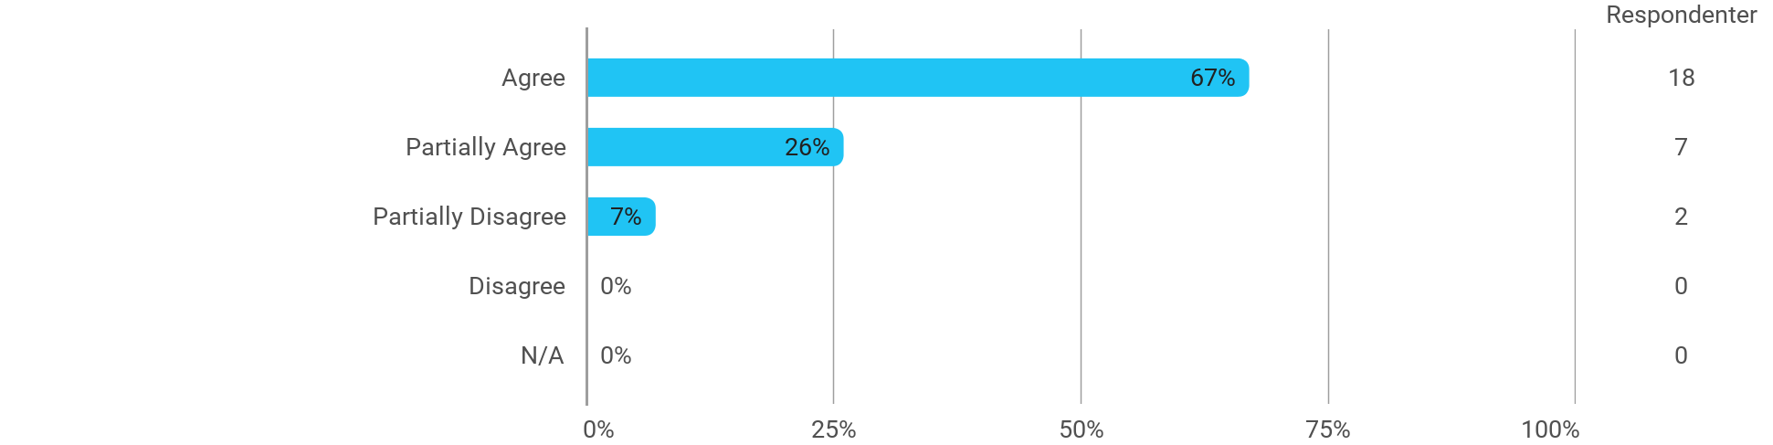

I experience the problem-based and project-oriented form of teaching as conducive to the development of: - My ability to organize a longer work process and "reach the goal" on time
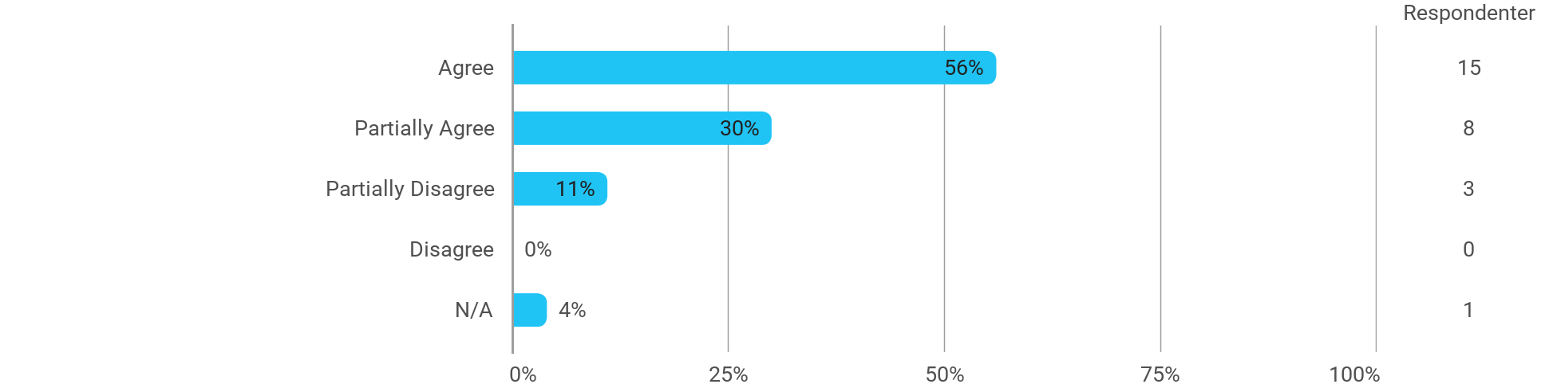

The following questions pertain to the semester as a whole: - I have received sufficient practical information about the semester's activities
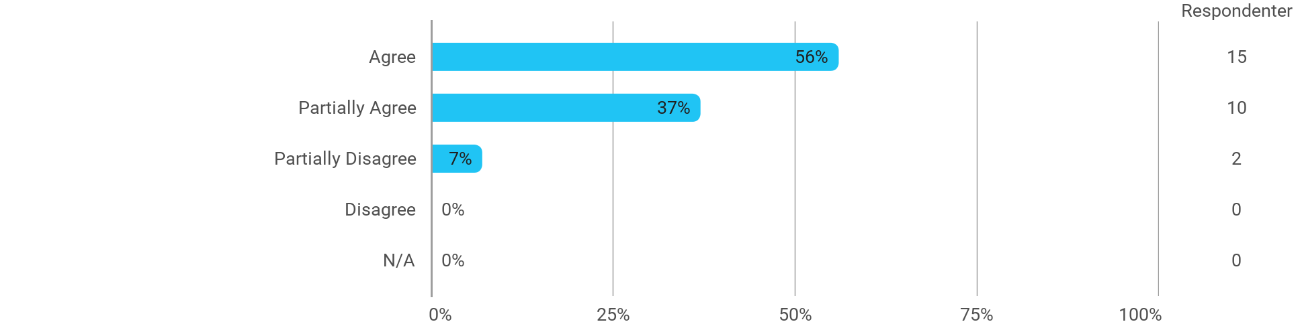

The following questions pertain to the semester as a whole: - I feel that the semester has given me the opportunity to engage in current issues relevant to external partners
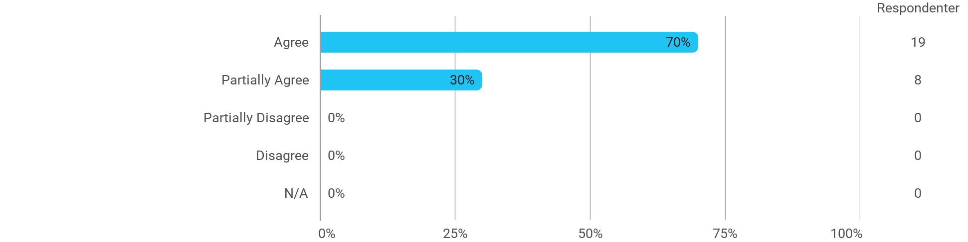

The following questions pertain to the semester as a whole: - I feel that I have addressed issues related to current societal challenges and opportunities

The following questions pertain to the semester as a whole: - I feel that the modules have supported the project work

