Study board conclusions of the semester and teaching evaluation report
Year: | 2024
Campus | Copenhagen
Semester | SSD9
Coordinator: | Luca Simone
Date: | 06.03.25

This document represents the public version of the evaluation of the semester. The document forms together with the semester and teaching evaluation report the basis of any adjustments to the semester’s description, planning, execution and/or evaluation of the next iteration of the semester and are used by the coming semester coordinator and semester planning group.

The document also represents the study board’s response to the students, teachers, coordinators and other interested parties about possible consequences of conditions that the students of the semester have pointed out.

The public conclusions and recommendations of the semester coordinator
As in previous years, the project module stood out as the highlight of this semester, valued by students for providing an opportunity to practically apply knowledge gained during their first year. Key semester processes and activities were generally well-organized and effectively communicated. Nevertheless, certain adjustments should be considered for implementation in future iterations of the semester:
• A student noted that it would be good if AAU could offer a course on “Danish business culture”. Luca Simeone is going to check with career service whether they already offer such course
• A student noted that the course ‘Strategy and business in services’ could contain some more theoretical elements. Luca Simeone is going to add some further (non-mandatory) reading
Conclusion of the study board
The Study Board (MSN) has processed the semester evaluation report and offers the following observations/conclusions:
- Response rate 43%
- Grade distribution fine
- The semester worked well

Samlet status
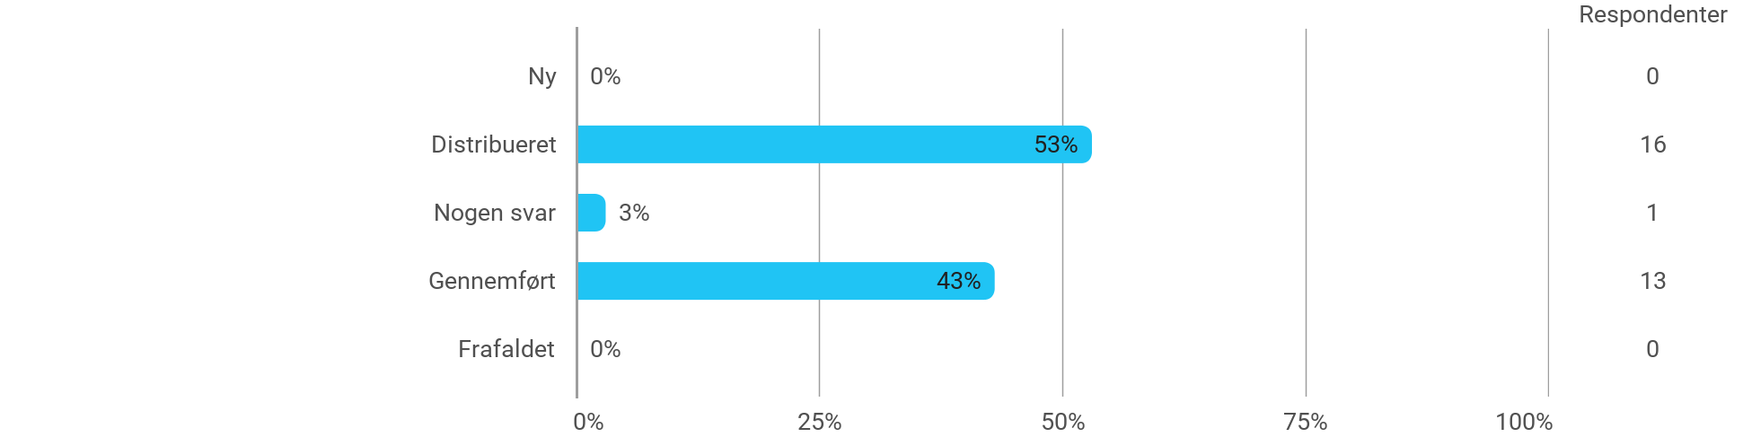

MSc03 SSD - Strategy and Business in Services - I have received the expected benefit from the module
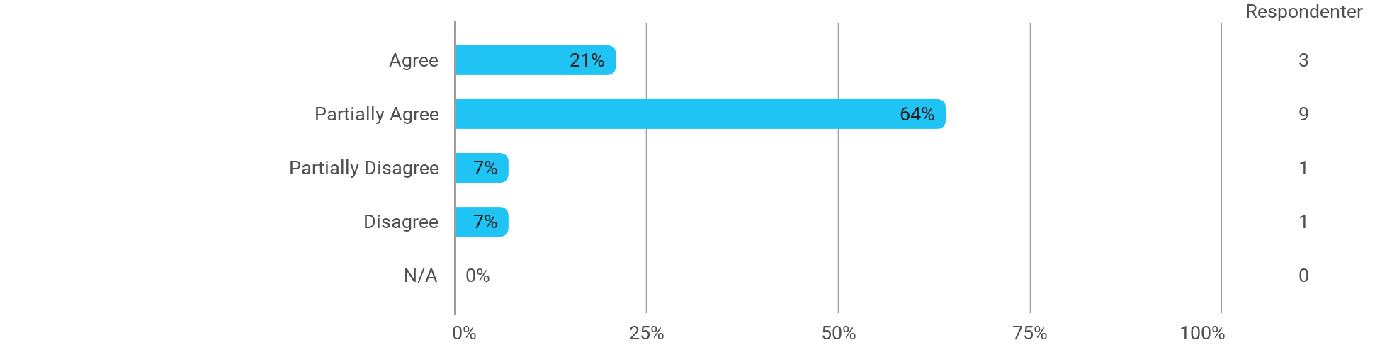

MSc03 SSD - Strategy and Business in Services - The literature used has supported my learning
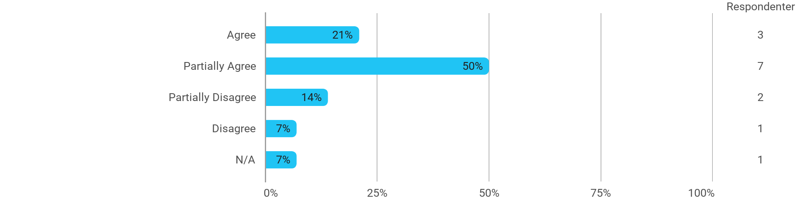

MSc03 SSD - Strategy and Business in Services - The form of teaching used has supported my learning
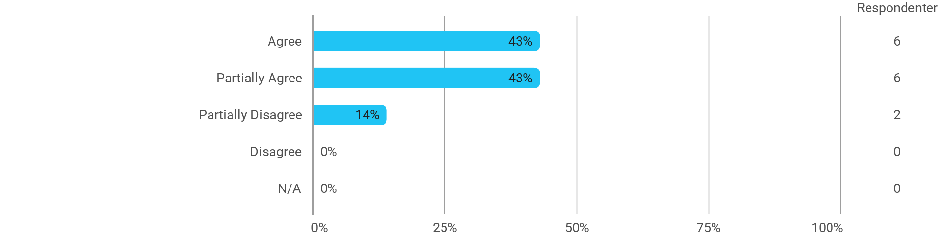

MSc03 SSD - Strategy and Business in Services - The exercises/tasks for the course have been relevant
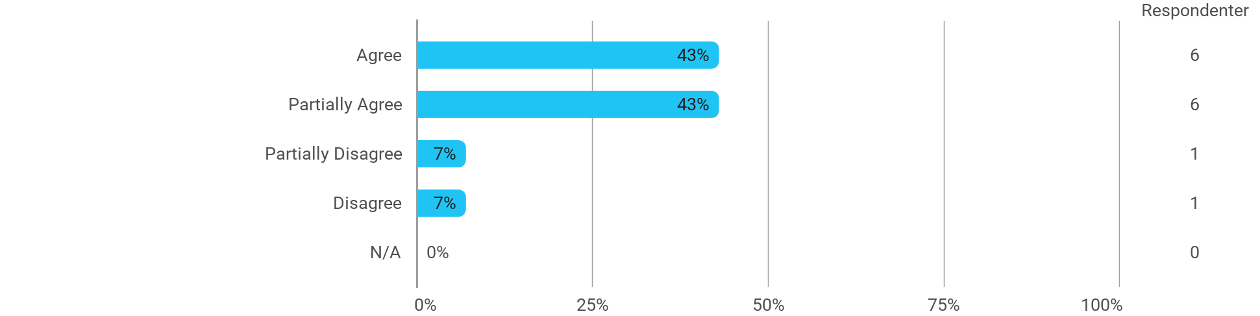

MSc03 SSD (elective project) - Project-Oriented Study in an External Organisation - I have received the expected benefit from the module
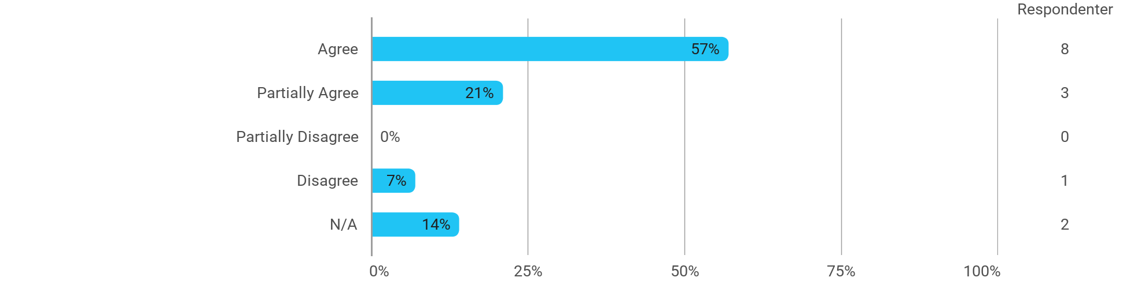

MSc03 SSD (elective project) - Project-Oriented Study in an External Organisation - The chosen problem has been a good foundation for unfolding my professional ambitions
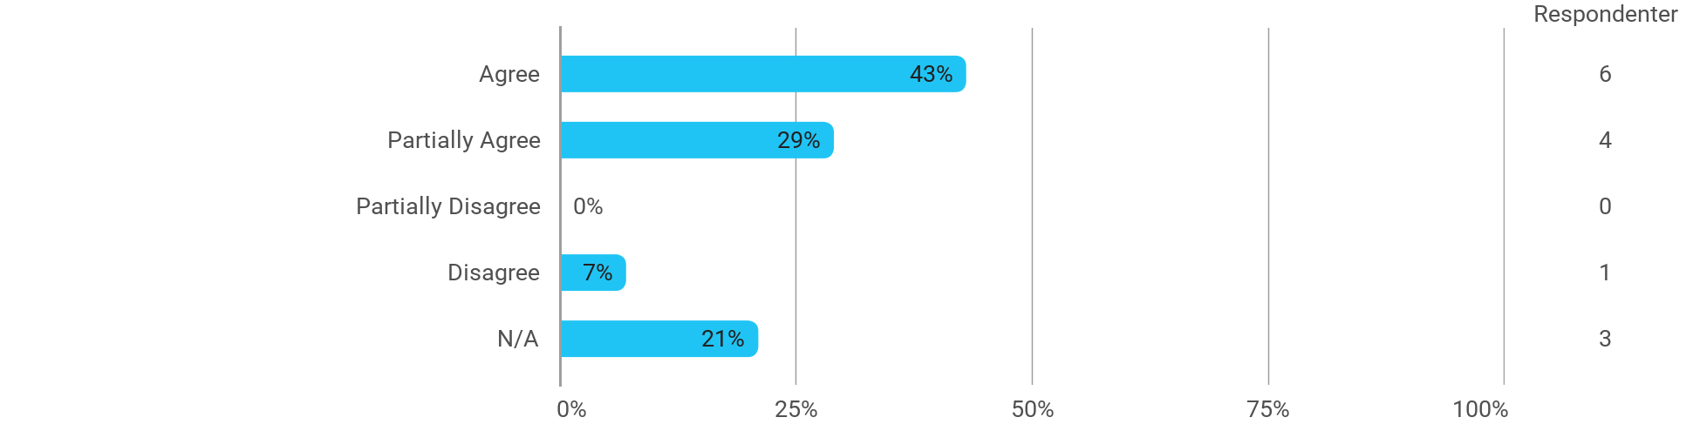

MSc03 SSD (elective project) - Project-Oriented Study in an External Organisation - The cooperation in the project group has worked well
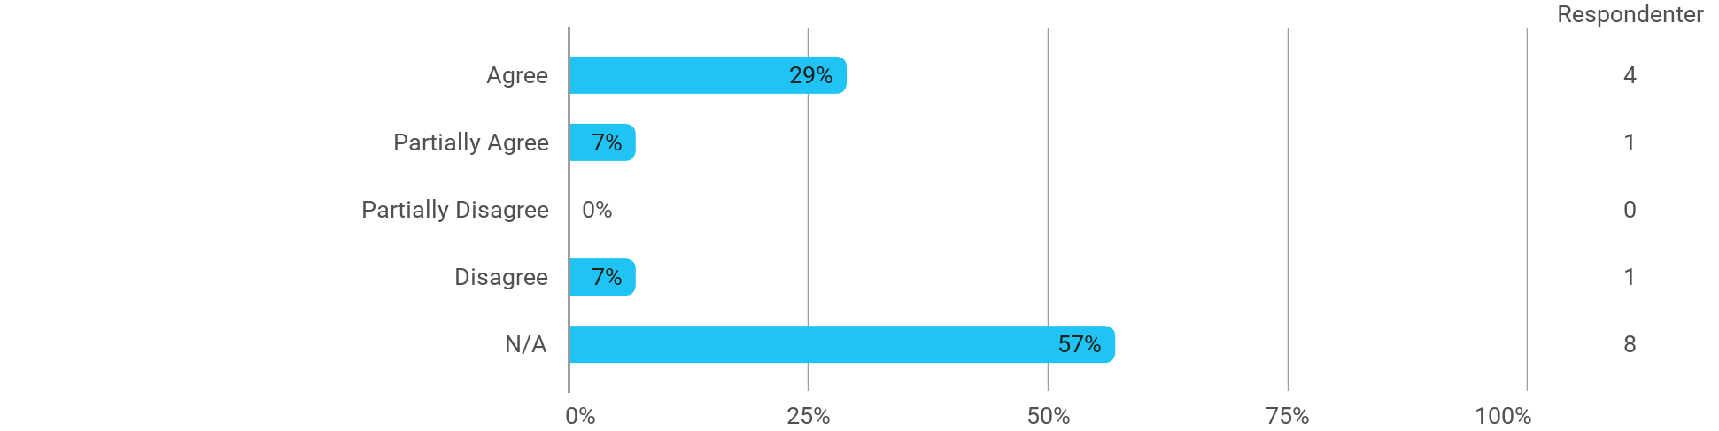

MSc03 SSD (elective project) - Project-Oriented Study in an External Organisation - The courses have supported the project work
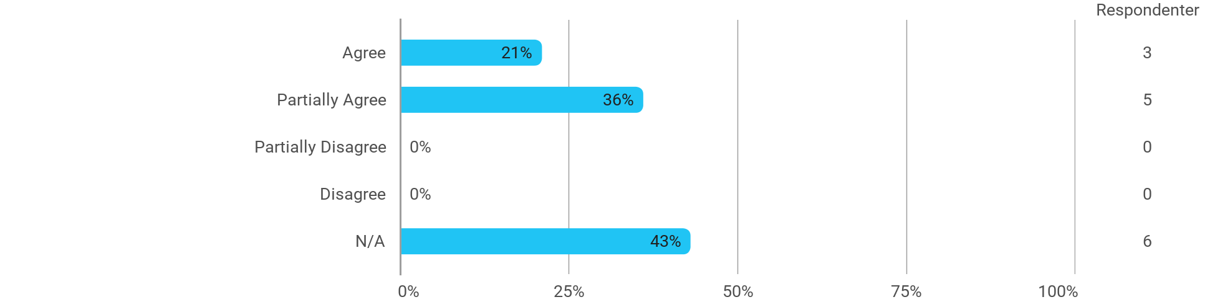

MSc03 SSD (elective project) - Project-Oriented Study in an External Organisation - I received the expected supervision
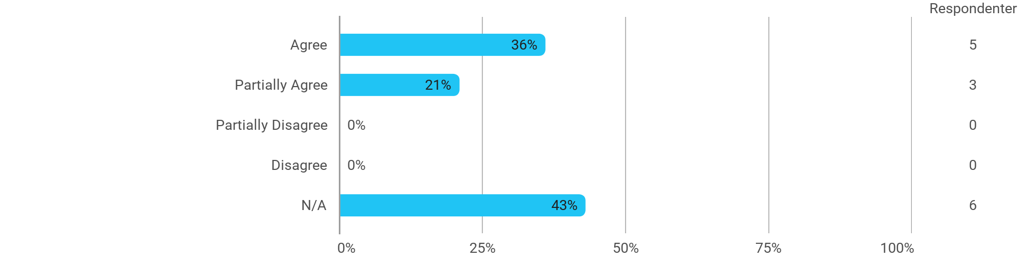

MSc03 SSD (elective project) -Theoretical Elaboration of a Topic or a Case - I have received the expected benefit from the module
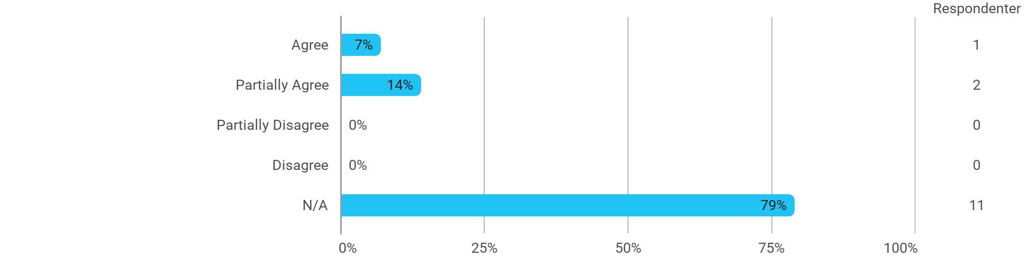

MSc03 SSD (elective project) -Theoretical Elaboration of a Topic or a Case - The chosen problem has been a good foundation for unfolding my professional ambitions
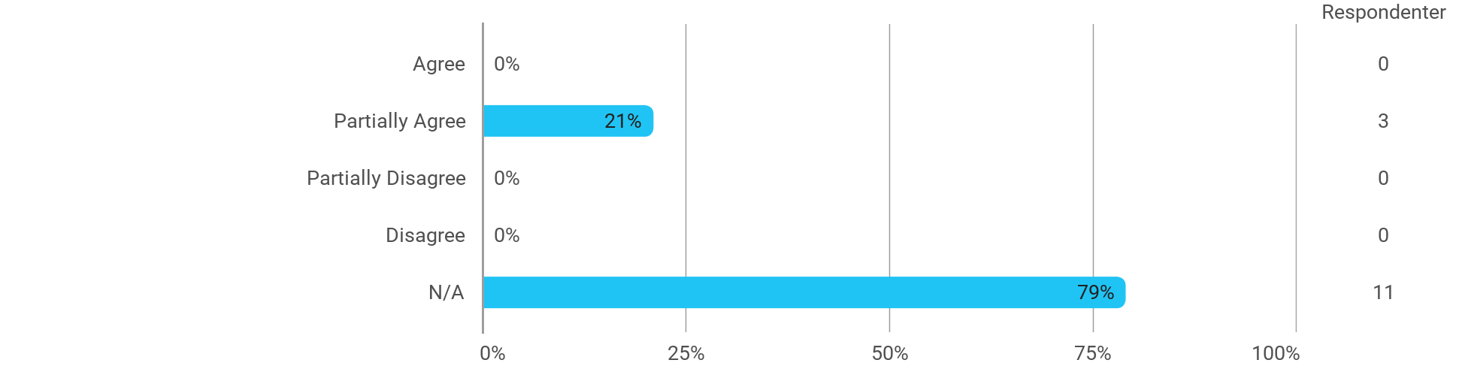

MSc03 SSD (elective project) -Theoretical Elaboration of a Topic or a Case - The cooperation in the project group has worked well
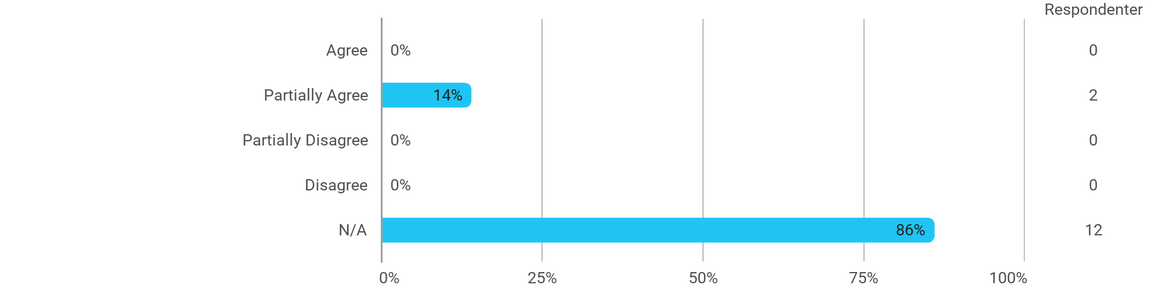

MSc03 SSD (elective project) -Theoretical Elaboration of a Topic or a Case - The courses have supported the project work

MSc03 SSD (elective project) -Theoretical Elaboration of a Topic or a Case - I received the expected supervision

Is there anything you would like to highlight positively about the module or do you have any constructive suggestions for improvements?

I have developed myself academically during the semester
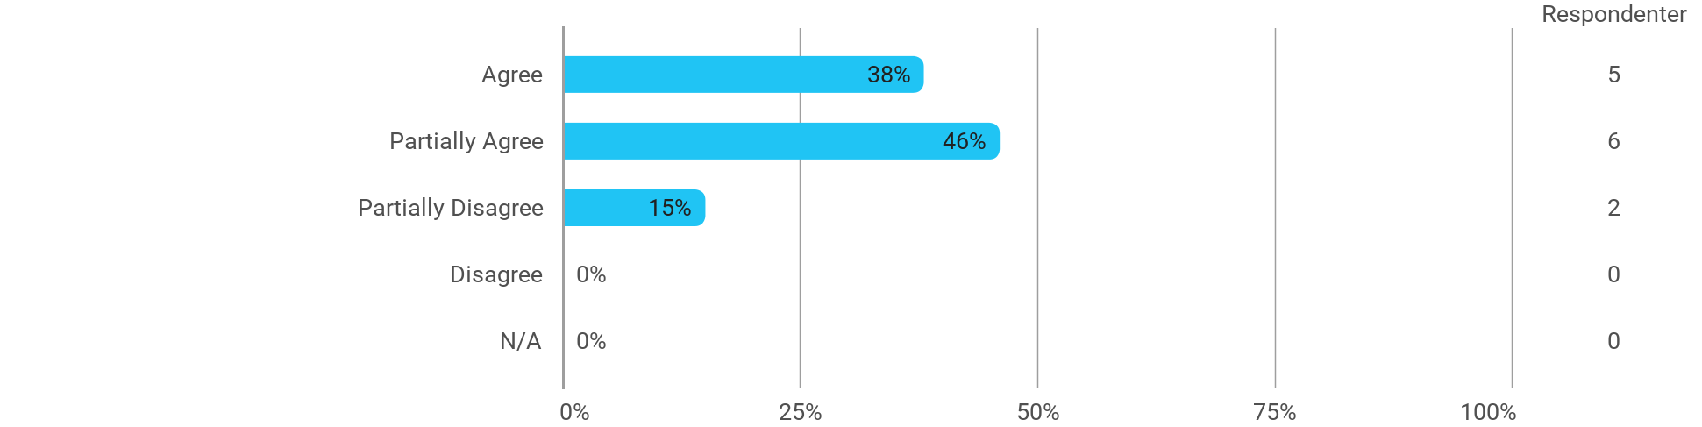

The following activities have developed me academically during the semester: - Project work
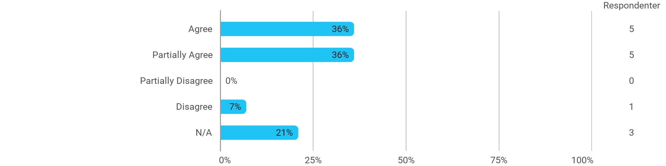

The following activities have developed me academically during the semester: - Academic discussions with fellow students
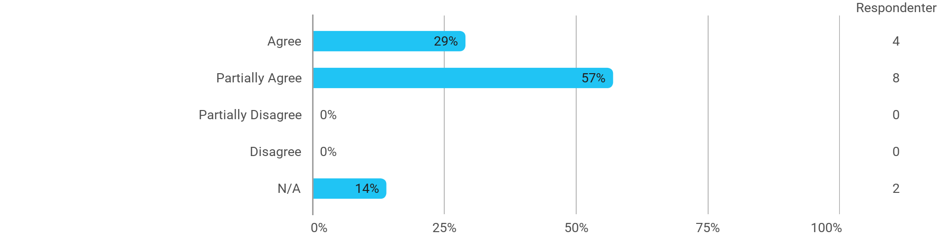

The following activities have developed me academically during the semester: - Academic discussions with teachers
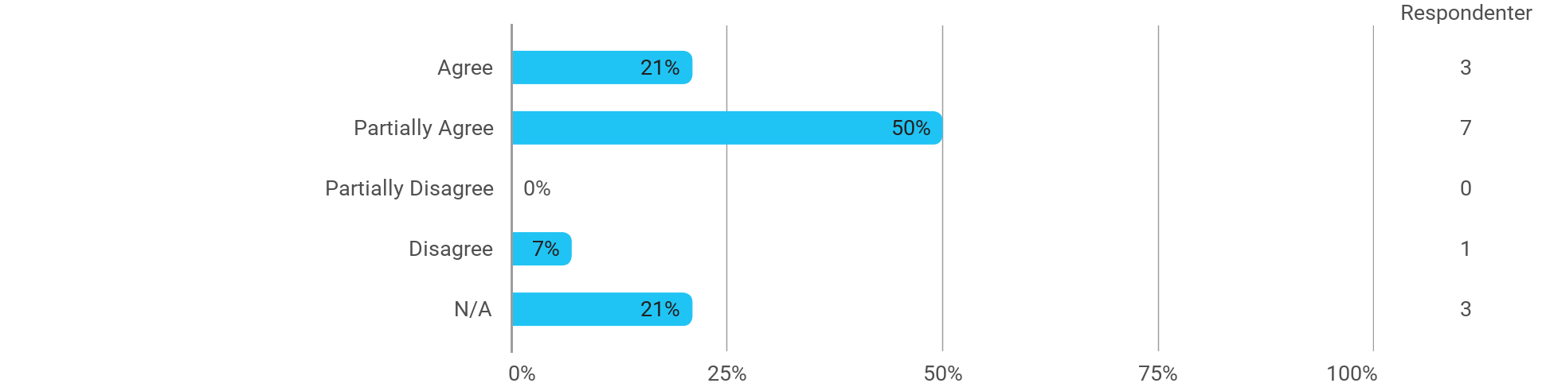

The following activities have developed me academically during the semester: - Practical exercises and experiments
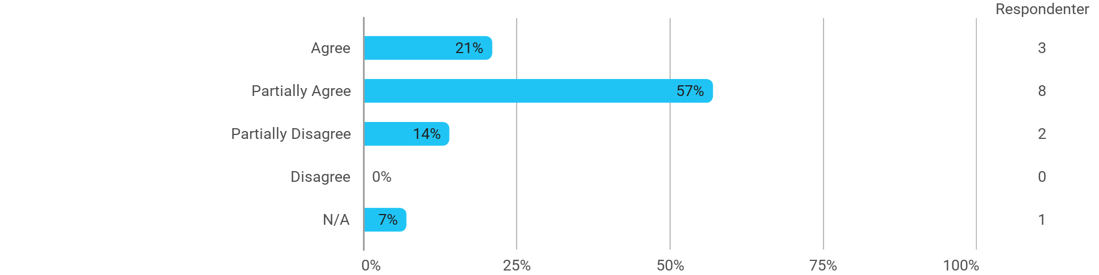

Other:

When I reflect on my own efforts, I have: - Been active in lectures
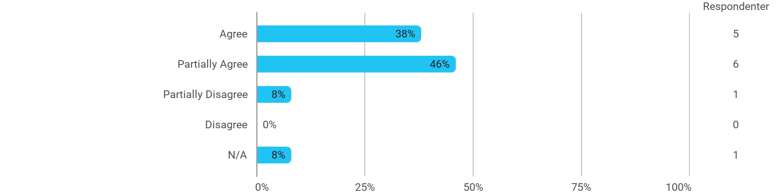

When I reflect on my own efforts, I have: - Participated actively in the project group work
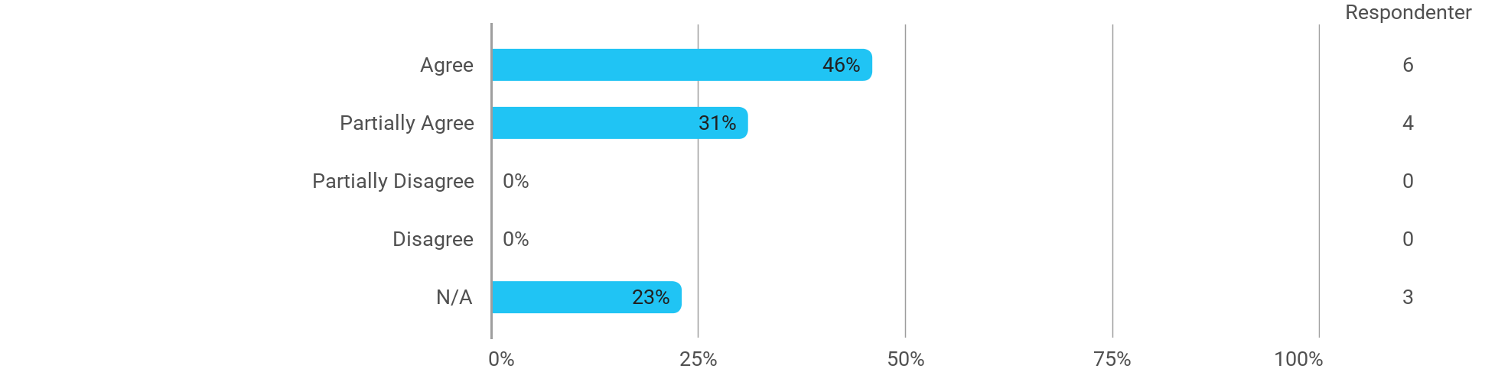

When I reflect on my own efforts, I have: - Prepared myself ahead of class
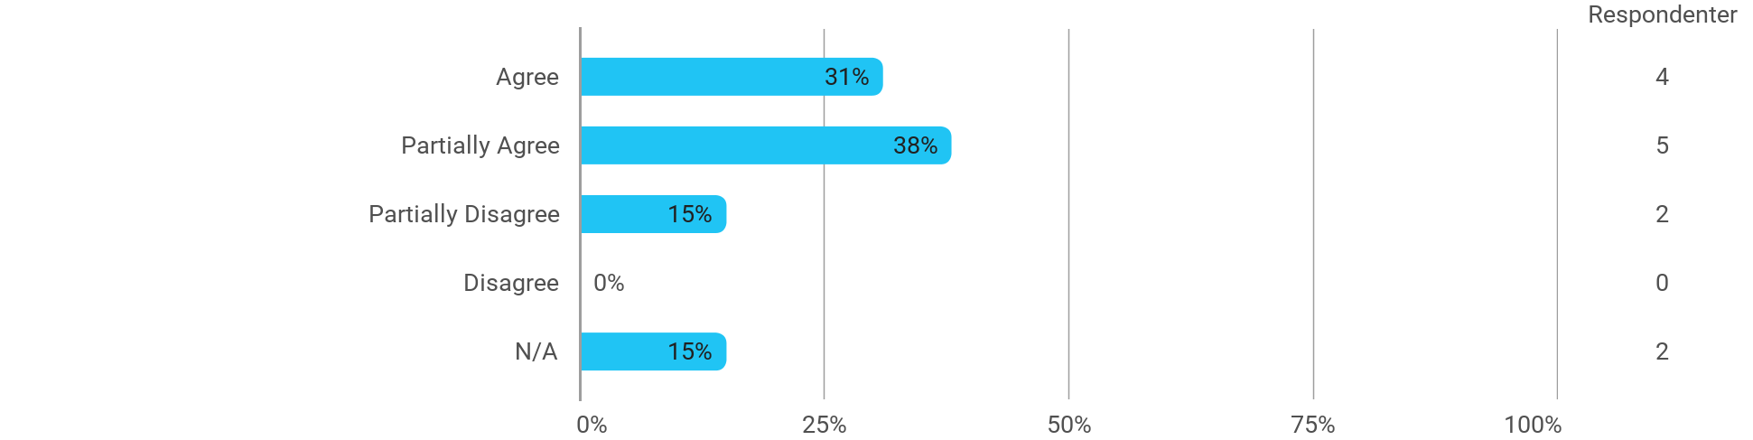

When I reflect on my own efforts, I have: - Prepared myself prior to the project group work
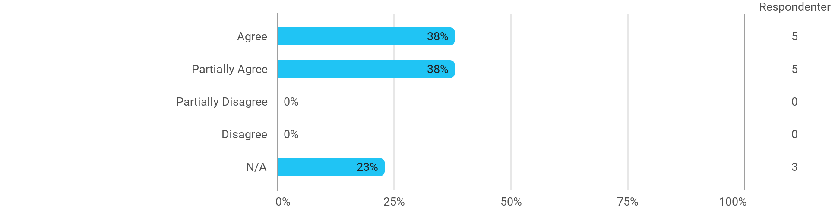

I experience the problem-based and project-oriented form of teaching as conducive to the development of: - My professional skills
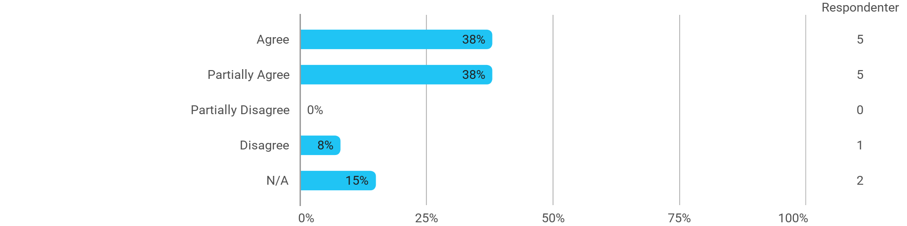

I experience the problem-based and project-oriented form of teaching as conducive to the development of: - My ability to identify and formulate problems
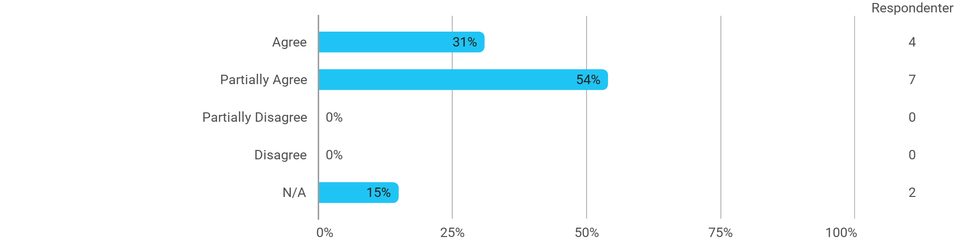

I experience the problem-based and project-oriented form of teaching as conducive to the development of: - My ability to attack and process problems

I experience the problem-based and project-oriented form of teaching as conducive to the development of: - My ability to organize a longer work process and "reach the goal" on time
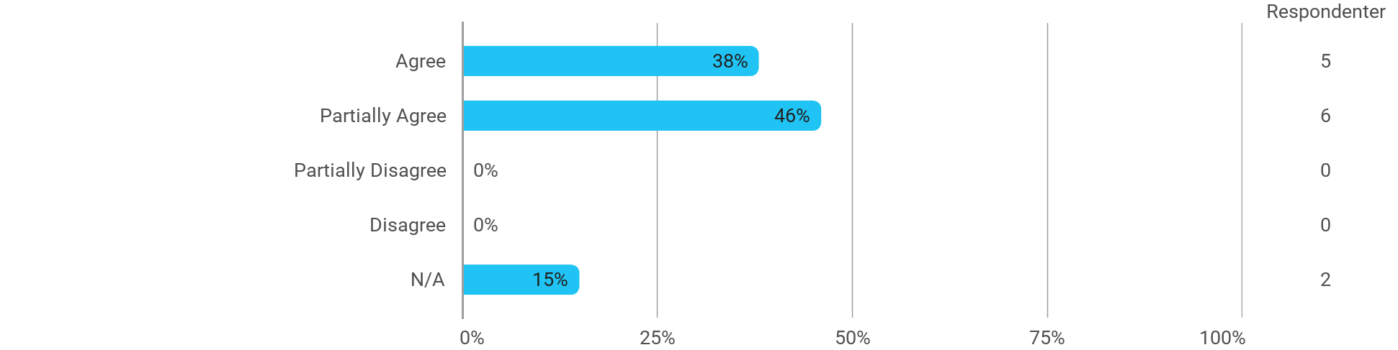

The following questions pertain to the semester as a whole: - I have received sufficient practical information about the semester's activities
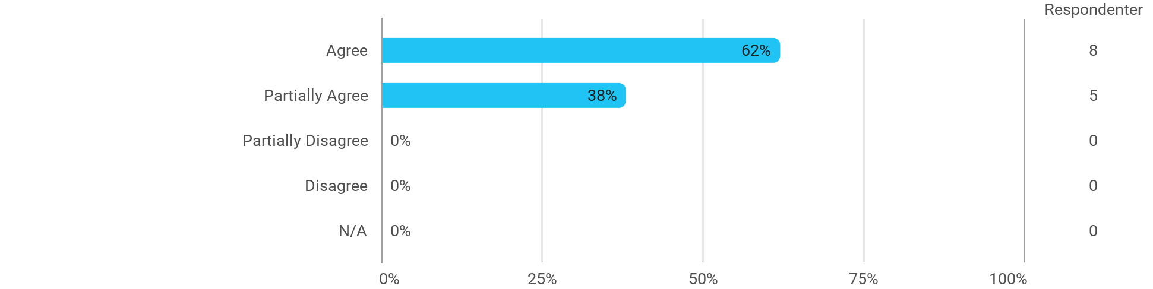

The following questions pertain to the semester as a whole: - I feel that the semester has given me the opportunity to engage in current issues relevant to external partners
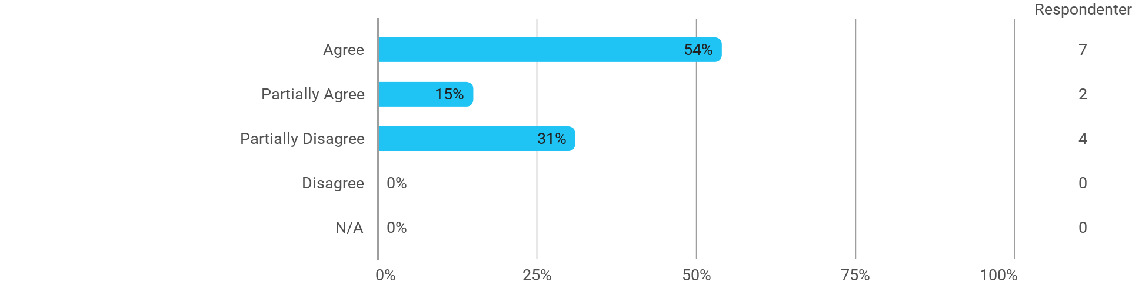

The following questions pertain to the semester as a whole: - I feel that I have addressed issues related to current societal challenges and opportunities
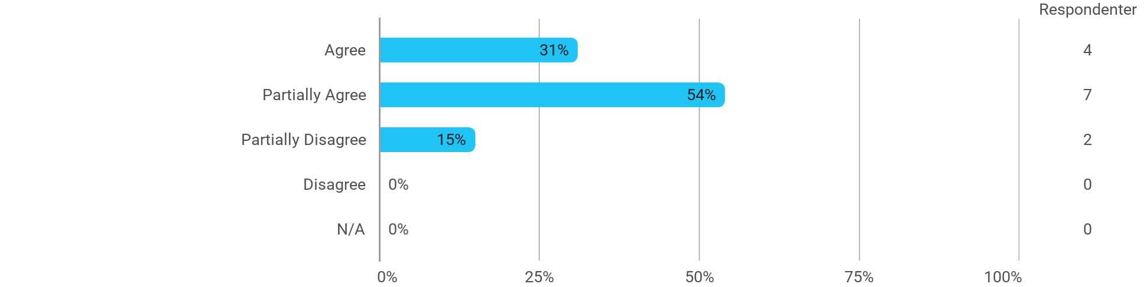

The following questions pertain to the semester as a whole: - I feel that the modules have supported the project work
