Study board conclusions of the semester and teaching evaluation report
Year: | 2024
Campus | Copenhagen
Semester | MED5C
Coordinator: | Rolf Nordal
Date: | 11.3.25

This document represents the public version of the evaluation of the semester. The document forms together with the semester and teaching evaluation report the basis of any adjustments to the semester’s description, planning, execution and/or evaluation of the next iteration of the semester and are used by the coming semester coordinator and semester planning group.

The document also represents the study board’s response to the students, teachers, coordinators and other interested parties about possible consequences of conditions that the students of the semester have pointed out.

The public conclusions and recommendations of the semester coordinator
Overall, the semester went well, and we have found a structure that works for the semester. The projects offered during the semester were well received overall, and a normal distribution of grades was given during the final exams. One teacher (who is also the semester coordinator) supervised 5 out of 10 groups – and 4 of these received top marks from three external examiners, who also remarked that these projects and reports were of a quality they had not seen earlier at Medialogy (2 of these projects were also accepted at IEEE VR 2025). One group in the semester has had ongoing complaints towards a teacher/supervisor with one pending case (which the study board has been asked to comment on). This group has been unwilling to meet and discuss their points of criticism with the teacher. This may also explain some negative comments received in the written evaluation.
The facilities (room) FKJ 3.05 have had ongoing problems during the semester, and the students and teachers should be able to expect a higher quality of service from AAU.
The students and coordinator had insufficient support from the study secretary, who was placed in Aalborg and suddenly disappeared during the semester. She has since been replaced by a new secretary in Aalborg, and I think we can already see improvements in the service level.
The written evaluation was answered by less than 50% of the student population. The study board needs to review the course AMMI as the students have many points of critique concerning this course. Furthermore, the negative comments continue the feedback from earlier years. Many students view it as a repetition of a MED 4 course, and they do not think it is relevant for the semester. Furthermore, the teacher has been recommended to update the Moodle pages for the course. Also, the mini-project needs to be clarified since it was very unclear to the students what the requirements were.
Several times during the semester and in the evaluations, the students suggested replacing the AMMI course with a course on Perception. As coordinator, this proposal makes sense. The study board should discuss this and decide.
The course DIE received some negative feedback regarding some of the examples and exercises. Furthermore, some students have trouble applying theories from one area to another (as required by the study plan). However, it is essential to note that the points of criticism are only seen in the written evaluation—they never came up during the semester. The course teachers will consider the feedback.
The course PIT received good marks. However, at semester meetings and evaluations, many students view it as too easy and has too little content. The coordinator will discuss this with the course teacher

Conclusion of the study board
The Study Board (MSN) has processed the semester evaluation report and offers the following observations/conclusions:

- Response rate 40%
- Grade distribution fine
- Issues regarding the AMMI and the DIE course have been noted. The Study Board concludes that the semester should be addressed as an entity before addressing single courses. CBM sets up a meeting with coordinators of MED5A and MED5C and the course teachers to discuss the course.

Samlet status
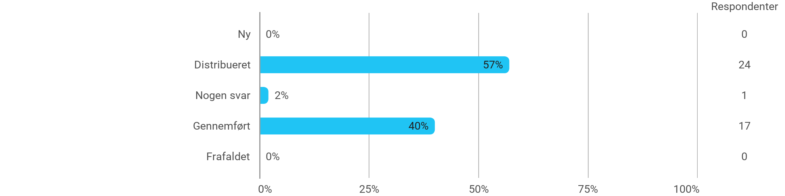

MED5C - Design af immersive oplevelser - Jeg har fået det forventede udbytte af modulet
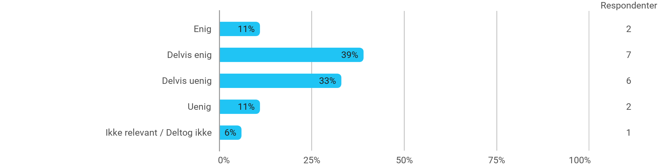

MED5C - Design af immersive oplevelser - Den anvendte litteratur har understøttet min læring
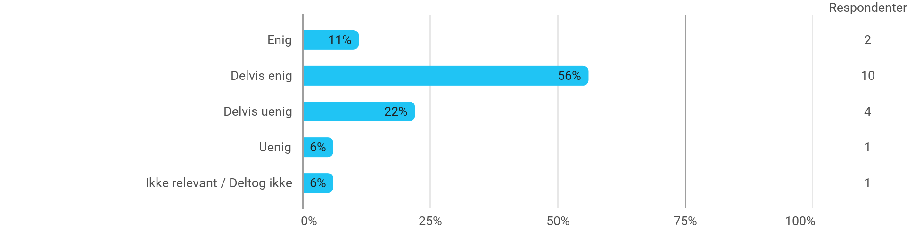

MED5C - Design af immersive oplevelser - Den anvendte undervisningsform har understøttet min læring
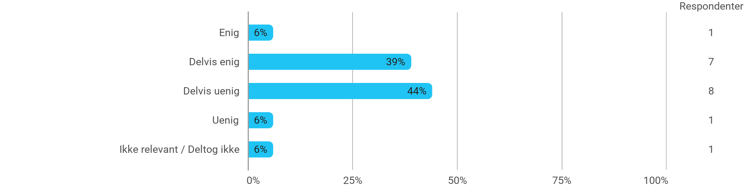

MED5C - Design af immersive oplevelser - Øvelserne/opgaverne for kurset har været relevante
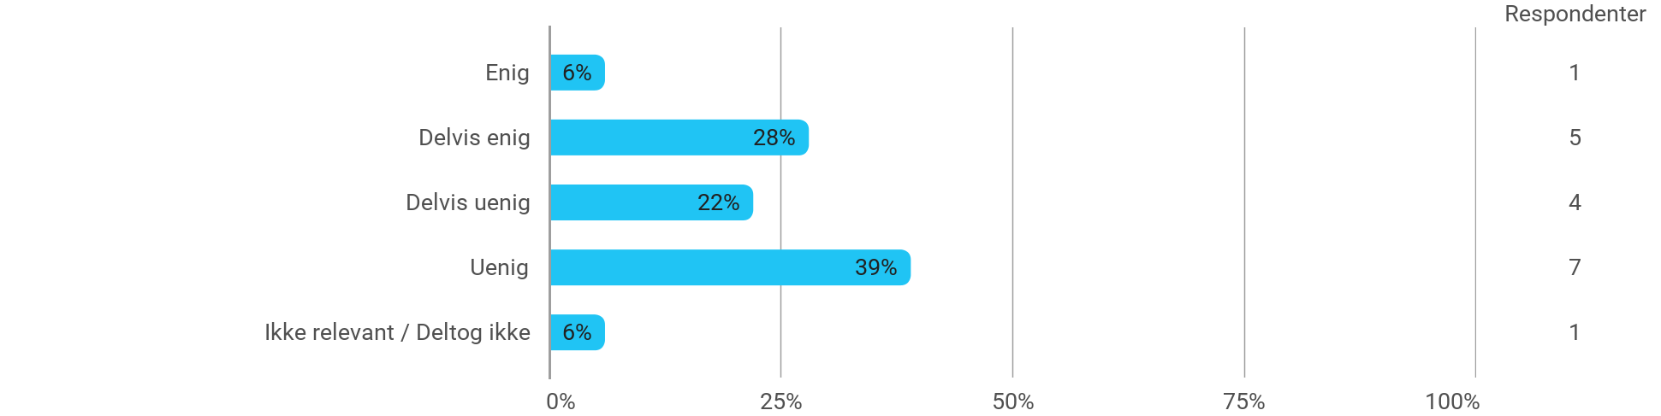

MED5C - Programmering af immersive teknologier - Jeg har fået det forventede udbytte af modulet
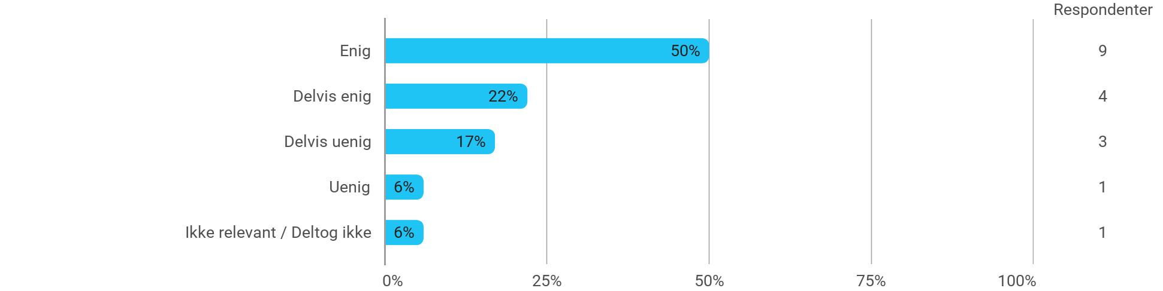

MED5C - Programmering af immersive teknologier - Den anvendte litteratur har understøttet min læring
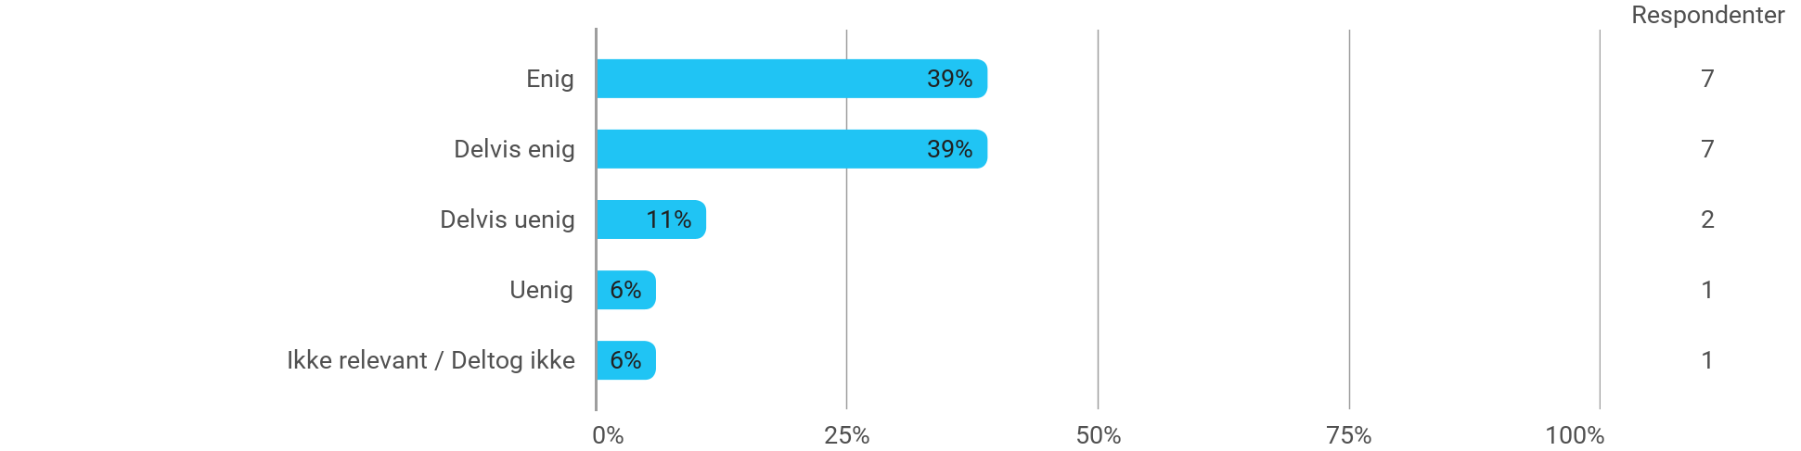

MED5C - Programmering af immersive teknologier - Den anvendte undervisningsform har understøttet min læring
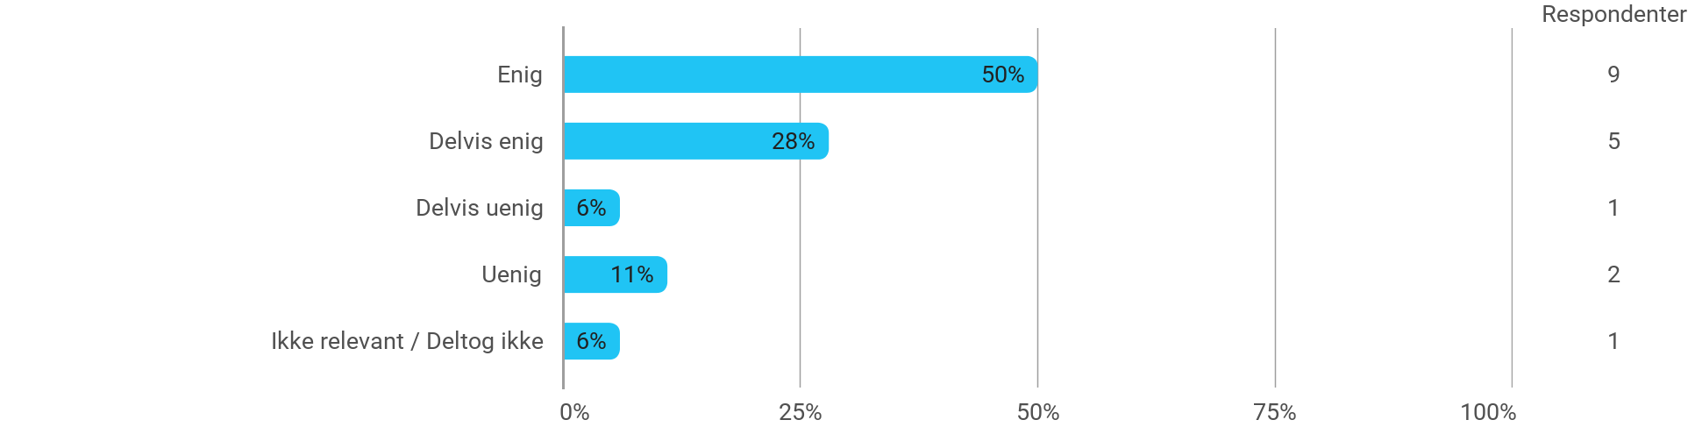

MED5C - Programmering af immersive teknologier - Øvelserne/opgaverne for kurset har været relevante
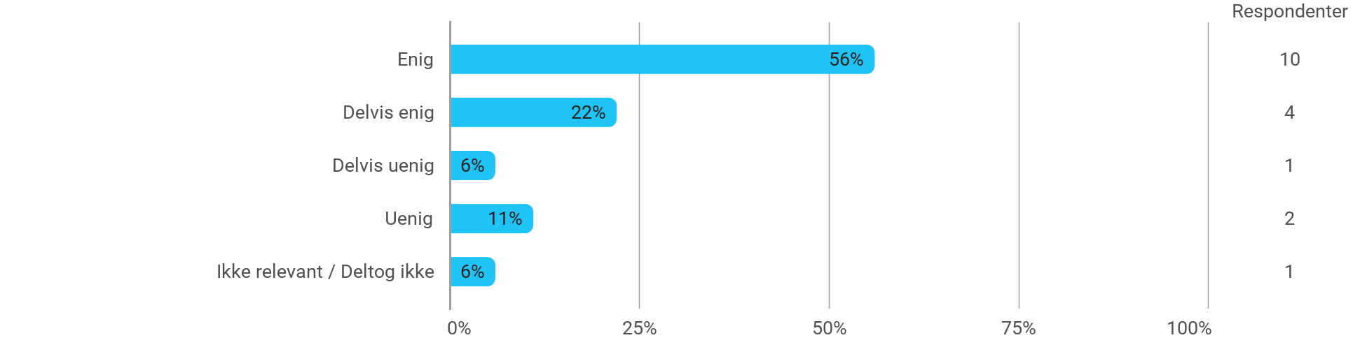

MED5C - Avanceret menneske-maskine interaktion - Jeg har fået det forventede udbytte af modulet
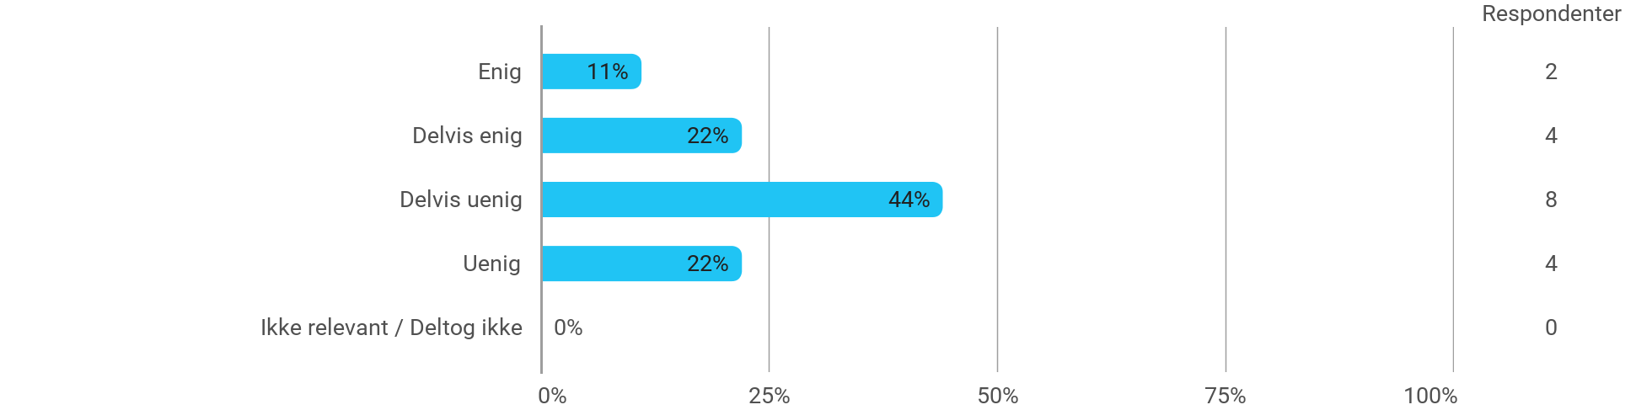

MED5C - Avanceret menneske-maskine interaktion - Den anvendte litteratur har understøttet min læring
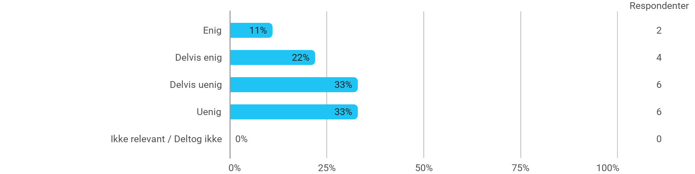

MED5C - Avanceret menneske-maskine interaktion - Den anvendte undervisningsform har understøttet min læring
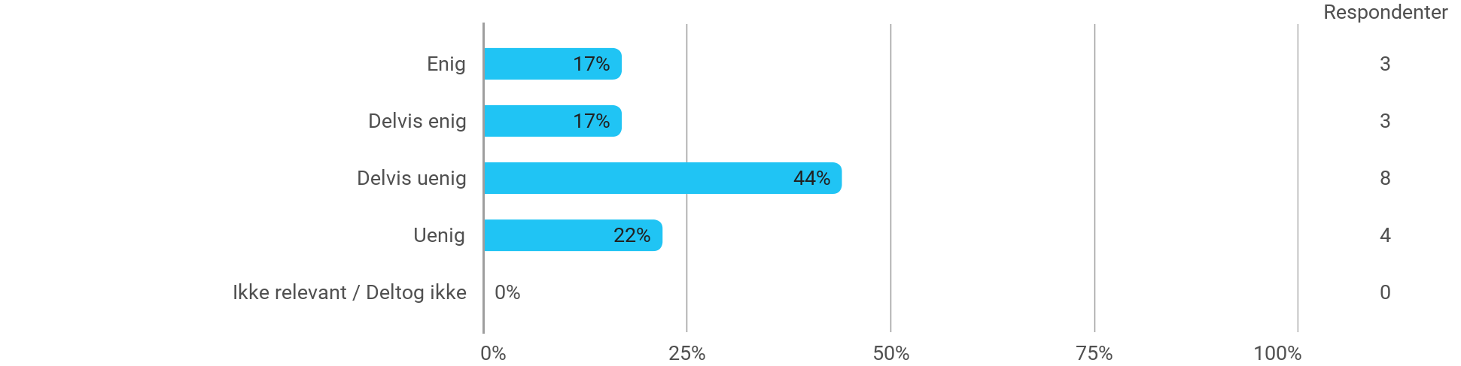

MED5C - Avanceret menneske-maskine interaktion - Øvelserne/opgaverne for kurset har været relevante
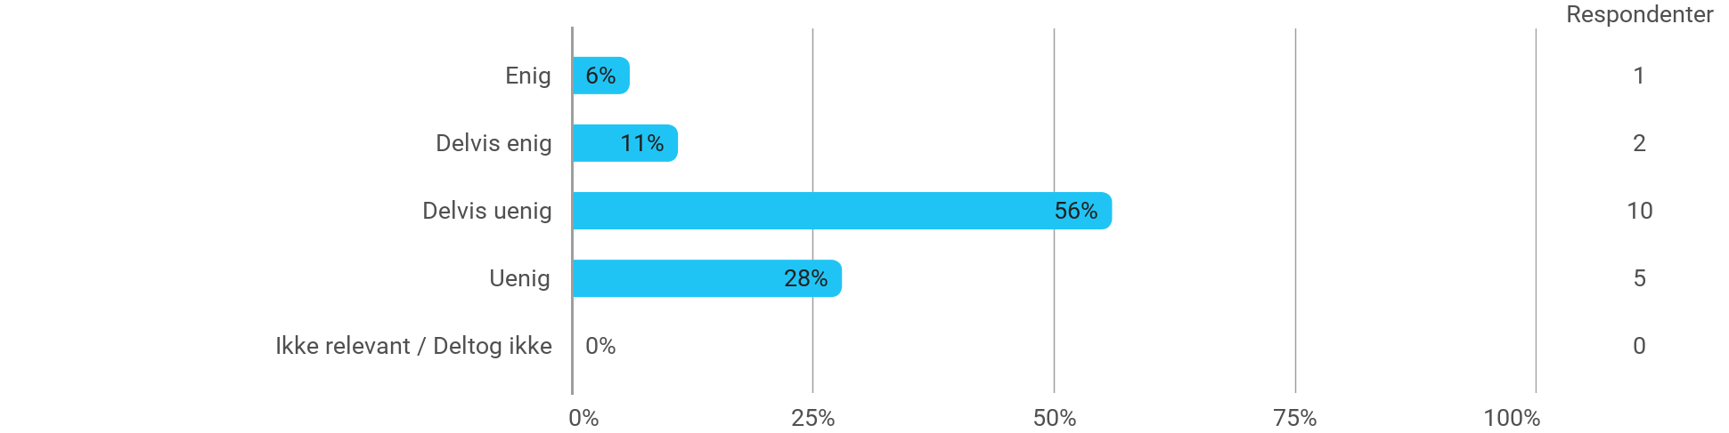

MED5C (projekt) - Mixed Reality - Jeg har fået det forventede udbytte af modulet
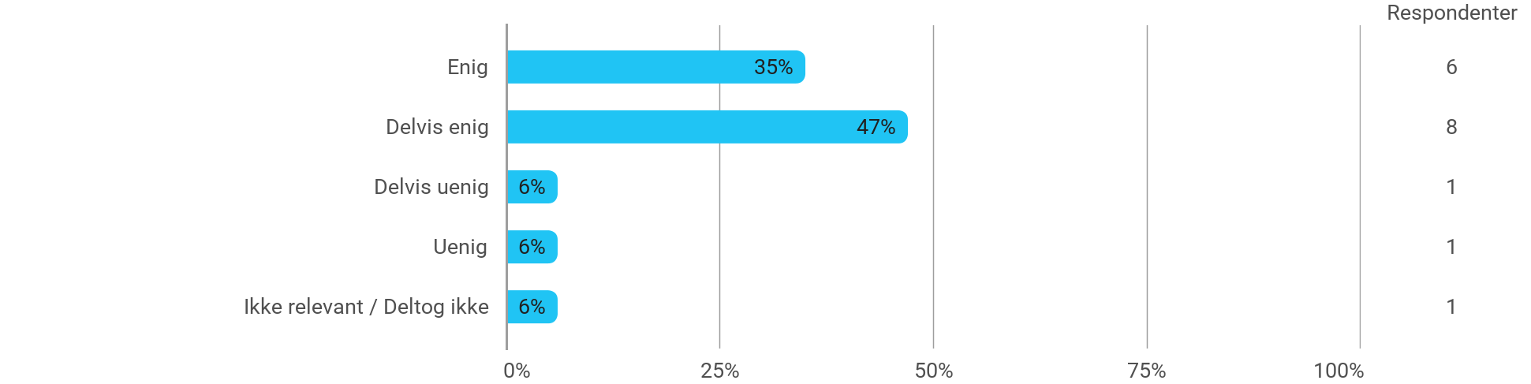

MED5C (projekt) - Mixed Reality - Det valgte problem har skabt en god ramme for at udfolde mine faglige ambitioner
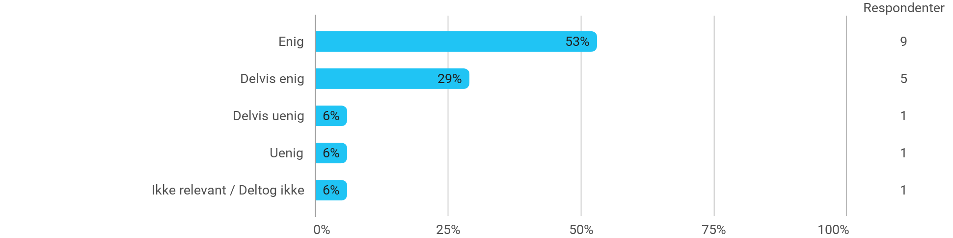

MED5C (projekt) - Mixed Reality - Samarbejdet i projektgruppen har fungeret godt
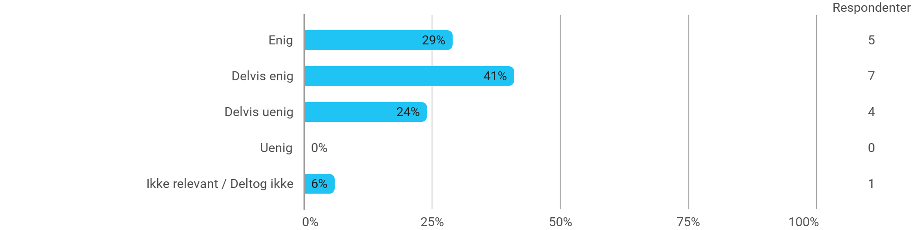

MED5C (projekt) - Mixed Reality - Kurserne har understøttet projektarbejdet
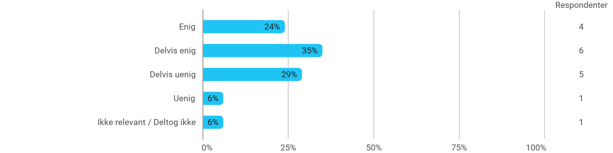

MED5C (projekt) - Mixed Reality - Jeg modtog den forventede vejledning
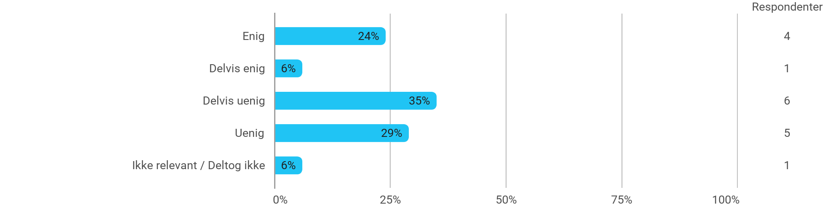

Jeg har udviklet mig fagligt i løbet af semesteret
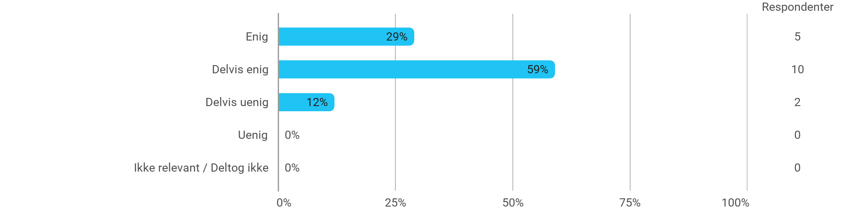

Nedenstående aktiviteter har udviklet mig fagligt i løbet af semesteret: - Projektarbejdet
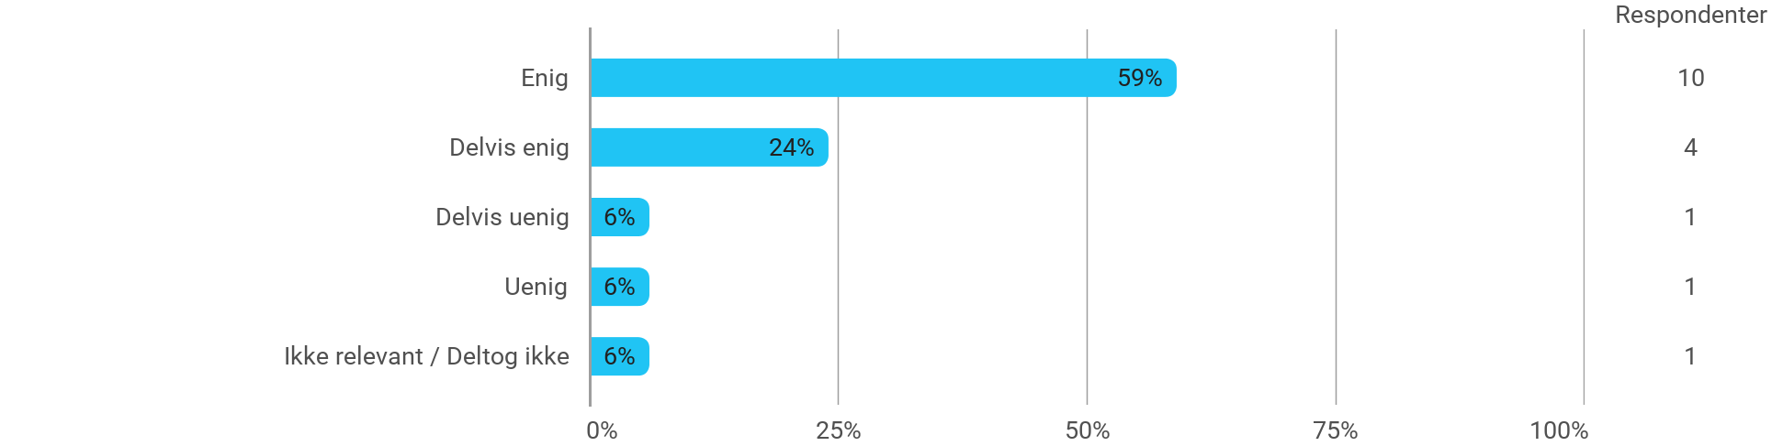

Nedenstående aktiviteter har udviklet mig fagligt i løbet af semesteret: - Faglige diskussioner med medstuderende
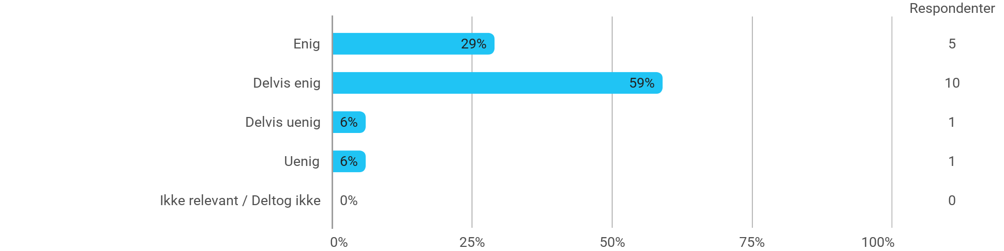

Nedenstående aktiviteter har udviklet mig fagligt i løbet af semesteret: - Faglige diskussioner med undervisere
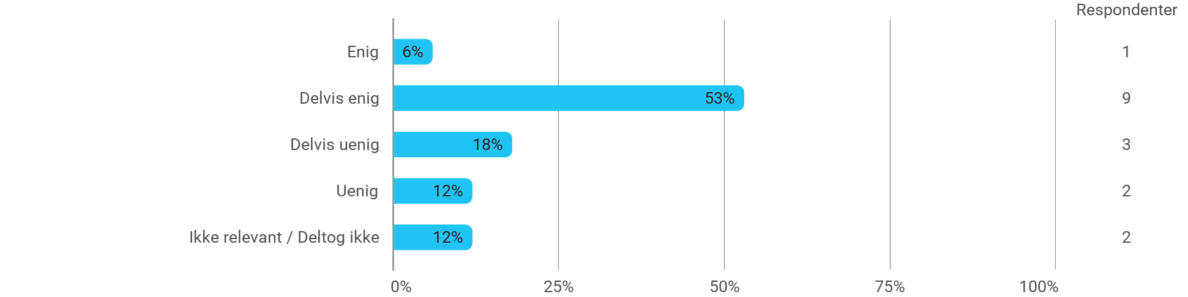

Nedenstående aktiviteter har udviklet mig fagligt i løbet af semesteret: - Praktiske øvelser og forsøg
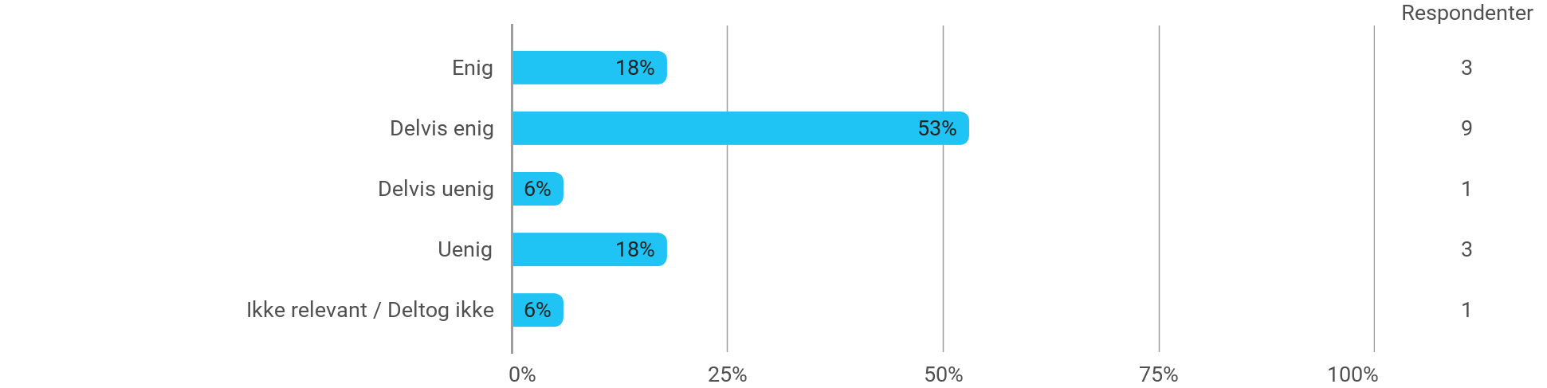

Når jeg reflekterer over min egen indsats, så har jeg: - Været aktiv i undervisningen
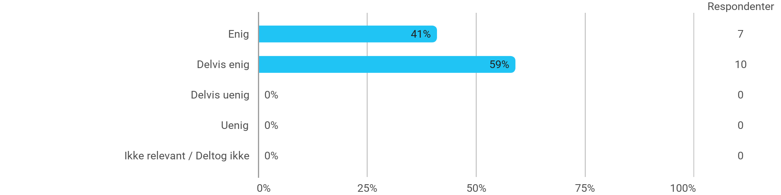

Når jeg reflekterer over min egen indsats, så har jeg: - Deltaget aktivt i projektgruppearbejdet
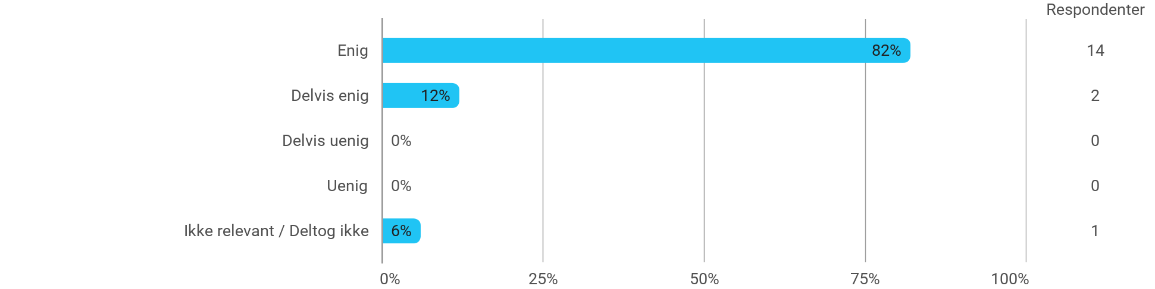

Når jeg reflekterer over min egen indsats, så har jeg: - Forberedt mig forud for undervisningen
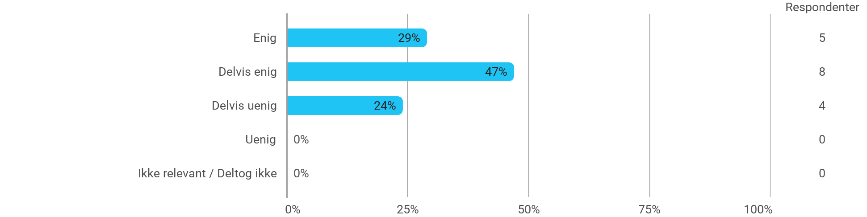

Når jeg reflekterer over min egen indsats, så har jeg: - Forberedt mig forud for projektgruppearbejdet
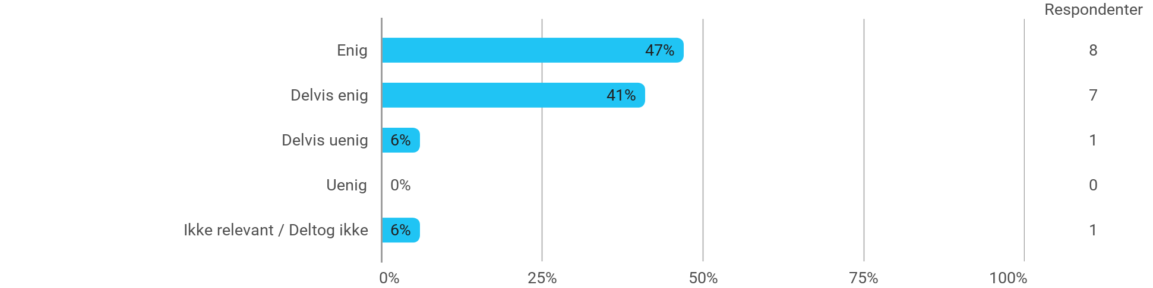

Jeg oplever den problembaserede og projektorienterede undervisningsform som befordrende for udviklingen af: - Mine faglige kompetencer
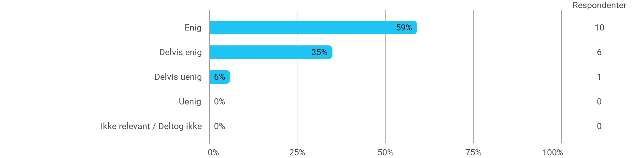

Jeg oplever den problembaserede og projektorienterede undervisningsform som befordrende for udviklingen af: - Min evne til at indkredse og formulere problemstillinger
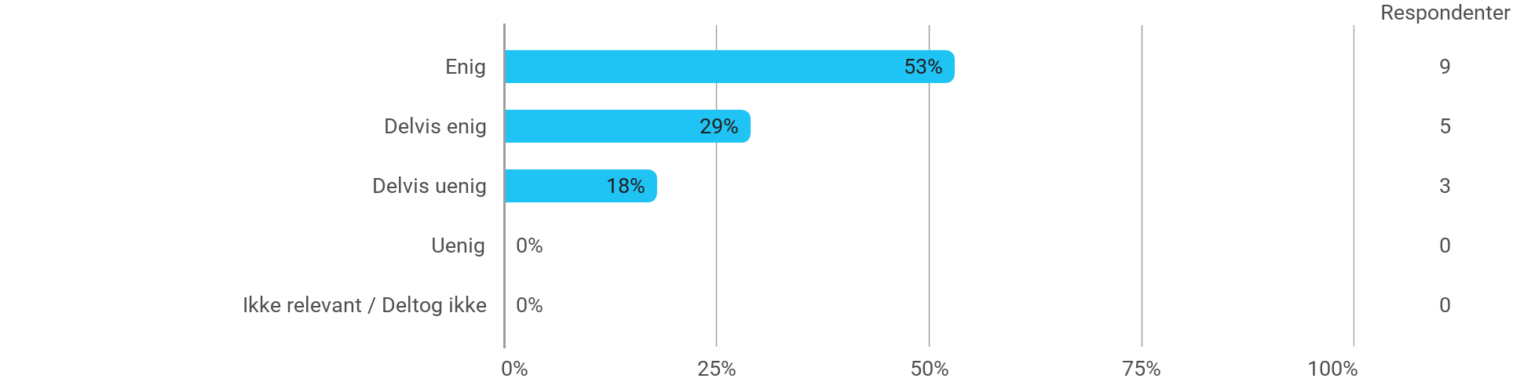

Jeg oplever den problembaserede og projektorienterede undervisningsform som befordrende for udviklingen af: - Min evne til at angribe og bearbejde problemstillinger
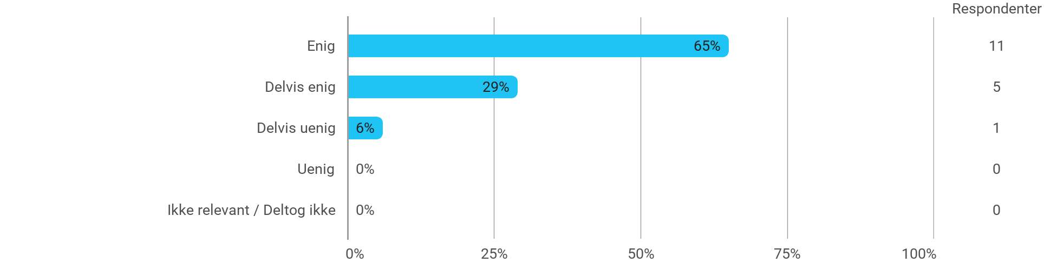

Jeg oplever den problembaserede og projektorienterede undervisningsform som befordrende for udviklingen af: - Min evne til at tilrettelægge en længere arbejdsproces og ”nå i mål” til tiden
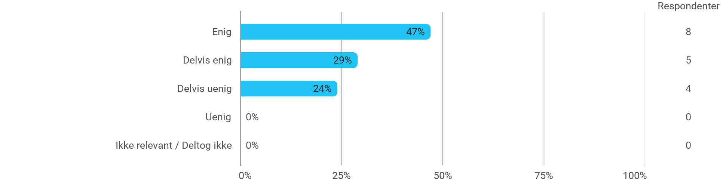

Følgende spørgsmål omhandler semesteret som helhed: - Jeg har modtaget tilstrækkelig praktisk information om semesterets aktiviteter
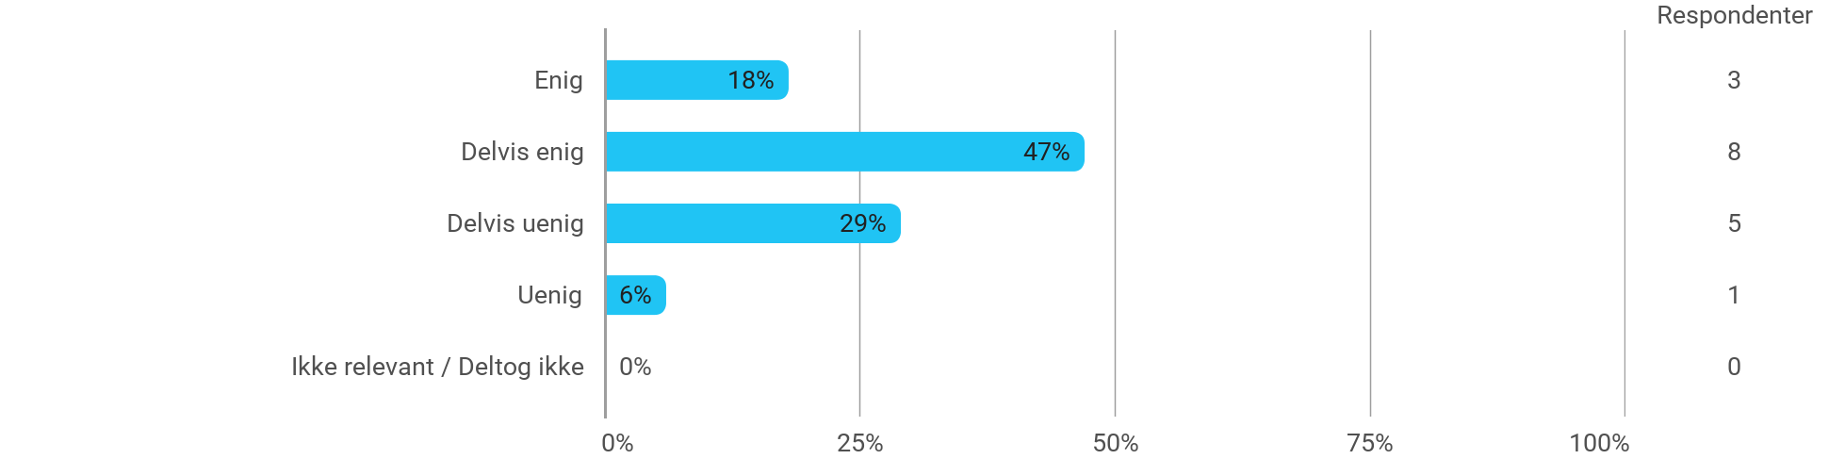

Følgende spørgsmål omhandler semesteret som helhed: - Jeg oplever, at semesteret har givet mig mulighed for at tage udgangspunkt i aktuelle problemstillinger med relevans for eksterne samarbejdspartnere
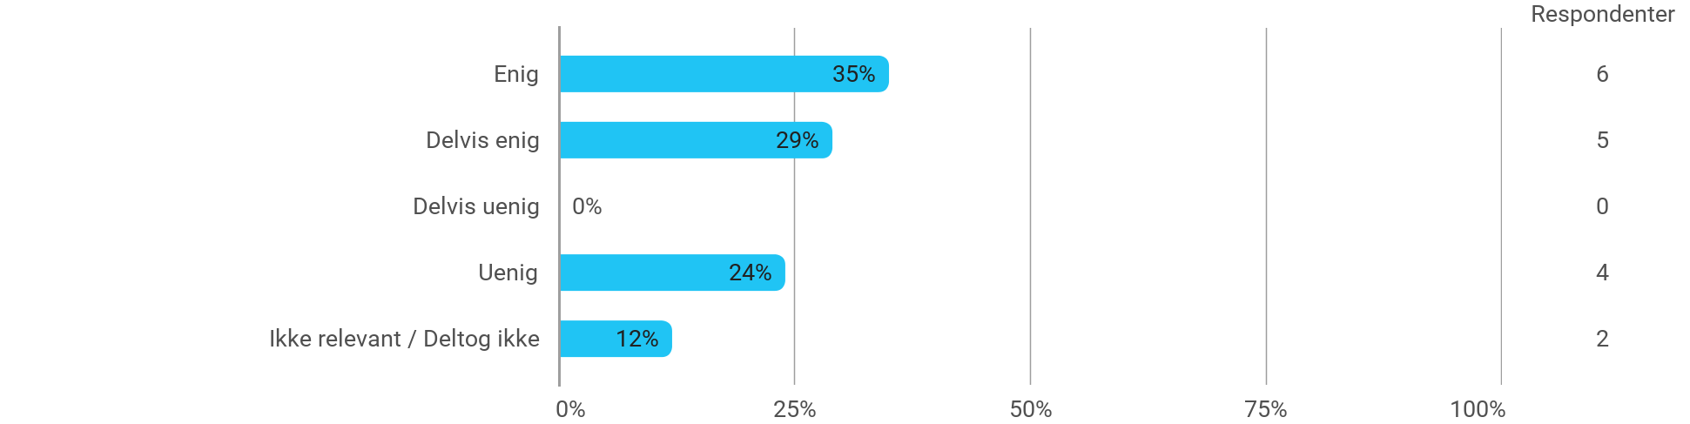

Følgende spørgsmål omhandler semesteret som helhed: - Jeg oplever, at jeg har adresseret problemer, der relaterer til aktuelle samfundsmæssige udfordringer og muligheder
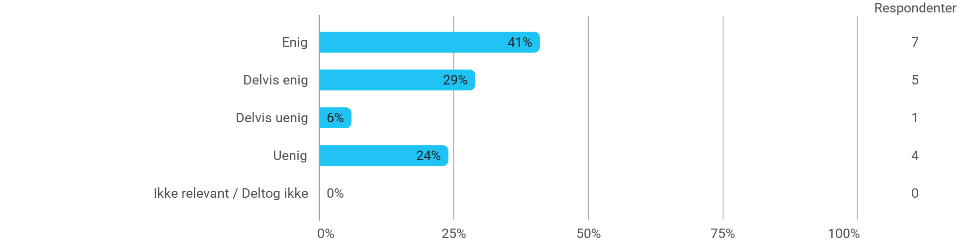

Følgende spørgsmål omhandler semesteret som helhed: - Jeg oplever, at kurserne har understøttet projektarbejdet
