|  |  |
| --- | --- |
| **Study board conclusions of the semester and teaching evaluation report** | |
| Year: | 2024 |
| Campus | Copenhagen |
| Semester | LiD9 |
| Coordinator: | Mette Hvass |
| Date: | 10.3.25 |
|  |  |

This document represents the public version of the evaluation of the semester. The document forms together with the semester and teaching evaluation report the basis of any adjustments to the semester’s description, planning, execution and/or evaluation of the next iteration of the semester and are used by the coming semester coordinator and semester planning group.

The document also represents the study board’s response to the students, teachers, coordinators and other interested parties about possible consequences of conditions that the students of the semester have pointed out.

|  |
| --- |
| **The public conclusions and recommendations of the semester coordinator** |
| The first five pages of the questionnaire concerns courses and innovation project that none of the students participated in because they were all in internship. I think this confusion might have led to the fact that the students didn’t think that the questionnaire concerned them. Questions about groupwork and courses and PBL are also not relevant in the questionnaire. Only two students answered and due to the confusion one student agreed on that the courses were good! Concerning POSEO, students were positive about the expected outcome of the internship, the supervision and the structure/information about the semester |

|  |
| --- |
| **Conclusion of the study board** |
| The Study Board (MSN) has processed the semester evaluation report and offers the following observations/conclusions:   * Response rate low 8% * Grade distribution fine * The semester worked well |

## Samlet status

## MSc03 LID (elective) - Design Experiments - I have received the expected benefit from the module

## MSc03 LID (elective) - Design Experiments - The literature used has supported my learning

## MSc03 LID (elective) - Design Experiments - The form of teaching used has supported my learning

## MSc03 LID (elective) - Design Experiments - The exercises/tasks for the course have been relevant

## MSc03 LID (elective) - User Experience Design for Service Interaction - I have received the expected benefit from the module

## MSc03 LID (elective) - User Experience Design for Service Interaction - The literature used has supported my learning

## MSc03 LID (elective) - User Experience Design for Service Interaction - The form of teaching used has supported my learning

## MSc03 LID (elective) - User Experience Design for Service Interaction - The exercises/tasks for the course have been relevant

|  |
| --- |

## MSc03 LID (elective) - Academic Paper Writing - I have received the expected benefit from the module

## MSc03 LID (elective) - Academic Paper Writing - The literature used has supported my learning

## MSc03 LID (elective) - Academic Paper Writing - The form of teaching used has supported my learning

## MSc03 LID (elective) - Academic Paper Writing - The exercises/tasks for the course have been relevant

|  |
| --- |

## MSc03 LID (project) - Lighting Design Innovation - I have received the expected benefit from the module

## MSc03 LID (project) - Lighting Design Innovation - The chosen problem has been a good foundation for unfolding my professional ambitions

## MSc03 LID (project) - Lighting Design Innovation - The cooperation in the project group has worked well

## MSc03 LID (project) - Lighting Design Innovation - The courses have supported the project work

## MSc03 LID (project) - Lighting Design Innovation - I received the expected supervision

## MSc03 LID (project) - Project-Oriented Study in an External Organisation - I have received the expected benefit from the module

## MSc03 LID (project) - Project-Oriented Study in an External Organisation - The chosen problem has been a good foundation for unfolding my professional ambitions

## MSc03 LID (project) - Project-Oriented Study in an External Organisation - The cooperation in the project group has worked well

## MSc03 LID (project) - Project-Oriented Study in an External Organisation - The courses have supported the project work

## MSc03 LID (project) - Project-Oriented Study in an External Organisation - I received the expected supervision

|  |
| --- |

## I have developed myself academically during the semester

## The following activities have developed me academically during the semester: - Project work

## The following activities have developed me academically during the semester: - Academic discussions with fellow students

## The following activities have developed me academically during the semester: - Academic discussions with teachers

## The following activities have developed me academically during the semester: - Practical exercises and experiments

|  |
| --- |

## When I reflect on my own efforts, I have: - Been active in lectures

## When I reflect on my own efforts, I have: - Participated actively in the project group work

## When I reflect on my own efforts, I have: - Prepared myself ahead of class

## When I reflect on my own efforts, I have: - Prepared myself prior to the project group work

## I experience the problem-based and project-oriented form of teaching as conducive to the development of: - My professional skills

## I experience the problem-based and project-oriented form of teaching as conducive to the development of: - My ability to identify and formulate problems

## I experience the problem-based and project-oriented form of teaching as conducive to the development of: - My ability to attack and process problems

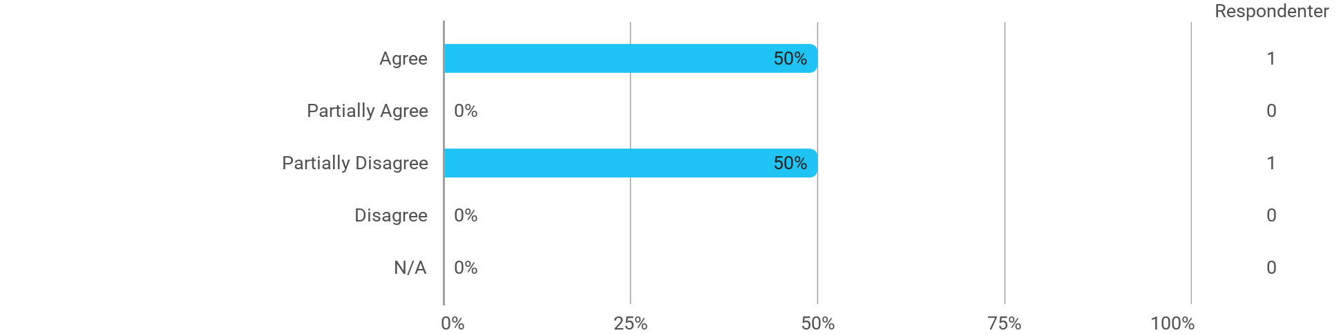

## I experience the problem-based and project-oriented form of teaching as conducive to the development of: - My ability to organize a longer work process and "reach the goal" on time

## The following questions pertain to the semester as a whole: - I have received sufficient practical information about the semester's activities

## The following questions pertain to the semester as a whole: - I feel that the semester has given me the opportunity to engage in current issues relevant to external partners

## The following questions pertain to the semester as a whole: - I feel that I have addressed issues related to current societal challenges and opportunities

## The following questions pertain to the semester as a whole: - I feel that the modules have supported the project work

