Study board conclusions of the semester and teaching evaluation report
Year: | 2024
Campus | Aalborg
Semester | MED7A
Coordinator: | Hendrik Knoche
Date: | 10.3.25

This document represents the public version of the evaluation of the semester. The document forms together with the semester and teaching evaluation report the basis of any adjustments to the semester’s description, planning, execution and/or evaluation of the next iteration of the semester and are used by the coming semester coordinator and semester planning group.

The document also represents the study board’s response to the students, teachers, coordinators and other interested parties about possible consequences of conditions that the students of the semester have pointed out.

The public conclusions and recommendations of the semester coordinator
Consider running RTCG online for all students. Introduce some machine learning concepts earlier in the education.
Conclusion of the study board
The Study Board (MSN) has processed the semester evaluation report and offers the following observations/conclusions:
- Response rate 79%
- Grade distribution fine
- The semester worked well

Samlet status

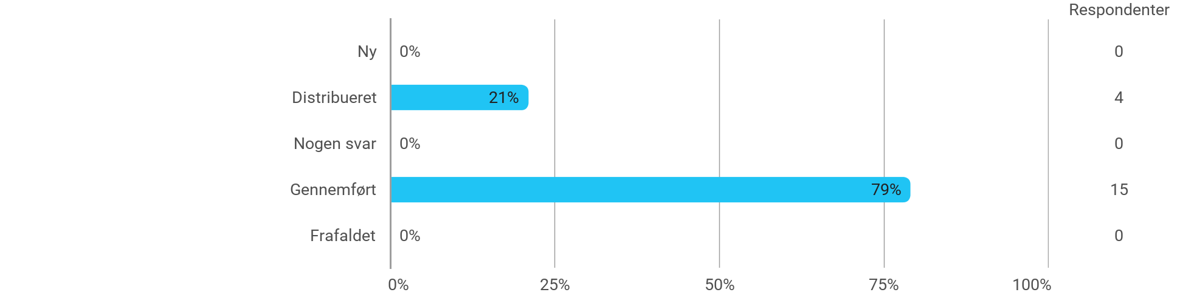

MSc01 MEDA - Machine Learning for Media Experiences - I have received the expected benefit from the module
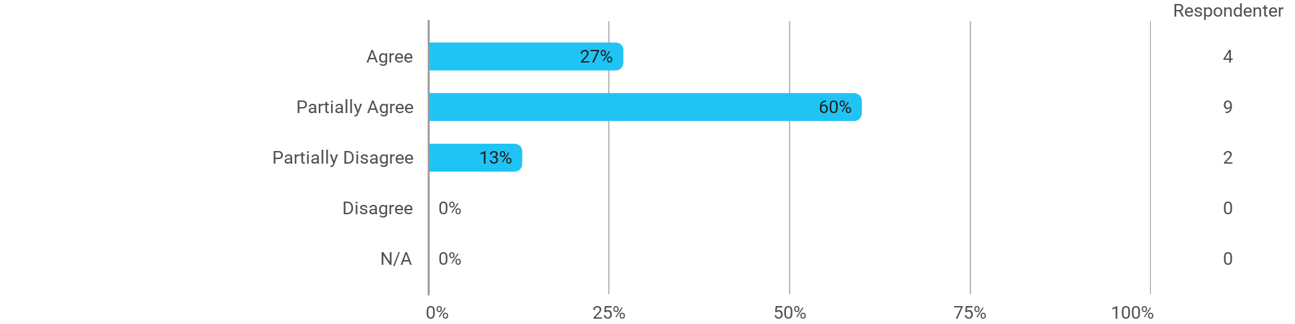

MSc01 MEDA - Machine Learning for Media Experiences - The literature used has supported my learning
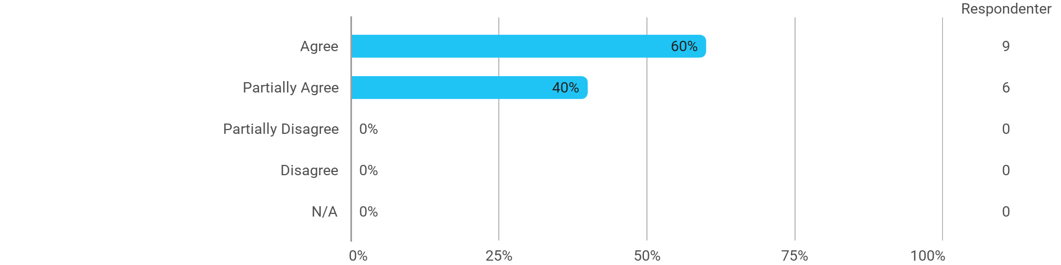

MSc01 MEDA - Machine Learning for Media Experiences - The form of teaching used has supported my learning
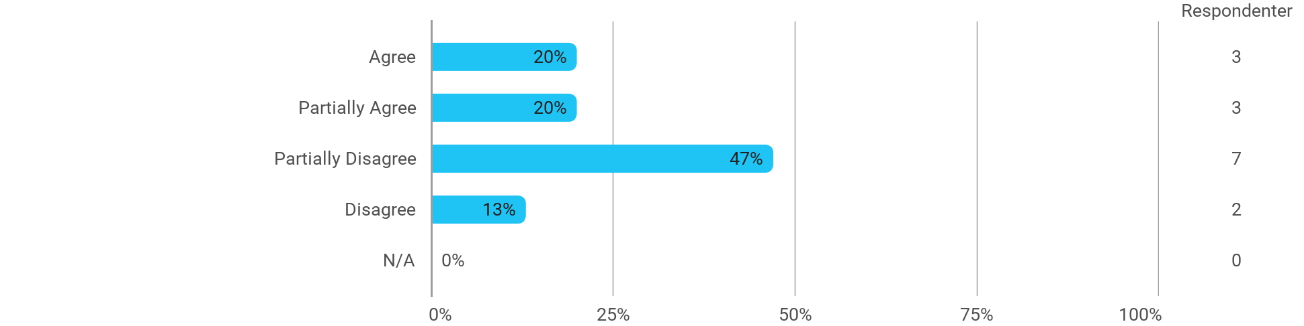

MSc01 MEDA - Machine Learning for Media Experiences - The exercises/tasks for the course have been relevant
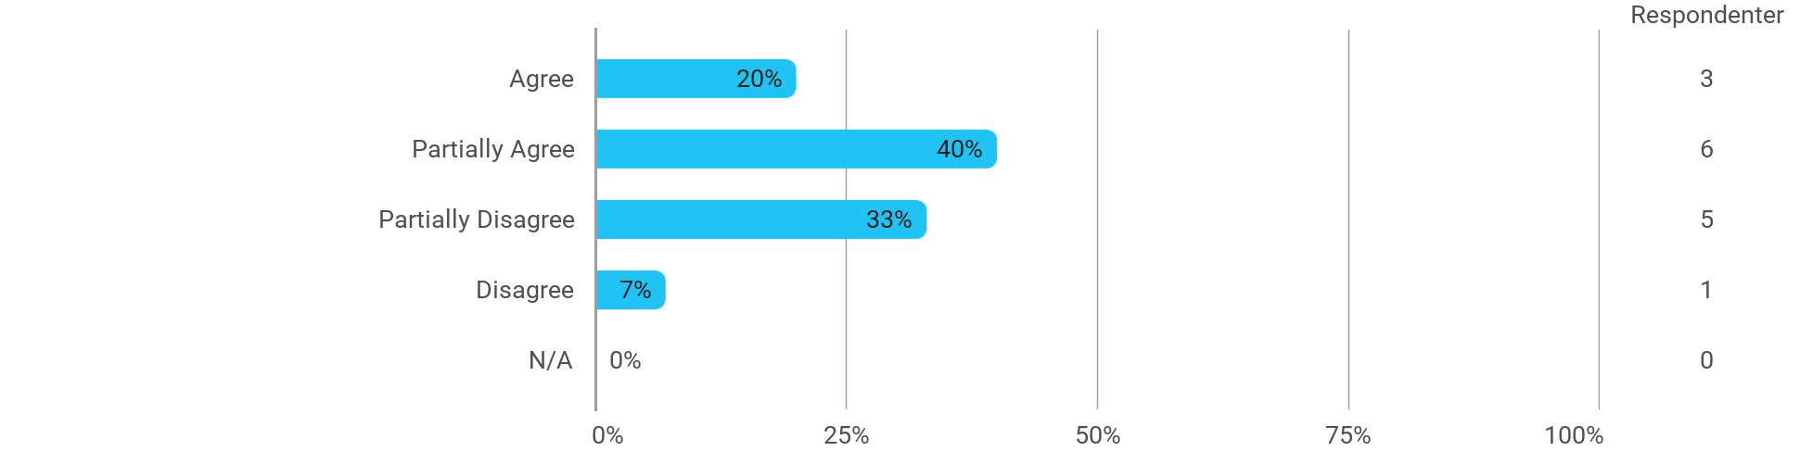

MSc01 MEDA (elective) - Real-Time Computer Graphics - I have received the expected benefit from the module
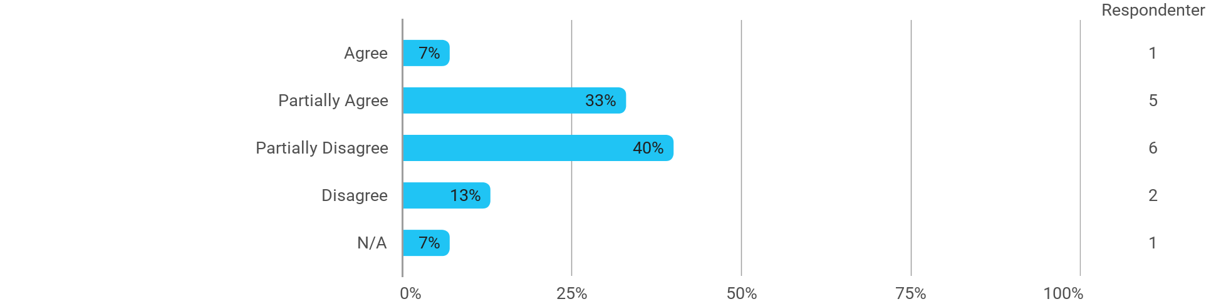

MSc01 MEDA (elective) - Real-Time Computer Graphics - The literature used has supported my learning
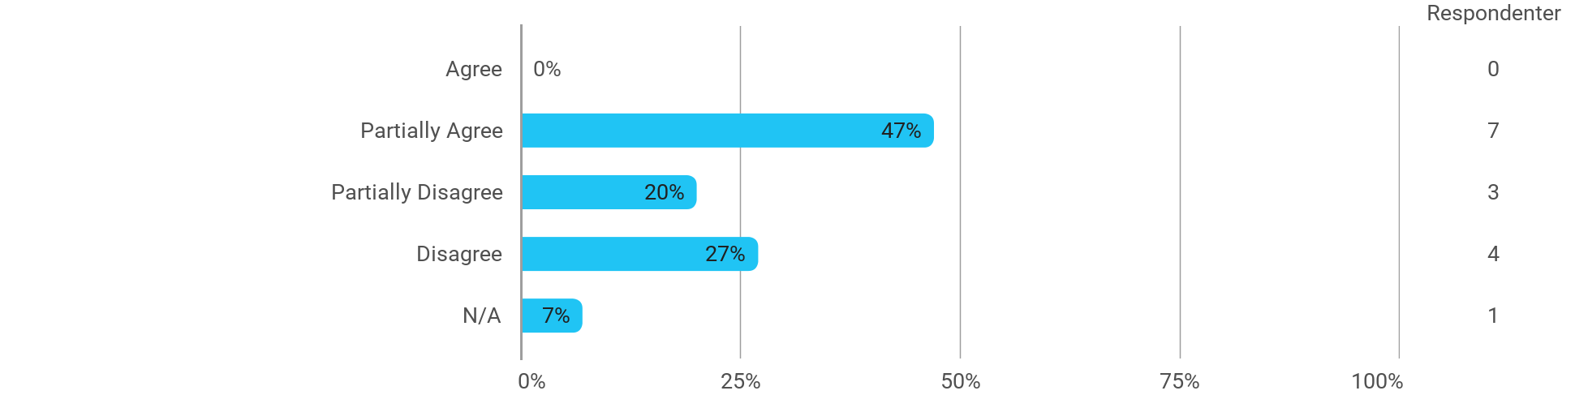

MSc01 MEDA (elective) - Real-Time Computer Graphics - The form of teaching used has supported my learning
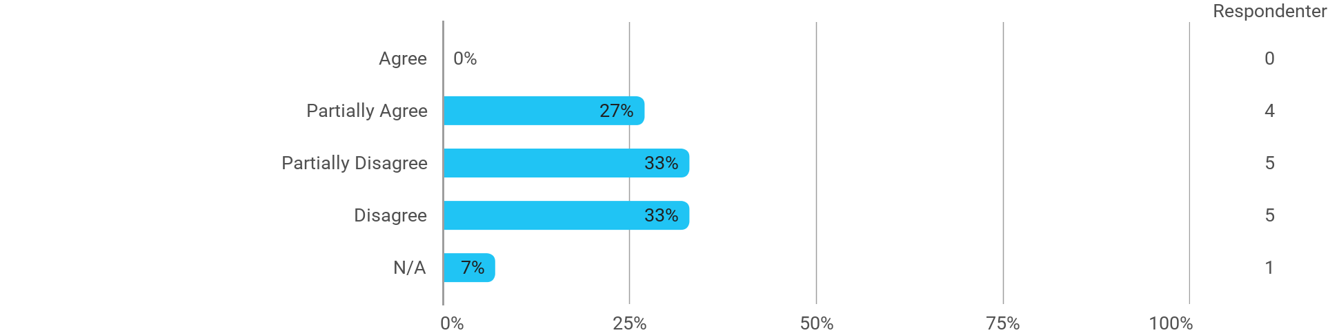

MSc01 MEDA (elective) - Real-Time Computer Graphics - The exercises/tasks for the course have been relevant
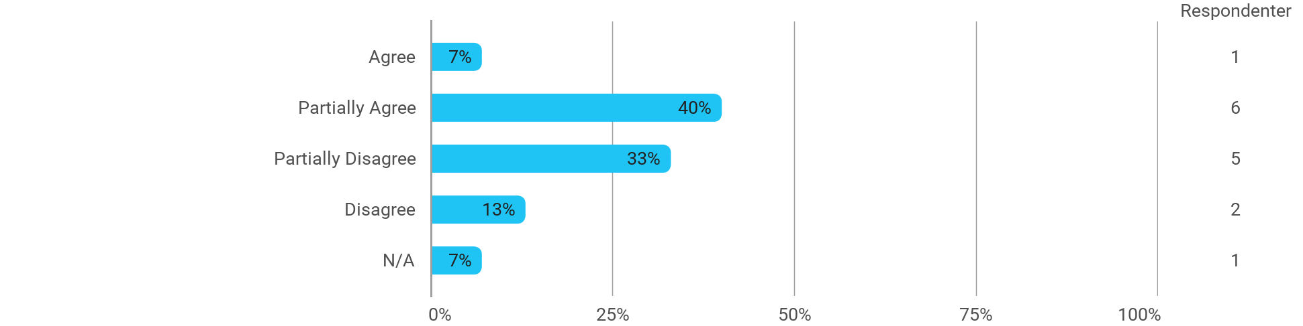

MSc01 MEDA (elective) - Narratives in Interactive Systems - I have received the expected benefit from the module
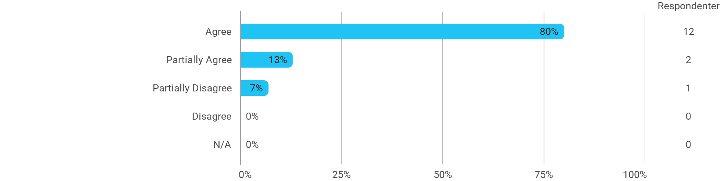

MSc01 MEDA (elective) - Narratives in Interactive Systems - The literature used has supported my learning
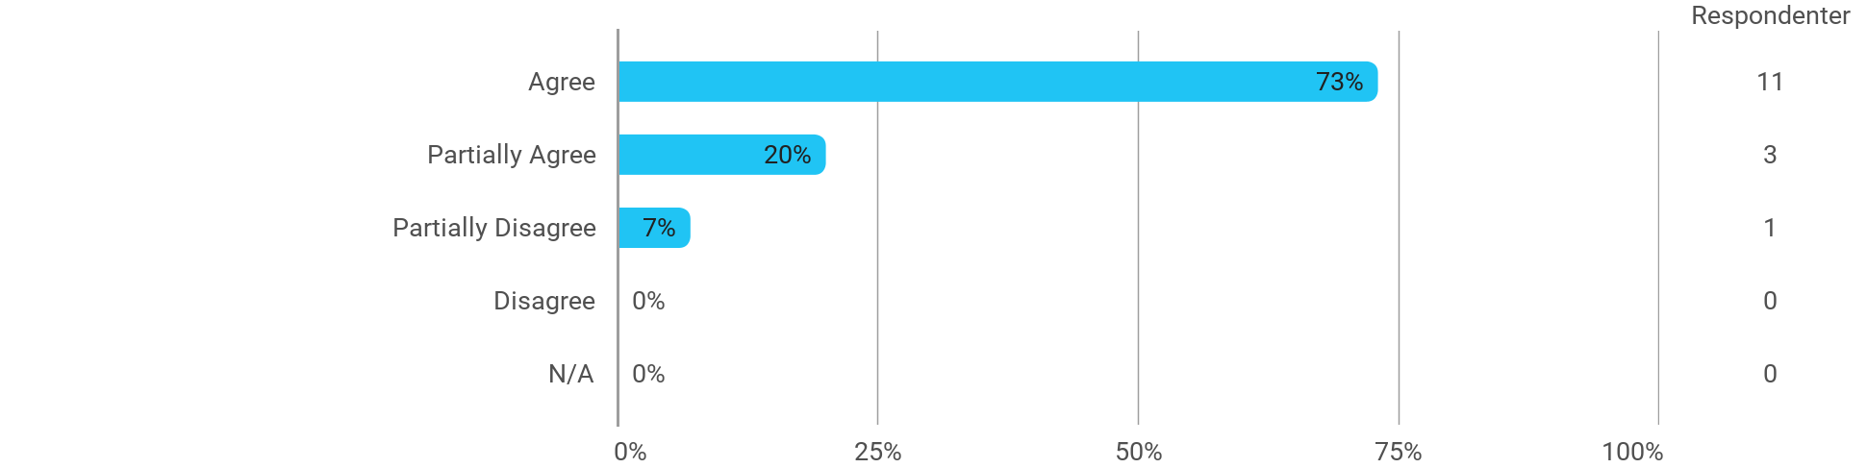

MSc01 MEDA (elective) - Narratives in Interactive Systems - The form of teaching used has supported my learning
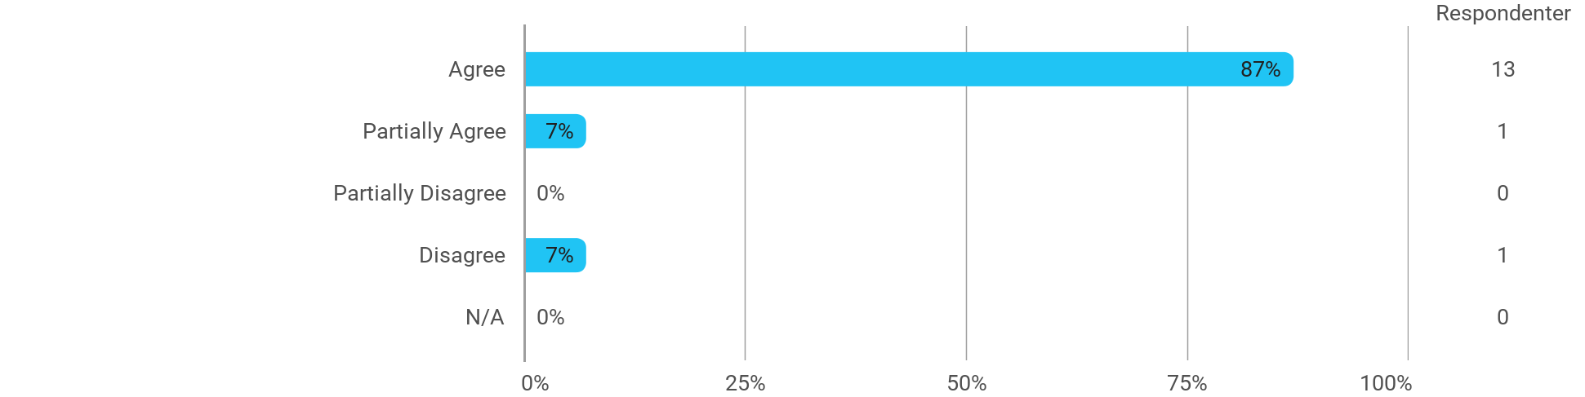

MSc01 MEDA (elective) - Narratives in Interactive Systems - The exercises/tasks for the course have been relevant
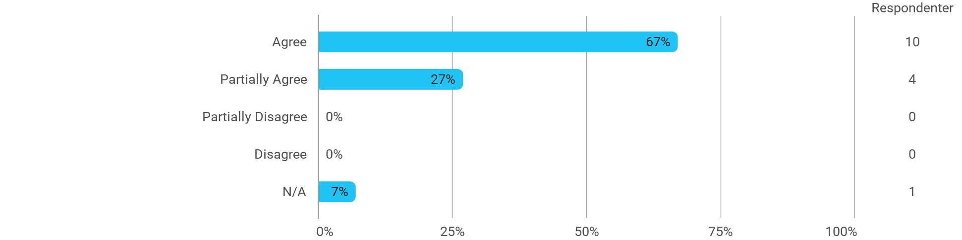

MSc01 MEDA (project) - Adaptive Media Systemsgn - I have received the expected benefit from the module
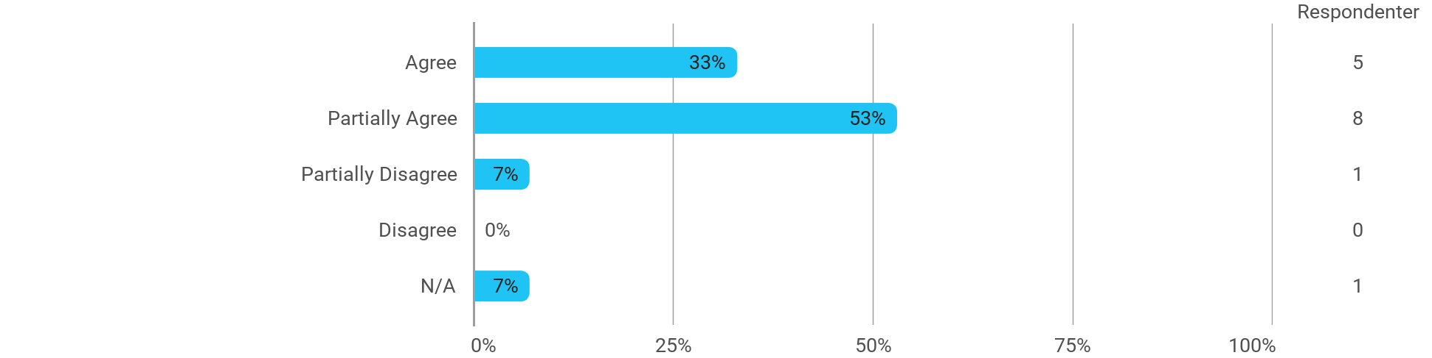

MSc01 MEDA (project) - Adaptive Media Systemsgn - The chosen problem has been a good foundation for unfolding my professional ambitions
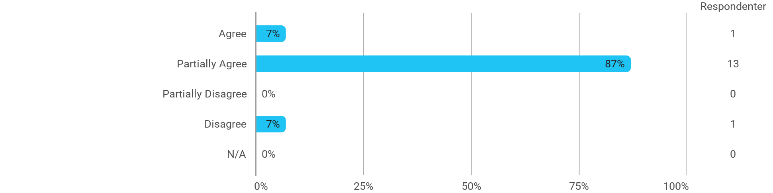

MSc01 MEDA (project) - Adaptive Media Systemsgn - The cooperation in the project group has worked well
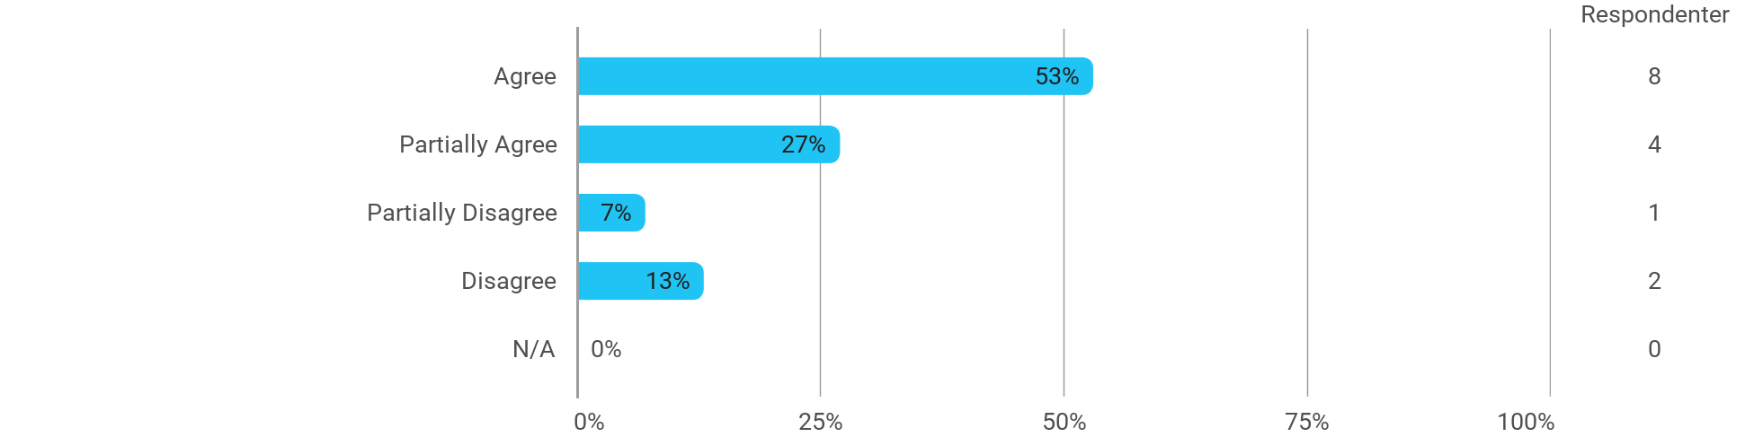

MSc01 MEDA (project) - Adaptive Media Systemsgn - The courses have supported the project work
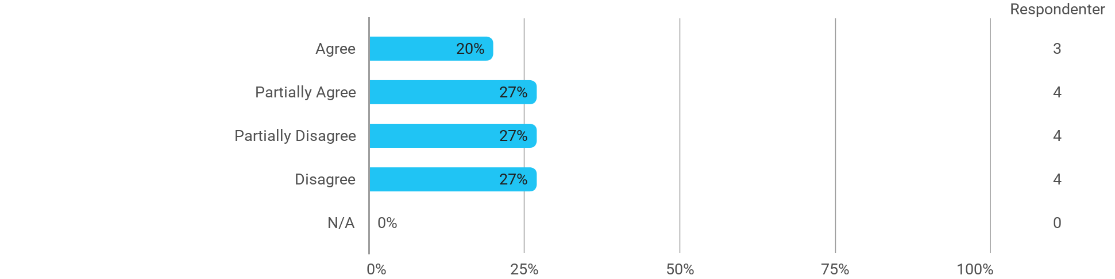

MSc01 MEDA (project) - Adaptive Media Systemsgn - I received the expected supervision
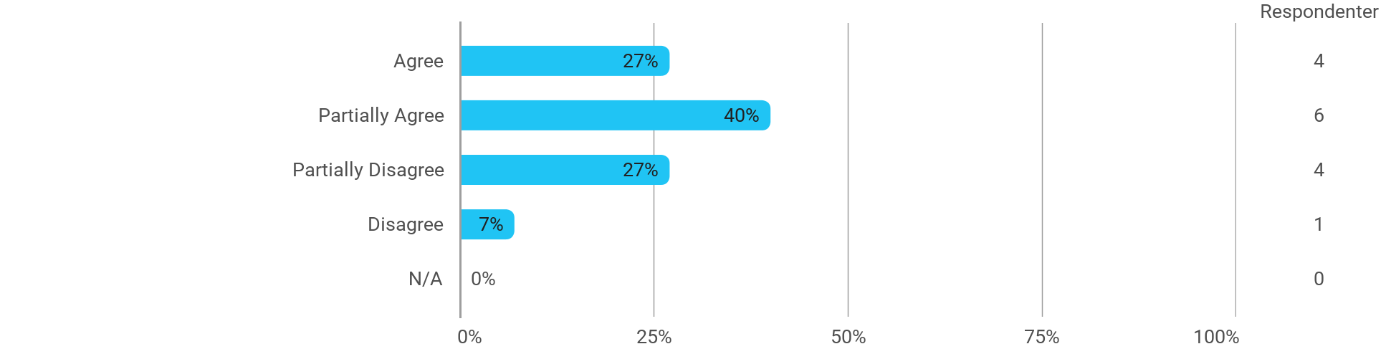

I have developed myself academically during the semester
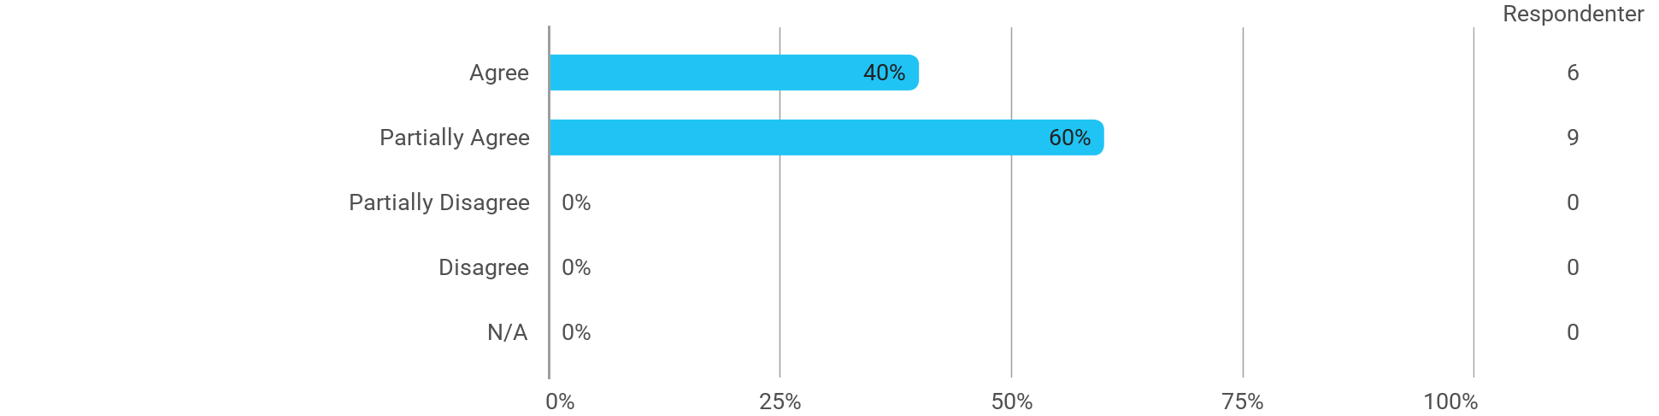

The following activities have developed me academically during the semester: - Project work
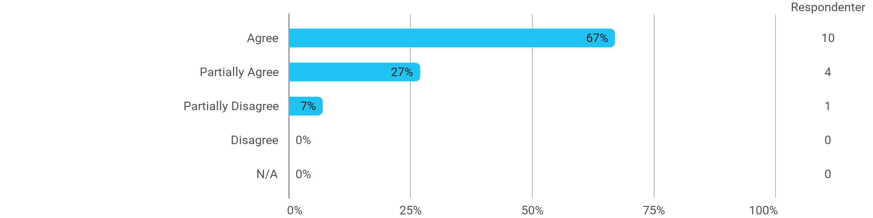

The following activities have developed me academically during the semester: - Academic discussions with fellow students
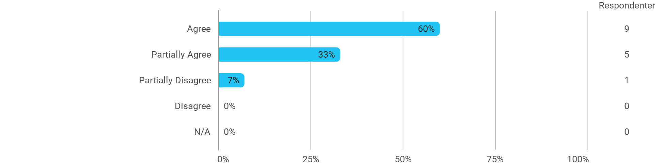

The following activities have developed me academically during the semester: - Academic discussions with teachers
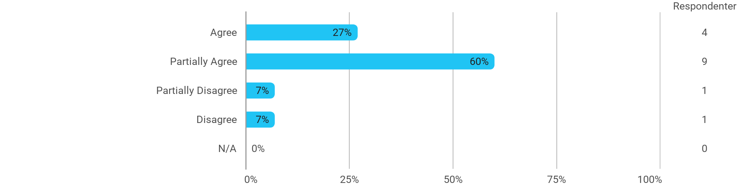

The following activities have developed me academically during the semester: - Practical exercises and experiments
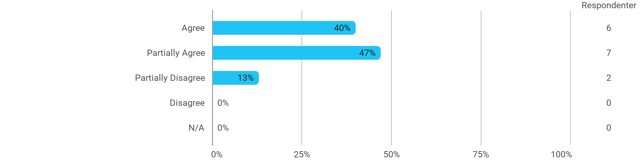

When I reflect on my own efforts, I have: - Been active in lectures

When I reflect on my own efforts, I have: - Participated actively in the project group work
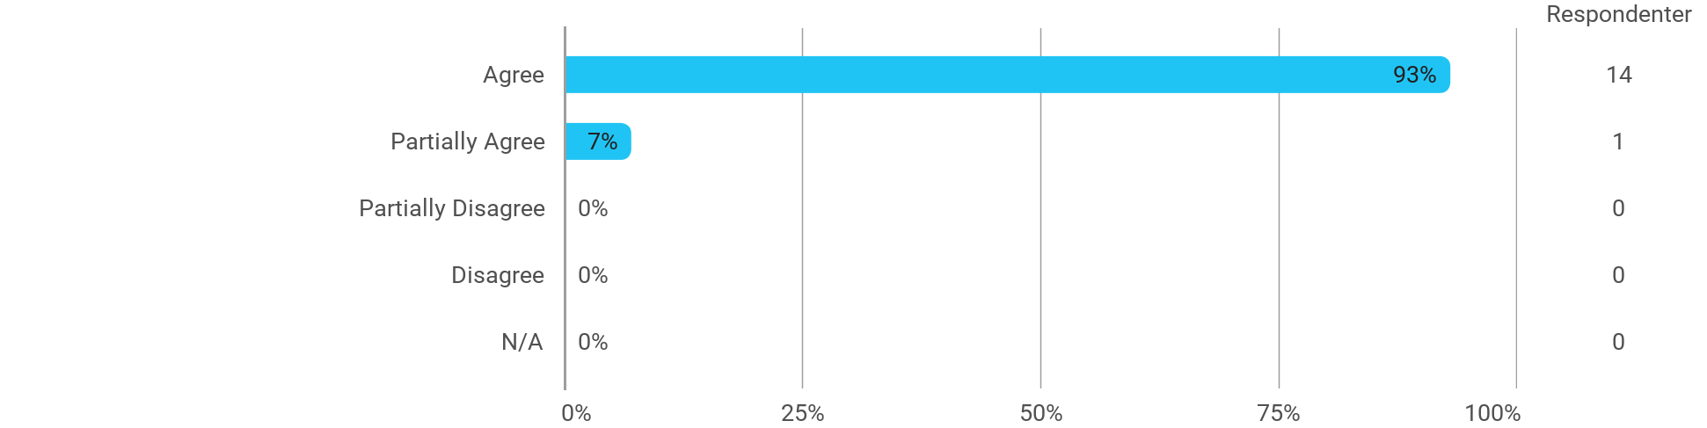

When I reflect on my own efforts, I have: - Prepared myself ahead of class
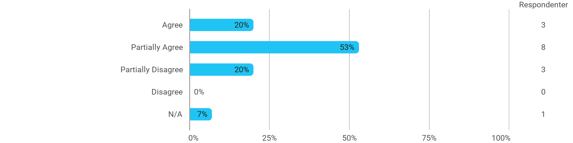

When I reflect on my own efforts, I have: - Prepared myself prior to the project group work

I experience the problem-based and project-oriented form of teaching as conducive to the development of: - My professional skills

I experience the problem-based and project-oriented form of teaching as conducive to the development of: - My ability to identify and formulate problems
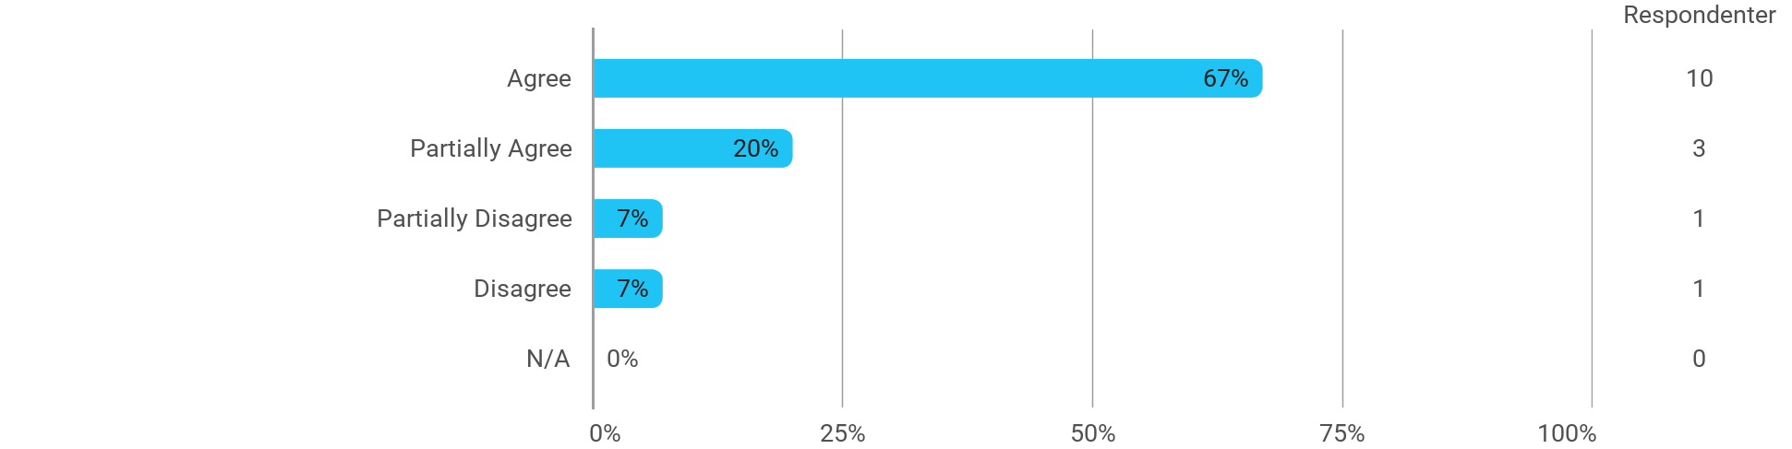

I experience the problem-based and project-oriented form of teaching as conducive to the development of: - My ability to attack and process problems
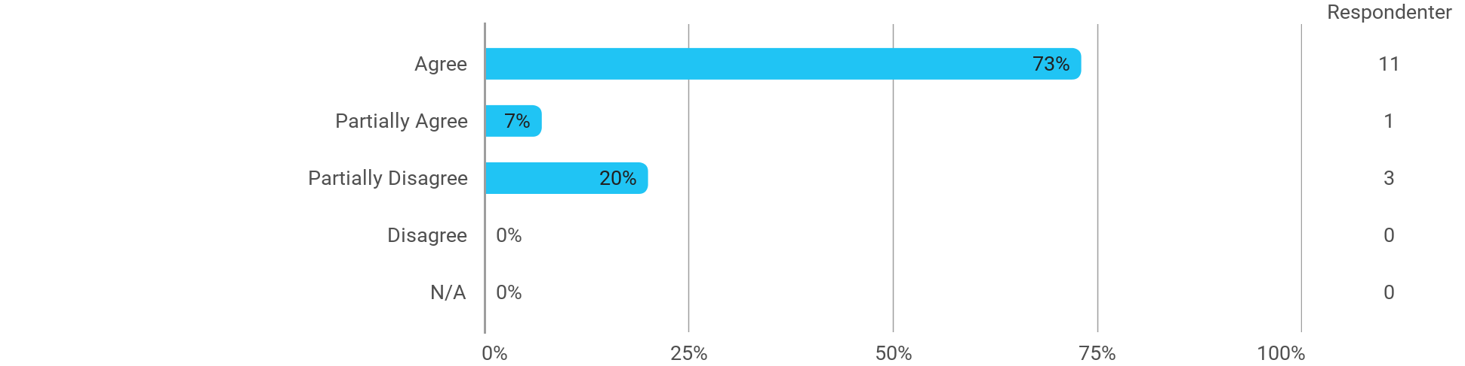

I experience the problem-based and project-oriented form of teaching as conducive to the development of: - My ability to organize a longer work process and "reach the goal" on time
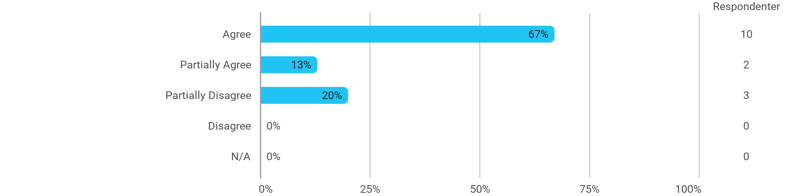

The following questions pertain to the semester as a whole: - I have received sufficient practical information about the semester's activities
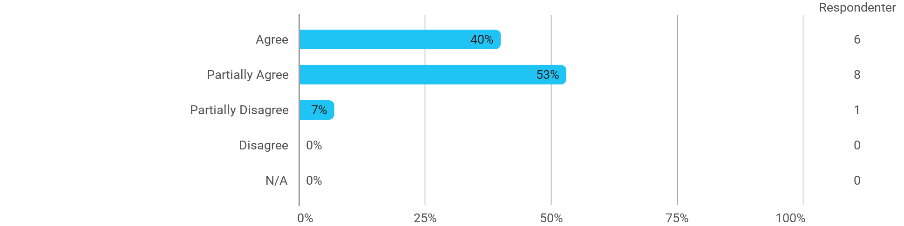

The following questions pertain to the semester as a whole: - I feel that the semester has given me the opportunity to engage in current issues relevant to external partners
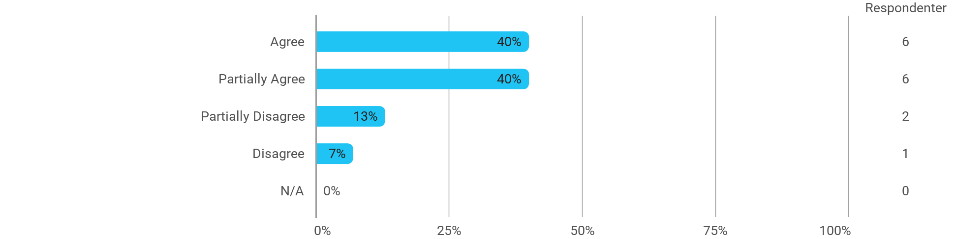

The following questions pertain to the semester as a whole: - I feel that I have addressed issues related to current societal challenges and opportunities
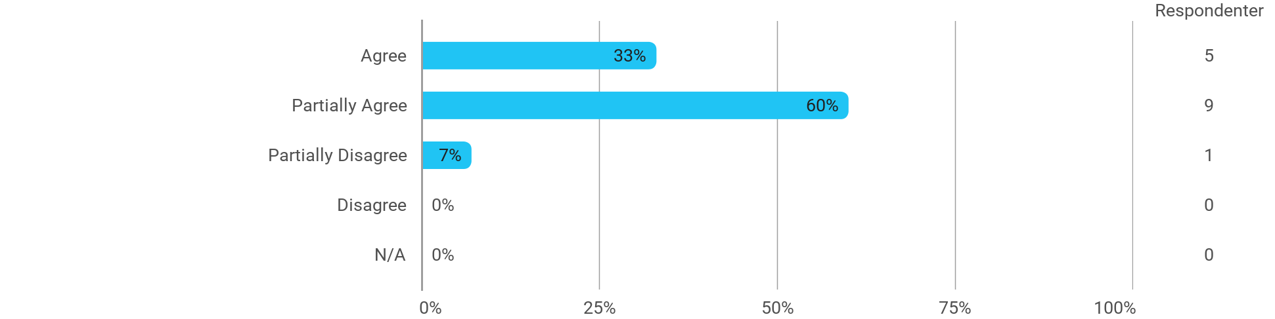

The following questions pertain to the semester as a whole: - I feel that the modules have supported the project work
