guidelines for Study board members

This document is primarily crafted to provide insight, especially to new study board members, into the tasks handled by a study board. The document is divided into two parts: Part 1 focuses on the general knowledge related to the execution of duties in study boards, including the opportunity to gain an overview of current legislation and other regulations in the area, as well as a brief description of the requirements and expectations for members’ work. Part 2 contains brief descriptions of selected areas that constitute relevant background knowledge for members of study boards, along with experiences from students in connection with their work in the study board.
These guidelines have been developed at the initiative of the students represented in the study boards.

Contents
guidelines for Study board members 1
Part 1: Introduction 3
DEL 1: Relevante emner i forbindelse med arbejdet i studienævnet 4
DEL 2: Viden og erfaringer fra de studerende ifm. arbejdet i studienævnet 7
Del 2: Fakulteterne 8
Del 2: andre udvalg 8
DEL 2: AAUVALG 9
DEL 2: Udnævnelse af årets Underviser på instituttet og fakultetet 9
Del 2: Kvalitetsudvikling 9
Del 2: institutionsAkkreditering 11
DEL2: Tidligere medlemmer (studerende) af Studienævnet 11

Ref to section headlines need re-established

COMMENT

I suggest to avoid the term chairperson , which in my eyes is inappropriate.
Chairman should in my opinion be regarded as a job function rather than a gender related term.

I suggest to meet any confusion on this matter that the first time the term is used in the text to indicate that it covers all gender: Chaiman ( omnigender )

However, I am aware that I may very well loose this battle on Faculty level.

Part 1: Introduction
Study boards encompassing one or more main or sub programsare established by the Deans. The study boards contribute to ensuring students and the academic staffs influence and involvement in matters related to education and teaching. The study boards are tasked with ensuring the organization, implementation, and development of education and teaching. The study boards express opinions on matters presented by the university’s daily management and can also comment on issues relevant to the activities of the departments.

According to AAU’s statutes, study boards undertake a number of tasks, including:
- To develop the quality of the study boards educations and teaching, and to ensure the head of department’s review of evaluations together with students.
- To prepare proposals for study programs and amendments therein.
- To approve plans for the organization of teaching and of tests and other assessments that are part of the exam, and in collaboration with the head of studies to oversee the practical organization thereof.
- To approve applications for credit, including in-advance credit transfer, and for dispensations.
- Providing recommendations when a new head of studies is to be appointed.
- To discuss inquiries regarding possible inappropriateness in teaching and to pass on information and any recommendations to the head of department in this regard.

The number of members of the study boards are determined by the deans, however it must count between 4 and 12 Members are elected by and from the academic staff, including employed Ph.D. students, and by and from the students in a 1:1 academic : student ratio. The representatives of the academic staff are elected for a term of 4 years, while student representatives are elected for a term of 1 year. The study board selects a chairman (omnigender) among the academic staff and a deputy chairman among the students. The election of the chairman must be approved by the dean.

See an intro the work here: https://youtu.be/830Korm1RWc

The study boards work, as well as key laws, frameworks, and regulations associated with the study board, are described on several levels (links are underlined):

1) The University Act
2) Rules for the independent institution Aalborg University
3) Standard Rules of Procedure for the collegial bodies at Aalborg University
4) Aalborg University study boards

In addition to thesethere are several laws, executive orders, and regulations that may be relevant for study board members to be familiar with. Therefore, particular attention should be drawn to the following:

5) Common provisions for education programs
6) Examination regulations
7) Legal basis – this website is continuously updated as new executive orders are issued
8) Executive order on full-time university education programs (uddannelsesbekendtgørelsen)
9) ) Executive order on examination and grading in university education programs (eksamensbekendtgørelsen)
10) Executive order on diploma educations
11) Executive order on the grading scale and other assesment for education programs under the Ministry of Education and Research (karakterbekendtgørelsen)
12) The Administration Act

As a member of a study board, one has an obligation to familiarize oneself with applicable legislation. Therefore, it is recommended not only to access this document but also to stay informed about changes in the legislation. All laws can be searched through www.retsinformation.dk. Similarly, the latest versions of most university internal regulations can be found on the university's websites, including in the The AAU Handbook.

Bachelor's and master's programs are subject to the University Act, while professional bachelor's programs fall under the Professional Bachelor's Degree Act.

It is expected that members of the study board proactively communicate the board's decisions to the group they represent. Members are also encouraged to discuss the issues that the study board needs to address with the group they represent.

Part 1: Relevant subjects in connection with the work of the study board

Voting
If there is no agreement on a decision, a decision can be reached by voting, cf. §6-9 of the standard rules of procedure. The chairman formulates the proposals to be voted on.

Grounds for Refusing Dispensations
If an application for dispensation is denied or only partially granted, the study board’s decisions for the refusal or partial approval must be justified. A refusal cannot be based on the belief that the student is unable to complete the education. In most cases, the study board must assess whether there are exceptional circumstances in the student’s situation justifying a dispensation. The justification will often be based on the applicant’s own explanation, which the study board deems insufficient to warrant a dispensation. In addition to the justification, the response must include the legal basis for the decision and information on the process of appeal.

Study Service has created letter templates for many of the decisions made by the study board. The letter templates can be found on The Study Services website.

Quorum
At least half of the members must be present at the beginning of the meeting for the study board to achieve quorum, according to the standard rules of procedure §6. Even if the members leave the meeting subsequently, resulting in less than half of the members present, the study board will still be considered to have achieved quorum, provided it was quorate at the beginning of the meeting. This ensures that it is not possible to speculate on the outcome of a decision by leaving the meeting before a potentially controversial matter which may lead to a vote.

Agenda
Before each meeting, the chairman and secretary of the study board – in collaboration with the deputy chairman – prepare an agenda, which is distributed at least 5 working days before the meeting, according to the rules pf procedure §5. Anyone can request an item to be addressed by the study board. Topics to be included in the agenda must be submitted to the study board at least 8 days before the meeting.
The chairpman may decide to deviate from the order of the agenda.

Dispensations, Credit Transfer Applications, etc.
If a student wishes to deviate from existing rules or apply for credit transfer, an application is to be submitted to the study board. Templates for students on educations under the study board of Chemistry and Bioscience can be found https://www.bio.aau.dk/uddannelse/regler-blanketter-og-dispensationer

The study board should be mindful of whether a decision might set a precedent, as similar cases should be treated equally. This means that if the essential circumstances in two cases are the same, the cases should be treated equally in legal terms.

Extraordinary meeting
If, between two scheduled study board meetings, a serious matter arises that requires an immediate decision and evidently requires an in-depth discussion, the chairperson of the study board may decide to convene an extraordinary meeting, cf. §1(3) of the standard rules of procedure.

Preparation for the meetings
Study board members have an obligation to prepare for the meetings. Members should familiarise themselves with the issues before the meeting. Some students choose to organise formal meetings where students discuss the issues.

Chairman's procedures
There is no authorisation in the University Act or in the statutes to delegate to the chairperson of the study board, just as there is no prohibition against delegation to the chairperson.

In general, there is nothing to prevent the chairperson from being authorised on behalf of the board to decide on cases concerning the exceeding of appeal deadlines or a request for reopening a case that has previously been considered by the board. If the chairperson is to have these authorisations, it must be stated in the board's rules of procedure that these authorisations have been granted.

On the other hand, the study board cannot generally authorise the chairperson to decide on the types of cases listed in § 18 of the Danish Universities Act.

However, it follows from administrative law practice that the study board may authorise the chairperson to make decisions in urgent cases in cases covered by § 18 of the Danish Universities Act if the following conditions are met:

- It must be an urgent matter which, due to the nature of the case, cannot be dealt with by the study board at an ordinary meeting or at an extraordinary meeting.
- The chairperson’s decision must not create new practice in the area.
- The chairperson’s decision must not be contrary to current practice.
- The chairperson’s decision must not change current practice.
- The chairperson’s decision must not be particularly interfering towards the party.
- The cases must be individual cases.
- The study board must subsequently be informed of the chairperson’s decision.

Finally, it can be stated that the delegation to the chairperon must not be so extensive that the study board is actually made redundant in the specific type of case.

Rules of procedure
The Study Board may establish its own rules of procedure within the framework of these
standard rules of procedure.

Main rules
To ensure a uniform, overall treatment in a number of matters, the faculty has established a number of main rules that must be observed, see in particular the links under items 5, 6 and 7 above (page 3).

Disqualification
Study Board members are obliged to inform the Study Board if they are disqualified in a case to be considered by the Study Board, cf. § 13 of the standard rules of procedure. A member is disqualified if the member has a direct or indirect interest in the matter. The rules on disqualification are set out in Chapter 2 of the Danish Public Administration Act.

Constituent meetings
Once elections have been held, the first meeting is held as a constituent meeting, where the study board chair and deputy chair are elected, cf. § 11 of the standard rules of procedure. Items cannot be discussed at a constituent meeting, but many study boards choose to hold an ordinary study board meeting immediately after the constituent meeting.

Closed items
Items containing information about personal matters or sensitive personal information must be treated as closed items, cf. § 2 of the standard rules of procedure, i.e. only members of the study board may be present during the meeting. Any listeners or observers must leave the meeting during the discussion of closed items. Examples of closed items include: Exemptions, teaching evaluation, complaints about a teacher, etc. Matters that are discussed behind closed doors are, as far as possible, discussed last.

Announcements
There is usually an announcement item on the agenda, where the head of studies, the chairperson of the study board and other members can present topics that may be of interest to the study board, but which do not require an actual discussion. The study board may discuss the presented announcements, and members may make oral announcements, which are recorded in the summary report. Should an announcement be discussed with a request for a decision, the item must be included as an agenda item at the next meeting before a decision can be made and reported in the summary. No decisions can be made during announcements.

Members
The members of a study board are all elected members. There is an equal number of VIP representatives and students on the study board.

Dates of meetings
Before each semester, the dates for the coming year's meetings are decided. The vast majority of study boards meet approximately once a month.An overview of meeting dates is posted on the Study board web page.

Attendance and obligation to attend meetings
Members are obliged to attend meetings, cf. §13 of the standard rules of procedure.

Observers
Heads of studies are automatically observers in the study board. In addition, the study board may decide to allow additional persons to be observers, e.g. student counsellors, administrative staff. Observers have the right to speak during meetings, but do not have the right to vote if a matter is put to a vote.

Public meetings
The study board meetings are public, i.e. anyone has access to attend the study board meetings to the extent that there is room in the room. Any audience members do not have the right to speak and must remain quiet during the meetings.
During closed items, only members of the study board may be present, i.e. members of the audience must leave the room during closed items.

Summary reports
The secretary of the study board prepares summaries of the study board meeting. The summary report must document the discussions and decisions made at the meeting in order to enable relevant and qualified follow-up. Everyone should be able to read what the study board has decided and on what basis. The reports must thereby provide a good basis for further work on the items discussed by the study board.
If a member requests it during the meeting, his or her argument or other statement may be recorded in the report. Personal data about students who have applied for exemptions or credits, for example, will never be included in the reports. The chair of the study board approves the reports and they are approved by the study board on the following meeting where study board members have the opportunity to raise question , commnnts and correction to the report whereafter it is published by posting it on the study board web page..

Written case processing
In routine cases, decisions may be made in writing. The chairperson of the study board will then formulate a proposal for a decision, which will be sent to the study board members with a response deadline. If no objections are received by the deadline, the chairperson's decision is approved. If objections are received, the same rules apply as for voting. Applications submitted for written consideration should not be controversial or contain decisions of a more fundamental nature, but should only be routine matters.

Heads of Studies
Heads of Studies are appointed by the dean on the recommendation of the study board. In collaboration with the study board, the head of studies is responsible for the practical organisation of teaching and of tests and other assessments that are part of the exam. In addition, heads of studies at AAU have a number of other tasks, such as requesting teaching in the departments.

Study board chair and deputy chair
At the first meeting after an election, a chairperson and deputy chairperson are elected, cf. §11 of the standard rules of procedure. The chairperson's tasks will typically be as follows: to set meeting dates, to present the study board's rules of procedure within the framework of the standard rules of procedure, to convene study board meetings, to present cases for the meeting, to organise the study board meetings (chair the meeting and present the cases) and to approve the summary of the meeting.

Obligation of confidentiality
Study board members have an obligation of confidentiality. This means that study board members are not allowed to disclose confidential information that they gain access to in connection with their work to outsiders

Supplemetary agenda
If, after the agenda has been sent out, items are received that cannot wait until the next meeting, the chairperson of the study board may choose to send out an addendum to the agenda so that the item can be dealt with at the meeting.

Communicating the study board's work and decisions
The study board members are expected to pass on relevant information and decisions from the study board meetings without being asked and to discuss the issues to be addressed by the study board with their respective backgrounds, such as the department, head of studies, sections, research and teaching groups, coordinators and students/co-students, to ensure that the work of the study board is communicated throughout the organisation.

PART 2: KNOWLEDGE AND EXPERIENCES FROM STUDENTS IN THE WORK OF THE STUDY BOARD

The practicalities of study board meetings
The meetings are organised by the chairpersonship jointly for the board. This can be done, for example, by the deputy chairperson contacting the other students, e.g. 1.5-2 weeks before the meeting to see if they have any items for the agenda. whether they have any items for the agenda.
The meeting frequency is approx. one meeting per month..

Pre-meetings:
It can be a good idea to have pre-meetings where you can discuss the agenda and the material.

Co-operation:
It can be a good idea to collaborate with other students who are members of the department council, academic council, student society, etc. If it makes sense in relation to the work in the study board. It is always good to be informed about what is going on in other bodies at the department, faculty and university.

Annual wheel for quality work and an example of an annual wheel in a study board
At the following link, you can get an overview of the quality work at AAU: Annual wheel for quality work.
In addition, it is also possible to see an example of an annual wheel for a study board here.

PART 2: THE FACULTIES

There are 4 faculties at AAU; the Faculty of Humanities and Social Sciences, the Faculty of Engineering and Science, the Faculty of Health Sciences and the Technical Faculty of IT and Design. Each faculty has a dean and associated deputy deans for specific areas. One of these deputy deans is in the field of education. He or she is the link between the dean's office and the study boards.
There is an academic council (AR) for each faculty. The council consists of a majority of academic staff (VP), a minority of technical-administrative staff (TAP) and a minority of students.
When deans are to be appointed, an advisory board is set up. The advisory board is elected by AR. One student must be a member. The advisory committee is involved in drawing up the job advertisement for the dean position. The advisory committee must then review the applications and recommend those who will be invited to an interview. There are two rounds of interviews. The interviews are conducted by a hiring committee, which often consists of people who will be working with the person in question; the rector is also a member of this committee.

When hiring associate deans, the dean has various options for appointing a new associate dean. The dean can choose to involve AR to appoint people to advisory committees that will read through applications and advise the hiring committee.

Part 2: Other committees
The Dean's Advisory Committee on Education (DRU) consists of the deputy dean, counsellor, heads of studies/deputy heads of departments, study board chairmen, study board vice-chairmen, and an observer from IASPBL. The meeting frequency for DRU is a minimum of 2 per semester.

At SN/Rector meetings, the rectorate/university management meets with the chairpersonship of SN, Head of Studies and TAP. The meeting frequency is 2 per semester

As deputy chair of SN, you have approx. 10 (SN) + 4 (DRU) + 4 (SN/Rector) = 18 meetings per committee year.

Read about the different committees here: https://www.aauvalg.aau.dk/studerende/Til+dig+der+stiller+op/#382714

PART 2: AAU ELECTIONS
Read more about elections at AAU at: https://www.aauvalg.aau.dk/

PART 2: NOMINATION OF THE DEPARTMENT AND FACULTY TEACHER OF THE YEAR

Students in each study board select a candidate for Teacher of the Year based on the criteria set by DSUR.

The nominees are notified to the faculty contact person. Along with the name of the nominee, a well-formulated, written justification for the nomination must be submitted.

Each lecturer who is elected "Lecturer of the Year" by a study board is paid an amount of DKK 25,000 as a tax-free gift of honour. The expenses are covered by the department at which the award recipient is employed.
Selection of the Faculty's Teacher of the Year - Deputy chairs of the study boards meet and discuss (October – November)
Study board deputy chairs are called to a meeting to decide which of the elected Teacher of the Year in the study board will be the Faculty Teacher of the Year. Here it is agreed which of the students is responsible for writing the recommendation for Teacher of the Year. It is preferably the spokesperson from the study board to which the Teacher of the Year belongs.

PART 2: QUALITY DEVELOPMENT
At AAU, we work continuously to develop our degree programmes. This work takes place via the university’s quality system and is crucial for our study programmes to meet the many different requirements for education programmes in Denmark. One of the core tasks of the study board is to contribute to the quality development of the study board's study programmes. In the study board, quality development takes place in two ways:

- Annual quality review
- Continuous quality review
Annual quality review
The annual quality review is the overall main process in AAU's quality system for the education area. The process is anchored in the Procedure for annual review and programme evaluation. This process is carried out in a six-year cycle, through which the programmes' action plans with initiatives are updated annually. As a basis for the update, a programme evaluation (year 1 of the cycle) or a quality report (years 3 and 5 of the cycle) is carried out every two years. By preparing a report and holding a meeting on the evaluation/status of the quality of the programme, challenges/improvement potentials are identified to be worked on via the programme's action plan. In the intervening years (2, 4 and 6), an internal departmental quality status is carried out in collaboration between the department management and the chair of the study board, which also aims to identify challenges/improvement potentials to be worked on via the action plan.

Each year, the study boards process and provide input for adjusting the programmes' action plans in connection with the processing of a data package with key figures for the study board's programmes. In years where programme evaluation or quality reporting is carried out, the study board processes the action plan and data package together with a draft evaluation report(s)/quality report(s). Next, the study board must ensure implementation of the initiatives in the action plan for which the study board is responsible.

Ongoing quality monitoring
In addition to the above tasks in connection with the annual quality review, the study board is also responsible for contributing to the ongoing quality work. This consists of collecting, processing and following up on information about various aspects of the quality of the programmes during each year. This includes following up on evaluations with students and the development of study programmes. The figure below provides an overview of the main quality areas of which the tasks are explainaned in the corresponding table describing the tasks that the study board has in connection with the quality system processes under the individual quality assurance programmes. quality system processes under the individual quality areas.

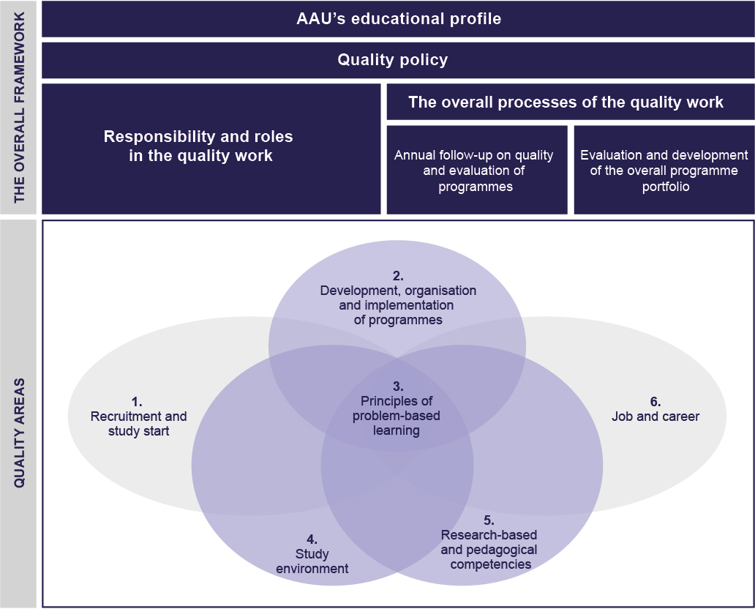

You can read more about the individual processes and the role of the study boards in these in the procedures linked to in the table.

Quality area | Procedure | What needs to be addressed
Quality area 1: Recruitment and enrolment | 1.3.1 Principles for study start | Results of the study start evaluation
Quality area 2: Programme development, organisation and operation | 2.3.1 Procedure for the development and organisation of programme semesters | The development and organisation of the programme semesters (semester descriptions)
 | 2.3.2 Principper for evalueringer med studerende | Results of evaluations with students  - Evaluation of study activities  - Evaluation of study programmes  - Evaluation of study environment
 | 2.3.3 Procedure for dialogue with external examiners and external examiner chairs | Annual report from the external examiner chairpersonships
Quality area 4. Study environment | 4.1.1 Procedure for following up on and developing the study environment | Summary/overview of challenges and wishes for improvement of the study environment
Quality area 6. Jobs and careers | 6.1.1 Procedure for graduate surveys | Results from graduate surveys
Quality area 6. Jobs and careers | 6.2.1 Procedure for setting up and dialogue with employer panels | Input from employer panel meetings

The processing of the above quality work must be documented in the reports from the study board meetings. The study board's discussions and decisions form the basis for further work on the affected aspects of programme quality in the form of both minor changes and more long-term, major initiatives via the programmes' action plans.

The study board's quality work and the documents that document it (including the reports from the study board meetings) are included in the material on which AAU is assessed in connection with institutional accreditation (see the section below). The reports must contribute to documenting that the quality system is realised and works in practice.

PART 2: INSTITUTIONAL ACCREDITATION

In Denmark, all higher education institutions must undergo institutional accreditation every six years. A positive institutional accreditation means that the university's quality system meets international and national requirements, and that the quality work continuously and systematically ensures and develops the quality and relevance of the programmes. The accreditation process is managed by the Danish Accreditation Institution and an accreditation panel, which in the accreditation process assesses whether the university's quality assurance system is acceptable, i.e. whether, for example, AAU is able to ensure the quality of its degree programmes. In this process, the accreditation institution and the panel visit the university twice. The visits are made with the university and faculty management as well as representatives from department management, study boards, lecturers and students. In the process, individual programmes are also selected for a "check" of the quality work in, among other things, study boards, which are included in the overall assessment. AAU has a positive accreditation from the first round of institutional accreditations and will be accredited again in 2023-2024.

Read more about accreditation at AAU here Read more about accreditation in general here.
PART2: FORMER MEMBERS (STUDENTS) OF THE STUDY BOARD
This chapter is a list of former members of the study board (students).

Year | Deputy chairperson | Member

