Study board conclusions of the semester and teaching evaluation report
Year: | 2024
Campus | Aalborg
Semester | MED9A
Coordinator: | Matthias Rehm
Date: | xxx

This document represents the public version of the evaluation of the semester. The document forms together with the semester and teaching evaluation report the basis of any adjustments to the semester’s description, planning, execution and/or evaluation of the next iteration of the semester and are used by the coming semester coordinator and semester planning group.

The document also represents the study board’s response to the students, teachers, coordinators and other interested parties about possible consequences of conditions that the students of the semester have pointed out.

The public conclusions and recommendations of the semester coordinator
[copy from the semester evaluation report of the semester coordinator]

Conclusion of the study board
The Study Board (MSN) has processed the semester evaluation report and offers the following observations/conclusions:
- The coordinator has not filled out a report
- Response rate 33%
- Grade distribution fine

Samlet status

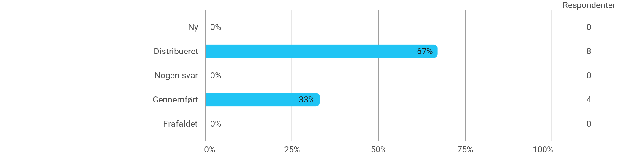

MSc03 MEDA A (project) - Project-Oriented Study in an External Organisation - I have received the expected benefit from the module
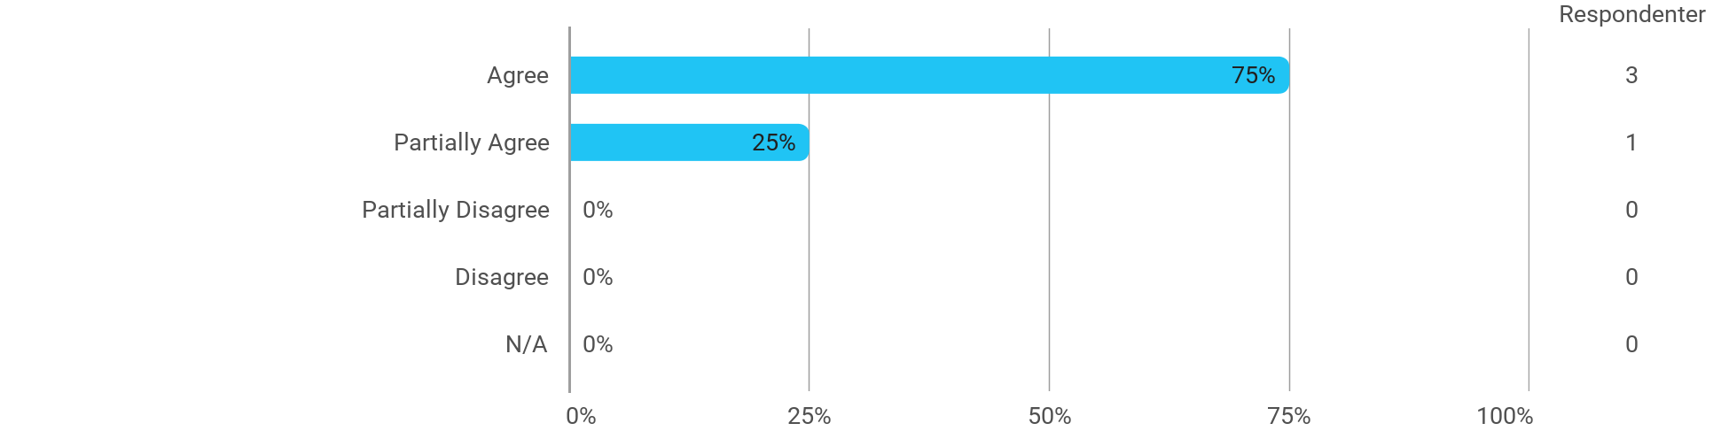

MSc03 MEDA A (project) - Project-Oriented Study in an External Organisation - The chosen problem has been a good foundation for unfolding my professional ambitions

MSc03 MEDA A (project) - Project-Oriented Study in an External Organisation - The cooperation in the project group has worked well
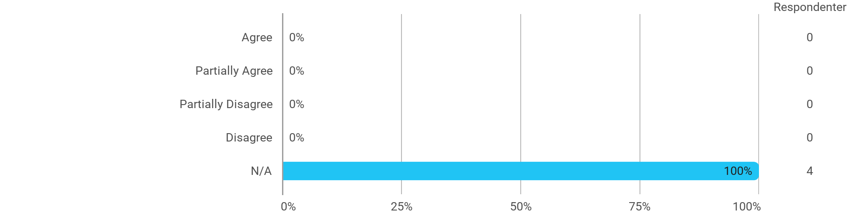

MSc03 MEDA A (project) - Project-Oriented Study in an External Organisation - The courses have supported the project work
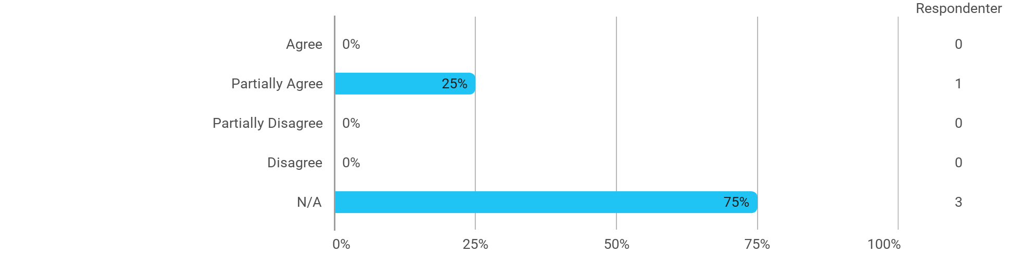

MSc03 MEDA A (project) - Project-Oriented Study in an External Organisation - I received the expected supervision
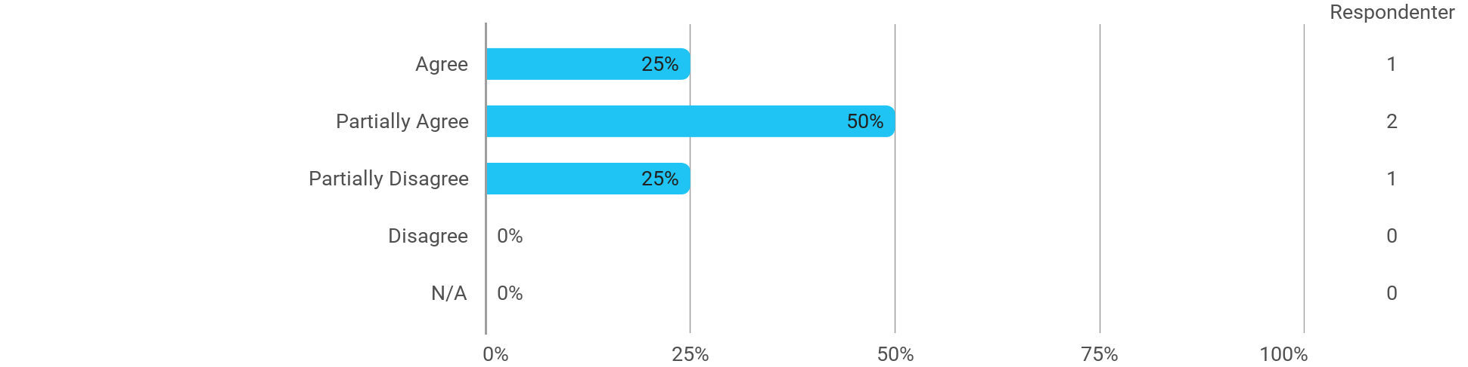

I have developed myself academically during the semester

The following activities have developed me academically during the semester: - Project work
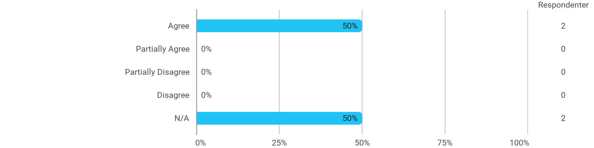

The following activities have developed me academically during the semester: - Academic discussions with fellow students
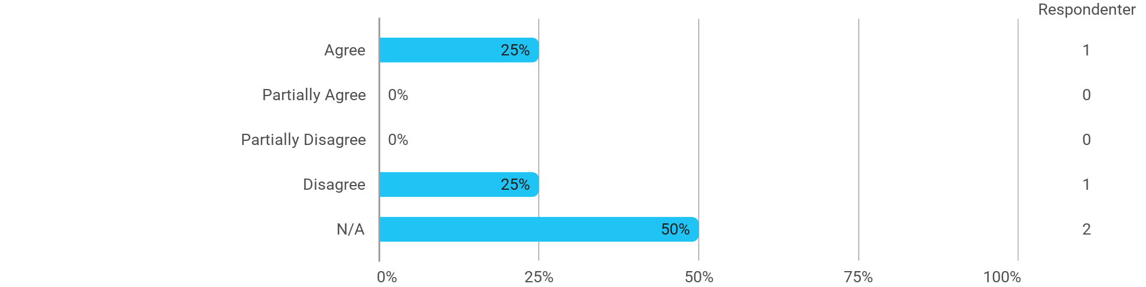

The following activities have developed me academically during the semester: - Academic discussions with teachers

The following activities have developed me academically during the semester: - Practical exercises and experiments
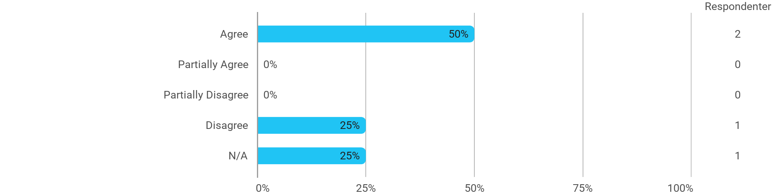

When I reflect on my own efforts, I have: - Been active in lectures

When I reflect on my own efforts, I have: - Participated actively in the project group work
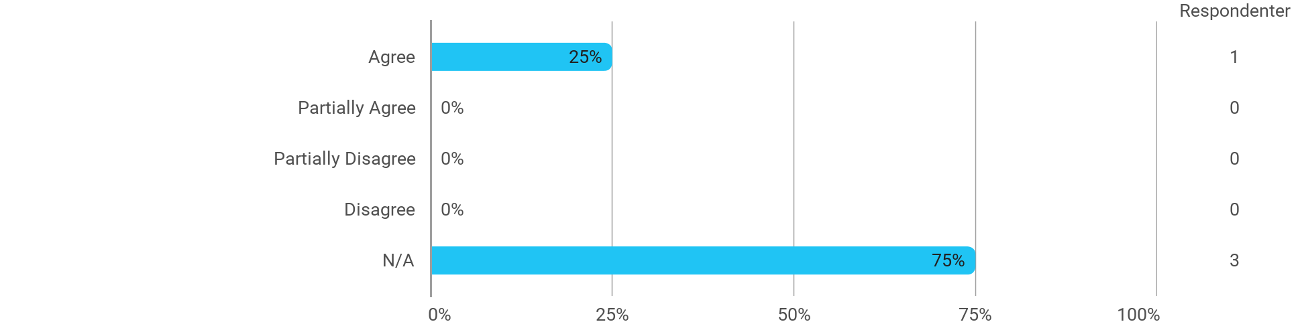

When I reflect on my own efforts, I have: - Prepared myself ahead of class

When I reflect on my own efforts, I have: - Prepared myself prior to the project group work

I experience the problem-based and project-oriented form of teaching as conducive to the development of: - My professional skills
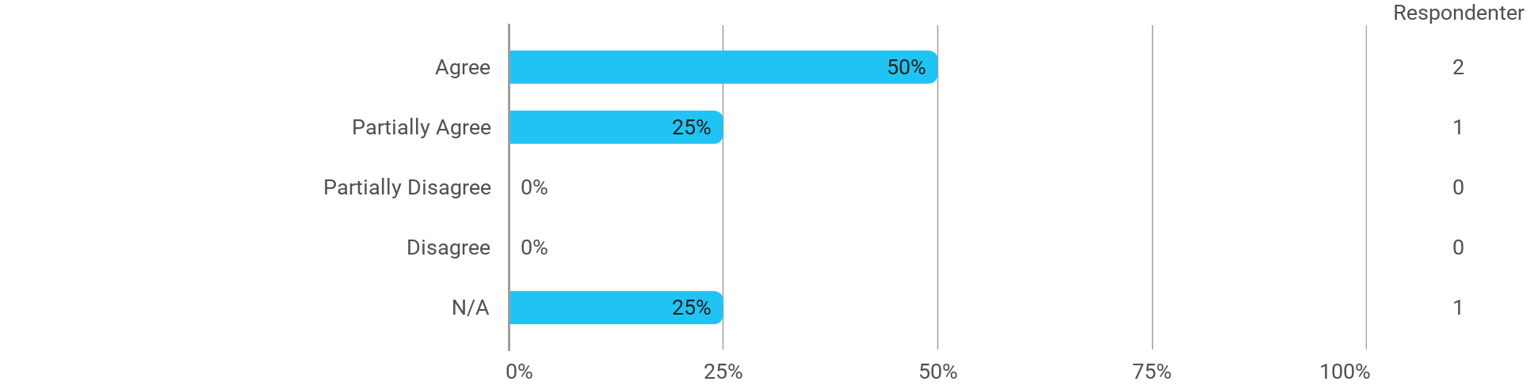

I experience the problem-based and project-oriented form of teaching as conducive to the development of: - My ability to identify and formulate problems

I experience the problem-based and project-oriented form of teaching as conducive to the development of: - My ability to attack and process problems
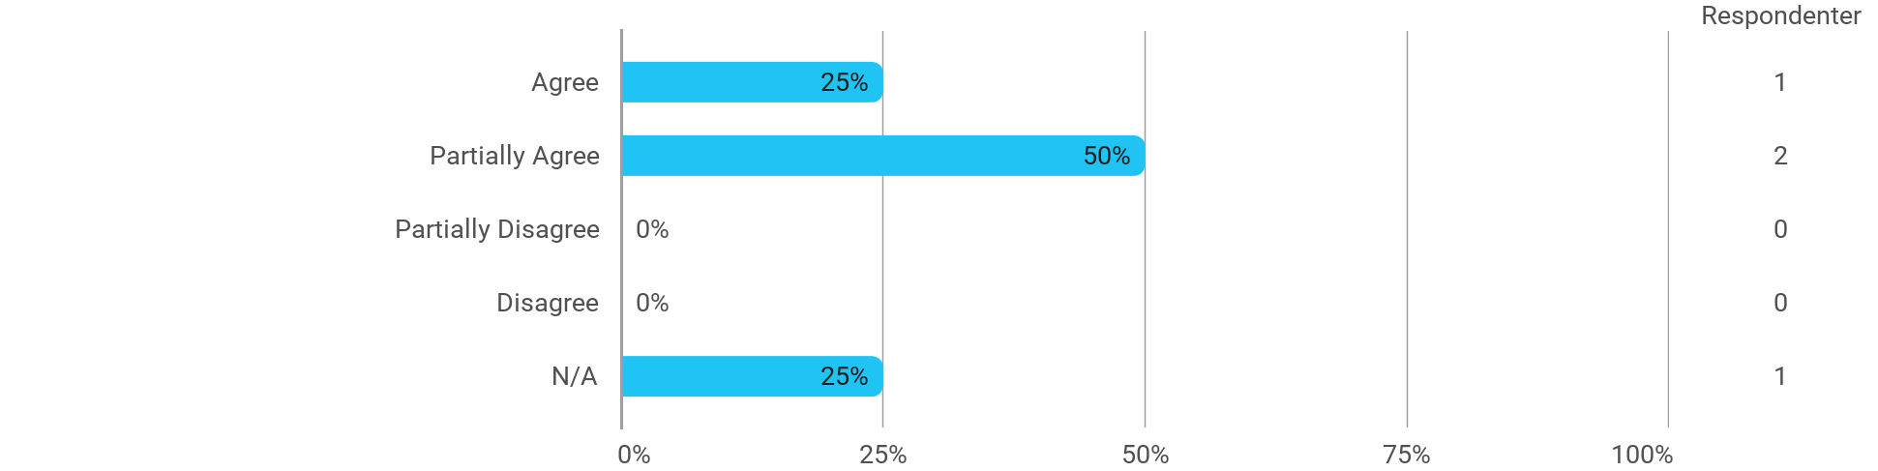

I experience the problem-based and project-oriented form of teaching as conducive to the development of: - My ability to organize a longer work process and "reach the goal" on time

The following questions pertain to the semester as a whole: - I have received sufficient practical information about the semester's activities
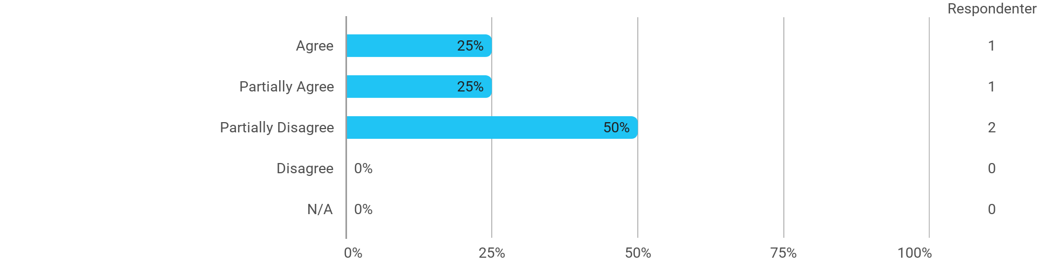

The following questions pertain to the semester as a whole: - I feel that the semester has given me the opportunity to engage in current issues relevant to external partners

The following questions pertain to the semester as a whole: - I feel that I have addressed issues related to current societal challenges and opportunities
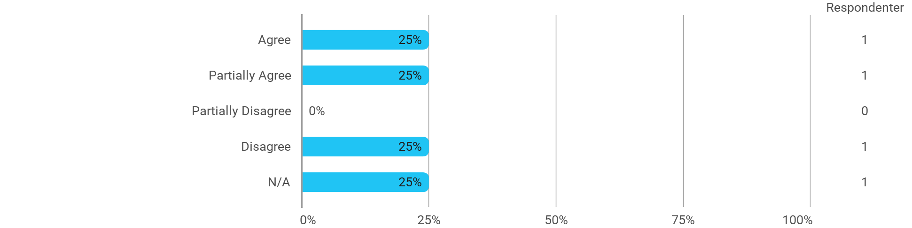

The following questions pertain to the semester as a whole: - I feel that the modules have supported the project work
