**ENERGY MISSION SEED FUNDING TEMPLATE**

**ENERGY MISSION: A CITIZEN-CENTRIC, RESILIENT AND SUSTAINABLE ENERGY SYSTEM IN DENMARK BY 2045.**

The Energy Mission is pleased to announce the allocation of seed funding for selected projects. Up to DKK 500,000 will be distributed in 2025, and up to DKK 1,000,000 in 2026.

Please fill out the template until Monday, the **22nd of September** and send to Prisca Ohler: [plo@adm.aau.dk](mailto:plo@adm.aau.dk) Max. 5 pages.

**Group Name & Principal Investigator (PI):**

*Enter group name, lead researcher and group members here.*

**1. Key Research Question(s):**

*Clearly state the main research question(s) your group has chosen to address.*

**2. Call Program & Key Challenges:**

* **Indicate which of the three call types** you would like to apply for and explain why. IGNITE, CULTIVATE, or ELEVATE
* 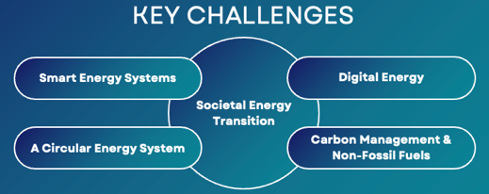**Challenges to Address:**  
  Describe which of the Energy Mission’s five key challenges your research project targets and explain how it contributes to addressing the challenge(s).

**3. Specific Actions & Milestones:**

* **Actions:**  
  *List specific steps and milestones to achieve project goals.*

**4. Partnerships:**

*Identify potential partners or collaborators who can support the initiative (e.g., academic institutions, industry, civil society, NGOs).*

**5. Potential Funding Programs:**

*Name specific funding opportunities your project could apply for. You can use the Call Finder to find a relevant upcoming call on EU level: https://eu-funding.aau.dk/*

**6. Resources Needed:**

*List the resources required for each action, such as funding, tools, or expertise.*

* *Expenses for team building and expansion (workshops, outreach activities etc.).*
* *﻿﻿Buyout of applying researchers, consultant support, lab equipment, and travel that supports idea development and funding applications.*
* *﻿﻿﻿﻿Funding should primarily be spent within 2025.*

|  |  |  |
| --- | --- | --- |
| TIMELINE AND KEY TASKS | | |
| PERIOD | **TASKS** | **KEY DELIVERABLE** |
|  |  |  |
|  |  |  |
|  |  |  |
|  |  |  |

|  |  |
| --- | --- |
| BUDGET | |
| ACTIVITY/EXPENSE ESTIMATED AMOUNT | |
|  | DKK |
|  | DKK |
|  | DKK |
|  | DKK |
| TOTAL DKK | |

**References**