Chemical Risk Assessment

Instructions:
Fill in this APV in short, clear bullet points.
Use Kemibrug (KBA) as the primary source of product information.
Use the product’s official classification in Kemibrug for hazard classification, pictograms, signal word, and H/P phrases. Only use 2 to 4 key H/P-phrases for each chemical
Use KBA section D for exposure limits, KBA section F for spill handling, KBA section G for first aid.
If information is not available in Kemibrug, use the SDS as a secondary source.
Replace or delete all example text when your own information has been added.

Setup name | Lab/room | Supervisor | Prepared by | Date | Revision date

- Process description
Guide: Describe the workflow in 3 to 6 simple steps. Focus on steps involving heat, pressure, vacuum, gas, chemicals, or other important hazards.
Example:
- Prepare and label glassware and receiving flasks.
- Pour the feed into the round bottom flask in the fume hood.
- Connect the setup and apply vacuum slowly.
- Heat the flask and collect fractions.
- Cool the system, release vacuum, and clean the equipment.
Student/staff entry:
1.
2.
3.
4.
5.

- Chemicals used

Guide: List all chemicals used in the experiment, including cleaning solvents, gases, and important products or fractions.
Use simple table: Name, Concentration, State (liquid/solid/gas).
Example:
A: “Bio-oil feed, 100 %, liquid”
B: “Distillation fractions (A, B, C…), liquid”
C: “Ethanol, 96 %, liquid”
D: “Dry ice (solid CO₂), solid”

Student/staff entry:
A:
B:
C:
D:
Expand with E, F etc. if more.

- Chemical hazard information

Chemical name: |  | CAS no/P number
A: |  | Enter if available
Hazard pictogram & signal word | 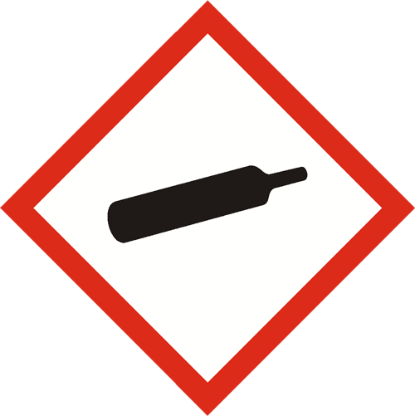  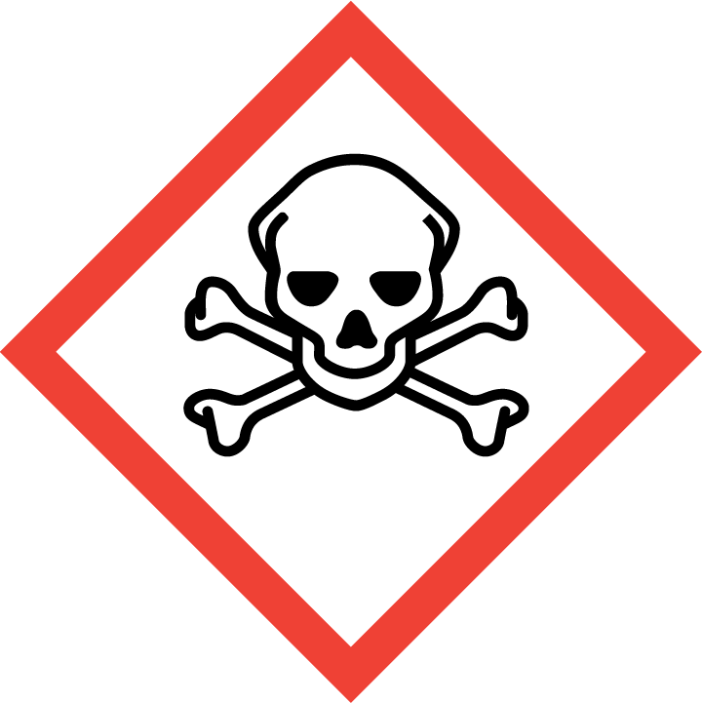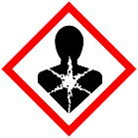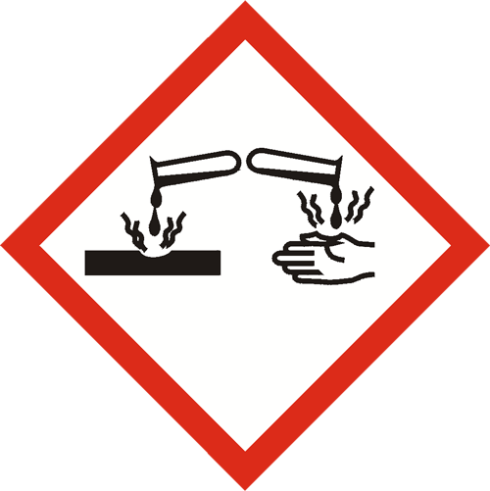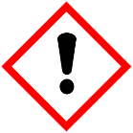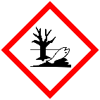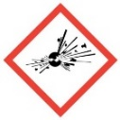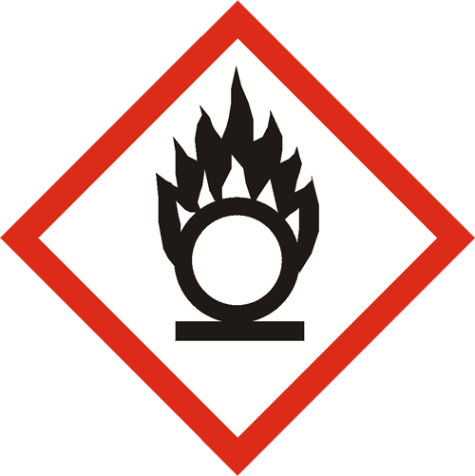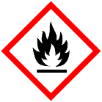  Delete the pictograms that do not belong.  Warning ☐ Danger ☐
H-phrases
P-phrases
CMR | Carcinogenic ☐ Mutagenic ☐ Reprotoxic ☐
Threshold limit | Enter if known, otherwise write “Not found, see KBA section D
Storage | Flamable, alkaline, acid, toxic chemical cabinets
Notes / main hazards | Write 1 to 2 short lines about the most important practical hazard during the work, for example fire risk, skin/eye contact, inhalation of vapours, dust exposure, or heat/vacuum hazards. Do not copy all H-phrases.  Examples:  - Risk of inhalation of vapours during pouring and heating.  - Risk of skin and eye contact during transfer and cleaning.

Chemical name: |  | CAS no/P number
B: |  | Enter if available
Hazard pictogram & signal word | Delete the pictograms that do not belong.  Warning ☐ Danger ☐
H-phrases
P-phrases
CMR | Carcinogenic ☐ Mutagenic ☐ Reprotoxic ☐
Threshold limit | Enter if known, otherwise write “Not found, see KBA section D
Storage | Flamable, alkaline, acid, toxic chemical cabinets
Notes / main hazards | Write 1 to 2 short lines about the most important practical hazard during the work, for example fire risk, skin/eye contact, inhalation of vapours, dust exposure, or heat/vacuum hazards. Do not copy all H-phrases.  Examples:  - Risk of inhalation of vapours during pouring and heating.  - Risk of skin and eye contact during transfer and cleaning.

Chemical name: |  | CAS no/P number
C: |  | Enter if available
Hazard pictogram & signal word | Delete the pictograms that do not belong.  Warning ☐ Danger ☐
H-phrases
P-phrases
CMR | Carcinogenic ☐ Mutagenic ☐ Reprotoxic ☐
Threshold limit | Enter if known, otherwise write “Not found, see KBA section D
Storage | Flamable, alkaline, acid, toxic chemical cabinets
Notes / main hazards | Write 1 to 2 short lines about the most important practical hazard during the work, for example fire risk, skin/eye contact, inhalation of vapours, dust exposure, or heat/vacuum hazards. Do not copy all H-phrases.  Examples:  - Risk of inhalation of vapours during pouring and heating.  - Risk of skin and eye contact during transfer and cleaning.

- Exposure type and duration.
Guide: State how exposure may occur, when in the procedure it happens, and roughly how long it lasts.
Example:
- Inhalation during pouring and transfer, less than 1 minute per sample.
- Skin contact possible during cleaning and sample transfer.
- Eye exposure possible in case of splashes.
- Glass breakage risk during vacuum operation.

Tip for students/staff:
Ask yourself: “At which steps are my hands close to the chemical? Where could vapor escape? When am I inside a walk-in or near a source without good ventilation?”

Student/staff entry:
- Inhalation:
- Skin contact:
- Eye contact:
- Ingestion:
- Other exposure / process hazard:
- Typical duration:

- Preventative measures
  - Substitution (S)
Guide: State whether a less hazardous chemical, lower concentration, smaller amount, or safer method can be used instead. If not, explain briefly why not.
Example:
- No substitution is possible, because the chemical is the actual research object.
- Ethanol was chosen instead of a more hazardous cleaning solvent.
- Substitution is not feasible because the method depends on the chemical’s specific physical or chemical properties.
- No safer alternative is currently available that is compatible with the equipment and intended process. Therefore, the amount used is kept to the minimum required for the experiment
- No suitable less hazardous alternative has been identified for the required reaction, separation, or analytical performance.
Student/staff entry:
[Write here]

  - Technical measures (T)
Guide: Describe engineering and workplace controls that reduce risk.
Example:
- All transfers are carried out in a fume hood.
- The setup is operated in a ventilated walk-in.
- A cold trap is used before the vacuum pump.
- Vacuum is applied slowly.
- Protective shield remains closed during operation.
Student/staff entry:

  - Personal protective equipment (PPE) (P)
Guide: Tick required PPE and add comments if needed.
Required PPE:
- Lab coat ☐
- Safety goggles ☐
- Nitrile gloves ☐
- Face shield ☐
- Heat-resistant gloves ☐
- Other: __________________
Comments / specific requirements:
[Write here]
Example: Full-face respirator with AX filter for large spills only, trained staff only.

  - Special groups
Guide: State whether the work may be unsuitable for pregnant or breastfeeding persons, or whether students must work under supervision.
Example:
- Pregnant and breastfeeding persons should not perform this work without individual assessment.
- Students may only perform this work under supervision after training.
Student/staff entry:

- First aid measures
First aid measures
Guide: Use KBA section G first. If the information is missing, use SDS section 4. Write one short line.
Skin contact:
[Write here]
Eye contact:
[Write here]
Inhalation:
[Write here]
Ingestion:
[Write here]
Example:
Skin: Wash with soap and water, remove contaminated clothing.
Eyes: Rinse with water for at least 15 minutes and remove contact lenses.
Inhalation: Move to fresh air.
Ingestion: Rinse mouth, do not induce vomiting.

only add chemical-specific notes if needed.

- Spill response
Small spill
Guide: Use KBA section F first. Describe what the student is allowed to do.
Example: Wear gloves and goggles. Absorb with paper towels or absorbent material. Dispose of waste as hazardous waste. Ventilate the area.
Student entry:
[Write here]
Large spill / strong vapour release
Guide: Use KBA section F first. Describe when to stop work, evacuate, and call for help.
Example: Stop work, alert others, and leave the lab if vapour is strong. Contact the supervisor. Only trained staff with respirator and spill kit may clean up.
Student/staff entry:
[Write here]

- Organisational measures and training
Guide: State who may perform the work, what training is required, and whether supervision is needed.
Example:
- Only trained and authorized users may run this setup.
- Students/staff must read this APV and the SOP before use.
- New users must receive hands-on training from the supervisor.
- The APV must be revised if chemicals, equipment, or procedures change.
Student/staff entry:

- Other process-related risks
Guide: Include non-chemical risks such as heat, pressure, vacuum, gas cylinders, cryogens, or moving parts.
Example:
- Hot surfaces may cause burns.
- Vacuum operation may cause glass implosion.
- Dry ice may cause cold burns and oxygen displacement.
- High pressure gas may cause risks.
Student/staff entry:

- Overall risk assessment
Guide: Summarize the remaining risk after all preventive measures are applied. Use 3 to 5 short sentences.
Example: If all technical measures, PPE, and instructions are followed, the overall risk is low. The main remaining risks are short-term exposure during transfer, hot surfaces, and glass breakage under vacuum. Additional caution is required for flammable and CMR-classified substances.
Student/staff entry:
[Write here]

Reviewed and approved by: (lab responsible)

____________________________________________________________

