Study board conclusions of the semester and teaching evaluation report
Year: | 2024
Campus | Copenhagen
Semester | MED7C
Coordinator: | Olga Timcenko
Date: | 10.3.25

This document represents the public version of the evaluation of the semester. The document forms together with the semester and teaching evaluation report the basis of any adjustments to the semester’s description, planning, execution and/or evaluation of the next iteration of the semester and are used by the coming semester coordinator and semester planning group.

The document also represents the study board’s response to the students, teachers, coordinators and other interested parties about possible consequences of conditions that the students of the semester have pointed out.

The public conclusions and recommendations of the semester coordinator
Although group forming was done relatively smoothly, students started working on the semester, and during Semester Group Meetings there have not been major objections, in a survey after the semester, filled by 17 students (slightly less that half), students complained a lot especially on elective course Real Time Computer Graphics. That is the only course in hybrid format, delivered partially online in collaboration with Aalborg, and partially organized as 3-days hackathon. This is the first time the course runs in this format with several guest lecturers. The idea of the course was to give information on several practical modern computer graphics themes, by guest-professionals working in the field, and teachers from Aalborg and Copenhagen, and then let students worked on chosen topics of their interest, as a mini project. Apparently, students think that this format was very problematic, and some complained on the grading process on the exam. Although students’ critique that it seems that the grade was predetermined before the oral exam is not correct, I think that this exam would benefit of being pass/fail, as with current format it is very difficult to find an objective level of grading – for example, some students opted to do just a simple shader, but did that very correctly, and some were very ambitions, making several mistakes and omissions. However, taking level of complains on the course, I think that we should reconsider hybrid format, and I am very open to discuss overall course structure.
Students also did not attend career days in Copenhagen, although this year they were invited on time, and said that they had bad experience from earlier semesters. So this event needs to be re-branded.

Conclusion of the study board
The Study Board (MSN) has processed the semester evaluation report and offers the following observations/conclusions:
-Response rate 47%
-Grade distribution fine
- Some challenges regarding group formation and dynamics are mentioned. The Study Board discussed the group formation processes and challenges related to this. The Study Board recognizes the recurring and general issues with group formation and will encourage coordinators to implement various approaches described in the group formation policy to address these challenges.

Samlet status
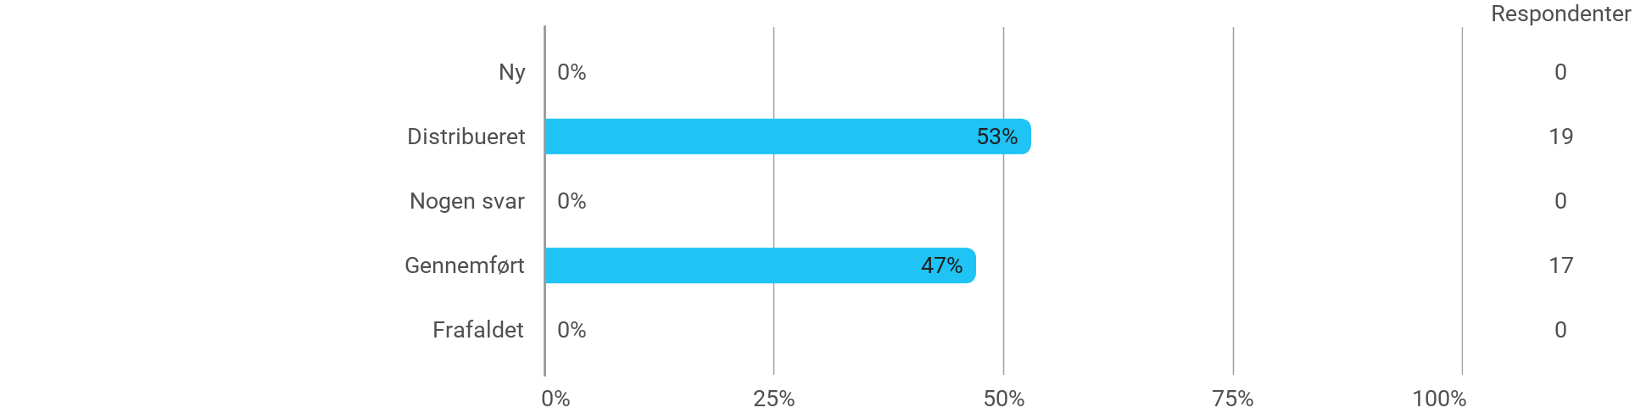

MSc01 MEDC - Machine Learning for Media Experiences - I have received the expected benefit from the module
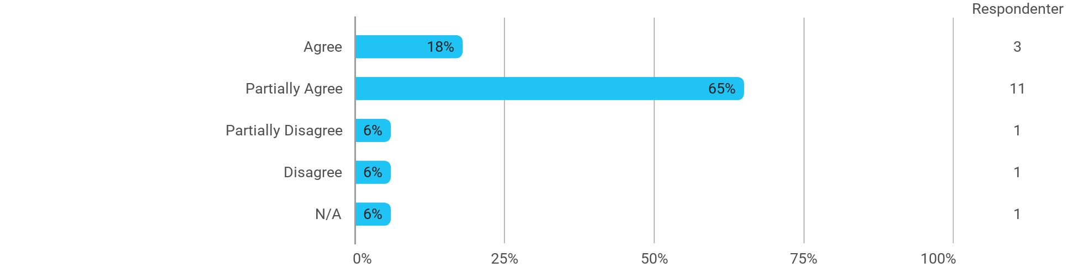

MSc01 MEDC - Machine Learning for Media Experiences - The literature used has supported my learning
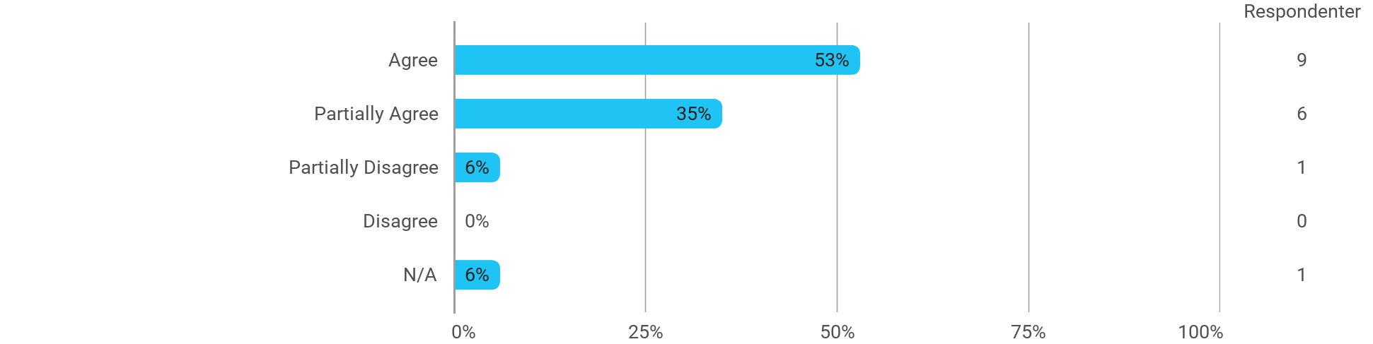

MSc01 MEDC - Machine Learning for Media Experiences - The form of teaching used has supported my learning
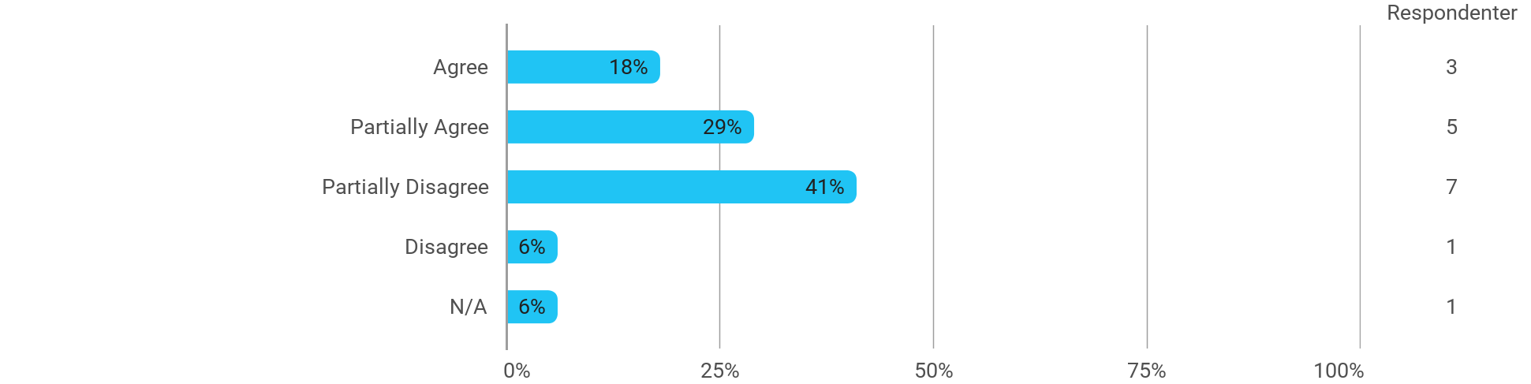

MSc01 MEDC - Machine Learning for Media Experiences - The exercises/tasks for the course have been relevant
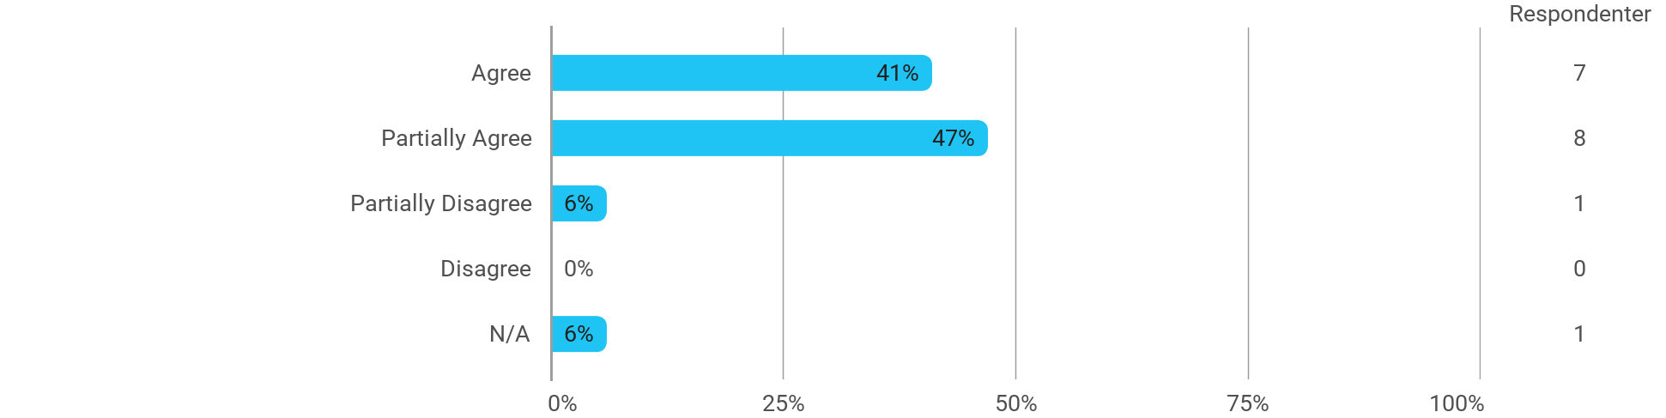

MSc01 MEDC (elective) - Real-Time Computer Graphics - I have received the expected benefit from the module
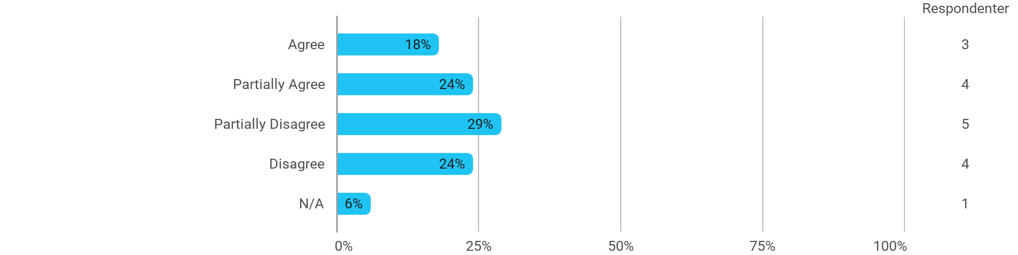

MSc01 MEDC (elective) - Real-Time Computer Graphics - The literature used has supported my learning
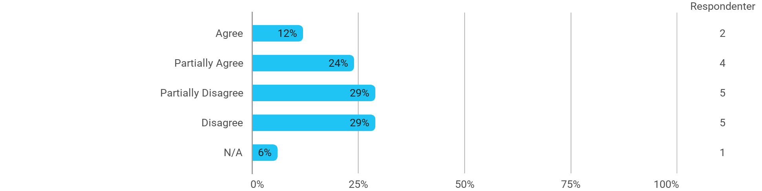

MSc01 MEDC (elective) - Real-Time Computer Graphics - The form of teaching used has supported my learning
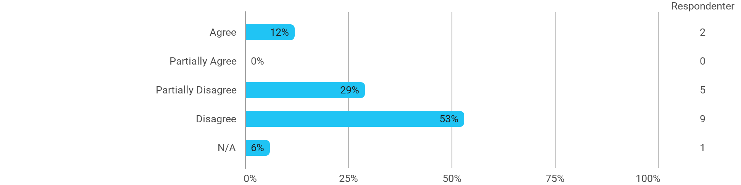

MSc01 MEDC (elective) - Real-Time Computer Graphics - The exercises/tasks for the course have been relevant
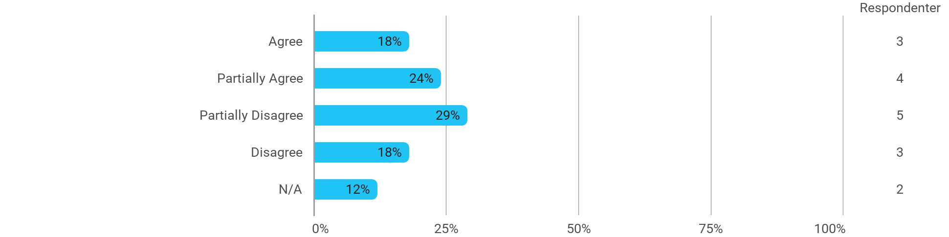

MSc01 MEDC (elective) - Mobile and Wearable Computing - I have received the expected benefit from the module
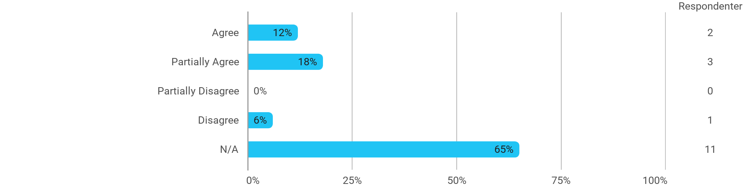

MSc01 MEDC (elective) - Mobile and Wearable Computing - The literature used has supported my learning
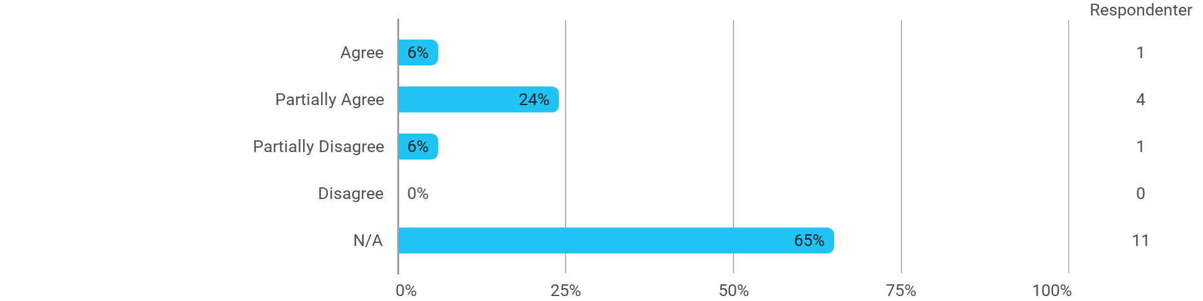

MSc01 MEDC (elective) - Mobile and Wearable Computing - The form of teaching used has supported my learning
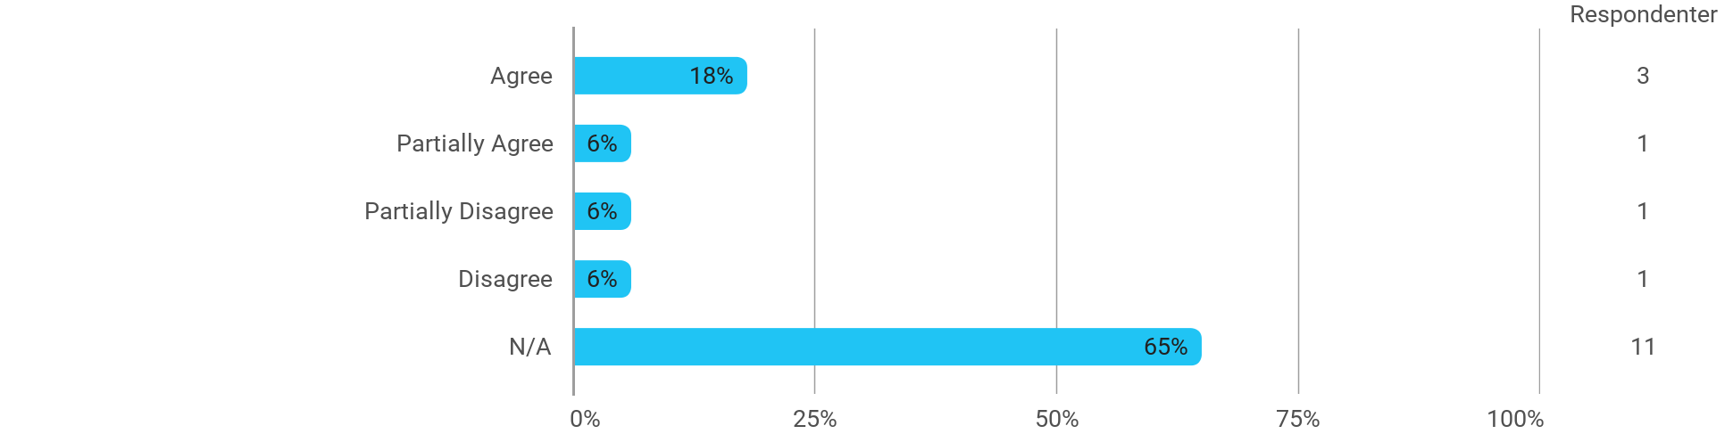

MSc01 MEDC (elective) - Mobile and Wearable Computing - The exercises/tasks for the course have been relevant
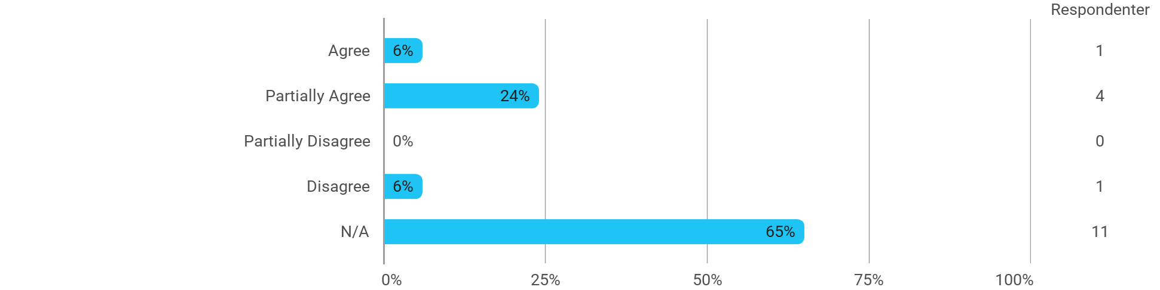

MSc01 MEDC (elective) - Narratives in Interactive Systems - I have received the expected benefit from the module
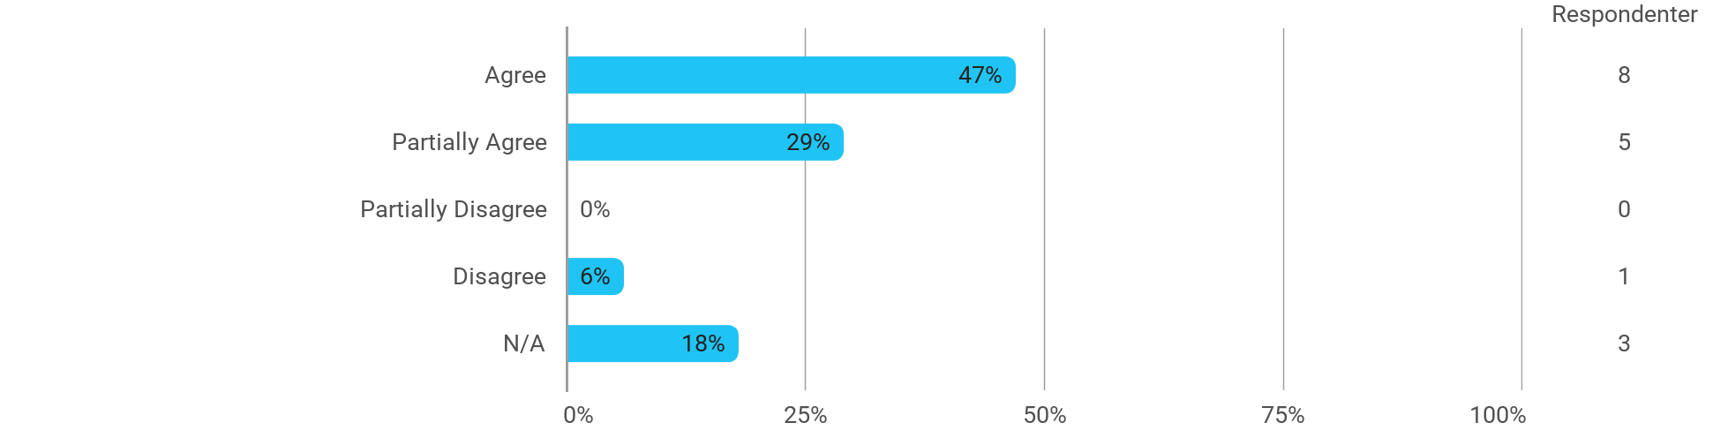

MSc01 MEDC (elective) - Narratives in Interactive Systems - The literature used has supported my learning
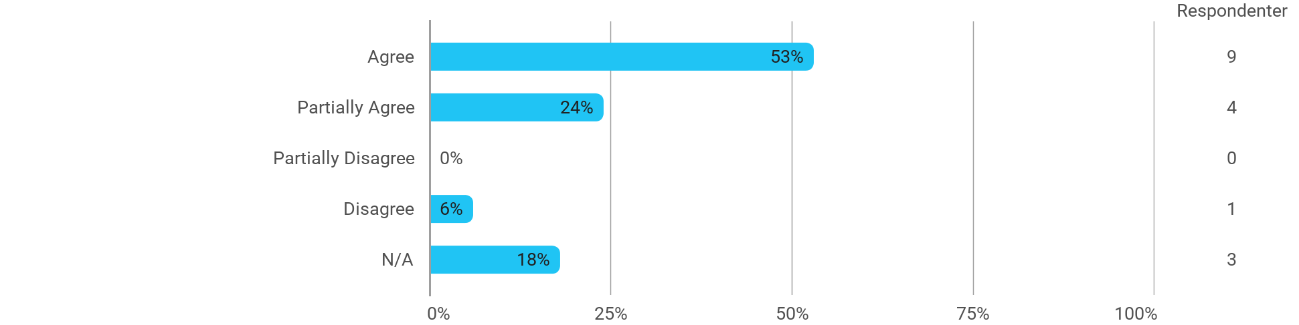

MSc01 MEDC (elective) - Narratives in Interactive Systems - The form of teaching used has supported my learning

MSc01 MEDC (elective) - Narratives in Interactive Systems - The exercises/tasks for the course have been relevant
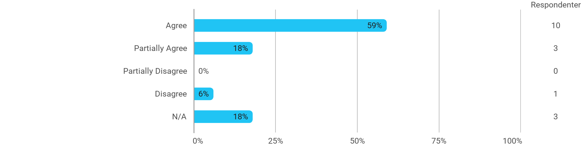

MSc01 MEDC (project) - Adaptive Media Systemsgn - I have received the expected benefit from the module
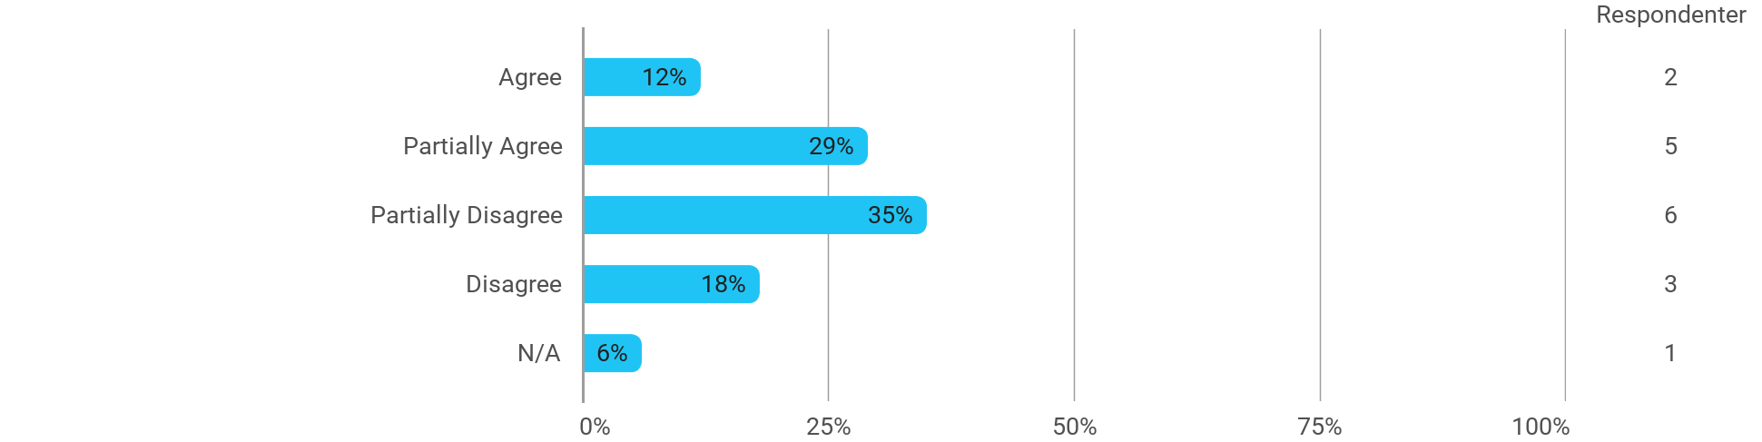

MSc01 MEDC (project) - Adaptive Media Systemsgn - The chosen problem has been a good foundation for unfolding my professional ambitions
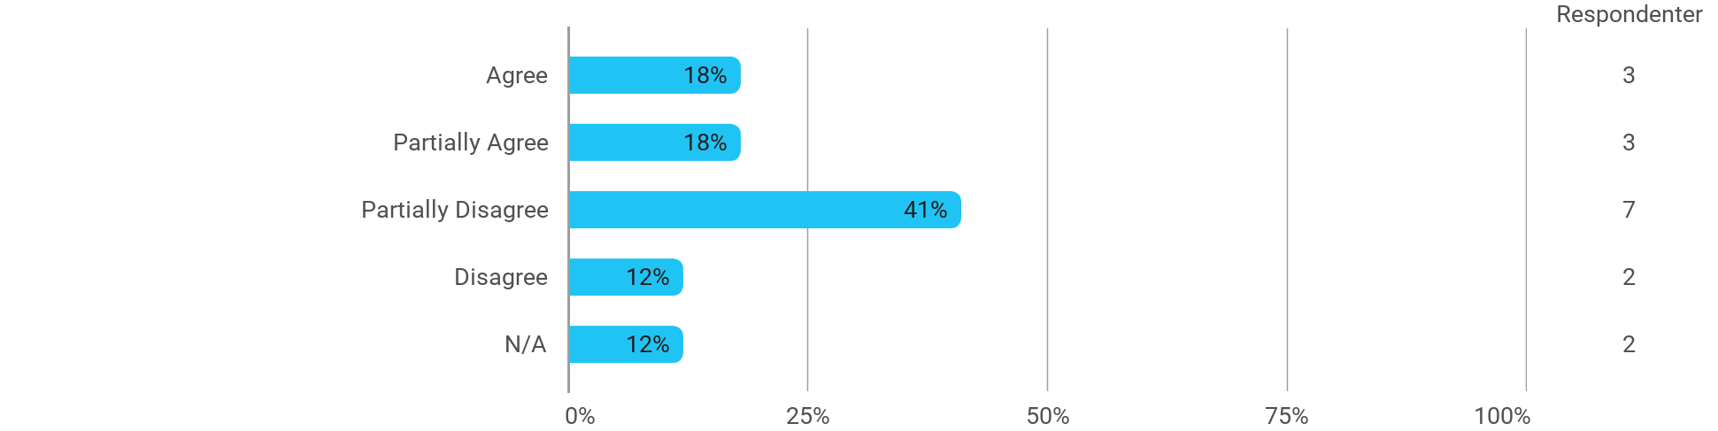

MSc01 MEDC (project) - Adaptive Media Systemsgn - The cooperation in the project group has worked well
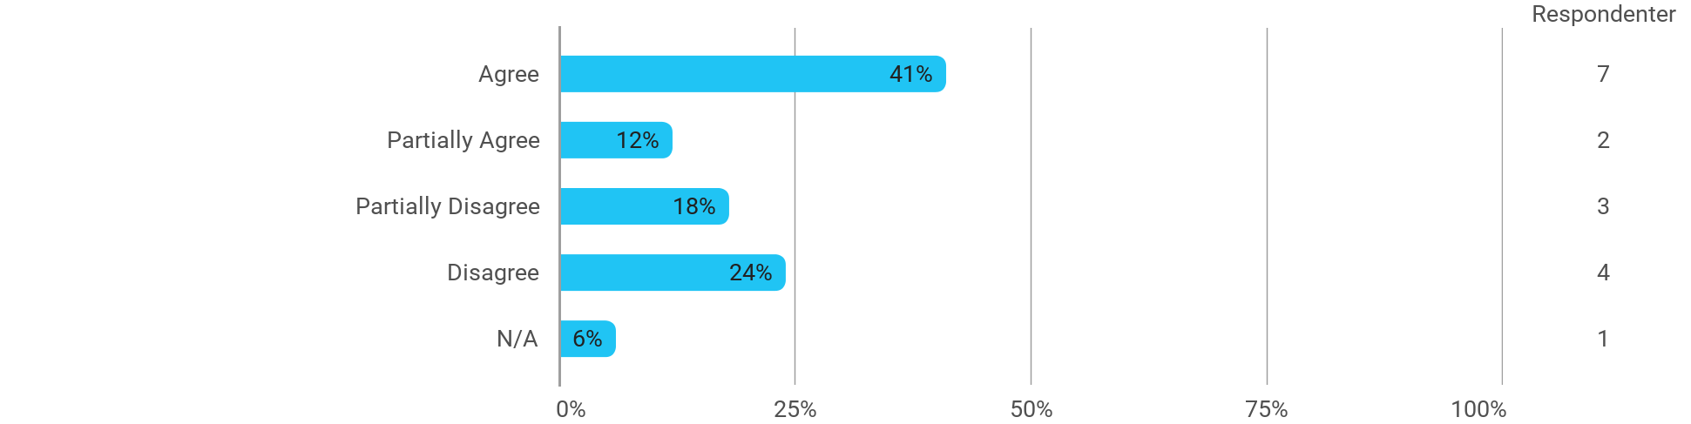

MSc01 MEDC (project) - Adaptive Media Systemsgn - The courses have supported the project work
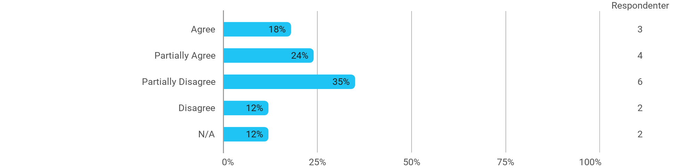

MSc01 MEDC (project) - Adaptive Media Systemsgn - I received the expected supervision
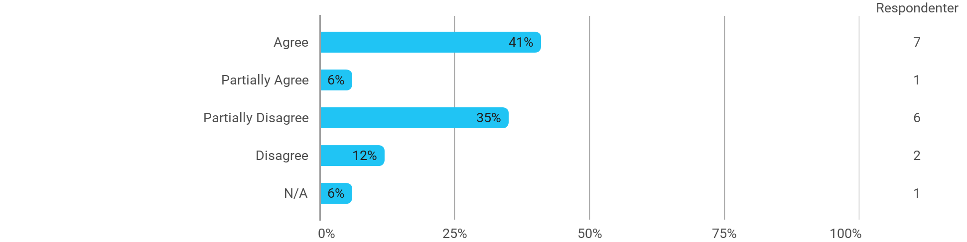

I have developed myself academically during the semester
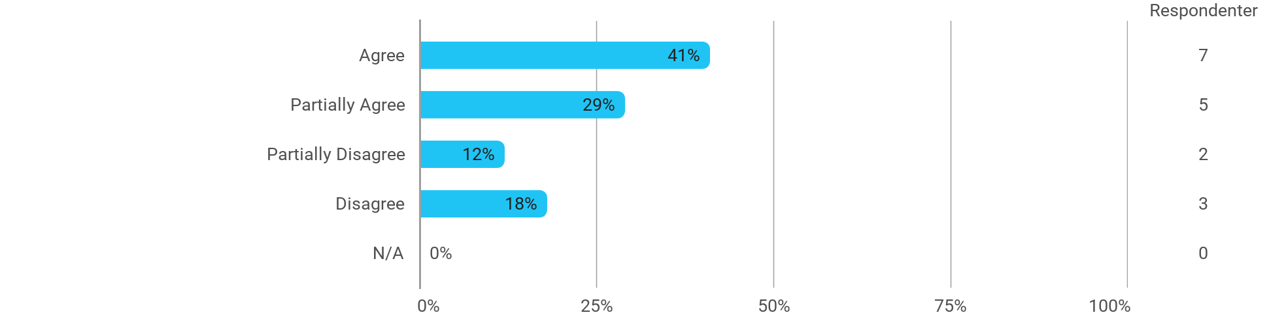

The following activities have developed me academically during the semester: - Project work
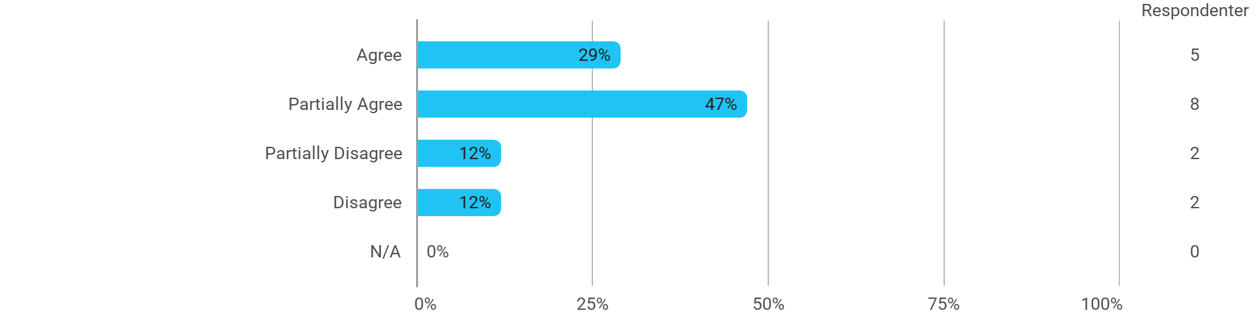

The following activities have developed me academically during the semester: - Academic discussions with fellow students
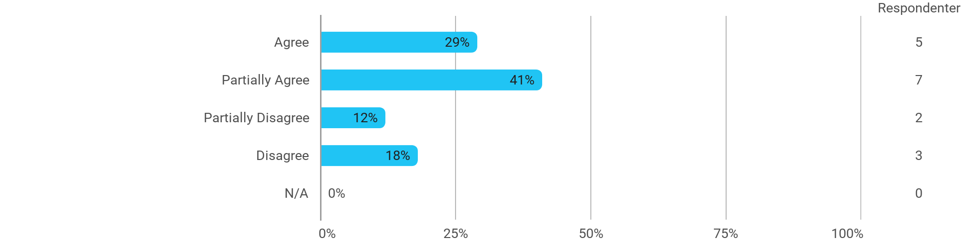

The following activities have developed me academically during the semester: - Academic discussions with teachers

The following activities have developed me academically during the semester: - Practical exercises and experiments
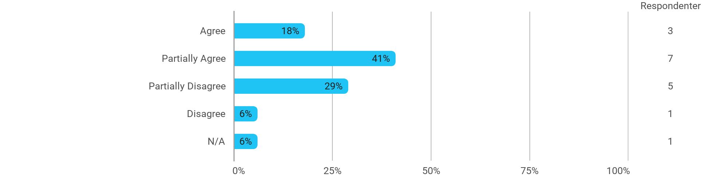

When I reflect on my own efforts, I have: - Been active in lectures
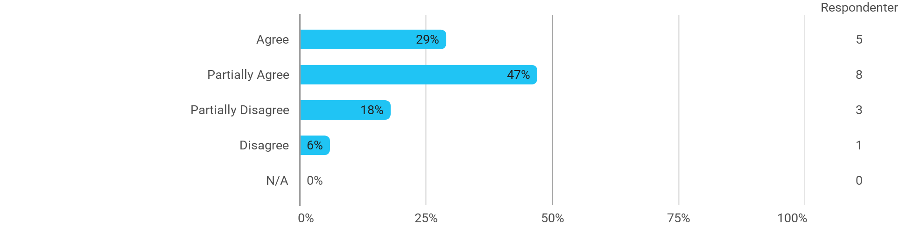

When I reflect on my own efforts, I have: - Participated actively in the project group work
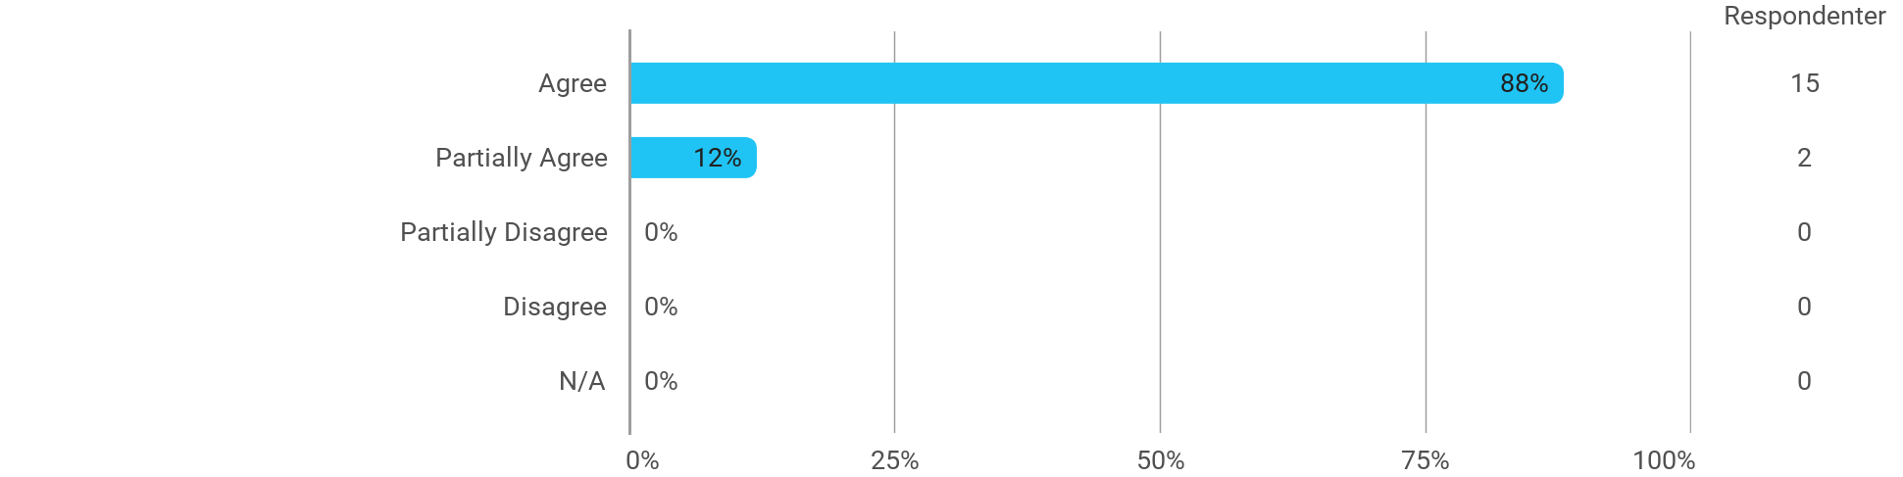

When I reflect on my own efforts, I have: - Prepared myself ahead of class
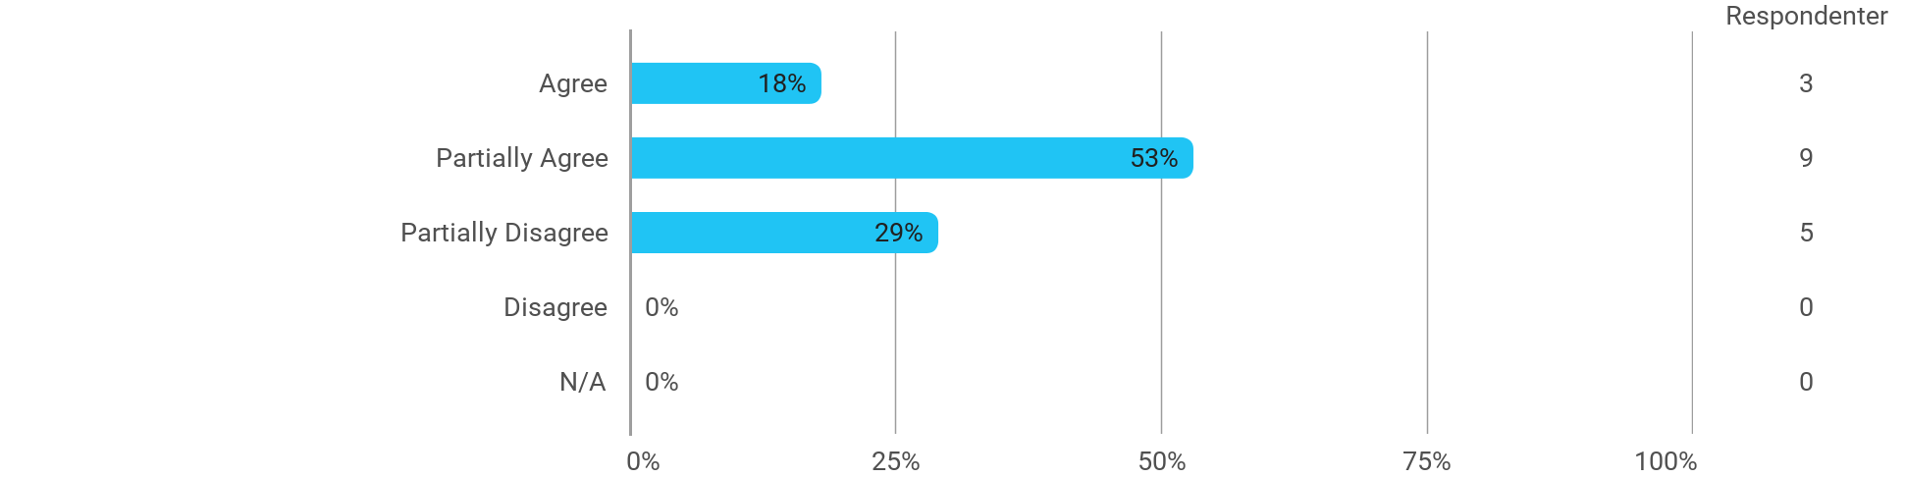

When I reflect on my own efforts, I have: - Prepared myself prior to the project group work
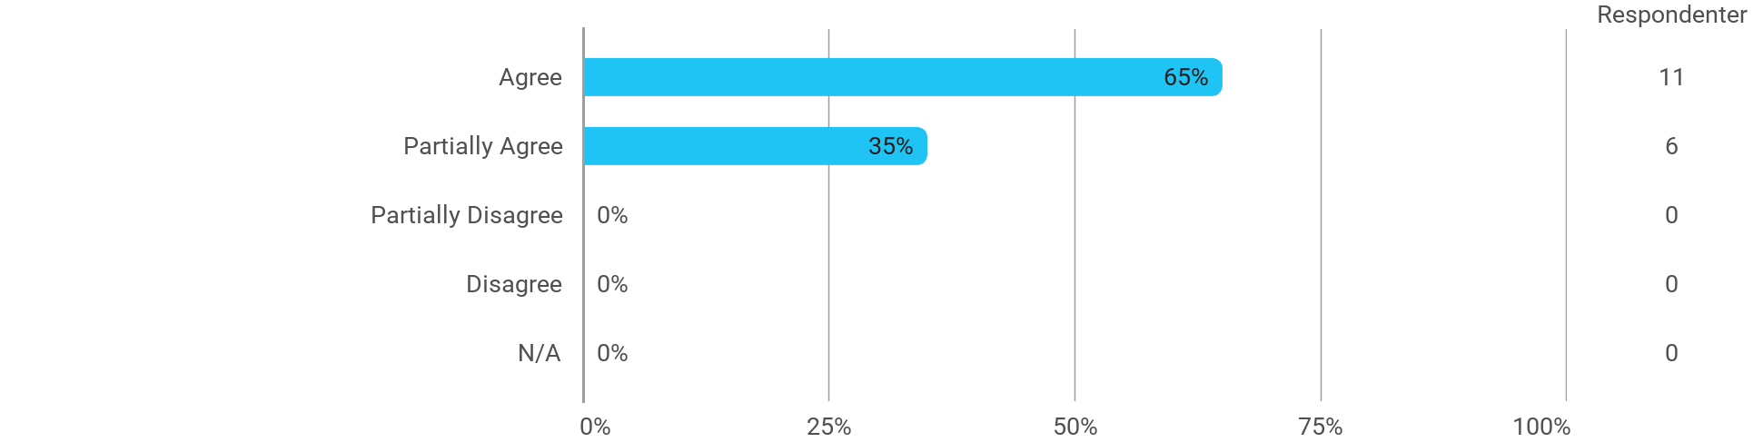

I experience the problem-based and project-oriented form of teaching as conducive to the development of: - My professional skills
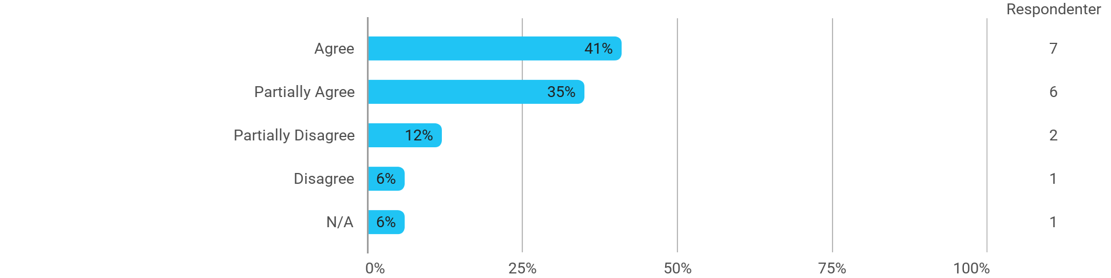

I experience the problem-based and project-oriented form of teaching as conducive to the development of: - My ability to identify and formulate problems
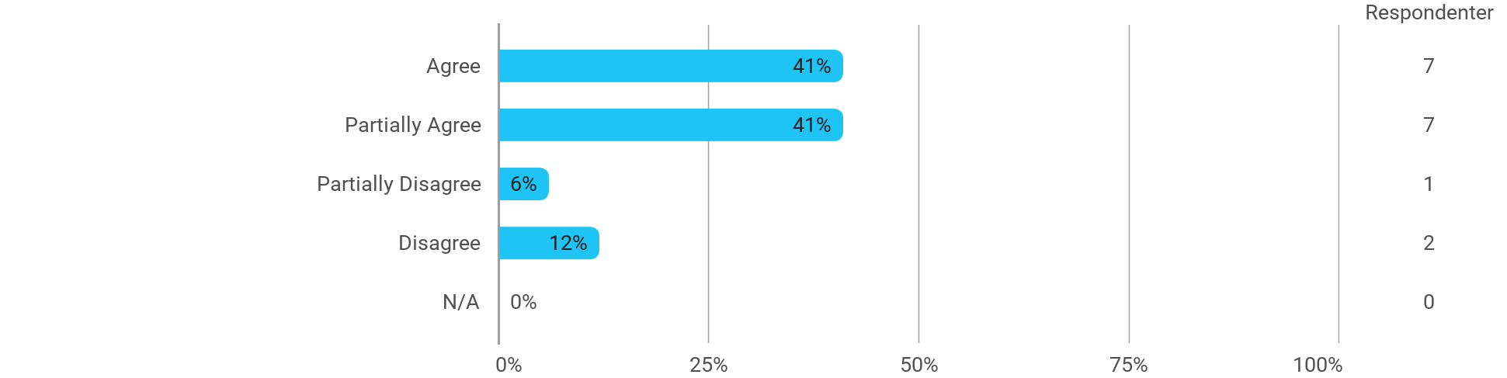

I experience the problem-based and project-oriented form of teaching as conducive to the development of: - My ability to attack and process problems
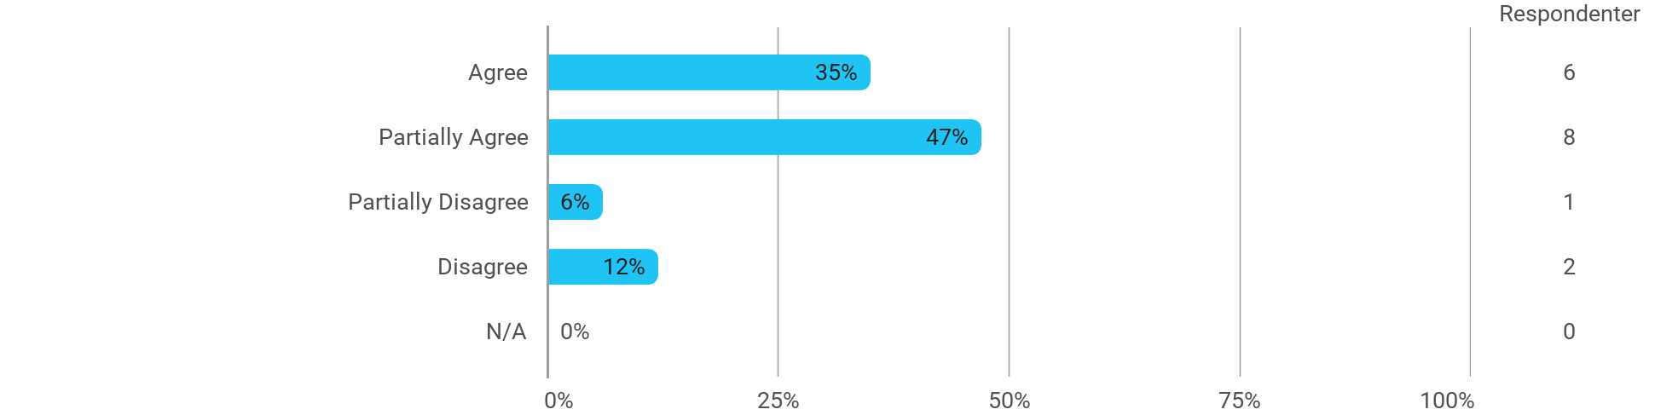

I experience the problem-based and project-oriented form of teaching as conducive to the development of: - My ability to organize a longer work process and "reach the goal" on time
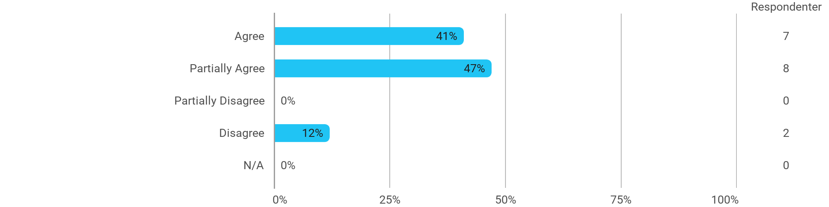

The following questions pertain to the semester as a whole: - I have received sufficient practical information about the semester's activities
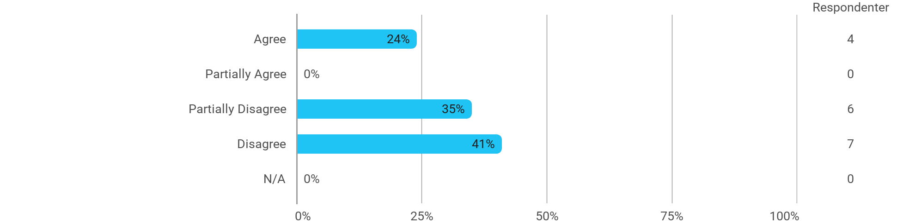

The following questions pertain to the semester as a whole: - I feel that the semester has given me the opportunity to engage in current issues relevant to external partners
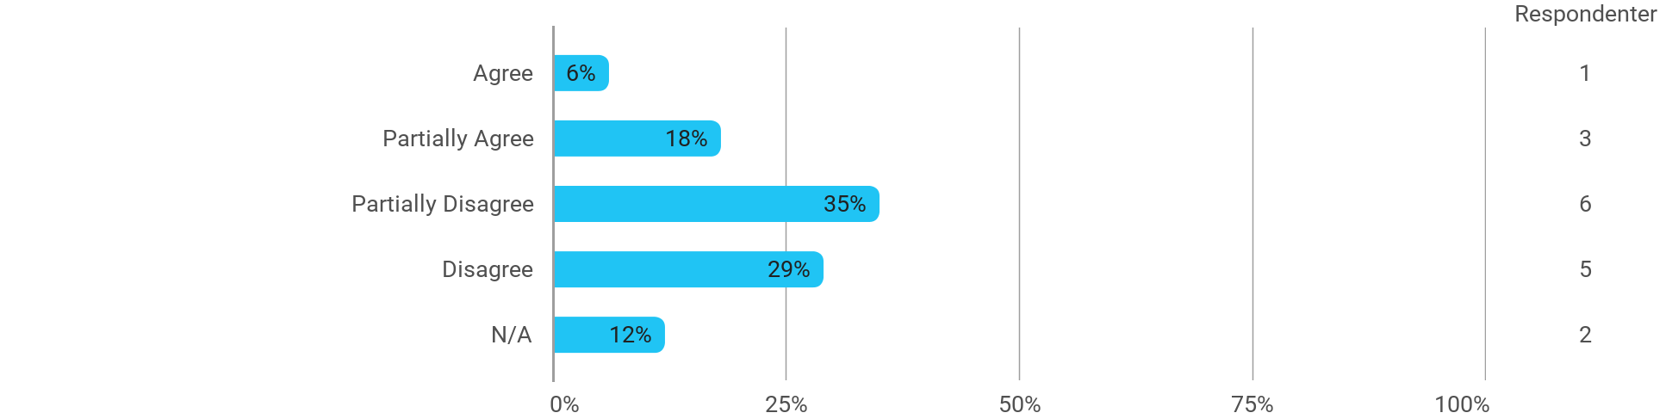

The following questions pertain to the semester as a whole: - I feel that I have addressed issues related to current societal challenges and opportunities
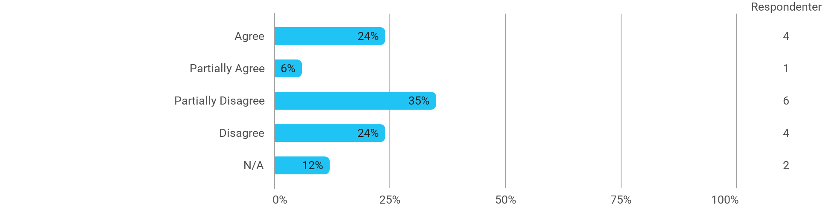

The following questions pertain to the semester as a whole: - I feel that the modules have supported the project work
