Study board conclusions of the semester and teaching evaluation report
Year: | 2024
Campus | Copenhagen
Semester | MED9C
Coordinator: | Luis Emilo Bruni
Date: | 07.03.25

This document represents the public version of the evaluation of the semester. The document forms together with the semester and teaching evaluation report the basis of any adjustments to the semester’s description, planning, execution and/or evaluation of the next iteration of the semester and are used by the coming semester coordinator and semester planning group.

The document also represents the study board’s response to the students, teachers, coordinators and other interested parties about possible consequences of conditions that the students of the semester have pointed out.

The public conclusions and recommendations of the semester coordinator
In general, the semester worked well, and all students managed to get their plans fulfilled and were generally satisfied in the 2 modalities that were implemented namely: POSEO in companies, POSEO in CREATE labs; there were no students that chose DADIU this semester.
Several detailed information meetings were held, and information posted online during the previous semester, and this resulted in many students having approved plans before semester start. There is better familiarity with the digital platform for POSEO approval, so the workflow was fluid in this regard.
There are still some gray zones in rules that raise questions from the students, as for example can the students have their POSEO in the same company where they have been holding a student job? This relates also to the question of possibility for being paid during the internship, which was clarified several times through the Moodle page.
As last year, POSEO remains the preferred option (17 students), followed by CREATE labs (6 students) and no DADIU participation as a rare event. POSEO in CREATE labs keeps being a very productive and satisfying experience both for the students and the staff involved.
Our Employability Ambassador and the career development staff at AAU-Sydhavn, we successfully included in the semester preparation and during the semester.
Note: Perhaps some of the questions in the Med 9 evaluation form have to be rethought in light of the new studypla

Conclusion of the study board
The Study Board (MSN) has processed the semester evaluation report and offers the following observations/conclusions:
- Response rate 24%
- Grade distribution fine
- The semester worked well

Samlet status
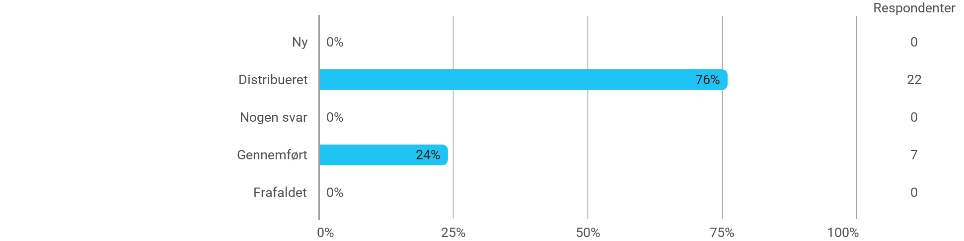

MSc03 MEDC A (project) - Project-Oriented Study in an External Organisation - I have received the expected benefit from the module
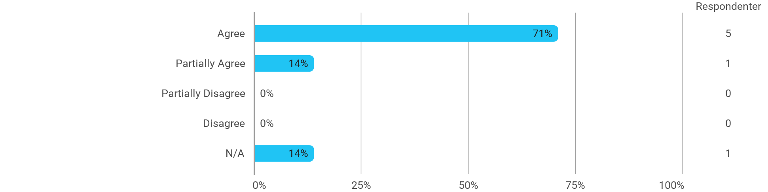

MSc03 MEDC A (project) - Project-Oriented Study in an External Organisation - The chosen problem has been a good foundation for unfolding my professional ambitions
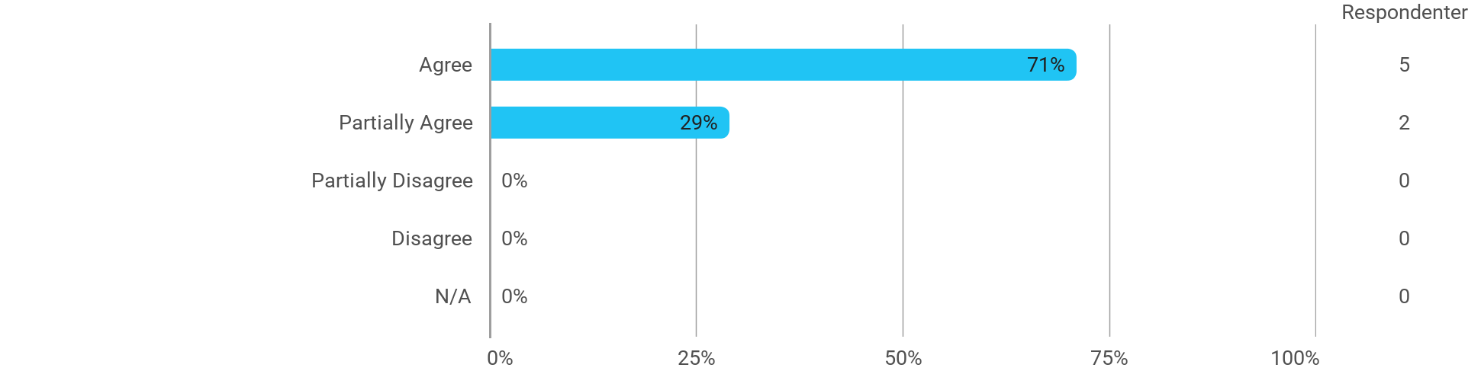

MSc03 MEDC A (project) - Project-Oriented Study in an External Organisation - The cooperation in the project group has worked well
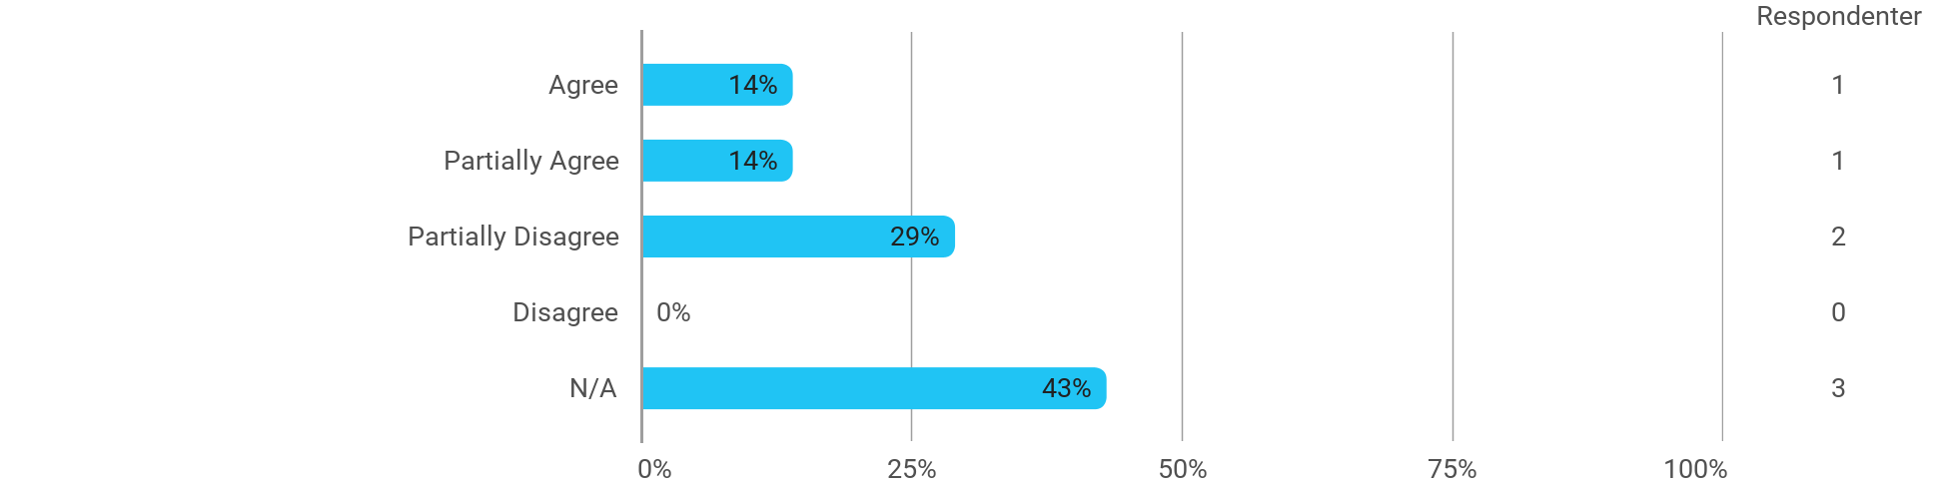

MSc03 MEDC A (project) - Project-Oriented Study in an External Organisation - The courses have supported the project work
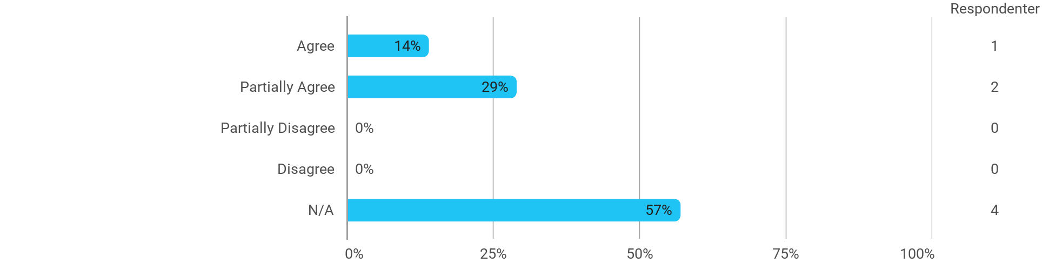

MSc03 MEDC A (project) - Project-Oriented Study in an External Organisation - I received the expected supervision

I have developed myself academically during the semester
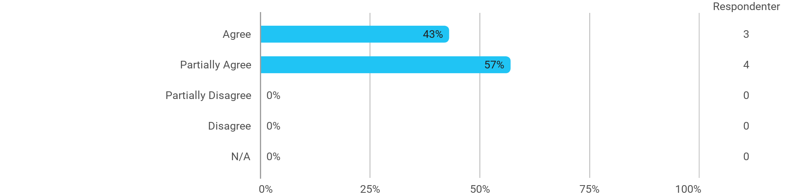

The following activities have developed me academically during the semester: - Project work
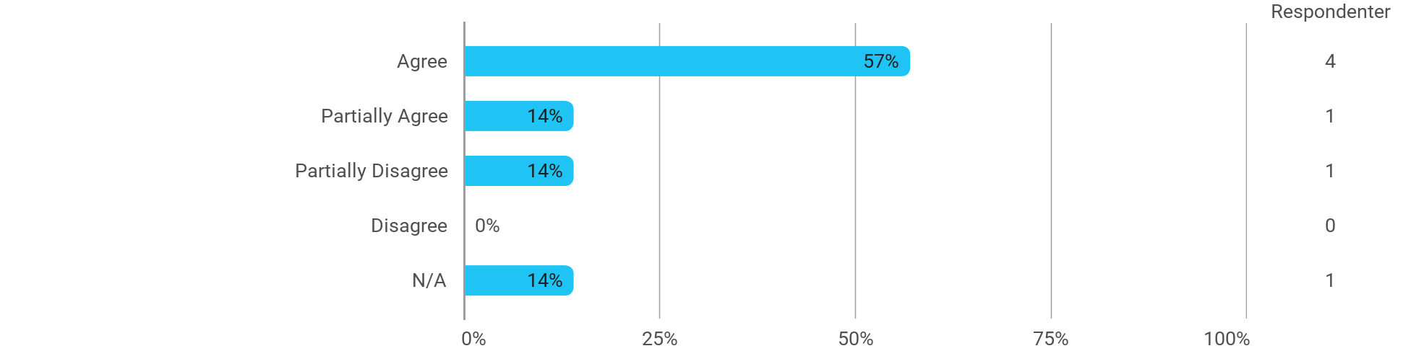

The following activities have developed me academically during the semester: - Academic discussions with fellow students
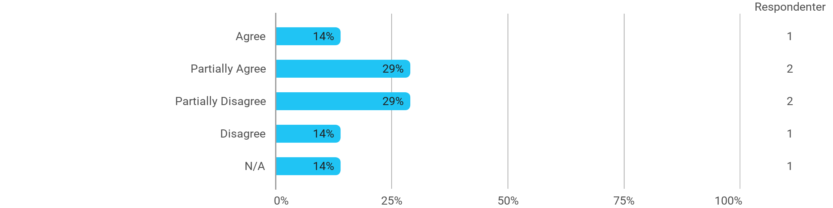

The following activities have developed me academically during the semester: - Academic discussions with teachers
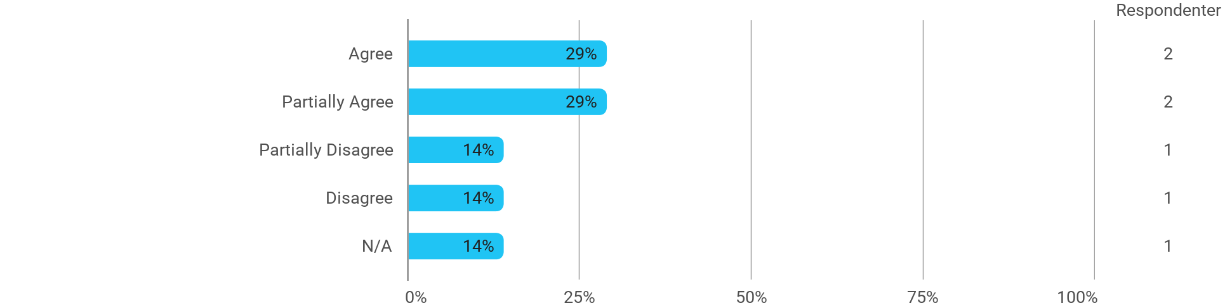

The following activities have developed me academically during the semester: - Practical exercises and experiments
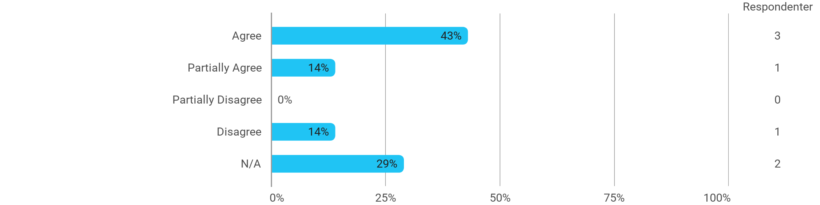

When I reflect on my own efforts, I have: - Been active in lectures
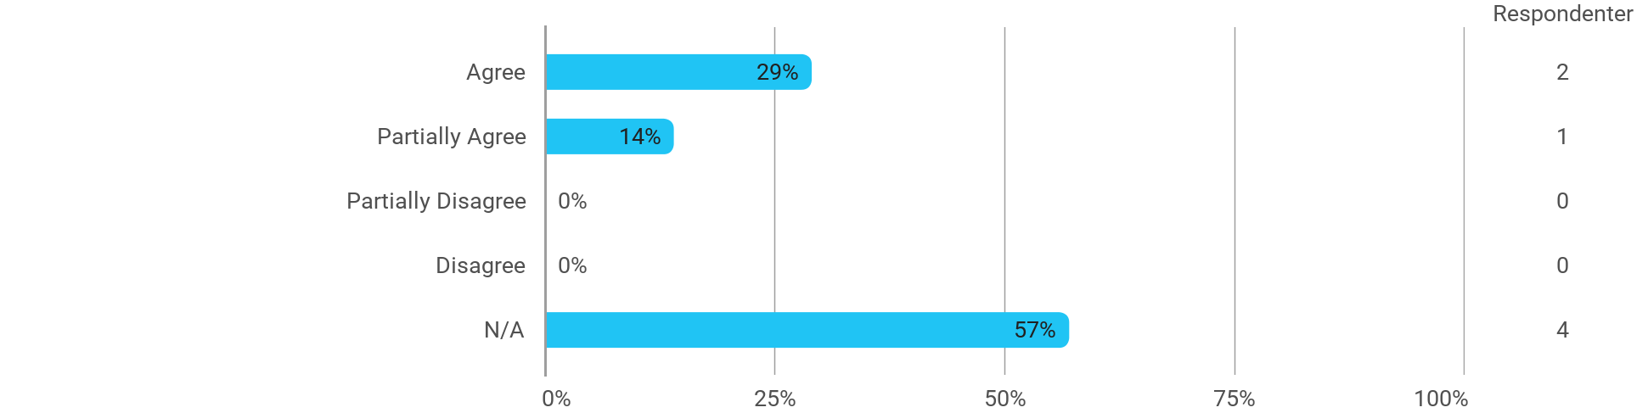

When I reflect on my own efforts, I have: - Participated actively in the project group work
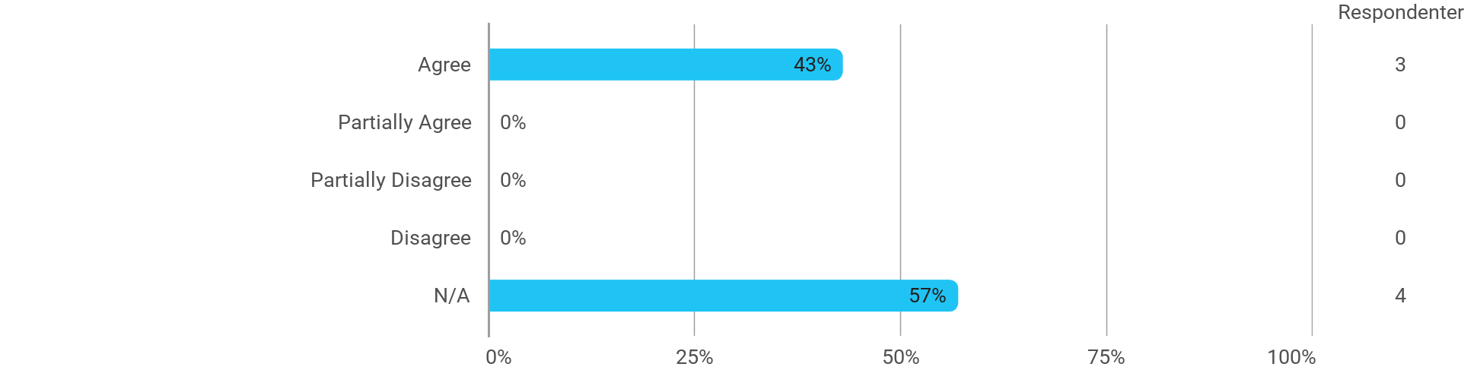

When I reflect on my own efforts, I have: - Prepared myself ahead of class
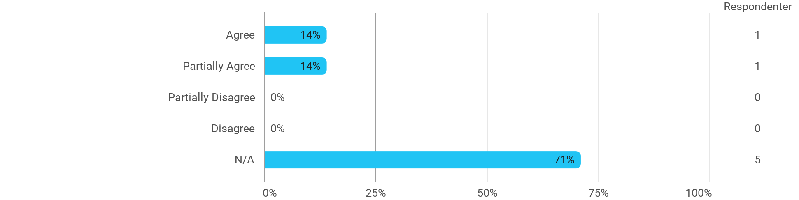

When I reflect on my own efforts, I have: - Prepared myself prior to the project group work

I experience the problem-based and project-oriented form of teaching as conducive to the development of: - My professional skills
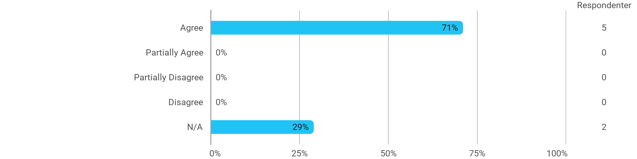

I experience the problem-based and project-oriented form of teaching as conducive to the development of: - My ability to identify and formulate problems
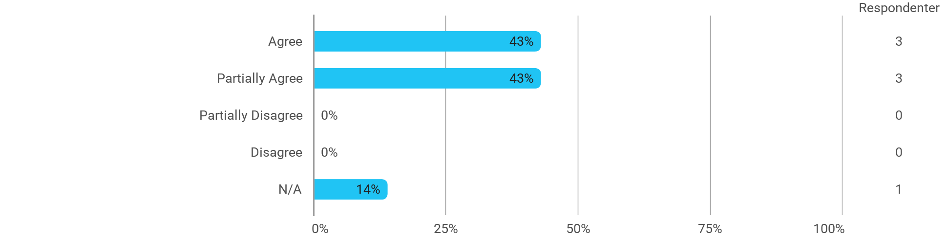

I experience the problem-based and project-oriented form of teaching as conducive to the development of: - My ability to attack and process problems
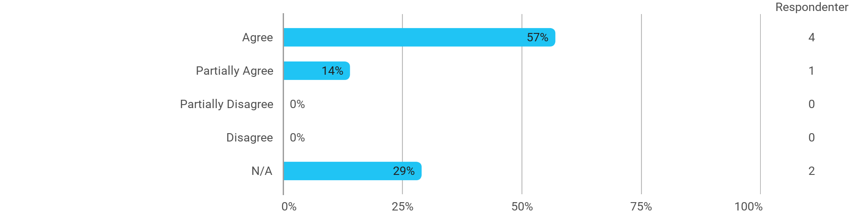

I experience the problem-based and project-oriented form of teaching as conducive to the development of: - My ability to organize a longer work process and "reach the goal" on time

The following questions pertain to the semester as a whole: - I have received sufficient practical information about the semester's activities
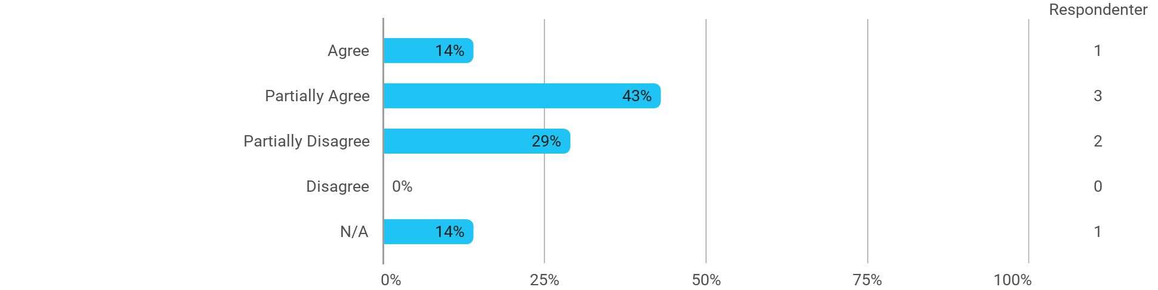

The following questions pertain to the semester as a whole: - I feel that the semester has given me the opportunity to engage in current issues relevant to external partners
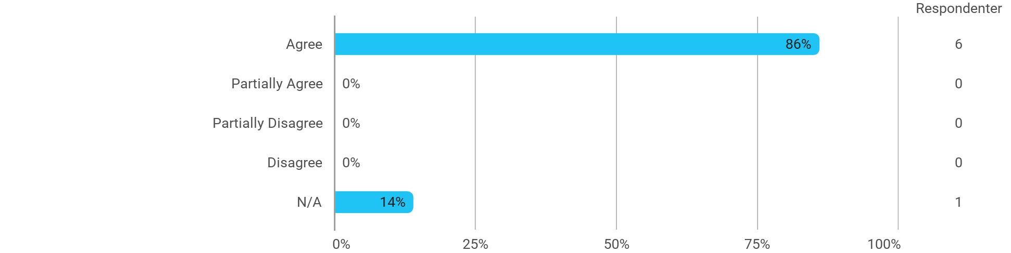

The following questions pertain to the semester as a whole: - I feel that I have addressed issues related to current societal challenges and opportunities
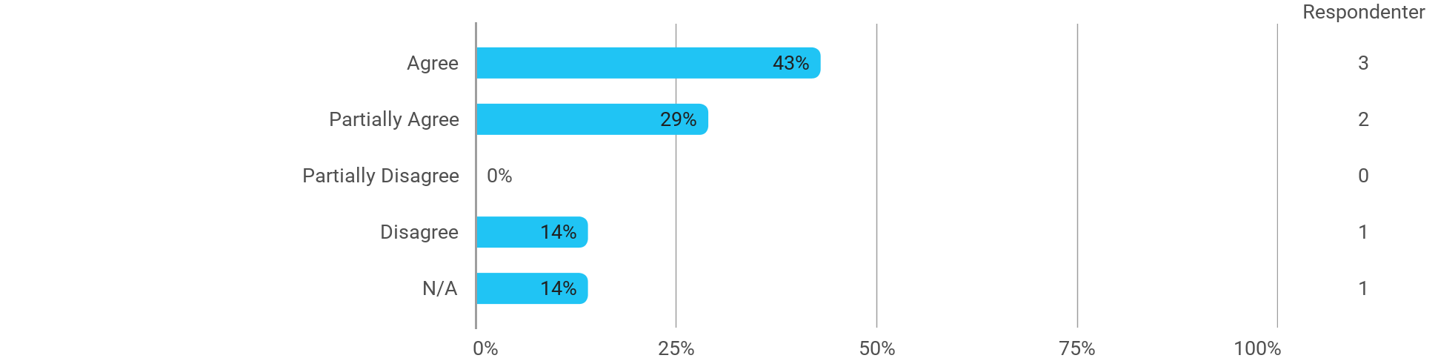

The following questions pertain to the semester as a whole: - I feel that the modules have supported the project work

